1
MARKING SCHEME
232/1
PHYSICS PAPER 1 (THEORY)
EMUHAYA CLUSTER EXAMIINATIONS TERM 2 2025
232/1
PHYSICS PAPER 1
JUNE, 2025

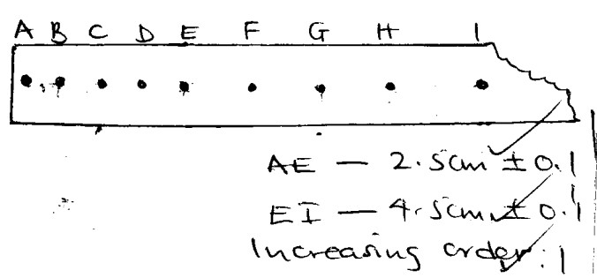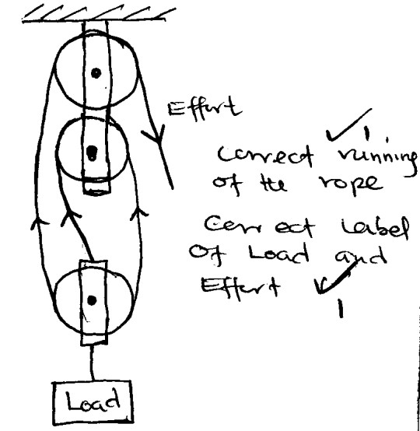

2
𝑤��� ������
But
= 𝑤��� �� ��� � ×100
End A✓1
i) Trolley runs on a straight path on the runway✓1
ii) Tape lies flat on the horizontal surface.
✓1
d)
e)
= = 1.5625ms
0.16
-2
9.
0.02 ×8
0 . 25
= 12 ms-1✓1
Work done on the mass
= force × distance
= 25 ×10 × 120
= 5000J. ✓1
Work done = power × time
= 200 × 30✓1
= 6000J✓1
= 0 . 5 6 25 −0 .3 1 25
4
�
✓1
∴ U2 =
a =
c)
120 ×0.4
= 56.25 cms-1✓1
�−�
4.5
8.
ii)
4×0.02
= 31.25cms-1✓1 OR 0.3125ms-1
E to I
Velocity = ✓1
4 ×0.02
= 2 . 5 ✓1
�����
i)
b)
Velocity = ������ 𝑎� ���� �
7.
V.R = 3✓1
Increase in temperature increases✓1 the speed of sound.
i) Convection takes place in air upwards direct due to✓1 to density defect.
ii) Convection requires a ✓1 material medium but the space between the sun and the earth i.e. space of the atmosphere has no material
medium
From the equation of continuity
A1U1 = A2U2 ✓1(flow rate is constant)
120 × 0.4 = 4 × U2
5.
6.
a)
13.
SECTION B
12.
30
= 1.8N✓1
To increase surface area of contact thus reducing pressure exerted on the road✓1
1.8×40 = 30X +18
X = 1 . 8 ×40 −18 ✓1
1000
× 100) × 40 = 30 ×X + (10× 1.8) ✓1
( 180
4.
At balance
Sum of clockwise = sum of anti-clockwise moments
11.
3000
= 154.55 sec✓1
⇒t =
463650
3.
216
= 3.0m/s✓1
Roofing materials allows radiations to penetrate into the greenhouse✓1 but not out. Higher concentration of carbon dioxide inside the greenhouse helps to retain higher temperature by trapping/ insulating✓1 the heat.
390 × 20 × (70 − 15)
= 34650.000 + 429000
= 463650✓1
Energy dissipation E = pt
3000 × 𝑡 = 463650✓1
× 1000 × 4200 × (70 − 15) +
=
1000
150
10.
2.
6000
= 83.3% ✓1
ΔH = MCΔ𝜃
16.21mm✓1 correct answer with correct units
Accept 1.621cm or 0.01621m
Momentum is conserved momentum before =
momentum after
72 ×9 = 216 ×4✓1
⇒ u = 72 × 9 ✓1
1.
= 5000 × 100

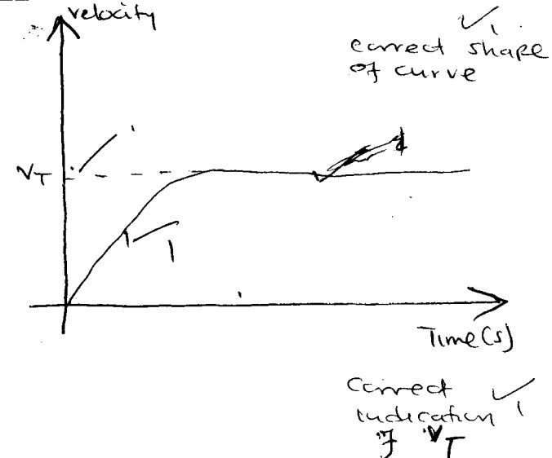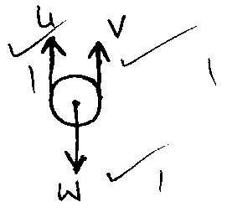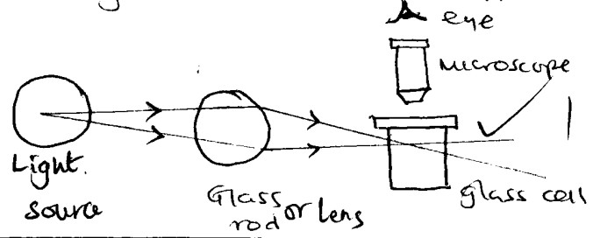

3
i)
a)
17.
2 ×10
= 4050JKg-1k-1
∑ C.m = ∑ A.C.M
2 × (30−20)
= 81000 ✓1
MCΔ𝜃
= 90 × 15 × 60 ✓1
i)
b)
pt = MCΔ𝜃
⇒C= ��
ii)
3
��
3𝑀
= � ms-1 ✓1
pt = MCθ
c = ✓1
𝑀𝜃
-
ii)
Electric heater is switched ✓1 on.
Time is obtained for a certain temperature rise✓1
Mass of block is obtained✓1
-
-
i)
b)
i)
a)
15.
ii)
ii)
500× 10−4
i) Oil spreads to form a monolayer✓1
ii) Oil patch formed is exactly
circular. There is no evaporation of oil molecules movement/ spreading ✓1 of the oil molecules are elastic.
In elastic collision – K.E and momentum of the objects are conserved✓1
Elastic collision – only momentum is conserved✓1
Initial momentum = Final momentum
2MBUB + MAUA = 3MV✓1
0 + MUA = 3Mu✓1
3Mu = MU
u - 𝑀𝑈
−9
3.14 × �2
= 0 . 01 × 10 = 2× 10−10m ✓1
= 62.83 rad-1
TA = M 𝜔 2r – mg
= (1 × 62.832 × 0.5) − (1 × 10)✓1
= 19 + 3.9 – 10
= 1963.9N✓1
At the lowest point
Fc = T – Mg
⇒ Fe + Mg
= mr 𝜔 2 + mg
= 1×0.5× 62.832+ (1 × 10)✓1
= 1973.9 + 10
= 1983.9N✓1
−9
-1
i)
b)
V= �r2h
0.01 × (10−3 )3= 3.14 ×r2 ×h✓1
h = 0 . 01 × 10 ✓1
��= 2�f
= 2� × 10
= 20�rad s
i)
a)
16.
-
-
ii)
-
A small glass with air and carbon
(smoke) particles✓1
the glass cell is strongly illuminated by a filament lamp directed by a perspex rod✓1
the particles scatter light and they can be viewed through a microscope✓1
they appear as bright specks (spots) moving with the same irregular random motion
-
ii)
Brownian motion is the continuous erratic/
random motion in either gas or liquid molecules✓1
i)
14.

4
𝐷������𝑦 �� 𝑎���������� 2.7 ×10−3
= 3.7 × 10−4 m3✓1
Mass of H2O = �𝑤 × ��𝑤
= 1000× 3.7 × 10−4
= 3.7× 10−1𝑘𝑔
∴upthrust = wgt of H2O displaced
= 3.7× 10−1 × 10
= 3.7N✓1
Since T + U = W T = W – U
= Mg – U
T = (10 × 1) – 3.7
= 6.3N✓1
ii)
i)
b)
0.00125 ×10
= 1180kgm-3✓1
A floating object displaces its own weight of the fluid on which it floats✓1
Tension + Upthrust = weight Upthrust = wgt of H2O displaced Vol. of H2O displaced = vol of aluminium
= 𝑀𝑎�� �� 𝑎� �� ������ � = 1
1000
∴ 14.75 = 0.00125 × � × 10
⇒� = 14 . 75 ✓1
𝜌𝑏
= 25 × 200 = 0.00125✓1
U = wgt of liquid displaced
14.75 = mg
= v × � × g
Vol of liquid displaced = vol of block
= 𝑀 𝑏
ii)
40
= - 14.75N✓1
∴ u = 14.75 (acting upwards)
40(0.25 - u) = 30 ×20✓1
10 – 40u = 600
40u - -590
U = − 5 90 ✓1

