NAME: ………………………………………………ADM NO: …………CLASS………… SCHOOL…………………………………………………………………….DATE: …..…….
PHYSICS
Paper 1
Time: 2 HOURS
JULY 2025.
END TERM TWO EVALUATION EXAMS 2025
(Kenya Certificate of Secondary Education)
Instructions to candidates
- Write your Name, Adm no., class and date in the spaces provided at the top of the page.
- This paper consists of two sections A and B.
- Answer all the questions in the two sections in the spaces provided after each question
- All working must be clearly shown.
- Electronic calculators, mathematical tables may be used.
- All numerical answers should be expressed in the decimal notations.
- This paper consists of 10 printed pages. Candidates should check to ascertain that all pages are printed as indicated and that no questions are missing.
- Take g=10ms⁻² and Specific Heat capacity of water=4,200JKg⁻¹K⁻¹
SECTION | QUESTION | MAX MARKS | CANDIDATE’S SCORE
A | 1 – 13 | 25
B | 14 | 11
 | 15 | 14
 | 16 | 12
 | 17 | 09
 | 18 | 09
TOTAL |  | 80

This paper consists of 11 printed pages. Candidates should check the question paper to ensure that all the pages are printed as indicated and no questions are missing.

SECTION A: 25 MARKS Answer All the Questions in this Section.
- On the space provided below sketch a micrometer screw gauge clearly showing the reading 14.43mm. (Take the pitch of the screw gauge as 0.5mm) (2mks)

- Distinguish between Cohesive and Adhesive forces. (1mks)
………………………………………………………………………………………………………………………………………………………………………………………………………………………………………………………………………………………………………………………………………………………………………………………………………………………………
- The fig.1 below shows a liquid-in-glass thermometer.

Y

Fig. 1
- Name the: I
- Thermometer…………………………………………………………(1mk)

: ii) Part labeled Y……………………………………………………..………………….. (1mk)
- State the change that can be made to the capillary bore in order to make the thermometer more sensitive. (1mk)
………………………………………………………………………………………………………………………………………………………………………………………………………………………………………………………………………………………………………………………
- The uniform rod of length one metre shown in the figure below is in equilibrium.
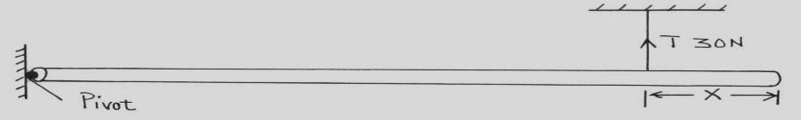
Find the value of χ if the weight of the rod is 40N. (3mks)
………………………………………………………………………………………………………………………………………………………………………………………………………………………………………………………………………………………………………………………………………………………………………………………………………………………………………………………………
- Give a reason why pollen grains placed on the surface of clean water are seen moving continuously and randomly. (1mk)
……………………………………………………………………………………………………………………………………………………………………………………………………………………………………………………………………………………………………………………..
- In the Fig.3 below, the cardboard is pulled suddenly. State the reason why the coin falls into the beaker. (1mk)
Coin

Can
Cardboard

Fig. 3

……………………………………………………………………………………………………………………………………………………………………………………………………………………………………………………………………………………………………………………..
- The pulley system in the figure below supports a load of 50N.

50N

If the efficiency of the system is 80%, calculate the effort, E. (3mks)
………………………………………………………………………………………………………………………………………………………………………………………………………………………………………………………………………………………………………………………………………………………………………………………………………………………………………………………………………………………………………………………………………………………………………………………………………………………………………………………………………………………………………………………………………………………

- State the Boyles’ law of gases. (1mk)
………………………………………………………………………………………………………………………………………………………………………………………………………………………………………………………………………………………………………………………
- A block of copper mass 0.5Kg and specific Heat capacity 400JKg⁻¹K⁻¹ initially at 80°C is immersed in water at 20◦C. If the final temperature is 21◦C and Specific Heat capacity of water=4,200JKg⁻¹K⁻¹, determine the mass of the water. (3mks)
.………………………………………………………………………………………………………………………………………………………………………………………………………………………………………………………………………………………………………….………………………………………………………………………………………………………………………………………………………………………………………………………………………
- State the reason why heat transfer by radiation is faster than conduction. (1mk)
………………………………………………………………………………………………………………………………………………………………………………………………………………………………………………………………………………………………………………………
- A student carried out an experiment to investigate the relationship between the force and extension produced on a spiral spring. The student tabulated his results as shown below.

Force (N) | 0 | 2 | 4 | 6 | 8 | 10 | 12
Extension (cm) | 0 | 0.5 | 1.0 | 1.5 | 2.0 | 2.5 | 3.0

With a reason state whether the spring obeys the Hooke’s law (2mks)
………………………………………………………………………………………………………………………………………………………………………………………………………………………………………………………………………………………………………………………
- Determine the least pressure that can be exerted by a 20kg solid of dimensions 10 cm x 20 cm x 40 cm on a horizontal surface. (3mks)
………………………………………………………………………………………………………………………………………………………………………………………………………………………………………………………………………………………………………………………………………………………………………………………………………………………………
- State the SI unit of the amount of substance. (1mk)
………………………………………………………………………………………………………………………………………………………………………………………………………………

SECTION B: 55 Marks.

- a) State the Archimedes’ principle. (1mk)
………………………………………………………………………………………………………………………………………………………………………………………………………………………………………………………………………………………………………………………
- Figure below shows a simple hydrometer.

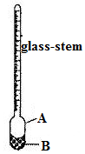

Identify the parts labelled A and B.
A…………………………………….. (1mk)
B…………........………………… (1mk)

- State the purpose of part labelled B. (1mk)
…………………………………………………………………………………………………………………
- How the hydrometer would be made more sensitive? (1mk)
………………………………………………………………………………………………………………...
- A weather balloons of volume 1.2m³ is tied to a rigid support while being filled with helium gas. The mass of the fabric making the balloon is 0.30kg. Determine the maximum tension on the string tying the balloon to the rigid support.
(Density of air is 1.25kgm⁻³ and density of helium is 0.18kgm⁻³). (4mks)
………………………………………………………………………………………………………………………………………………………………………………………………………………………………………………………………………………………………………….…………………………………………………………………………………………………………………………………………………………………………………………………………………………………………………………………………………………………………………………………………………………………………………………………………………………………………

- Explain how a submarine can be made to float and sink in water. (2mks)
………………………………………………………………………………………………………………………………………………………………………………………………………………………………………………………………………………………………………………………………………………………………………………………………………………………………………………………………………………………………………………………………………
- a) Two identical containers A and B are placed on a bench, container A is filled with oxygen gas and B with hydrogen gas such that the two gases have equal masses. If the containers are maintained at the same temperature, state with a reason the container which pressure is high (2 mks)
………………………………………………………………………………………………………………………………………………………………………………………………………………………………………………………………………………………………………………………………
b) The fig below shows a set-up of an experiment used to investigate Charles’s law

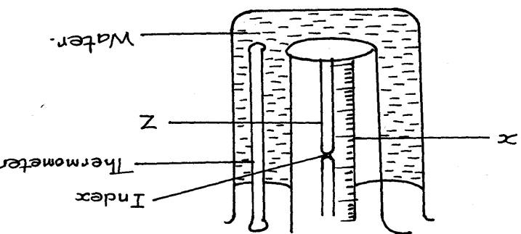

(i) Name the parts labeled X and Z (1mk)
………………………………………………………………………………………………
………………………………………………………………………………………………
(ii) State the measurements to be taken in this experiment (2mks)
…………………………………………………………………………………………………………………………………………………………………………………………………………………………….......................................................................................................................................
(iii) Explain how the readings taken in (ii) above may be used to investigate Charles law (3marks)
………………………………………………………………………………………………………………………………………………………………………………………………………………………………………………………………………………………………………………………………………………………………………………………………………………………………
- State two purposes of mercury index (2marks)
………………………………………………………………………………………………………………………………………………………………………………………………………………………………………………………………………………………………
(v) A constant mass of hydrogen gas occupies a volume of 4.0cm³ at a pressure of 2.4x 10⁵ Pa and temperature of 15⁰C. Find its volume at a pressure of 1.6xl0⁵ Pa when the temperature is 20ºC (4 marks)
………………………………………………………………………………………………………………………………………………………………………………………………………………………………………………………………………………………………………………………………………………………………………………………………………………………………………………………………………………………………………………………………………………………………………………
- a) Define a radian as applied in circular motion. (1mk)
………………………………………………………………………………………………………………………………………………………………………………………………………………………………………………………………………………………………………………………
b) A car negotiating a corner at a constant speed is said to have a change of momentum.
Explain this observation. (1mk)
………………………………………………………………………………………………………………………………………………………………………………………………………………………………………………………………………………………………………………………
- The Figure below shows a ball being whirled in a vertical plane.
Sketch on the same figure the path followed by the ball if the string cuts when the ball is at the position shown in the figure. (1mk)
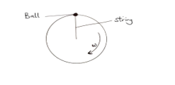

- State the purpose of banking roads at bends. (1mk)
……………………………………………………………………………………………………………………………………………………...................................................................................................................................................................................................................................................

- A boy whirls a stone of mass 0.2kg tied to a string of length 0.4m in a vertical plane at a constant speed of 2rev/s. (Take g=10ms⁻²)
- State two forces acting on the stone when it is at the highest point. (2mks)
…………………………………………………………………………………………………………………………………………………………………………
- Determine the:
I.) angular velocity of the stone; (3mks)
………………………………………………………………………………………………………………………………………………………………………………………………………………………………………………………………………………………………………………………………………………………………………………………………………………………………
II) tension in the spring when the stone is at the highest point; (3mks)
………………………………………………………………………………………………………………………………………………………………………………………………………………………………………………………………………………………………………………………………………………………………………………………………………………………………………………………………………………………………………………………………………
- a) State Bernoulli’s principle. (1mk)
………………………………………………………………………………………………………………………………………………………………………………………………………………………………………………………………………………………………………………………………………………………………………………………………………………………………
b) Figure below shows a tube of varying cross-sectional area. V₁V₂V₃ and V₄ represents the velocities of water as it flows steadily through the sections of the tube.
V₄
V₂
V₃
V₁

_{Fig. 8}

Arrange the velocities V₁, V_{2,} V3 and V₄ in descending order. (1mk)
………………………………………………………………………………………………………………………………………………………………………………………………

c). The diagram below shows a Bunsen burner

Gas in

Barrel

Hole
Nozzle

Explain how air is drawn into the barrel (2mks)
………………………………………………………………………………………………………………………………………………………………………………………………………………………………………………………………………………………………………………………
d)The figure below shows air being blown through a tube of a varying cross-sectional area.
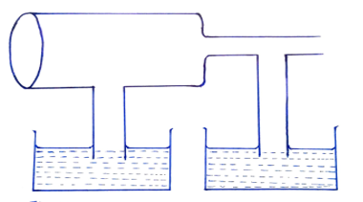
- Show the relative water levels in the two capillary tubes. (2mks)

- The larger cross-section area is 4cm² and velocity of air is 20m/s, find the velocity at the narrow section whose cross-section area is 1cm² (3 mks)
…………………………………………………………………………………………………………………………………………………………………………………………………………………………………………………………………………………………………………………………………………………………………………………………………………………..
- a) state the second Newton’s law of motion (1mk)
………………………………………………………………………………………………………………………………………………………………………………………………………………………………………………………………………………………………………………………………………………………………

b) Using the definition of impulsive force, show that F=ma. (3mks)
………………………………………………………………………………………………………………………………………………………………………………………………………………………………………………………………………………………………………………………………………………………………………………………………………………………………………………………………………………………………………………………………………
c) Two stationary trolleys A and B are separated by a compressed spring and held together by a thread. The mass of trolley A is 2.0kg and that of B is 1.0kg. When the thread is cut the trolleys move rapidly apart.
i) What is the cause of movement of trolleys when the thread is cut? (1mk)
………………………………………………………………………………………………………………………………………………………………………………………………
ii) What is the total momentum of the trolleys just before the thread is cut. (1mk)
………………………………………………………………………………………………………………………………………………………………………………………………………………………………………………………………………………………………………………………
- If trolley A moves off with a speed of 0.25m/s. Calculate the speed with which trolley B moves off. (3mks)
……………………………………………………………………………………………………………………………………………………………………………………………………………………………………………………………………………………………………………………………………………………………………………………………………………………………………………………………………………………………………………………………………………………………………………………………………………………

LAST PRINTED PAGE

