CATHOLIC DIOCESE OF KAKAMEGA EVALUATION TEST MARKING SCHEME PAPER 1
PHYSICS 232/1

SECTION A
1. Let x be the volume of milk
2+ 2.4 x = 1.9
2 + x 1
3.8 + 1.9x = 2 + 2.4x
1.8 = 0.5x
X = 3.6

Vol. of milk = 3.6cm3 (3 marks) Mass of milk = ℓv
= 2.4 x 3.6√
= 8.64g√
2 | (a) Mercury barometer | ( 1mark)
 | (b) The liquid fills the empty space | (1 mark)
3.

( 2 marks)
4 Increase in cross sectional area increases the number of electrons per unit area √ (hence increase in thermal conductivity). ( 1 mark)
5 The stream of air between the two vehicles moves at a higher velocity hence less pressure √, the higher
atmospheric pressure on the sides pushes the vehicles together. √ ( 2 marks)
6 a) This is a collision where momentum is conserved but kinetic energy is not conserved
( 1 mark)

b) m1v1 + m2v2 = v(m1 + m2) ( 2 marks)
(1.5 x 1.2) + (0.5 x -0.2) = v (1.5 + 0.5) √
1.8 – 0.1 = v (2 )
V = 1.7 = 0.85m/s √
2
7 2 x 10 = W x 40
W = 2 x 10
40
= 0.5 N Tension, T = 0.5 + 2
= 2.5N

8 Mechanics ( 1 mark)

9 e= 26 – 10

= 16cm

Elastic P.E = ½ Fe√
= ½ x 40 x 0.16 √

= 3.2 J√

Allow P.E = ½ ke2 (3 marks)

Page 1 of 4 PHYSICS PAPER 1 MARKING SCHEME
10 Molecule at the surface A experiences a net inward force due to cohesive force on the sides and below the molecule while molecule B is inside the water experiences no force ( Net force is zero)

11 The lorry is stable

The vertical line from C.O.G passes through the base of the lorry

SECTION B

12 (a) Provided the fluid is non-viscous, incompressible and its flow is streamline, increase in its velocity causes a corresponding decrease in pressure. √ ( 1 mark)
( b) – The flow is streamline ( 1 mark)

- The fluid should be non- viscous. any one

- The fluid should be incompressible

( c) 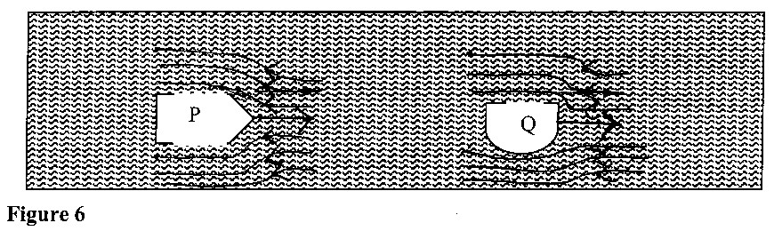

i) P √ ( 2 marks) The front part is more streamlined√ (as compared to Q hence will result into streamline flow)
ii) Shown on the diagram √√ (arrows should point to the left.) ( 2 marks)

d) A1V1 = Vol. flux = 45cm2/s or ABVB = 45 ( 2marks) TT. (2.5)2 VB = 45√
VB = 2.2915cm2√

13 (a) Latent heat of fusion is the quantity of heat required to change the state of a given mass of a substance from solid to liquid without temperature change while latent heat of vaporization is the quantity of heat required to change a given mass of a substance from liquid to vapour without temperature change. √ ( 1 mark)
(b) Heat removed by fridge = heat lost by aluminium tray + heat lost by water ( 3 marks)

= MAlCAl∆θAl + MwCw∆θ W + Mlf√

= ( 0.4 X 20 X 900 ) + ( 0.3 X 4200 X 20) + (0.24 X 3.4 X 105) √

= 7200 + 25200 + 81600

= 114000J

Page 2 of 4 PHYSICS PAPER 1 MARKING SCHEME
Heat per minute = 114000 = 1425J√

80

( c) Pt = MlCl∆θl + MwCw∆θ W + Mlf + Mlv√ ( 3 marks)

1500 x t = (0.2 x 5 x 2100) + ( 0.2 x 3.4 x 105) + ( 0.2 x 4200 x 100) √ + ( 0.2 x 2.26 x 106)

1500t = 2100 + 68000 + 84000 + 452000

T = 606100 = 404.067S√

1500

14 ( a) The temperature at which the volume of a gas is assumed to be zero. √ OR The lowest temperature a gas can fall to / The temperature at which the internal energy of a gas is zero.
( 1 mark)
( b) Decrease in volume of a container increases the number of collisions per second √ and the rate of change of momentum this increases the pressure of the gas. √ ( 2 marks)
( c) i) I) To show change in volume of the gas by moving up and down √ ( 1 mark) OR
Serve as a pointer to the volume of the gas.
II) To ensure uniform temperature √ in the bath and the gas. ( 1 mark) ii) As the heating is done, the gas expands and the volumes are recorded at each temperature. √ A graph of volume against temperature is plotted which is a straight line. √ ( 2 marks)
iii) 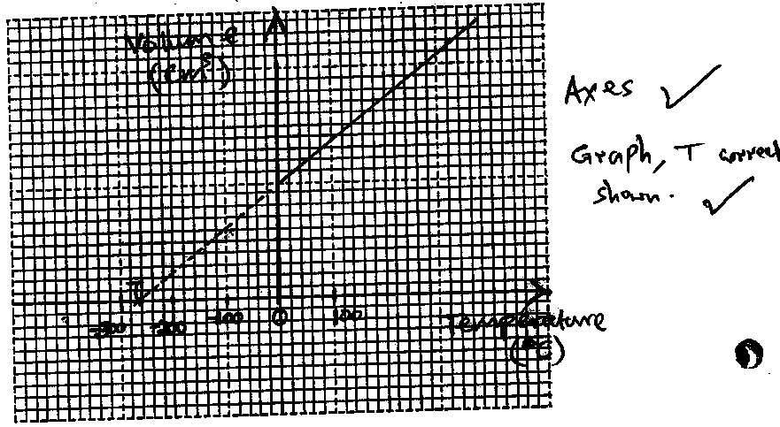

( d) P1V1 = P2V2 ( 2 marks) ( 5 + 76) 25 = (76 – 5) V2√
81 X 25 = 71 X V2
2025 = 71V2
V2 = 28.52 cm3√

15. (a) The centrifuge has centripetal force√ highest at the bottom ends. A pressure gradient is created along the distance of the mixture producing centripetal force at each section water being lighter will move towards the top and mud towards bottom end. √ ( 2 marks)

(b)

Page 3 of 4 PHYSICS PAPER 1 MARKING SCHEME
(i) Fr = mv2 ( 2 marks)
r
= mw2r
0.4 = 0.2 x w2 x 0.08 √
W2 = 0.4
0.016
W= 5 rad s-1√
ii) ( 2 marks) F = 0.2 X 52 X 0.12 √
= 0.6N √

iii) Frictional force required Fr = mw2r ( 2 marks)
= 0.2 x 52 x 0.12
= 0.6N
Since 0.8N > 0.6N the block will slide. √
16. a) A floating object displaces its own weight of the fluid in which it floats. √ ( 1 mark) (b) (i) Indicated on the diagram ( 3 marks)
(ii) Tension = upthrust – weight √ ( 1 mark) T = U – W
( c ) (i) ( 3 marks)
U = Weight of solid
= V x ℓ x g√
= 11.5 x 10-6 x 800 x 10√
= 0.092N√
ii) ( 3 marks)
U = ℓl Vl g√
0.092 = ℓx 8.5 x 10-6 x 10√
ℓ = 0.092
8.5 x 10-6 x 10
= 1082.35kg/m3 or 1.082g/cm3√

17. (a) i) 900 x 0.3 = E x 1.2√ ( 2 marks) E = 900 x 0.3 = 225N√
1.2
ii) Energy transformed = Effort x effort arm ( 2 marks)
= 225N x 1.2m
= 270 Joules
b.i) V.R = Dist. Moved by effort = 2Л R √ ( 3 marks) Dist. moved by load 2Лr
= R
r
ii) ( 3 marks)
V.R = 8/5 = 1.6√
M.A X 100 = 80
V.R
M.A = 80 X 1.6
100
= 1.28√

END
1.28 = L E
1.28 = 20
E E = 20
1.28
E = 15.625N√

Page 4 of 4 PHYSICS PAPER 1 MARKING SCHEME

