GATUNDU SUB- COUNTY JOINT EVALUATION

PAPER 1
FORM FOUR TERM TWO 2025
MARKING SCHEME P1

MATHEMATICS 121/1

1. | Numerator  $\frac{5}{2}x\frac{7}{4}-\frac{21}{4}$=$\frac{35}{8}-\frac{21}{4}=\frac{-7}{8}$  denominator  $$\frac{7}{5}+2\left(\frac{-6}{4}\right)=\frac{7}{5}-3=\frac{-8}{5}$$  $$\frac{-7}{8}÷\frac{-8}{5}=\frac{-7}{8}X-\frac{-5}{8}$$  $$\frac{35}{64}$$ |  | M1  M1  A1
 |  |  | 3mks
2 | $$Exterior=x∴i\text{nterior}=\text{3x}+\text{20} \\ x+\text{3x}+\text{20}=\text{180} \\ x=\text{4}{\text{0}}^{o} \\ Noofsides=\frac{360}{40} \\ =9$$  Nonagon |  | M1  A1  B1
 |  |  | 3mks
3. | $buying price$=$\frac{100}{70}X1400$  $$\frac{ 2300-2000}{2000}X100$$  15$\%$ |  | M1  M1  A1
 |  |  | 3mks
4 | 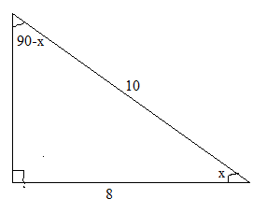  $$\sin\left(90-x\right)=\frac{8}{10} \\ \tan{x}=\frac{6}{8} \\ \cos\left(90-x\right)=\frac{6}{10} \\ 2\tan{x}+\cos\left(90-x\right)=2\left(\frac{6}{8}\right)+\frac{6}{10} \\ =\frac{6}{4}+\frac{6}{10} \\ =2\frac{1}{10}$$ |  | b1  m1  a1
 |  |  | 3mks
5. | 5625=3X3X5X5X5X5  $$5^{4}X3^{2}$$  T=5 and s=3 |  | M1  M1  A1
 |  |  | 3mks
6. | 2y+5x+2=0  y= $\frac{-5}{2}x-1$  gradient = $\frac{-5}{2}$= -2.5  $\tan^{-1}2.5$=68.13  Obtuse angle= 180-68.13=111.9  =111.9$°$ |  | M1  M1  A1
 |  |  | 3mks
7. | Numerator  $$\left(12x^{2}-8ax\right)\left(9ax-6a^{2}\right)$$  4x$\left(3x-2a\right)+3a\left(3x-2a\right)$  $$\left(3x-2a\right)\left(4x+3a\right)$$  Denominator  9$X^{2}-4a^{2}$  $$\left(3x-2a\right)\left(3x+2a\right)$$  Combined  $\frac{\left(\left(3x-2a\right)\right)\left(4x+3a\right)}{\left(3x-2a\right)\left(3x+2a\right)}$= $\frac{4x+3a}{3x+2a}$ |  | M1  M1  A1
 |  |  | 3mks
8  . | $$\frac{1}{2}X15Xh=456.8$$  h=$\frac{456.8x2}{15}$  h=60.91m  Longest side=$\sqrt{{60.91}^{2}+{15}^{2}}$  $$\sqrt{3935.0281}=62.73m$$ |  | M1  M1  A1
 |  |  | 3mks
9. | 1250 X 105.5= 131875  1318756-85400=46475  46475$÷110.8=419.449$  = 419 US dollars |  | M1  M1  A1
 |  |  | 3
10 | _{L1=}$x≥0$  L2=$y<\frac{-4}{5}x+4$  L₃₌$y≥\frac{3}{4}x-3$ |  | B1  B1  B1
 |  |  | 3MKS
11. | 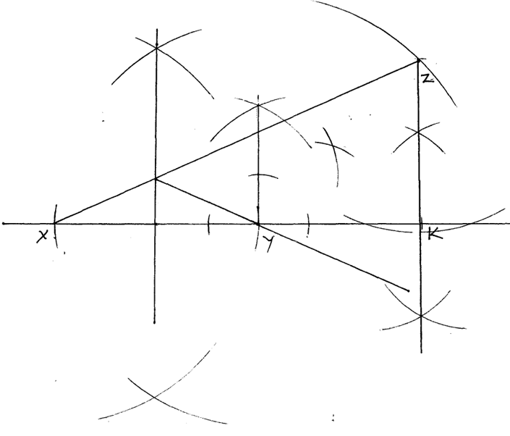 |  | B1  B1 | construction of 135º at y and 6 cm.  $∆$xyz
b) | ZK=4.9 cm ± 0.1 |  | b1  b1 | construction of perpendicular
 |  |  | 4
12 | Time take by bus= 11.45am  -9.15am  2.30  Distance covered= $2\frac{1}{2}X63=157.5km$  Time taken by car=11.45am-10.00am =$1\frac{3}{4}hrs$  Speed of the car= 157.5$÷1\frac{3}{4}$  157.5 X$\frac{4}{7}=90km/h$ |  | M1  M1  A1
 |  |  | 3
13. | 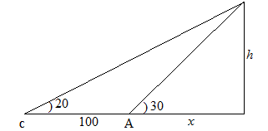  $$\tan{2}0=\frac{h}{100+x}⇒h=\left(100+x\right)\tan{2}0 \\ \tan{3}0=\frac{h}{x}⇒h=x\tan{3}0 \\ x\tan{3}0=\left(100+x\right)\tan{2}0 \\ 0.5774x=36.40+0.3640x \\ x=\frac{36.40}{0.2134} \\ =170.57 \\ h=170.5757\tan{3}0 \\ 98.48m$$ |  | M1  A1  b1
 |  |  | 3mks
14 | $$3\left({6 \atop 2}\right)-2\left(\begin{matrix}-2 \\ -4\end{matrix}\right)+2\left(\begin{matrix}a \\ b\end{matrix}\right)=\left(\begin{matrix}32 \\ 20\end{matrix}\right)$$  $$\left(\begin{matrix}18 \\ 6\end{matrix}\right)-\left(\begin{matrix}-4 \\ -8\end{matrix}\right)+\left({2a \atop 2b}\right)=\left({32 \atop 20}\right)$$  $$\left({22 \atop 14}\right)+\left({2a \atop 2b}\right)=\left({32 \atop 20}\right)$$  $$\left({2a \atop 2b}\right)=\left({10 \atop 6}\right)$$  2a=10 a=5  2b=6 b=3  Hence C=$\left({5 \atop 3}\right)$ |  | M1  A1  B1 | substitution  values of a and b
 |  |  | 3mks
15  a)  b) |  | LCM = $2^{3}×3 × 5^{3}=600$  11;20 a.m+10 mins  12;05 p.m  30 / 10 =3 times | B1  B1  B1  B1
 |  |  | 4
16 |  | L.S.F=$\frac{16+8}{8}$=3  Hence 1:3  v.s.f=1:27  Volume of the cone =160 x27=4320${cm}^{3}$  Volume of frustum= 4320-160= 4160${cm}^{3}$ | M1  M1  A1
SECTION 11
17 |  | a) 30$\% of 4,000,000=1,200,000$  $$\frac{2}{8} X 1.200,000=300,000$$  b) money paid=4,000,000-120000= 2,800,000  $$\frac{125}{100} x2800000=3,500,000$$  Hassan paid $\frac{3}{8} X 3,500,000$  =1,312,500  c) money shared= 4800000-3,500,000=1,300,000  $\frac{3}{8}$ X 1,300,000  = 487,500 | M1  M1A1  M1  M1  M1  A1  M1  M1  A1
 |  |  | 10mks
18  b) |  | 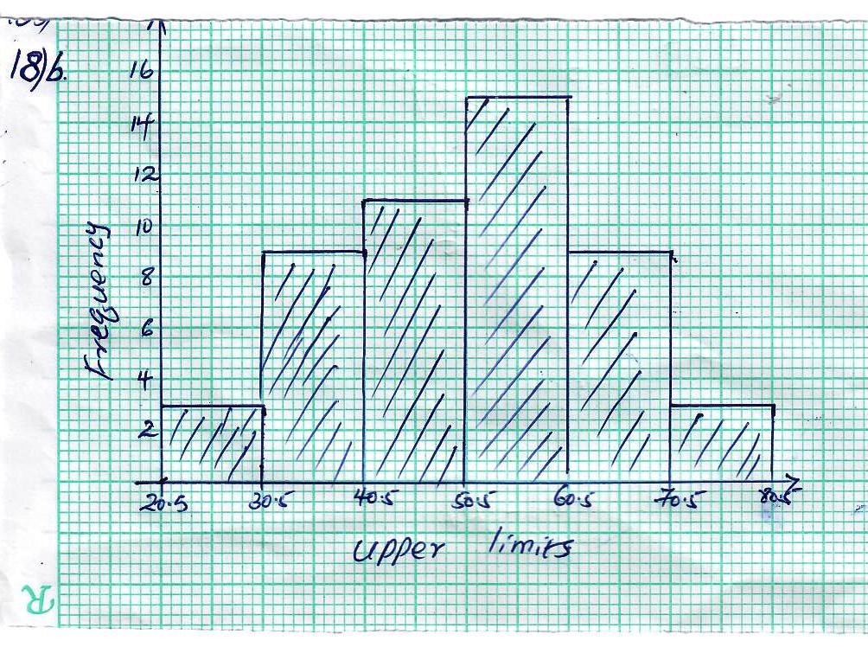  c) 51-60  d) mean =$\frac{1}{2}X10\left(3+9+11+15+9+3\right)=250$  mean $\sim$ at 51.8 $±0.1$ | B1  B1  B1  B1  B2  B1  B1  B1  B1 |  | For classes  For tally  For frequency  accept  Histogram dawn using frequencies or frequency densities since the class intervals are equalFor correct frequency  For modal class  Upper limit  For line of mean on histogram
  Class | tally | frequency
  21-30 | /// | 3
  31-40 | //// //// | 9
  41-50 | //// /// / / | 11
  51-60 | //// //// //// | 15
  61-70 | //// //// | 9
  71-80 | /// | 3
   |  | $$\sum{f=50}$$
 |  |  | 10mks
19. |  | i) Tan 30$°$=$\frac{AE}{100}$  AE=100Tan 30$°$  =100x.0.5774  =57.74M  ii)AC=$\sqrt{{57.74}^{2}+{57.74}^{2}}$  =81.66  AD²=${81.66}^{2}+{80}^{2}-2X81.66X80\cos{100}$  =123.84m  iii)$\sqrt{{100}^{2}+57.74 }$²  $\sqrt{10000+3333.9}$  115.47  115.5  Perimeter= 115.5+123.8+80+57.74+100  477.05  477.1m  b) total length of the wire one strand =477.1-2.8x3  =468.7  Five strands= 468.7x5 =23343.5m  =$\frac{23343.5}{480}=4.882$  =5rolls | M1  A1  M1  A1  M1  M1  A1  M1  M1  A1
 |  |  | 10mks
20a)  b)  C)  d) |  | $$\frac{y-3}{x--1}=\frac{-1}{2}$$  y-3=$\frac{-1}{2}\left(x+1\right)$  y-3=$\frac{-1}{2}x-\frac{1}{2}$  y= $\frac{-1}{2}x+2\frac{1}{2}$  $$\frac{5—3}{4-1}=\frac{8}{3}$$  $$\frac{y-5}{x-4}=\frac{8}{3}$$  y-5=$\frac{8}{3}-\frac{32}{3}$  3y-15=8x-32  8x-3y-17=0  Gradient of l₂ =$\frac{8}{3}$  Gradient of perpendicular line=$\frac{-3}{8}$  Equation= y=$\frac{-3}{8}x+5$  Gradient of parallel line =$\frac{-1}{ 2}$  $$\frac{y-5}{x-4}=\frac{-1}{2}$$  Y-5 =$\frac{- 1}{2}x+2$  Y=$\frac{-1}{2}x+7$ | M1  A1  M1  M1  A1  BI  MI A1  M1  A1
 |  |  | 10MKS
 |  |  | 10mks
23 a)  b)i  ii)  c) |  | Inverse=$\left(\begin{matrix}-2 & 3 \\ 3 & -4\end{matrix}\right)$  $20x+15y=9500$ $4x+3y=1900$  $30x+20y=13500$ $3x+2y=1350$  $$\left(\begin{matrix}4 & 3 \\ 3 & 2\end{matrix}\right)\left(\begin{matrix}x \\ y\end{matrix}\right)=\left(\begin{matrix}1900 \\ 1350\end{matrix}\right)$$  $$\left(\begin{matrix}-2 & 3 \\ 3 & -4\end{matrix}\right)\left(\begin{matrix}4 & 3 \\ 3 & 2\end{matrix}\right)\left(\begin{matrix}x \\ y\end{matrix}\right)=\left(\begin{matrix}-2 & 3 \\ 3 & -4\end{matrix}\right)\left(\begin{matrix}1900 \\ 1350\end{matrix}\right)$$  $$\left(\begin{matrix}1 & 0 \\ 0 & 1\end{matrix}\right)\left(\begin{matrix}x \\ y\end{matrix}\right)=\left(\begin{matrix}-3800+4050 \\ 5700-5400\end{matrix}\right)$$  $$\left(\begin{matrix}x \\ y\end{matrix}\right)=\left(\begin{matrix}250 \\ 300\end{matrix}\right)$$  X=250  Y=300  New price of oranges=$\frac{110}{100}x250=275$  New price of mangoes=$\frac{90}{100}x300=270$  Anina= 20x275+15x270=9550  Nafula= 30x275+20x270= 13650 | B1  B1  B1  M1  M1  M1  A1  M1  A1  B1 |  | Inverse  both
 |  |  | 10
24.a)  i)  II |  | $$A=\frac{1}{2}×1\left[\left(22+22\right)+2\left(15+10+7+6+7+10+15\right)\right] \\ =\frac{1}{2}\left[44+140\right] \\ =92 sq unit$$  A =2 ( 15+7+7+15)  = 88 | b1  m1  a1  M1  A1 |  | -all ordinates
  x | -4 | -3 | -2 | -1 | 0 | 1 | 2 | 3 | 4
  y=x²+6 | 22 | 15 | 10 | 7 | 6 | 7 | 10 | 15 | 22
III  b |  | $$\int_{-4}^{4}{\left(x^{2}+6\right)dx=\frac{x^{3}}{3}+6x+c}{\left.\right|}_{-4}^{4} \\ =\left(\frac{4^{3}}{3}+6\left(4\right)\right)-\left(\frac{{\left(-4\right)}^{3}}{3}+6\left(-4\right)\right) \\ \frac{64}{3}+24+\frac{64}{3}+24 \\ =\frac{128}{3}+48$$  $$90\frac{2}{3} \\ \%Error\left(\frac{90\frac{2}{3}-92}{90\frac{2}{3}}\right)×100 \\ =1.471\%$$ | m1  m1  a1  m1  A1 |  | Corr integration
 |  |  | 10MKS

