Name……………………………………………………………………………………Stream……….…….………….
School ………………………………………………………………….. Index Number:…………………….…....
Candidate’s Signature……………............... Date:…...……………………………..........
121/2
Mathematics ALT A.
Paper 2
JUNE 2025
2 ½ Hours

EMUHAYA CLUSTER EVALUATION 2025
Kenya Certificate of Secondary Education
MATHEMATICS ALT A.
PAPER 2
TIME: 2 ½ HOURS

INSTRUCTIONS TO CANDIDATES:
- Write your name, index number, admission and class in the spaces provided above.
- Sign and write the date of examination in the spaces provided above.
- This paper contains TWO sections: Section I and Section II.
- Answer ALL the questions in Section I and ONLY FIVE questions from section II.
- All answers and working MUST be written on the question paper in the spaces provided below each question.
- Show all the steps in your calculations, giving your answers at each stage in the spaces below each question.
- Marks may be given for correct working even if the answer is wrong.
- Non-programmable silent electronic calculators and KNEC Mathematical tables may be used, except where stated otherwise.
- Candidates should answer the questions in English.
FOR EXAMINE’S USE ONLY
SECTION I
1 | 2 | 3 | 4 | 5 | 6 | 7 | 8 | 9 | 10 | 11 | 12 | 13 | 14 | 15 | 16 | Total

SECTION II
Grand Total

17 | 18 | 19 | 20 | 21 | 22 | 23 | 24 | Total
SECTION 1 (50 Marks)
Answer ALL the questions in the spaces provided after each.

1. Rationalise the denominator and simplify leaving your answer in the form $\sqrt{a}$ $+ b$ (3marks)
$\frac{\sqrt{2} + 2\sqrt{5}}{\sqrt{5} − \sqrt{2}}$

2. The radius of a sphere was corrected to 1 decimal place as 3.5cm. Taking $π$ = $\frac{22}{7}$, find :
(a) the surface area of the sphere. (1mark)

(b) the percentage error in calculating the surface area of the sphere. (3marks)

3. Find the value of $p$ if $px^{2}−\frac{3}{2}x+ \frac{1}{16}$ is a perfect square and $p$ is a constant. (2marks)

4. A circle of radius 3cm has its centre at (3, $−$2).Express the equation of the circle in the form
$x^{2}+ y^{2}+ mx+ny+c=0$ where $m$, $n$ and $c$ are constants. (3marks)

5. A transformation matrix $\left(\begin{aligned}p 2 \\ 4p−3 3p\end{aligned}\right)$maps an object of area 21${cm}^{2}$ to an image of area 42${cm}^{2}$. Determine the value of $p.$ (3Marks)

6. Solve for x in the equation.
6Cos²x – Sin x – 4 = 0 in the range $0^{0 }≤ x≤ {180}^{0}$ (4Marks)

7. Given the function ; $y= \frac{\sqrt[3]{x}}{z − r^{2}}$
(a) find the value of $y$ truncated to 2 decimal places if $x=200, z=50$and r = 6 (1mark)

(b) Make $r$ the subject of the function above. (2marks)

8. (a) Using the binomial expansion, expand ${\left(2 + \frac{2}{x} \right)}^{5}$ up to the term in $x^{−3}$ (2marks)

(b) Use the expansion above to evaluate ${\left(3.5\right)}^{5}$ (2marks)

9. Five men working 8 hours a day take 2 days to cultivate an acre of land. How many days would four men working 10 hours a day at double rate to cultivate 3 acres of land? (3marks)

10. The following table shows monthly income tax rates for a certain year
Monthly income in kshs | Tax % in each shilling
0 – 24, 000 | 10
24, 001 – 32, 333 | 25
32, 334 – 50, 000 | 30
Above 50, 000 | 32.5
In June of that year, an employee earnings were as follow:
Basic salary sh.92, 000
House allowance sh.45, 000
Travel allowance sh.12, 000
He was entitled to a monthly tax relief of sh. 2, 400.
Calculate his monthly tax (4 Marks)

11. Draw a line $AB=9cm.$ On the upper side of line $AB,$ construct the locus of a point P such that the area of $∆APB=13.5{cm}^{2}.$ On the same locus of $P$ locate two points labeled $P_{1}$ and $P_{2}$ such that $<AP_{1}B=<AP_{2}B= {90}^{0}$. (3Marks)

12. Calculate the quartile deviation for the following scores
9, 12, 14, 16, 18, 20, 23, 24 (3Marks)

13. The position vectors of A and B are given as $a=2i−3j+4k$ and $b= −2i−j+2k$ respectively . Find to 2 decimal places, the length of the vector AB. (3Marks)

14. In the figure below ABC is a tangent to the circle at point B. Given that BE = 6.9cm,
FE = 7.8 cm, GE = 4.1 cm, DC=11.2cm and ED = x cm. Determine the length BC, give your answer in four significant figures. (4 marks)
15. Find $m$ given that: $\int_{2}^{m}{\left(5x−12\right)dx=16.5}$ | (4Marks)

16. In an experiment involving two variables, time ($t)$ hours and height ($h)$cm, the following results were obtained.
$$Time \left(t\right)hours$$ | $$0$$ | $$0.7$$ | $$1.5$$ | $$2.1$$ | $$3.2$$ | $$3.6$$
$$Height \left(h\right)cm$$ | $$97$$ | $$82$$ | $$64$$ | $$46$$ | $$32$$ | $$18$$
- On the grid provided, plot height, against time, $t ( h)$ (1mark)

- Use the plotted points to draw the line of best of fit for the data and hence determine the rate of change of height with time. (3Marks)

SECTION II (50 MARKS)
Answer only five questions in this section in the spaces provided.
17. Three similar bags A, B and C each contains grey and pink balls. A has 2 grey and 7 pink balls, bag B has 4 grey and 3 pink balls while bag C has 5 grey and 5 pink balls. The balls are identical except of colour. A bag is selected at random and two balls randomly picked from it, one at a time without being returned.
a) using a tree diagram or otherwise, find the probability that;
i) The two balls are from bag A and are both pink. (2Marks)

ii) The two balls are of different colours and picked from bag B or C. (3Marks)

b) All balls initially in the three bags are gathered in one bag and 3 balls randomly picked from it, one at a time and placed in a second bag which is empty. Find the probability that all the three balls picked are grey. (2Marks)

c) A bag contains 15 red balls and x blue balls, two balls are selected at random one at a time, the probability of selecting balls with different colours is $\frac{1}{2}$. Find the number of balls in the bag. (3Marks)

18. (a) Complete the table below for the functions $y= −3\cos{2x}$ and $y=2\sin{{\left(\frac{3}{2}x+30\right)}^{0}}$ for $0^{0}≤x≤{180}^{0}$ (2marks)
$$x^{0}$$ | $$0$$ | $$20$$ | $$40$$ | $$60$$ | $$80$$ | $$100$$ | $$120$$ | $$140$$ | $$160$$ | $$180$$
$$−3\cos{2x}$$ | $$−3.00$$ |  |  | 1.50 | $$2.82$$ | $$2.82$$ |  | $$−0.52$$ | $$−2.30$$
$$2\sin{{\left(\frac{3}{2}x+30\right)}^{0}}$$ | $$1.00$$ |  | $$2.00$$ | $$1.73$$ |  | $$0.00$$ | $$−1.00$$ |  |  | $$−1.73$$
(b) Using the grid provided, draw the graphs of $y= −3\cos{2x}$ and $y=2\sin{{\left(\frac{3}{2}x+30\right)}^{0}}$ for $0^{0}≤x≤{180}^{0}$ on the same pair of axes. Take 1cm to represent ${20}^{0}$ on x – axis and 2cm to represent 1 unit on the y – axis. (5Marks)
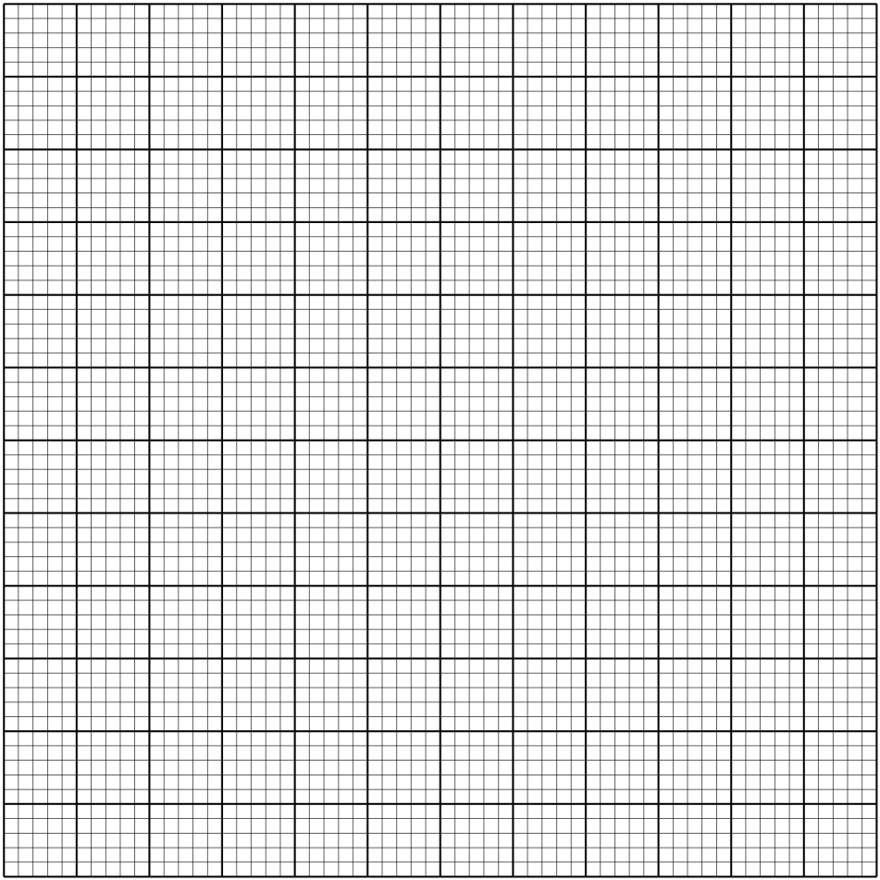
© From the graphs in (b) above, find:
- The period of $y=2\sin{{\left(\frac{3}{2}x+30\right)}^{0}}$ (1Mark)

- The values of $x$ that $2\sin{{\left(\frac{3}{2}x+30\right)}^{0}}$ $+$ $3\cos{2x=0}$ (2Marks)
19. A triangle ABC with vertices at $A\left(1, −1\right), B\left(3, −1\right)$and $C\left(1, 3\right)$ is mapped onto triangle $A^{1}B^{1}C^{1}$ by a transformation whose matrix $\left(\begin{aligned}−1 0 \\ 0 1\end{aligned}\right)$. Triangle $A^{1}B^{1}C^{1}$ is mapped onto $A^{11}B^{11}C^{11}$ with vertices at $A^{II}\left(2, 2\right), B^{II}\left(6, 2\right)$ and $C^{II}\left(2, −6\right)$by a second transformation.
(a) Find the coordinates of $A^{1}B^{1}C^{1}$. (2Marks)

(b) Find the matrix which maps $A^{1}B^{1}C^{1}$ on to $A^{11}B^{11}C^{11}$. (3Marks)

(c ) Determine the ratio of the area of triangle $A^{1}B^{1}C^{1}$ to triangle $A^{11}B^{11}C^{11}$. (2Marks)

(d) Find the transformation matrix which maps $A^{11}B^{11}C^{11}$ onto $ABC.$ (3Marks)

20. An aircraft leaves town $P\left({30}^{0}S,{17}^{0}E\right)$ and flies due North to $Q\left({60}^{0}N, {17}^{0}E\right)$. It then flies at an average speed of 300 knots for 8hours due West to town R. Determine;
(a) The distance PQ in nautical miles. (2Marks)

(b) The position of town R. (3Marks)

( c ) The local time at R if the local time at Q is 3.12pm on Tuesday. (2Marks)

(d) The shortest distance between Q and R to the nearest kilometers.$\left(R=6370km, π=\frac{22}{7}\right)$(3Marks)

21. The $2^{nd}$ and $5^{th}$terms of an arithmetic progression are 8 and 17 respectively. The $2^{nd}, {10}^{th}$ and ${42}^{nd}$ terms of the A.P form the first three terms of a geometric progression.
Find :
- The $1^{st}$ term and the common difference of the A.P. (3Marks)

- The first three terms and the ${10}^{th}$ term of the G.P. (4Marks)

- The sum of the first 10 terms of the G.P. (3Marks)

22. The following are marks scored by form 4 students in a Mathematics test.
Marks | 10 - 19 | 20 -29 | 30 - 39 | 40 -49 | 50 - 59 | 60 - 69 | 70 - 79 | 80 - 89 | 90 - 99
Number of students | 2 | 6 | 10 | 16 | 24 | 20 | $x$ | 8 | 2

- If the assumed mean was $54.5$ and $\sum{fd^{2}}=31400$ where $d=\left(x−A\right),$ determine;
- The value of $x.$ (5Marks)

- The mean. (3Marks)

- Calculate the standard deviation. (2Marks)

23. (a) The speed V m/s of a moving particle is partly constant and partly varies as time t seconds. It is given $V=28m/s$ when $t=2s$ and $V=53 m/s$ when $t=7s.$
Find the speed of the particle when $t=11s.$ (4Marks)

- A quantity R varies directly as T and inversely as the cube root of Q. Given that $Q=64$when $T=6$ and $R=30;$
- Find the equation connecting Q , R and T. (3Marks)

- Find the percentage change in R when T is decreased by 10% and Q increased by 25%. (3Marks)

24. A sculptor takes 2.5 hours to mould a teapot and 5 hours to carve a dining table. It takes the sculptor at least 100 hours to mould x teapots and carve y dining tables. The labor cost of molding a teapot is Ksh 100 and that of carving a table is Ksh 150. The total labor cost must not exceed Ksh 6000. The dining tables the sculptor’s carved must not be more than twice the teapots moulded.
i) Write down in terms of x and y, all the inequalities representing the above information. (4Marks)

ii) On the grid provided, draw the inequalities and shade the unwanted region. (4Marks)
c) The sculptor makes a profit of Ksh 160 on a teapot and Ksh 270 on a dining table. Use the graph to determine the maximum profit that the sculptor can make. (2Marks)

