MARKING SCHEME

312/1
GEOGRAPHY
PAPER 1

GATUNDU SOUTH SUB - COUNTY FORM FOUR JOINT EVALUATION TEST 2025
KENYA CERTIFICATE OF SECONDARY EDUCATION

SECTION A
Answer all the questions in this section.

1. (a) Define the term geography (2mks)
- Study of earth as a home for man
- Study of distribution and interrelationship of natural and human phenomena on the earth surface
(b) Name three branches of geography (3mks)
- Physical geography
- human and economic geography
- practical geography
2(a) Define the term folding (2mks)
Bending of the rocks of the earth crust due to earths movement
(b) List down any three orogenies (3mks)
- Caledonian
- hercynian
- Alpine
-charnian orogeny

3(a) Name any three causes of earth movements (3mks)
- Magma movement in the crust
- Gravitational forces
- Convectional currents in the mantle
- Isostatic adjustment
(b) Name any two boundaries associated with plate tectonics (2mks)
-Extension boundary/ constructive margin
- Compressional boundary/destructive margin
- Transform faults/ conservative margins
4(a) Name any two sources of underground water (2mks)
- Rain water
- Lake and sea water
- Melt water
- Magmatic water
(b) State any three conditions ideal for the formation of an artesian well. (3mks)
-The region must outcrop in a region which is a source of water
- Aquifer must be sandwiched between impermeable rocks so that it can retain water.
- The aquifer must dip from a region of water intake and the rock layers must form a broad syncline or basin
- The mouth of the well must be lower than the intake area to allow water to be forced out to the surface by pressure.
5. Explain how a sea breeze occurs (5mks)
- Occurs during the day
- The land surface gets heated faster than the water surface,
-The heated air on land becomes lighter and develops low air pressure
- Over the water the air is cooler, denser and has a higher pressure.
-The cooler air over the water flows to the low pressure area over the land to replace the rising warm air
- This movement of cool air from the water surface to the land during the day is called a sea breeze.

SECTION B
Answer question 6 and any other two questions
- Study the map of Tambach 1:50000 (sheet 90/3) provided and answer the questions that follow.
a. (i) What type of a map is the map of tambach? (1mk)

Topographical map
(ii) Calculate the area of Kaptagat forest in the South West of the area covered by the map. (2mks)
Complete squares= 0
Imcmplete squares=9
9/2=4.5
4.5Km²

(iii) Give the six figure grid reference of the air photo principal point 5141 near Mbogei. (2mks)

041704
b (i) Citing evidence from the map identify three social functions of Tambach township. (6mks)

Function | Evidence
Health Center | Hospital
Education Centre | School
Administrative Centre | Dc office
Religious Centre | Church
Residential Centre | Houses

(ii) Identify two methods used to represent relief in the area covered by the map. 5829 (2mks)
Contours
Trigonometrical stations

(iii)What is the magnetic declination of the map? (2mks)

1⁰ 24’
c. Enlarge the area enclosed by easting 84 and 86 and Northing 71and 73 by three. (1mk)

Show the following in the enlarged section of the map. (3mks)
- River
- school
- road C52

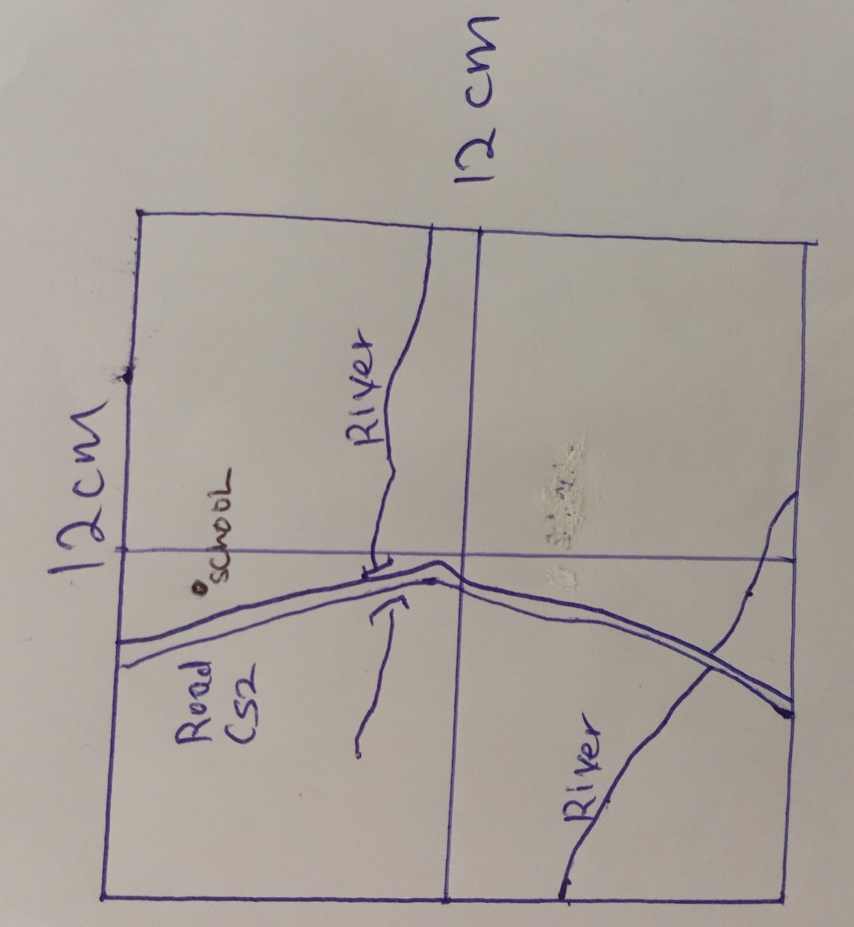

d. Describe the drainage of the area covered by the map. (6mks)

Main drainage feature are the rivers
There are Lakes eg Lake Kamnorock
River Kerio is the main river
River Kerio flows from south to north
There are permanent rivers eg river Kerio
Rivers form a dendritic drainage pattern eg around Mbogei.
There are disappearing rivers
7(a) (i) Name three factors that influence river erosion (3mks)
- River volume
- Slope of land
- Nature of bed rock
- Rivers load
(ii) Give three ways in which a river transports its load (3mks)
- Suspension
- Saltation
- Traction
- Solution
(b) State four ideal conditions necessary for the formation of a delta at a river mouth. (4mks)
- Large load such as from a large catchment area where erosion is taking place actively
- River course must be free from obstacles such as swamps so as not to filter sediments before the reach of the mouth
- The river must flow at a slow speed as it enters a sea or a lake to allow deposition to take place
- Higher rate of deposition than the rate of erosion by lake or sea currents
(c) Explain how a delta is formed (7mks)
- Speed of the river is checked by the sea or lake
- Heavy load is first deposited
- Lighter materials is carried further into the sea causing that part of the sea to become shallower
-the part is colonised by plants making it swampy and firmer
- plants help to trap more alluvium making that part to grow in height
- the river builds levees making it narrower
- the river bursts its banks and smaller channels branch from the main river
- the rivers carry water into the sea/ocean and helps to carry the sediments further
- The lying tract of alluvial deposits is called a delta
(d) Explain four positive influences of rivers. (8mks)

Positive
- Rivers are sources of water for domestic and industrial use
- River water is used in agriculture for irrigation
- Rivers provide port facilities where they have rias and estuaries
- Some rivers are used for water transportation
- Some rivers are fishing grounds
- Some rivers are dammed for production of HEP
- Features formed by river action are tourist attraction
8. (a) (i) Differentiate between rocks and minerals. (2mks)

Rocks are hard substances made up of mineral particles forming the earths crust while minerals are naturally occurring inorganic substances with definite chemical composition and physical properties.
(ii) Identify three types of rocks according to their mode of formation (3mks)
Metamorphic rocks
Sedimentary rocks
Igneous rocks
(b) (i) Give two types of minerals. (2mks)
- Metallic
- Non-metallic
- Energy minerals

(ii)Describe the following characteristics of minerals: (4mks)
- Texture
- Minerals vary in texture,some are rough and others soft
- Tenacity
- The ability of a mineral to resist/to withstand tearing, crushing or breaking differs/vary.
(c) i. Describe the formation of mechanically formed sedimentary rocks. (6 mks)
- They are formed from previously existing rocks.
- Particles are derived from pre-existing rocks through the process of weathering.
- They are transported by either wind, water or ice.
- They are deposited in layers according to their sizes with large debris deposited first and fine debris last.
- Compaction due to pressure is applied.
- The sediments are cemented together forming a mechanically formed rock
ii. Give two methods used to estimate the age of rocks. (2marks)
Relative dating
Absolute dating
(d) Explain the significance of rocks to the economy of Kenya under the following sub-headings.
- Tourism - Some rocks form unique features that attract tourists earning the country foreign exchange.
- Energy - Some sedimentary rocks contain fossils fuels which are sources of energy for domestic/industrial use.
- Water - Some rock act as storage for water which can be supplied for domestic/industrial/farming.

9(a) (i) Name two ways in which water moves in the ocean. (2mks)
- Horizontal movement
- Vertical movement
(ii) State any three causes of ocean currents (3mks)
- Difference in ocean water density
- Shape of the coastal water landmass
- rotation of the earth
- wind blowing over the surface of the ocean
(b) Briefly explain how the following are formed
(i) Fringing reef (4mks)
- Formed when the coral polyps start building a reef near the shore/island extending sea ward
- rate of accumulation is faster sea ward than towards the shore
- reef become steeper sea ward than towards the shore
- the reef exposes a narrow and shallow lagoon
- Accumulated coral materials form a fringing reef
(ii) Atoll reef (4mks)
- coral starts to grow round an island forming a fringing reef
- the island begins to sink or subside as the level of the sea rises
- coral continues to grow at a faster rate than the rate at which the sea is rising forming a barrier reef around the island
- the sea level rises submerging the island
- the coral reefs form a ring around a deep lagoon forming an atoll
(c) Explain four ways in which coral reefs contribute to economic development of Kenya (8mks)
- Attracts tourists earning foreign exchange used to develop other sectors of the economy
- They provide breeding grounds for fish promoting the fish industry
- Limestone coral is used in manufacturing cement for building and construction
- Many local people use coral directly as building stones for houses
- Some coral are extracted and sold as ornaments
(d) Students from Mtongwe high school carried out a field work around the coastal region to study about coral
(i) State how the following items were used
- Jembe (1mk)
To break the ground for rock samples
To dig out soil so as to reach the rock
- Paper bag (1mk)
To carry/wrap the rock samples
(ii) Give any two follow up activities they would have engaged in after field work (2mks)
- hold class discussions
- writing a summary of the various group reports
- labelling of samples
- labelling of sketches
- mounting of photographs
10. (a) (i) Define the term secondary vegetation. (2marks)
Secondary vegetation refers to plants growing naturally in a place but has been interfered with by people
(ii) Explain how the following factors influence the distribution of vegetation. (4marks)
(i)Climate
- Areas which have low temperatures have scarce/no vegetation/areas which have moderate temperature have dense vegetation.
- Regions which receive high rainfall have dense vegetation growth/areas which have low rainfall have scanty/scrub vegetation.
- Hot dry winds cause drought conditions which is responsible for scanty/scrub vegetation/moist winds lead to increased precipitation when they blow over a region hence dense vegetation.
- Places which receive long hours of sunlight have many varieties of plants/areas which receive less/short hours amounts of sunlight have few/little variety of plants. ( Any 1x2mks)

(ii) Human beings (2 mks)
- Some human activities have led to clearing of natural vegetation causing the establishment of deserts/semi natural vegetation.
- Conservation measures geared towards protecting the existing vegetation have led to establishment of forest/natural reserves.
( Any 1x2mks)

(b) i. Explain three factors that have led to a decline of natural grassland in Kenya. (6mks)
- The frequent outbreak of bush fires destroys the grass retarding its regeneration.
- The increasing human population / human encroachment into the grassland replacing them with settlement and cultivation land.
- Pests such as army worms / locusts destroy the grass reducing the rate of growth and regeneration.
- Frequent drought experienced in the country destroy the grass and the vegetation degenerate into a semi-desert type.
- Wild and domestic animals overgraze and cause stunted growth of grass.
ii. Give two uses of Savannah vegetation. (2mks)
- Commercial ranching/grazing is practiced in some parts of the grassland.
- Are home to wild animals.
- The trees are habitats for bees which provide honey.
- Some of the shrubs/herbs are used for medicinal purposes.
- Some of the wild fruits/berries are consumed as food.

(c) The map below shows some vegetation zones of Kenya. Use it to answer the questions that follow.

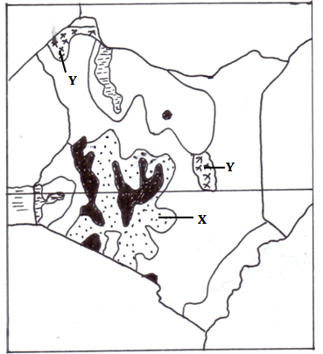
- Name the vegetation zone marked X and Y. (2mks)

X -Woodland and grassland
Y -Swamp vegetation

- Explain three ways in which desert vegetation adapts to climatic conditions. (6 mks)
- Some plants have thick/fleshy/succulent leaves/barks to enable them store water.
- Some plants have long roots to tap the underground water.
- Some have no leaves/have thin/spiky/waxy/needle like leaves to reduce transpiration.
- Some plant seeds remain dormant awaiting the short rains.
- Some plants have thick/hard barks to reduce transpiration.
- Some plants have underground bulbs to store water.
- Most plants are stunted/dwarf like due to the harsh conditions.
- Some plants are quick sprouting to take advantages of the short-lived desert rains.
d. Name the temperate grasslands found in the following countries:
      - Canada…… Prairies (1mk)
      - Russia……. Steppes (1mk)
      - Australia… Downs (1mk)

