NAME: …………………………………………. INDEX NO: ……………………………….

SIGNATURE: ………………………………… DATE : …………………………………..

233/2
CHEMISTRY
PAPER 2 THEORY
JULY / AUGUST 2025
TIME: 2 HOURS

GATUNDU SOUTH JOINT EVALUATION TEST 2025

INSTRUCTIONS TO CANDIDATES
- Write your Name and Index Number in the spaces provided above.
- Answer all the questions in the spaces provided after each question.
- Mathematical tables and non-programmable electronic calculators may be used.
- ALL working must be clearly shown where necessary.

FOR EXAMINER’S USE ONLY

QUESTIONS | MAX SCORE | CANDITATE’S SCORE
1 | 11
2 | 12
3 | 13
4 | 13
5 | 8
6 | 12
7 | 11
TOTAL | 80

- The scheme below represents an industrial process. Study it and answer the questions that follow
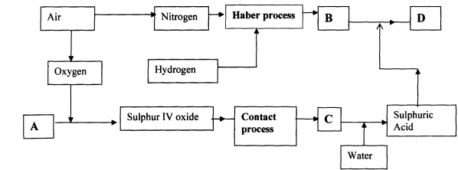

a) Identify substances. (2 Mks)
I) A
II) B
III) C
IV) D

b) Write balanced chemical equations for the reactions leading to formation of. (2 Mks)
I) Product B

II) Product D

c) State 3 optimum conditions applied in the haber process. (3 Mks)

d) State 2 reasons why Vanadium (V) Oxide catalyst is preferred to Platinum catalyst in the contact process. (1 Mk)

e) Sulphur (IV) Oxide is one of the environmental pollutants. State two methods in which the pollution effects can be reduced. (2 Mks)

f) Give one use of compound D. (1 Mk)

- The grid below represents part of the periodic table. Study it and answer the questions that follow. The letters do not represent the actual symbols of the elements.
A
R

Y

P

N

S
V
B

F

W
Z

Q

- Give the chemical family name to which element V belong. (1 Mk)

- Select an element that can form an ion with a charge of 2⁻ (1mk)

- Select a letter that represents the most reactive metal (1mk)

- I) Write the formula of the compound formed when element N reacts with element Z. (1Mk)

II) What type of structure exists in the compound formed in b(I) above. (1mk)

III) Suggest the most likely Ph for the solution formed when the compound formed in b(I) is placed in a beaker containing water. (1mk)

- Explain why element Q has the smallest atomic radius. (1mk)

- I) Write the electron configuration of ; (1mk)
P⁺

P²⁺
II) Compare the 1st (P⁺) and the 2nd (P²⁺) Ionization energy of P. (2 Mk)

- The oxide of S has a higher melting point than the oxide of B. Explain. (2mks)

- (a) State the particles responsible for conductivity of an electric current in (2mks)
(i) A Solution

(ii) A metal

(b) Study the standard electrode potentials for the half-cells given below. The letter do not represent the actual symbols of the elements .

half cell EºV
U⁺_{(aq)} + e⁻ U_{(s)} -3.02
V²⁺_{(aq)} + 2e⁻ V_{(s)} - 2.87
W²⁺ _{(aq)} 2e⁻ W_{(s)} + 0.34

(I) Calculate the e.m.f of a cell made when U and V combine. (1 Mk)

II . Identify the Strongest Oxidizing agent. (1mk)

(III) Determine the equation of the cell reaction made of U and W. (1mk)

(IV) Show the cell representation for the cell reaction in b(ii) above. (1mk)

(b) One use of electrolysis is electroplating as shown below.
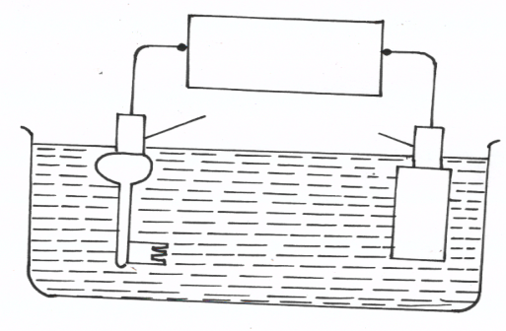
Power sources

K

Silver nitrate solution
Key

,,

(i) To what terminal of the power source is the key connected. (1mk)

(ii) Name the most suitable material for electrode K (1mk)

(iii) Write the equation at (2mk)
- Anode

- Cathode

(iv) If 3 Amperes power was used for 5 hours, calculate the increase in mass of the Key. ( Ag = 108, 1 F = 96500C) (3mks)

- (a) Define standard heat of combustion of a substance. (1mk)

(b) Study the Heats of combustion shown below.

H_{2(g)} + ½O_{2(g)} H₂O_{(l)} ΔH=-393KJMol⁻¹
C_{(s)} + O_{2(g)} CO_{2(g)} ΔH=-286KJMol⁻¹
C₃H₈ + 5O_{2(g)} 3CO_{2 (g)} + 4H₂O_{(l)} ΔH=-2218KJMol⁻¹

(i) Draw an energy cycle diagram linking heat of formation of propane with its heat of combustion and the heat of combustion of the constituent elements. (2mks)

(ii) Use the information above to calculate the heat of formation of propane. (2mks)

(c). A given amount of Propane was used to heat one litre of water. The temperature of the water rose from 25ºC to 50.5 ºC. (S.H.C of water = 4.2Jgk⁻¹)
(i) Calculate the Heat change for the reaction. (2mks)

(ii) Find the mass of Propane burnt (C=12, H=1) (2mks)

(d) Calculate the calorific value of Propane. (2mks)

(e) Apart from heating value, state two other factors to consider when choosing a fuel. (2mks)

- (a) Two reagents that can be used to prepare Chlorine gas are Manganese (IV) Oxide and Concentrated Hydrochloric acid.

(i) Write a balanced chemical equation for the reaction. (1mk)

(ii) Give the formula of another reagent that can be reacted with Concentrated Hydrochloric acid to produce Chlorine gas. (1mk)

(iii) Describe how the Chlorine gas could be dried and collected in the laboratory. (1mk)

(b) In an experiment, dry Chlorine gas was reacted with Aluminum as shown in the diagram below

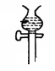

Dry Chlorine gas
Aluminium
Calcium Chloride
A
Heat

- Name substance A (1mk)

- Write a balanced chemical equation for the reaction that took place in the combustion tube. (1mk)

(iii) State the function of the Calcium Chloride in the set-up above (1mk)

c) Water from a town in Kenya is suspected to contain Chloride ions but not Sulphate ions. Describe how the presence of the Chloride ions in the water can be shown. (2Mks)

- In an experiment to determine the rate of reaction, 2.0 g of Zinc powder was added to 100 cm3 of 2 M hydrochloric acid. The volume of hydrogen gas was measured at intervals of 10 seconds and recorded in a table below.

Time(sec) | 0 | 10 | 20 | 30 | 40 | 50 | 60 | 70 | 80 | 90
Volume(cm3) | 0 | 60 | 90 | 105 | 112 | 116 | 118 | 120 | 120 | 120



- Plot a graph of the Volume of Hydrogen gas(Vertical axis) against Time. (3 Mks)

- From the graph ;
- Find the rate of the reaction in the first 30 seconds (1 Mk)

- Find the rate of reaction at t= 65 seconds. (2 Mks)

- Explain why the volume of Hydrogen produced does not exceed 120 cm3. (1 Mk)

- On the same axes, draw a sketch graph for the reaction when Zinc granules were used instead of zinc powder. (1 Mk)

- Name a suitable Catalyst that can be used to speed the rate of this reaction. (1 Mk)

- Given the equation below
$N_{2}O_{2}$ NO₂

- Explain the observations made when the pressure of the equilibrium mixture is increased. (1 Mk)

- How will the yield of Nitrogen (IV) Oxide be affected by lowering the temperature of the equilibrium mixture. (1 Mk)

- What happens to the position of the equilibrium when Nitrogen (IV) Oxide is removed from the mixture. (1 Mk)

- a) What is homologous series. (1 Mk)

b) Given that the first member of member of the alkanes is Methane, write the general formula for the members of this group. (1 Mk)

c) When Hexane is heated to high temperature, one of the products is Ethene.

I) Name the process described in (c) (1 Mk)

- Write the equation for the reaction in (c) (1 Mk)

d) Study the reaction scheme below and answer the questions that follows

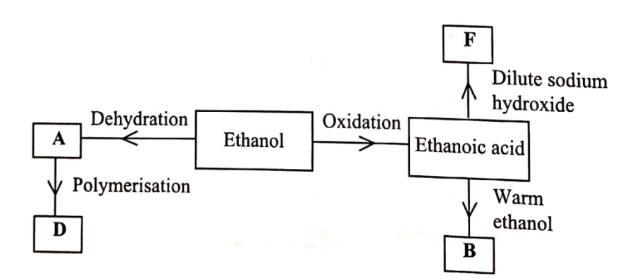

- Identify compound A. (1 Mk)

- Write an equation for formation compound D. (1 Mk)

- State one disadvantage of using compound D. (1 Mk)

- What type of reaction occurs during the formation of F. (1 Mk)

- Describe an experiment which can be used to distinguish butanoic acid from butanol. (2 Mks)

- State one use of the group of compounds to which B belongs. (1 Mk)

