Name _______________________________________________ IndNo.__________________________
Candidate’s Signature ______________Date ____________________________

233/1
CHEMISTRY
PAPER 1
THEORY
JULY / AUGUST 2025
TIME: 2 HOURS

Kenya Certificate of Secondary Education
CHEMISTRY
PAPER 1
THEORY
2 HOURS
INSTRUCTIONS
- Write your name and index number in the spaces provided above.
- Sign and write the date.
- Attempt ALL the questions in this paper.
- Electronic non-programmable calculators or mathematical tables may be used.

FOR EXAMINER’S USE

QUESTIONS | MAX. SCORE | CANDIDATE’S SCORE
1 – 29 | 80

This paper consists of 12 printed page
- Name the processes which takes place when
- Iodine changes directly from gas to solid (1mk)

- Fe²⁺ (aq) to Fe³⁺ (aq) (1mk)

- White sugar changes to black solid when mixed with excess conc sulphuric (VI) acid
(1mk)

- Paper chromatography is a method of separating colours or dyes. What two properties should the components of a mixture have that would make the separation possible.(1 mk)

- The table below shows the pH values of solutions J K, L, M, and N
Solution | J | K | L | M | N
pH | 5 | 13 | 2 | 10 | 7

- Which solution contains the largest concentration of hydroxide ions (1mk)

- Which solution is likely to be a solution of acetic acid (1mk)

- The set-up below was used to prepare a sample of oxygen gas. Study it and answer
the questions that follow.
Liquid Q
Sodium peroxide

- Complete the diagram to show how Oxygen can be collected (1mk)
- Name liquid Q(1mk)

(iii) Write a chemical equation of the reaction to produce oxygen (1mk)

- The setup below was used to investigate the reaction between metals and water.
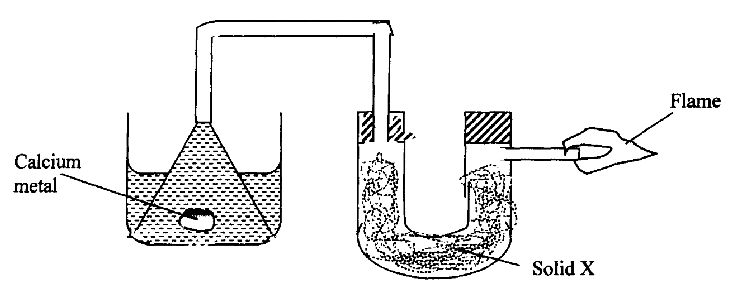

(a) Identify solid X and state its purpose
Solid X - (1mk)

Purpose - (1mk)

(b) Write a chemical equation for the reaction that produces the flame. (1mk)

- Z grammes of a radioactive isotope take 100days to decay to 20grammes .If the half life of the element is 25 days calculate the initial mass of Z radioisotope. (2mks)

- Element W has two isotopes, W-36 and W-40 which occur in the ratio x: 4. Given that the R.A.M of W is 37.25 find the value of x (3mks)

- Study the information in the table below and answer the questions that follow.
(The letters do not represent the actual symbols of the elements)
Element | Electronic configuration | Ionization energy Kj/mol)
P | 2.2 | 1800
Q | 2.8.2 | 1450
R | 2.8.8.2 | 1150

- What is the general name given to the group in which elements P, Q and R belong? (1mk)

(b) Explain why P has the highest ionization energy (1mk)

(c) Write a balanced chemical equation for the reaction between the oxide of element Q and water (1mk)

- Using dots(●) and crosses (×) to represent electrons, draw the structures of the following:
(a) Phosphorous chloride (PCl₃) (1$\frac{1}{2}$ mks)

(b) Hydroxonium ion (H₃O⁺) (1$\frac{1}{2}$ mks)
( H=1.0, O=16.0, P= 15.0 , Cl = 17.0)

- Describe how to prepare crystals of potassium sulphate starting with 50cm³ of 1M potassium hydroxide (3 mks)

- A student mixed equal volumes of Ethanol and butanoic acid. He added a few drops of
concentrated Sulphuric (VI) acid and warmed the mixture
(i) Name and write the formula of the main products
Name………………………………………..(1mk)

Formula……………………………………..(1mk)

(ii) Which homologous series does the product named in (i) above belong? (1mk)

- Study the diagram below and use it to answer the questions that follow:-
Lead (II) bromide
A
B
Heat

(a) Identify electrodes A and B (1 mk)

(b) Name the product formed at the anode (1 mk)
(c) Write the electrode half equation of reaction at electrode A (1 mk)

- State and explain the observation made when a piece of charcoal is dropped in a jar containing Concentrated nitric (V) acid (1 mk)

- When Carbon (IV) oxide is passed through lime water, a white precipitate is formed but
when excess Carbon (IV) Oxide is passed, the white precipitate disappears;
- Explain why the white precipitate disappears (1 mk)

(b) Give an equation for the reaction that takes place in (a) above (1 mk)

- (a) State the Graham’s law (1 mk)

(b) 100cm³ of Carbon (IV) oxide gas diffused through a porous partition in 30seconds.
How long would it take 150cm³ of Nitrogen (IV) oxide to diffuse through the same?
partition under the same conditions? (C = 12.0, N = 14.0, O = 16.0) (2 mks)

- Potassium Manganate (VII) oxidizes concentrated hydrochloric acid form chlorine gas according to the following equation.
2 KMnO₄ ( s) +16 HCl( aq) 2KCl ( aq) +2MnCl₂( aq) + 8H₂O ( l) +5Cl₂ ( g)
Calculate the mass of KMnO₄ required to form 1.68dm³ of chlorine measured at s.t.p in the presence of HCl ( K =39.0 , Mn =55.0 ,O= 16.0, M.G.V at stp = 22.4 dm³) (3 mks)

- (a) What is meant by isomerism? (1 mk)

- Draw and name two isomers of Butene (2 mks)

- When hydrogen sulphide gas was bubbled into an aqueous solution of Iron (III) chloride, a yellow precipitate was formed.
a) State another observation that was made. (1 mk)

b) Write an equation for the reaction that took place. (1 mk)

c) Describe a laboratory chemical test for a sample of hydrogen sulphide gas. (1 mk)

- Study the flow chart below and answer the questions that follows

Brown gas
Step 1
Blue solution
Copper
Reagent Z
STEP 2
Reagent Y
Pale Blue precipitate

STEP 3
Reagent Y
Deep Blue solution

- Name the reagents Z and Y (2mks)

- Write the formula of the complex ions present in the deep blue solution (1mk)
- In an experiment, dry chlorine gas was reacted with aluminium as shown in the diagram below

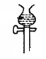

Dry Chlorine gas
Aluminium
Calcium Chloride
A
Heat

(i) Name substance A (1mk)

(ii) Write an equation for the reaction that took place in the combustion tube(1mk)

(iii) State the function of the calcium chloride in the set-up above(1mk)

- (a)Distinguish between a strong acid and a concentrated acid. (1 mark)

(b)Giving a reason in each case, identity an acid and a base in the equation.

H₃O⁺_{(aq)} + NH_{3(g)} NH₄⁺_{(aq)} + H₂O_{(l)}

Acid: ($\frac{1}{2}$ mk)
Reason: ($\frac{1}{2}$ mk)
Base: ($\frac{1}{2}$ mk)
Reason: ($\frac{1}{2}$ mk)

- Study the following information and answer the question that follows.

Heat of hydration of x²⁺ = -1480 kJ/mol
Heat of hydration y⁻ = -364 kJ/mol
Lattice energy of XY₂ = +2112 kJ/mol
Determine the heat evolved when 31.8g of XY_{2(s)} is dissolved in water to give an infinitely dilute solution. (RAM of Z = 88, Y = 35.5) (3 marks)

- A solution of bromine in water is a chemical reaction in equilibrium. The reaction involved is represented by the equation below;
Br_{2(aq)} + H₂O_{(l)} 2H^{+(aq)} + Br⁻_{(aq)} + OBr⁻_{(aq)}
Yellow Colourless
- State and explain the observation made when dilute sulphuric (VI) acid is added to the mixture at equilibrium. (2mks)

- Define the term dynamic equilibrium (1mk)

- Aluminum metal is mainly extruded from molten Bauxite by electrolysis.
a) Name the main impurity in this ore. (1mk)

b) Briefly describe how the impurity is removed from the ore before electrolysis process.
(2 mks)

- During purification of copper by electrolysis, 1.48 g of copper were deposited when a current was passed through copper (II) sulphate solution for 2$\frac{1}{2}$ hours. Calculate the amount of current that was passed ( Cu =63.5, 1F = 96500 C) (3 mks)

- The diagram below represents a set-up that can be used for the electrolysis of dilute sulphuric acid
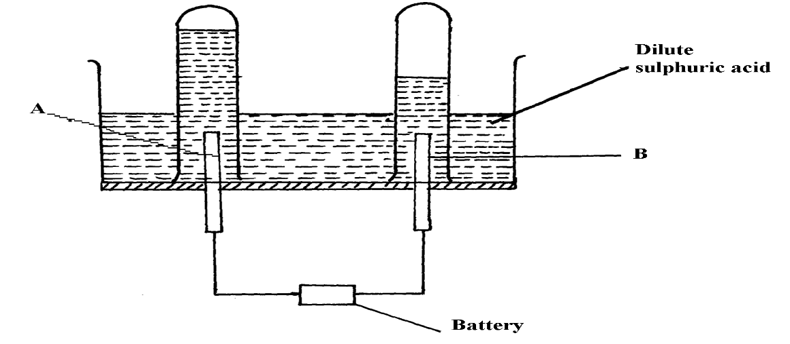

- Name the electrodes A and B (1mk)

(b) Write an equation for the reaction taking place at electrode B (1mk)

(c) What happens to the concentration of dilute sulphuric (VI) acid as the reaction continues? (1mk)

- Study the table below and answer the questions that follow
Bond type bond energy kJmol⁻¹
C-C 348
C = C 612
C-H 432
C-Br 282
Br-Br 195
a) Calculate the enthalpy change for the following reaction
C₂H_{4(g)} + Br_{2(g)} C₂H₄Br_{2(g)} (2mks)

b) Name the type of reaction that took place in (a) above (1mk)

- A condensation polymer formed by loss of water molecules has the following structure.
O O
‖ ‖
$- O –$CH₂ $–$CH₂$– C – O –$CH₂$–$CH₂$– C –$
n

- State two advantages of using natural polymers over synthenic ones. (2 mks)

- Draw the structure of the monomer. (1 mk)

- (a)What is fractional crystallization (1mk)

(b)The table below gives the solubility of X and Y at 0ᵒC and 45ᵒC

Salt | Solubility in g/100g of water
 | OᵒC | 45ᵒC
X | 53 | 73
Y | 10 | 11
A solution containing 57g of X and 8g of Y in 100g of water at 70ᵒC was cooled to 0ᵒC.Some crystals were observed
- Identify the crystals formed (1mk)

- Calculate the mass of the crystals formed(1mk)

