EMUHAYASUBCOUNTY
CHEMISTRY PAPER 2
MARKING SCHEME
FORM 4 2025

- a. X₃N
- R
- Q
- F has higher melting point than D (1mk). F has a stronger intermolecular force of attraction than D (1mk).
- Ionic radius of F is bigger than its atomic radius (1mk). F reacts by gaining an electron increasing repulsion among the electrons (1mk).
- D has a smaller atomic radius than X (1mk). D has stronger nuclear attraction pulling electrons towards the nucleus (1mk).
- 2.8
- 7
- I.M II.J
- a)i)Zn_{(s)} + H₂SO_{4(aq)} ZnSO_{4(aq)} + H_{2(g)}
ii)Hydrogen gas is produced which escapes to the environment
iii)Copper(ii)sulphate
iv).
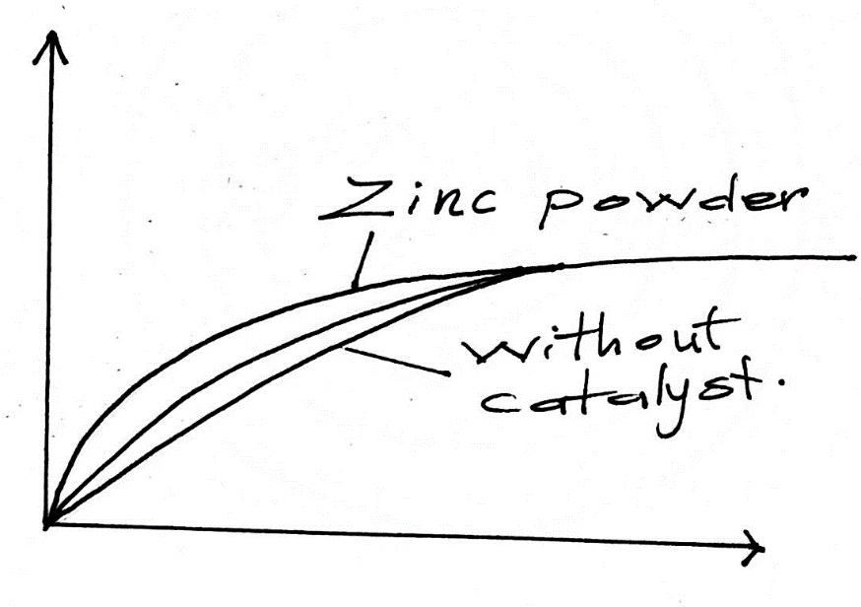
b)i)When a state of balance is attained the forward and reverse reaction occurs at the same rate
ii) a)Equilibrium shifts to the right, forward reaction is exothermic, it is favored by low temperature

b)Equilibrium swift to the left, less pressure favors high volume which is the reactants

iii) Yellow colour intensifies. OH- ions react with H+ ions decreasing concentration on the reactants hence reverse reaction is favored.

3.(a) (i). ethane

(ii) CH3CH2COONa(s) + NaOH(s) CH3CH3(g) + Na2CO3(s)

- (i) conc. Sulphuric acid
  - polymerization
  - nickel catalyst/ high temperature 150⁰c -250⁰c
  - hardening of oil to solid fat
  - CH2CH2 + HCl CH3CH2Cl

(c)- using acidified potassium manganate (vii) or bromine water (1)- ethene turns them Colourless (1).
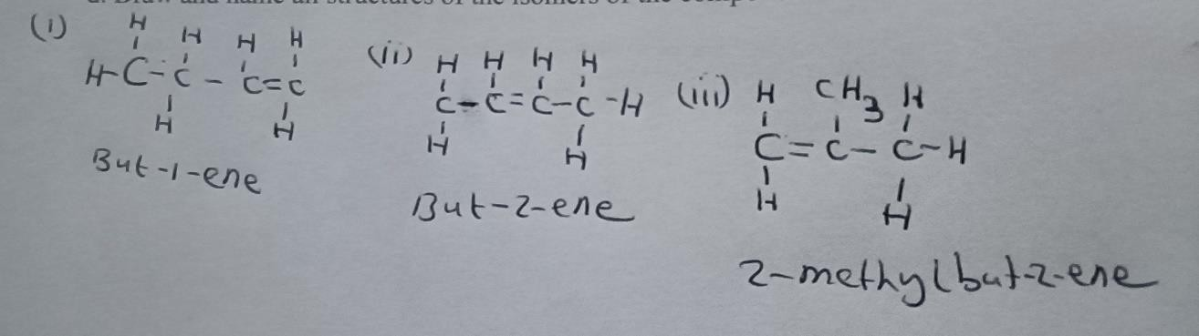
(d)

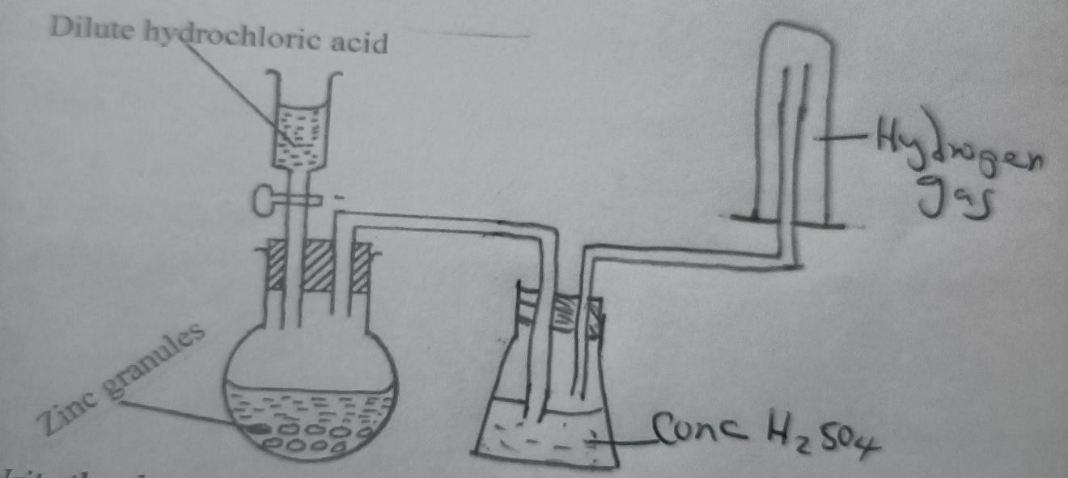
4(a)
(b)Naming – conc sulphuric acid (1)
- Hydrogen gas (1)
- Workability (1)

(c ) Zn(s) + 2HCl(aq) ZnCl2(aq) + H2(g)

- it contains air initially present in the apparatus
- (i) red brown solid is formed/ black solid turns to red-brown
  - CuO(s) + H2(g) Cu(s) + H2O(l)
  - reducing agent
  - Potassium is above hydrogen in the reactivity series.
  - -Large-scale manufacture of ammonia
- hardening of fat
- used in air balloon
- mixed with oxygen in welding
- rocket fuel
-manufacture of HCl
-fuel in fuel cells

5.
- (i) Fractional distillation of liquid air
(ii) argon.

- Sulphur/Zinc sulphide/any other metal sulphide
- Ammonia
- Sulphur (VI) Oxide
D- Ammonium sulphate
(c) Haber process Finely divided Iron
(ii) Contact process Vanadium (V) Oxide / Platinum
(iii)Haber Process: Increases the rate of reaction between nitrogen and hydrogen gases to form ammonia.Contact Process: Speeds up the reaction between Sulphur (iv) oxide and oxygen to form sulphur (vi) oxide.
- (i)
2NH₃(g)+H₂SO₄(aq) (NH₄)₂SO₄(aq)
(ii)
$$\frac{28}{132} ×100\%=21.21\%$$
(iii) .Used as a fertilizer.
6.
- -2.70v
- Hydrogen. Reference electrode/electrode potential 0.00v.
- (i)

(c) (ii) E_{cell} = E_{reduction}-E_{oxidation}
= +1.32$--1.20$
= +2.52v
(d)
(i) H⁺(aq) + 2e H₂(g)
ii)4OH⁻(aq) O₂(g)+2H₂O(l) +4e (1mk)
Q= It
0.8$×2.5×3600$
= 7200C
386000C = 24 dm³
7200C = $\frac{7200 ×24}{386000}$
= 0.44767 dm³ OR 447.67 cm³

7.
- H⁺(aq) + OH⁻(aq) H₂O(l)
(b)
(i Initial temperature = $\frac{25+27}{2}=26℃$ (1/2mk)
Change in temperature, $∆T=34-26=8℃$ (1/2mk)
(ii)
Heat change = mc$∆T$ = 150$×4.2×8$ (1/2mk)
= 5040J
= 5.04Kj (1/2mk)

(iii)
Moles of HCl= $\frac{100×1}{1000}=0.1 moles$
0.1 moles = 5.04kj
1 mole = $\frac{1×5.04}{0.1}=50.4kJ$
Molar heat of neutralization = -50.4kJmole⁻¹
(c)

- -Heat lost to the surroundings and also absorbed by the apparatus. (1/2mk)
-Error in measurement and taking of reading of volume and temperature
- - By wrapping glass beaker with rags
-Use of plastic beaker
-Using smaller beaker.
- NaOH(aq) + HCl(aq) NaCl(aq) + H₂O(l) $∆Hneut= -50.kJmole-1$

THIS IS THE LAST PRINTED PAGE

