END OF TERM 2 BUSINESS STUDIES PP2 MS
1. (a) IMPORTANCE OF WAREHOUSING TO A BUSINESS
a. Promote mass production / by allowing producer to continue producing goods since there is space for storage of (finished) goods / raw materials.
b. Stabilize prices by regulating the flow of goods / storing the surplus / realizing goods when demanded.
c. Ensure continuity of supply / steady supply of goods by storing them /gradually releasing to the market / when need arises.
d. It facilitates the preparation / processing for sale by branding / sorting / packaging / (accept relevant method of preparation for sale as expansion)
e. Creates time utility by ensuring that consumers get goods when required
f. Ensure safety of goods from physical damage / the damaging effects of weather/ pests
g. May add value to some goods e.g. wine / some goods can improve in quality / tastes (better) when they stay for long / fetch better prices / better satisfaction of needs.
h. Enables traders to look for market /sell goods while still in the warehouse.
i. Ensure seasonally demanded goods are stored until required.
j. Bonded warehouses helps to store goods awaiting clearance by custom authority / allow importer to claim the goods / look for money to pay for custom duty / clearance.
k. Security for goods since they are protected from theft / pilferage
(b) FACTORS TO CONSIDER WHEN EVALUATING A BUSINESS IDEA.
i Profits to be earned / return from investment there should be reasonable profit from the investments / in order to cover all operating expenses.
ii Existing attitudes / practices / beliefs of the target market the new products / services/ business idea must be in line with the people’s attitude / practices / beliefs if it has to be accepted / hence marketed.
iii Technology the technology to be used in producing the product / offering the service should be efficient / cost effective / available / to produce desired quantity / quality
iv Size / availability of the market / demand should be adequate /sustain the end of the output / sale of the product.
v Government policy / legal requirements should be favorable / easy to be met / to operate smoothly.
vi Channel of distribution this will ensure that product is available in the markets / so that consumers buy it when they decide to / should be available / effective / affordable.
vii Competition it should be fair / healthy / capable to cope with.
Viii Capital should be adequate to start / operate / run / easy to source / raise.
ix Input / supplies should be readily available / affordable for continuous operations (accept examples of input as a mention)
x Risks involved should be minimal / manageable / bearable.
xi Management skills whether the owner has them / can hire.
xii Pay-back period duration of getting back the amount invested should be considered
- (a)
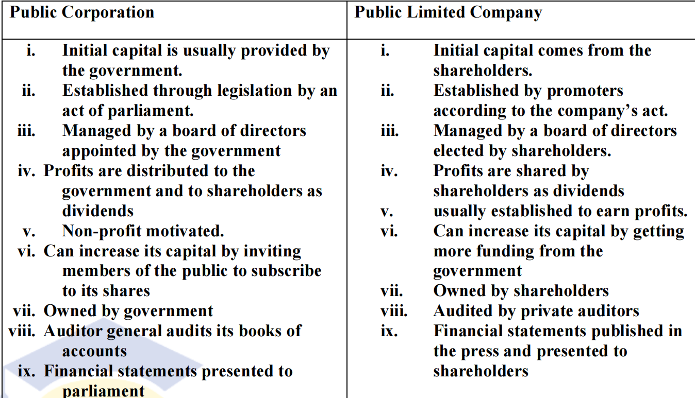

- (b) Explain five benefits that accrue to a country with a large labour force.(10 marks)
i Saving on foreign exchange that would have been used to pay expatriates/ imported labour.
ii Production of high quality goods/services as the workers are experts in their respective areas/have training/ skills.
iii Increased /better exploitation of natural resources increased investment leading to increased output/services/national income/economic growth as workers are competent. NBMention and explanation can interchange. Reduction in cost of production since the labour tends to be efficient/less wasteful.
iv Increase in purchasing power/ demand due to higher incomes/salaries earned.
v Reduction in dependency ratio since the employment rate is higher.
vi Enhances creativity/innovation/invention research leading to new improved/ variety of goods / services
vii Promotes specialization/ division of labour leading to faster production. (Accept any correct advantages of specialization as expansion.)
viii Ease /simplify setting of wage employment policy due to abundance /availability of skilled labour/ may reduce labour strife /unrest/improve industrial relations.
ix Increased government revenue due to income taxes levied.
x Export of skilled labour leading to increased foreign exchange/ reduced unemployment.
xi Enhances entrepreneurial culture since skilled labour is more willing to undertake risks/leads to creation of job opportunities.
xii Adaptability/ flexibility as they are ready / willing to embrace changes/are open minded.

3(a) Explain five disadvantages of using direct taxes to raise government revenue.
(10 marks)
- Direct taxes are very unpopular with the citizens. The burden of paying the tax is borne directly by the individual tax payer and is paid at once or even in advance.
- give the tax payers motivation to evade tax payment. The taxpayers may come up with ways of concealing their incomes in order to avoid paying the tax or reduce the amount to be paid.
- Non consultation of tax payers in the determination of tax rate. The determination of the rate and amount of tax to be paid is at the discretion of the tax authority.
- Not an adequate source of government revenue. Most people in developing countries are low income earners hence limiting the amount of tax revenue from this source.
- Reduced ability to save and invest. Direct taxes take away money from the citizens hence reducing their purchasing power causing low investment.
- Tax payers are not involved in the expenditure of the tax revenue. There’s low civic involvement and call for govt accountability since tax payers do not make decisions on govt expenditure.
- May encourage capital flight. Foreign investors may conceal their profits in order to transfer such earnings to other countries.

3(b) Explain five factors that should be considered when determining the type of office furniture to buy for use in an office. (10 marks)
i Cost- it should be affordable / economical / cost effective
ii Design – should be suitable for the intended purpose
iii Comfort should enable the user work in a relaxed / conducive environment
iv Durability should be able to last for a long time
v Appearance should be attractive in terms of finish and prestige
vi Weight should be light to ease movement
vii Risk of fire should be resistant to fire to reduce premiums when insuring the furniture
( accept any other relevant point)
4 (a) Metal Company Limited has located its new factory in a major town in Kenya. Explain five factors that may have attracted the factory to the town. (10 marks)
i Wider market / increased demand that will ensure increased sales / higher profit margin / high turnover.
ii Well developed transport network that ease movement / ensures easy accessibility to market
iii Well developed communication network that ensures easy passage of information to customers/ suppliers
iv Large labour supply / well trained labour that ensures efficiency / production of quality goods / services
v Enhanced security ensuring safety of employees / property
vi Availability of social amenities that improves on welfare of employees.
vii Source of raw materials from subsidiary / recycled materials hence reduce cost of acquiring raw material
viii Availability of auxiliary / support services like banks that ensure smooth / continuous operation of the business.
( Accept any other relevant point)

4.(b) a) turnover (1 mark)
turnover = sales – Return inwards / sales returns
= 680,000 – 35,000
= 645,000

b) Net purchases (2 marks)
Net Purchase = Purchase + carriage inwards – Return outwards / purchase returns
= 301,000 + 55,000 – 24,000 = 332,000

c) Mark-up (2 marks)
Cost of goods sold = opening stock + net purchase – closing stock
= 45,000 + 332,000 – 30,000
= 347,000
Gross profit = net sales – cost of sales
= 645,000 – 347,000
= 298,000
markup = 298,000 x 100
347,000
= 85.87%

d) Margin (2 marks)
Gross profit = 298,000 x 100
sales 645,000
= 46.2%

e) Net profit. (3 marks)
Net profit = Revenue – expenses
= (298,000 + 4,000 + 50,000) – (3,500 + 8,000 + 85,000 + 8,500+ 50,000 + 180,000)
= 352,000 – 285,000
= 67,000

5. (a) Describe five features of a less developed country.
(10 marks)
i High population growth/ overpopulation high birth rate-the growth rate of population is higher than output / resources (accept negative consequences of overpopulation)
ii Large /dominant subsistence sectors/traditional subsistence sector such as agriculture tend to dominate the economics leading to low output incomes (accept causes/consequences of subsistence sector as qualification)
iii High level of poverty level /survive on less than a dollar a day.
iv Low level of technology due to lack of capital (to acquire modern technology) leads to low quality/quantity goods/services.
v Unequal disparity in income distribution much of the wealth is in the hands of few individuals/majority are poor.
vi Low levels of investment due to limited markets/ low savings/ capital
vii Poor governance due to corruption/embezzlements/ lack of accountability/ transparency/ misappropriation/ mismanagement of resources.
viii Poor/underdeveloped infrastructure which hinders mobility/production/ accept examples of poor infrastructure as a mention.
ix Limited markets /low demand due to low levels of incomes.
x High rates of unemployment due to low levels of economic activities (accept any correct cause effect of unemployment as qualification)
xi Negative social/cultural practices which hinder production/consumption
xii Balance of payments deficit/low foreign exchange/poor terms of trade due to high value of imports /low value of exports.
xiii Over-reliance/dependence foreign countries/aid leading on to political blackmail/vulnerability.
xiv Political instability/insecurity which hinders investments/production.
xv Poor social amenities leading to poor services.
xvi Large pool of unskilled labour due to inappropriate education system
xvii Poor plans /policies due to inadequate data/ being over ambitious.
Xviii Limited entrepreneurial skills/culture due to lack of role
models/entrepreneur/education/exposure.
xix High levels of illiteracy leading to ignorance/limited exposure.
xx Frequent diseases/epidemic outbreaks due to poor hygiene
(b) Explain five circumstances in which a firm may acquire monopoly powers. (10 marks)
i If firm has secretive production technique which denies other firms the use of the technique/production/sale of the product
ii If a firm has control over strategic inputs/raw material which make the firm to have sole access to the input/raw materials used in the production of the commodity.
iii If the ventures require large capital /investment of substantial capital such that other firms may not be able to raise, leaving the field to one firm.
iv If the firm enjoys substantial economies of scale which enable it to produce at a lower cost than the other firms/thus edging out less efficient firms.
v If the firm is set up as state monopoly/given exclusive legal right of production of a particular product by the government thus shutting out the competition.
vi If the firm merge /amalgamate/combine/absorption/buy others/join together to become the only firm /supplier/producer (this gives them an advantage due to size)/eliminates competition/chokes competitors.
vii If the market is best served by one firm more economically such that other firms entering the market may make losses due to low sales hence the firm remain dominant.
viii If the firm has patent right/copy right which bars other firms from producing/selling a product.

6 (a) Explain five benefits that Kenya may enjoy as a member of East African community.
i. Availability of wider market for the goods and services produced by the member countries. This enables them to produce to their full capacity
ii. It enables the country to specialize in the goods they produce best, making them to effectively utilize their resources
iii. It leads to promotion of peace and understanding among the member countries through interaction
iv. It leads to high quality of goods and services being produced in the country due to the competition they face
v. It allow members to get access to wider variety of goods and services which satisfy different consumer needs
vi. It leads to creation of employment for individuals living within the region, as they can work in any of the member country
vii.It increase the economic bargaining power in trading activities by the countries forming a trading bloc
viii. Improvement of the infrastructure in the region due to increased economic activities.
ix. It brings about co-ordination when developing industries, as the members will assign the industries to each other to create balance development and avoid unnecessary duplication

6 (b) NB. ( 30 TICKS X 1/3 = 10 MARKS)

Chui Traders
Three column cash book
For the month of February 2020
