NAME.............................................................. Adm NO..................Class ……………

231/3
Biology paper 3
(Practical)
1 ¾ HRS
2025.

Kenya Certificate of Secondary Education 2025

231/3
Biology paper 3
(Practical)
TIME: 1 ¾ HRS.

INSTRUCTIONS TO CANDIDATES
- Write your name, admission number and class in the spaces provided at the top of this page.
- Answer all the questions in the spaces provided.
For examiner’s use only

Question | Maximum score | Score
1 | 16
2 | 13
3 | 11
Total score | 40

- You are provided with the following reagents:
- Benedict’s solution
- Iodine solution
- Solution Q
- Use the reagents above to test for food substance present in solution Q (6 marks)

TEST | PROCEDURE | OBSERVATION | CONCLUSION

- Procedure two
- Open the visking tubing
- Tie one end of the visking tubing using one of the strings provided
- Put solution Q in the visking tubing and tie the upper end tightly using the other string
- Immerse the visking tubing in a beaker half-filled with distilled water as shown below.
- Allow the set up to settle for 20 minutes
- Repeat the test procedures in 1(a) above to determine the food substance present in the distilled water in the beaker
(4 marks)

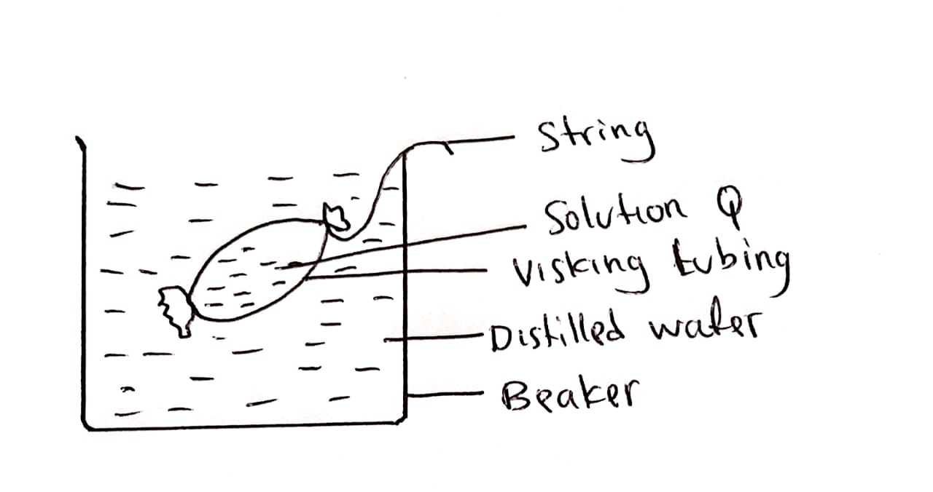

TEST | OBSERVATION | CONCLUSION

c) Account for the results obtained in the 1 (b) above (4 marks)
……………………………………………………………………………………………………………………………………………………………………………………………………………………………………………………………………………………………………………………………………………………………………………………………………………………………………………………………………………………………………………………………………………………………………………………………………………………………………………………………………………………………………………………………………………………………………………...………………………………………………………………………………………………………………
d) Give two roles of the physiological process being investigated in plants (2 marks)
………………………………………………………………………………………………………………………………………………………………………………………………………………………………………………………………………………………………………………………………………………………………………………………………………………………………………………

- The photograph below shows a physiological process that occur in mammalian blood when a blood vessel is damaged. Study the photograph and answer the questions that follow.
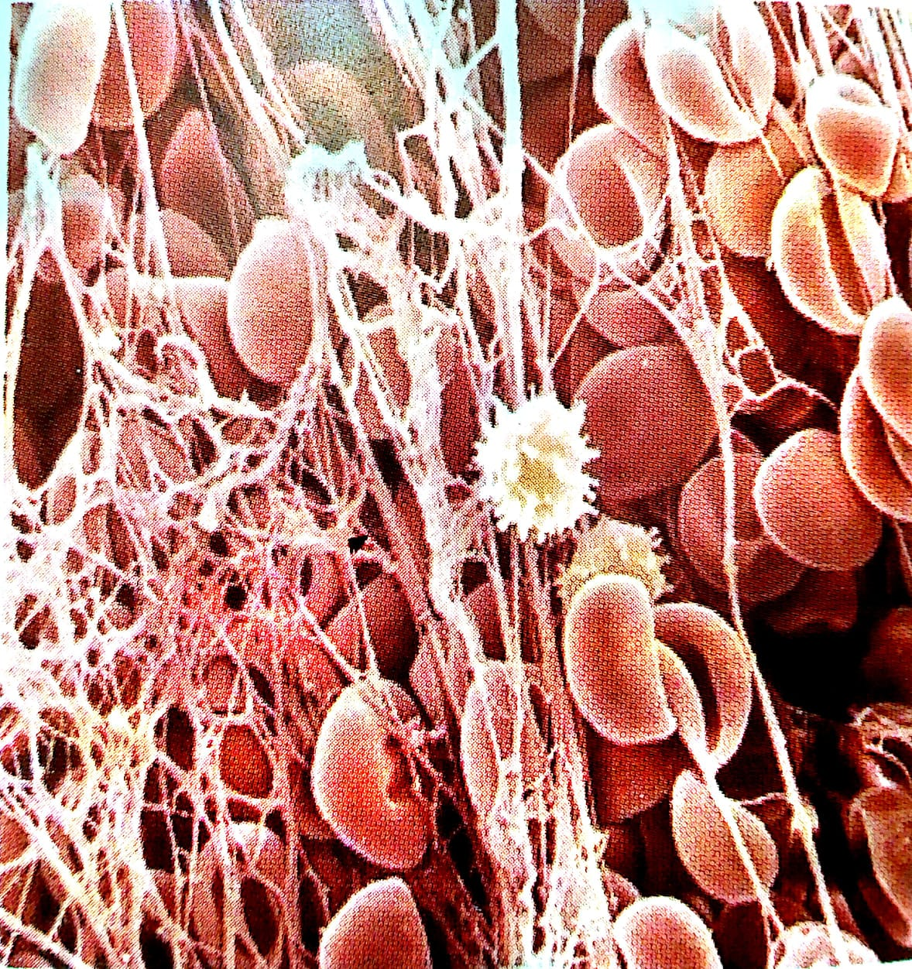

- i) Name the process shown in the photograph (1 mark)
………..…………………………………………………………………………………………………………………………………………………………………………………………………………………………………………………………………………
ii) Name the cells responsible for the process named in a(i) above (1 mark)
……………………………………………………………………………………………………………………………………………………………………………………………………………………………………………………………………………………
iii) Describe the mechanism that lead to the process in the photograph above (5 marks)
……………………………………………………………………………………………………………………………………………………………………………………………………………………………………………………………………………………………………………………………………………………………………………………………………………………………………………………………………………………………………………………………………………………………………………………………………………………………………………………………………………………………………………………………………………………………………………...………………………………………………………………………………………………………………………………………………………………………………………………..……………………………………………………………
- You are provided with a specimen labeled P. Study it carefully to answer the question that follow.
- Name the phenomenon exhibited by the specimen (1 mark)
…………………………………………………………………………………………………………………………………………………………………………………………………………………………………………………………
- State the condition under which specimen P was grown (1 mark)
…………………………………………………………………………………………………………………………………………………………………………………………………………………………………………………………
- Account for the following observation on the specimen
Long stem (2 marks)
………………………………………………………………………………………………………………………………………………………………………………………………………………………………………………………………………………………………………………………………………………………………………………………………………………………………………………
Yellow leaves (2 marks)
………………………………………………………………………………………………………………………………………………………………………………………………………………………………………………………………………………………………………………………………………………………………………………………………………………………………………………

- The photograph below shows exposed fish gills. Study it carefully and answer the questions that follow.

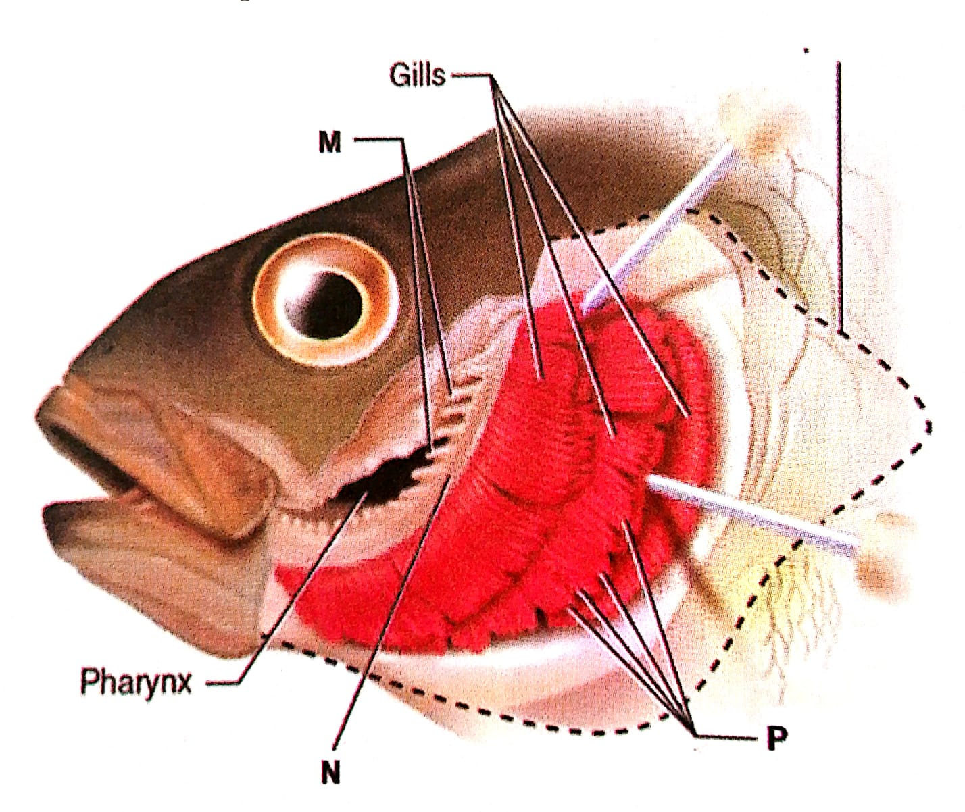
- Name the structure that was removed to expose the gills (1 mark)
……………………………………………………………………………………………………………………………………………………………………………………………………………………………………………………………………………………
- Give two functions of the structure named in (a) above (2 marks)
………………………………………………………………………………………………………………………………………………………………………………………………………………………………………………………………………………………………………………………………………………………………………………………………………………………………
- From the photograph, state two adaptations of the structure labeled P to its function
(4 marks)
………………………………………………………………………………………………………………………………………………………………………………………………………………………………………………………………………………………………………………………………………………………………………………………………………………………………………………………………………………………………………………………………………………………………………………………………………………………………………………………………………………………………………………………………………………
- Draw a well labelled diagram of a fish gill (4 marks)

