GATUNDU SOUTH JOINT MOCK EXAMINATION
Kenya Certificate of Secondary Education
231/ 2 Paper 2
BIOLOGY - (Theory)
Time 2 hours
Name …………………………………………….……… Adm Number…………………………………… ..
Instructions to candidates
- Write your name and class in the spaces provided above.
- Sign and write the date of examination in the spaces provided above.
- This paper consists of two sections: A and B.
- Answer ALL the questions in section A in the spaces provided.
- In section B answer question 6 (compulsory) and either question 7 or question 8 in
the spaces provided after question 8Candidates should answer the questions in English.
- Candidates should check the question paper to ascertain that all the pages are printed as indicated and no questions are missing.
For Examiner’s Use Only
SECTION | QUESTION | MAXIMUM SCORE | CANDIDATES SCORE
A | 1  2  3  4  5 | 8  8  8  8  8
B | 6  7 or  8 | 20  20  20
TOTAL SCORE |  | 80 MARKS

SECTION A (40 MARKS)
- Study the diagram below and answer questions that follow;

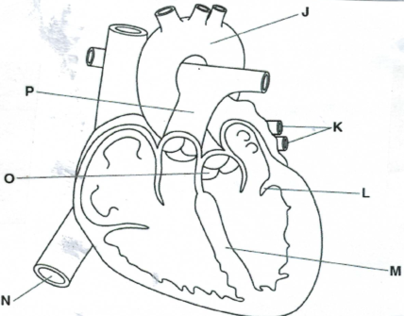

- Name the structures labelled O and M (2 marks)
O
M
- Identify a letter in the diagram that represents blood with the highest concentration of carbon (IV) oxide (1 mark)

- Describe how blood is moved by the heart from blood vessel k to blood vessel J. (3 mks)

- State two features of blood vessel K (2 marks)

- The diagram below shows exchange of materials between embryo’s bloodstreams and mother’s blood stream
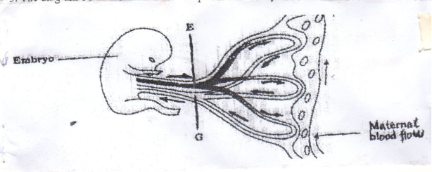
- (i) Give the names of the parts labeled E and G (2 marks)
E.
G.
(ii) Name one substance that is in high concentration in E (1mark)

(iii) In which organ does this kind of exchange shown occur? (1mark)

- Suggest the biological significance of each of the following
- Development of the pollen tube in fertilization in plants. (1mark)

- Fusion of petals to form funnel-shaped corolla tube in certain flowers.(1mark)

- Give 2 advantages of cross-pollination over self-pollination. (2marks)

3. In tomatoes hairy stem are produced;
a) By a dominant gen ‘H’ and hairless (smooth) stem by its recessive allele ‘h’. Using a
punnet square, work out the outcome between two heterozygous hairy stemmed plants. (4mks)

b) State the phenotypic ratio of the products (l mark)
……………………………………………………………………………………………… ………………………………………………………………………………………………
c) What will be the genotypes if the smooth variety is crossed with one of its parents? (l mark)
…………………………………………………………………………………………… ………………………………………………………………………………………………
d) State two ways in which. Genetics can be used in the field of Agriculture. (2 mks)
……………………………………………………………………………………………… ……………………………………………………………………………………………… ……………………………………………………………………………………………… ………………………..…………………………………………………………………….
4. The diagram below shows three different types of neurones a long a reflex arc

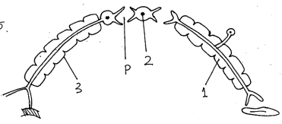


a. Identify the neurones labelled 1, 2 and 3 (3mks)
1 ………………………………………
2 ………………………………………
3………………………………………
b. Using arrows show the direction of impulse transmission on the diagram. (l mark)
……………………………………………………………………………………………
c. Name the part of the spinal cord where the cell bodies of neurone 2 and 3 are located. (l mark)
……………………………………………………………………………………………… ………………………………………………………………………………………………
d. Describe the transmission impulse across the part labelled P. (3mks)
………………………………………………………………………………………………………………………………………………………………………………………………………………………………………………………………………………………………………………………………………………………………………………………………………………………………………………………………………………………………………………………………………………………………………………
5. The diagram below represents a section through a human tooth.

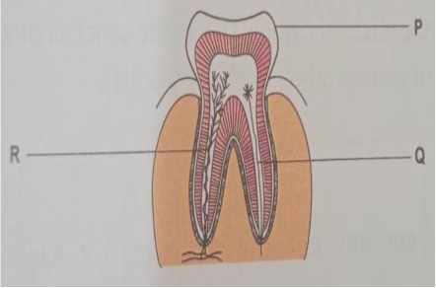
- Name the type of tooth shown (1mark)
.
- Give a reason for your answer (i) above. (1mark)

- Name the structures P, Q, R. (3marks)
P –
………………………………………………………
Q –
……………………………………………………….
R –
……………………………………………………..
- State three ways of keeping teeth healthy. (3marks)
.

SECTION B (40MARKS) set 3
Answer question 6 (compulsory) and either question 7 or 8 in the spaces provided after question 8.
- In an experiment to investigate a certain process in a given plant species, the rate of carbon (IV) oxide consumption and the rate of carbon (IV) oxide released were measured over a period of time of the day. The results of the investigation are shown in the table below.
Time of day | 6am | 8am | 10am | 12pm | 2pm | 4pm | 6pm | 8pm | 10pm | 12am
CO₂ consumption (mm³/min) | 0 | 43 | 69 | 91 | 91 | 50 | 18 | 0 | 0 | 0
CO₂ release (mm³/min) | 38 | 22 | 10 | 3 | 3 | 6 | 31 | 48 | 48 | 48
- On the same axis, plot graphs of volume carbon (IV) oxide against time (7mk



- Name the biochemical process represented by:
- Carbon (IV) oxide consumption (1 mark)

- Carbon (IV) oxide released (1 mark)

- Account for the shape of the curve for:
- Carbon (IV) oxide consumption (3 marks)

- Carbon (IV) oxide released (3marks)

- (i) What is meant by the term compensation point? (1marks)

(ii) From the graph state the time of the day when the plant attains compensation point (2 mark)

- Explain how temperature affects the rate of CO₂ consumption in a plant. (2 marks)

- Explain how the following plants are adapted to their habitats.
a) Xerophytes (14marks)
b) Halophytes. (6marks)

8. Describe the mechanism of inhalation in man. (8marks)
b) State three factors affecting breathing rate in human beings. (6marks)
c) Describe how the brain regulates breathing. (6marks)

……………………………………………………………………………………………………………………………………………………………………………………………………………………………………………………………………………………………………………………………………………………...……………………………………………………………………………………………………………………………………………………………………………………………………………………………………………………………………………………………………………………………………………………...……………………………………………………………………………………………………………………………………………………………………………………………………………………………………………………………………………………………………………………………………………………...……………………………………………………………………………………………………………………………………………………………………………………………………………………………………………………………………………………………………………………………………………………...……………………………………………………………………………………………………………………………………………………………………………………………………………………………………………………………………………………………………………………………………………………...……………………………………………………………………………………………………………………………………………………………………………………………………………………………………………………………………………………………………………………………………………………...……………………………………………………………………………………………………………………………………………………………………………………………………………………………………………………………………………………………………………………………………………………...……………………………………………………………………………………………………………………………………………………………………………………………………………………………………………………………………………………………………………………………………………………...……………………………………………………………………………………………………………………………………………………………………………………………………………………………………………………………………………………………………………………………………………………...………………………………………………………………………………………………………………...……………………………………………………………………………………………………………………………………………………………………………………………………………………………………………………………………………………………………………………………………………………...……………………………………………………………………………………………………………………………………………………………………………………………………………………………………………………………………………………………………………………………………………………...………………………………………………………………………………………………………………………………………………………………………………………………………………………………………………………………………………………………………………………………………………………………………...……………………………………………………………………………………………………………………………………………………………………………………………………………………………………………………………………………………………………………………………………………………...……………………………………………………………………………………………………………………………………………………………………………………………………………………………………………………………………………………………………………………………………………………...……………………………………………………………………………………………………………………………………………………………………………………………………………………………………………………………………………………………………………………………………………………...……………………………………………………………………………………………………………………………………………………………………………………………………………………………………………………………………………………………………………………………………………………...……………………………………………………………………………………………………………………………………………………………………………………………………………………………………………………………………………………………………………………………………………………...…………………………………………………………………………………………………………………………………………………………………………………………………………………………………………………………………………………………………………………………………………………THIS IS THE LAST PRINTED PAGE

