Marking Scheme

231/1
Biology Theory. Paper 1
June/ july 2025
Time: 2 Hours

Biology Examinations
Kenya Certificate of Secondary Education (K.C.S.E) - 2025

Instructions to candidates
- Answer all questions in this paper in the spaces provided after each question.
- This paper consists of 11 printed pages. candidates should check the question paper to ensure all pages are printed as indicated and that no questions are missing.
- Candidates should answer the questions in English.

For Examiners’ Use Only
1 | 2 | 3 | 4 | 5 | 6 | 7 | 8 | 9 | 10 | 11 | 12 | 13 | 14 | 15 | 16 | 17

18 | 19 | 20 | 21 | 22 | 23 | 24 | 25

TOTAL
- During a microscopy class a student was unable to see the field of view. State two possible adjustments she needed to make to ensure that the field of view becomes visible (2 marks)
Ensure that the objective lens is clicked into position with the eye piece lens; Adjust the mirror;
Ensure that the diaphragm is fully open;
Mark 1st 2 responses

- State why the following processes are essential in living organisms (2 marks)
  - Excretion

Organisms get rid of metabolic wastes which could be toxic to cells;
  - Irritability

Enables organisms to detect and adjust to changing environmental conditions; Acc. To locate food/mates
To escape predation/danger;

- The diagram below shows a type of epithelial tissue

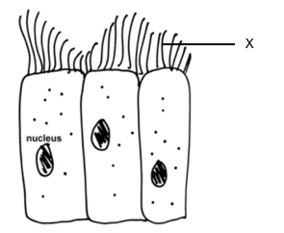

- What is the name of the hair like structures labeled X (1 mark)

Cilia;
- State the function of the hair – like structure (1 mark)

Moving materials over the epithelium;
- Name two mammalian organs where this type of epithelium is found (2 marks)

Trachea; Oviduct/Fallopian tube;

- a) Name a method that could be used to estimate the population size of the following
organisms.

i) Fish in a pond. (1 mark)

Capture recapture/capture-recapture; rej. Capture and recapture
ii) Black jack in a garden. (1 mark)

Quadrat;

b) Name the type of skeleton that makes up each of the following animals. (2 marks) i) Centipede

Hydroskeleton;

ii) Bird

Endoskeleton
- The diagram below shows cell structures.

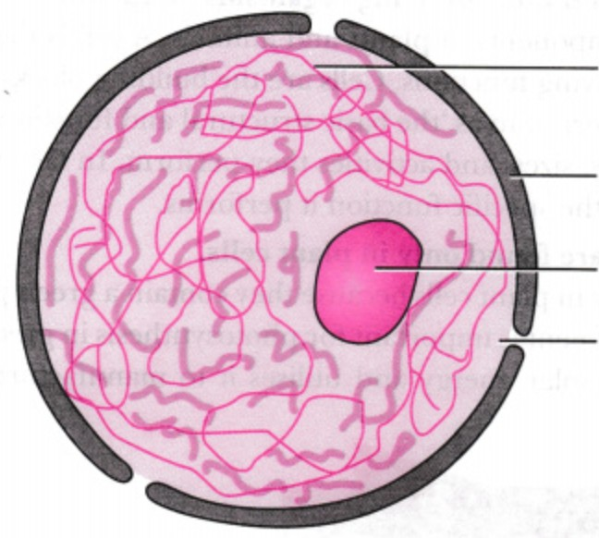
A

B

C
C

D

  - Name the structures labelled C and D (2 marks)

C Nucleolus; rej. Incorrect sp

D Nuclear pore;

  - State the functions of the structures; (2 marks) A - Carries the genetic material;

B- Regulates movement of substance into and out of the nucleus;

A number of industries in Nairobi and Machakos counties have recently been found to direct their effluents into Nairobi river and river Athi respectively. State the effect of the following substances present in the industrial effluents.
- Lead (2 marks)
- Can cause mental retardation in children;
- Can block the stomata of aquatic plants;
- Interferes with proper physiological functioning of body organs such as kidneys;

- Oils (2 marks)
- Blocks light penetration hindering primary productivity;
- Clogs respiratory surfaces of aquatic animals;
- Reduces the amount of dissolved oxygen causing suffocation to aquatic animals;

- Study the process below and answer the questions that follow.

Glucose
Process P
Pyruvic acid + Energy

  - Name process P. (1 mark)

Glycolysis;
  - Name the part of a cell in which the process named in a) above occurs. (1 mark)

Cytoplasm;
- For a long time, chloroquine was the most effective in the treatment of malaria. Explain why it is becoming more difficult to treat malaria using chloroquine? (2 marks)

Some plasmodium have gene for resistance/acquire resistance through mutation; the plasmodia with resistance gene survive; and reproduce offsprings with the resistance gene; leading to a strain of resistant plasmodia;

- Account for the following observations.
  - When a fish is taken out of water, it dies. (2 marks)

The gill filaments clump together reducing the surface area for gaseous exchange; this causes suffocation of the fish;
  - The palisade cells are closely packed together. (1 mark)

To ensure maximum trapping of light;

- Below is a graphical representation of the concentration of hormones involved in the menstrual cycle against time. Study it and answer the questions that follow

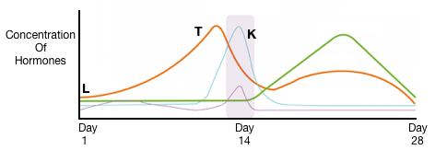
- Name hormone K. (1 mark)
Luteinizing hormone;

- Did pregnancy occur based on the cycle above? Explain your answer. (2 marks)
Pregnancy didn’t occur;
At the end of the cycle the level of progesterone reduces due to degeneration of the corpus luteum;
- Name the organ that secretes hormone T (1 mark)
Ovary;
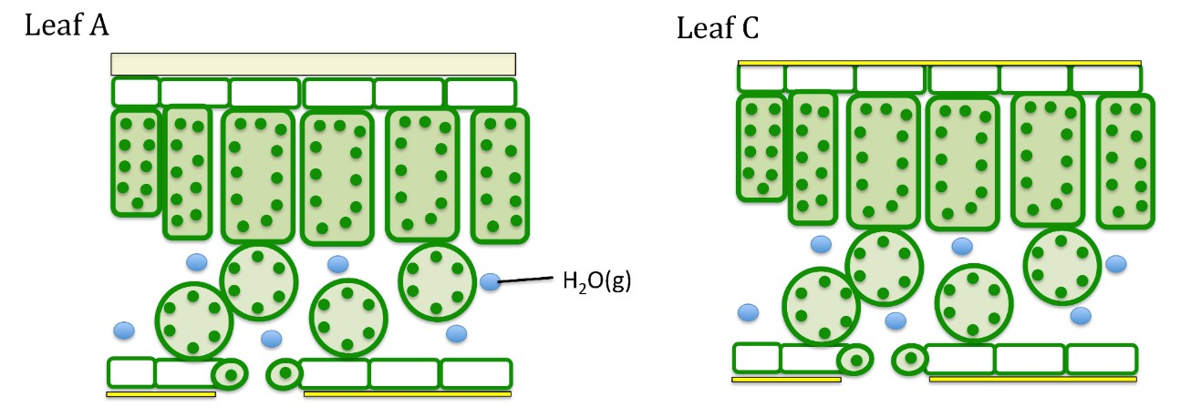
- The diagrams below shows leaves obtained obtained from plant A and C grown in the same habitat.

Identify the leaf that will lose the least amount of water. Justify your answer. (2 marks)

A;

It has a thick(er) cuticle; which increases the distance of diffusion lowering transpiration;

- a) Name the chemical abundant in the mitochondria. (1 mark)
Adenosine triphosphate; rej ATP
b) Name the respiratory gas necessary for the synthesis of the chemical named in (a) above.
( 1 mark)

Oxygen;
- State two differences between the products of mitotic division and those of meiotic division. (2 marks)

In mitosis 2 daughter cells formed, in meiosis 4 daughter cells formed;
In mitosis the daughter cells are diploid, in meiosis the daughter cells are haploid;

- Give the significance of the following features of the red blood cells.
- Being biconcave in shape. (1 mark)

Increases the surface area for gaseous exchange;

- Lacking mitochondria. (1 mark)

Ensures the red blood cells do not utilise the oxygen they carry;

- a) A person fell from the third floor of a building and had part of his brain damaged. Name the part of the brain damaged if the person suffers from the following.
- Loss of speech (1mark)

Cerebrum;
- Inability to regulate body temperature. (1mark)

Hypothalamus;
- Lack of body balance. (1 mark)

Cerebellum;

a) Complete the table below. (4 marks)

n a

Hormone | Endocrine gland |  | Target organ
Insulin | Liver;
Antidiuretic hormone | Pituitary gland; |  | Kidney; rej. nephron
b) Explain why glucose and proteins are absent in the urine of a healthy person. (2marks)

All glucose (actively) reabsorbed at the PCT; proteins are large molecules and do not filter out of the glomerulus;

- (a) Name the gaseous exchange surface in cockroaches. (1mark)

Tracheole;
(b) How is the surface named in (a) above suited to its function. (1 mark)

Lacks chitin hence permeable to respiratory gases;
Thin walled to reduce the distance of diffusion of respiratory gases; Has moist tips to dissolve respiratory gases;
rej numerous …..

- The graphs below shows the effect of pH on the rate of activity of two digestive enzymes X and Y.

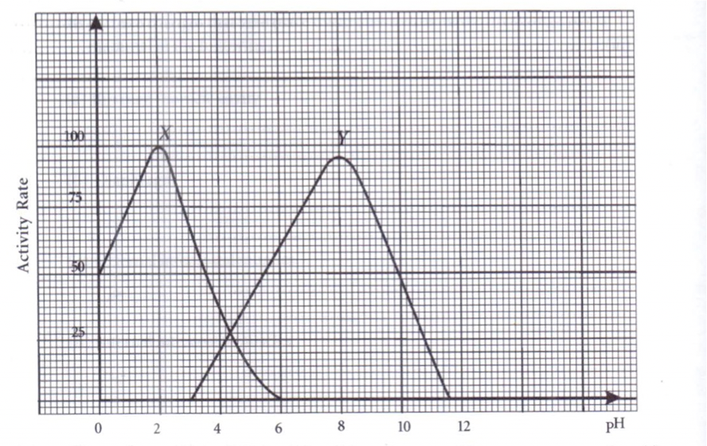

  - Name one protease enzyme that could be represented by X and Y (2marks) X pepsin; / rennin; Y - trypsin;
  - How is an optimum pH for enzyme X attained in the human body? (2marks)
Secretion of gastric juice; containing hydrochloric acid to maintain acidic pH;

- A food sample was made into a suspension and a few drops of iodine solution was added into it. A blue black colour developed. A sample of the same food had no effect on Benedict’s solution. Some millet seeds which had been soaked for 48 hours were crushed and mixed with the food suspension. The mixture was incubated in a warm water bath for 6 hours. After incubation, the sample gave negative results with iodine solution and positive results with Benedict’s solution.
  - What does the blue-black colour developed on addition of Iodine solution indicate?
(1 mark)

Presence of starch;
  - Account for the negative results with iodine solution after incubation. (1 mark)

Diastases present in the seeds hydrolyzed starch to maltose;
  - Why was it necessary to soak the millet seeds first in the second test? (1 mark)

To activate the enzymes;
  - What is the role of the incubator in the above experiment (1 mark)

To maintain a constant/optimum temperature for enzyme activity;

A section of nucleic strand contains the following sequence.
A — C — G — A — G — A — T — A— C
a) i) Write the complimentary DNA stand. (lmk)
T—G— C—T—C— T—A—T—G

ii) Write the mRNA strand of the strand in (a) above. (lmk)
U—G—C—U—C—U—A— U—G

b) Name the site for protein synthesis in a cell. (lmk)
Ribosomes
c) State one disorder caused by non-disjunction mutation. (lmk)
-Turner’s syndrome
- Down’s syndrome
- Klinefelter’s syndrome

- Study and complete the table below. (3mks)
Character | Monocot | Dicot
a) Number of stamens | In multiple of three | Multiples of 4/5
b) Arrangement of vascular bundle in stem | Vascular bundle are scattered | Vascular bundle arranged in a ring
c) Type of root | fibrous | Tap root

- The table below show description of sizes of glomeruli and renal tubules of two animals, which are in different environments.
 | Animal Q | Animal W
Glomeruli | Few | Many
Renal tubules | Long | Short

a) Name the likely environment in which each animal lives. (2mks)
Q – Arid and semi-arid
W- Aquatic

b) Suggest the main nitrogenous waste produced by animal W. (lmk)
Ammonia
c) What is the importance of the renal tubules being long? (lmk)
To increase the surface area for reabsorption of water in the kidney tubules for them to conserve water.
23. Three stems of tradescantia of equal length were placed in three solutions of different concentrations. The set ups were left to stand for 30 minutes. The results were recorded in the table below.
Solution | Initial length of stem (mm) | Final length of stem (mm)
A | 37 | 37
B | 37 | 35.2
C | 37 | 39.7

- Describe the nature of solution A in relation to the final length of the tradescantia stem. (1mark)
Isotonic solution;
- Explain the observation that was made on the tradescantia stem which was put in solution B. ( 2marks)
Solution B was hypertonic to trandescatia cells; The cells lose water by osmosis and become plasmolysed; hence reduces in size;

- State what would happen to red blood cells if they were placed in solution C.
(1 mark)
Absorb water by osmosis, swell and burst/ hemolysis;

- The researcher found out that oxygen concentration and sugar consumption is directly related to potassium ion uptake in wheat roots. Name the process by which potassium ions is taken by the roots. Give a reason for your answer ( 2 marks)

Active transport; – sugar molecule oxidized by oxygen to give energy for active transport;
24. a) Define parthenogenesis? (1 mark)
A type of asexual reproduction in insects where eggs produced without being fertilized are able to hatch into adult insects;
(b) Name the plant hormone that induces fruit ripening.
Ethylene;
25. Germinating cowpeas seeds were place in a vacuum flask and left for five days.
a) What is the expected change in composition of gases in the flask on the sixth day? (1mark)
Decrease in oxygen and increase in carbon(1V)oxide;
b) Give a reason for your answer in (a) above
Germinating seeds respire using oxygen and release carbon(IV)oxide;
c) (ii) Give any two advantages of metamorphosis in the life of an insect. (2 marks)
Each stage occupies a different ecological niche; hence there’s no competition for resources e.g food;

