BOKAKE JOINT EXAMINATION TEST
443/2 - AGRICULTURE - Paper 2
MARKING SCHEME

1. Name the hormone responsible for milk let down (½mark)
- oxytocin
2. List any two chemicals used to treat wood against weather elements (1mark)
- Creosote.
- Tar.
- Tanex.
3. State any four characteristics of exotic breeds of cattle (2marks)
- Have no humps.
- Have low tolerance to high temperatures.
- Have fast growth rates leading to early maturity.
- Cannot walk for long distances.
4. State three uses of biogas on a farm (1½marks)
- For lighting.
- For cooking.
- Used in internal combustion engines.
5. State four practices done to make wooden fence posts last longer (2marks)
- Proper drying.
- Chemical treatment.
- Reinforcing with concrete.
- Slightly burning of the posts
6. | Tick borne diseases
 | - East coast fever (ECF/Spiro chastises)
 | - Heart Water
 | - Red water (Babesiosis)
 | - Anaplasmosis (Gall-sickness)
 | - Tick bite fever. | 4x1/2 = | 2 mks

7. (a) Functions of esophageal groove
- Allows food into the rumen when it is swallowed the first time:
- - It allows food into the reticulum during second swallowing. 1x1 = 1mk

(b) Methods of ration computation
- Trial and error method
- Pearson’s square method 2x1 = 1mk.
8. Advantages of contemporary comparison method
- Enables to compare animals of different age groups since heifer locations are used.
- Eliminates differences brought about by environment since average performance of the herd is used.
- It is possible to make direct comparison of bulls at different Artificial insemination centres since the environmental differences are removed.
- It is accurate – can only be used accurately in large herds of animals.

9.(a) Notifiable disease - Is an infectious disease which once noticed must be reported to
Government authorities for the purpose of taking action. 1x1 = 1 mk

(b) Examples of notifiable diseases:-
- Foot and mouth disease
- Rinderpest
- Anthrax
- Rift valley fever
- New castle
- Avian flu in poultry
- Rabbies | - 3x1/2 = | - (1 ½ mk)

10. (a) State four ways in which fleas cause economic losses to the farmer. (2mark)
- Cause irritation which leads to scratching.
- Stick fast fleas cause wounds on the point of attach.
- Lower quality
- Lower price
- Leads to mortality rates.
b) List three limitations of water as a source of power in the farm. (1½
marks)
- Most rivers are small and seasonal.
- It is expensive to harness the power.
- Most farms do not have access to large quantities of moving water.
11). Tabulate two features that differentiate between dairy and beef cattle. (2 marks)

Dairy | Beef
Wedge or triangular shaped | Blocky in shape
Selective grazing | Reduced selective grazing
Large udder | Small udder

12). Define the following terms as used in livestock production. (1½marks)
a) Digestibility
- The portion of food retained in an animal’s body after taking care of losses through urine,faces and gases, expressed as a percentage.
b) Prolificacy
- Ability to give birth to many young once.
c) Malpresentation
- Abnormal calving where the forelegs don’t come out first.
13). Give three methods of selecting livestock for breeding (1½marks)
- Mass selection
- Progeny testing
- Contemporary comparison
14). Methods of preserving fish.
- Sun drying
- Salting
- Freezing
- Smoking Any 4× ½ =2 mks
15). Factors determining nutritional requirement of an animal.
- Age
- Body weight
- Physiological condition
- Exercise /Activity.
- Level of production.
- Weather condition. Any 4× ½ =2 mks
16). Rip saw are used for cutting along grains of wood while cross cut saw is used for cutting across the grains. 1×1=1 mks
17). Signs of parturition in cattle
- Restleness
- Swollen vulva
- Clear mucus discharge from the vulva.
- Pelvis muscles slacken.
- Full and distended udder.
- Thick milk from the teats.
- Water bag appears and burst before calving. Any 4× ½ =2 mks

18. (a) E- smoothing wood surface /curved surfaces.
F - Holding objects securely while carrying out various operations.
G - Driving wood chisels.
H - Cutting thin sheet of metal. 4× ½ =2 mks
(b)
- Lubricant moving parts
- Oil to prevent rusting.
- Clean after use. Any 1×1=1m

19 The diagram below is an illustration of a fish pond. Study it and answer the questions that follow.

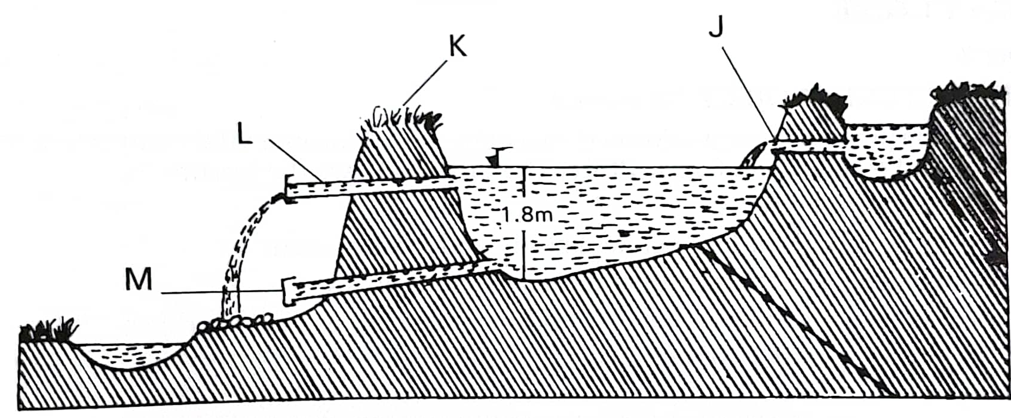
a). J, L and M are pipes through which water flows. Give the function of L and M.
(2 marks)
- L- Outlet pipe
- M-Drain pipe
b). Give two precautions that should be taken on the part labeled K during construction to ensure a longer life of the pond. (2 marks)
- Raise the top soil on the top of the pond
- Plant grass on the part K.

c). State two factors considered when siting a fish pond. (2 marks)
- Reliable source of water.
- Clay soil
- Gently sloping land
20 .Below is structure used in poultry production. Use it to answer the questions that follow.
a) Identify the structure illustrated above. (1 mark)
- An artificial incubator
b) State the main function of the structure illustrated above. (1 mark)
- It provides an egg with all conditions suitable for embryonic development artificially
c)Give the main function of the following in the structure (3 marks)
i)Water
- Gives the required relative humidity
ii)Source of heat
- To provide the required warmth
iii) Thermometer
- To determine the actual temperature in the incubator

21. The diagram below shows a farm implement. Study it and answer the questions that follow.
a). Identify the implement (1mk)
- Disc plough

b). Name parts labeled H, J, K and S. (2 mks)
H – Beam
J – Lower link
K – Furrow wheel
S – Concave disc
c). Give two reasons why the above implement is suitable in hard soils (3 mks)
- Ride over obstacles
- Work well in sticky, non – scouring and black waxy soil
- Plough at varying depth.
SECTION C (40 MARKS)
Answer any two questions
22. . a). Describe Newcastle disease under the following sub – headings
i). Causal organisms (1 mk)
- Virus
ii). Signs of infection (7 mks)
- Difficulties in breathing
- Beaks wide open and neck strained
- Dull
- Stand with eyes closed
- Loose appetite
- Nasal discharge
- Staggering motion
- Beaks and wings down
- Watery greenish diarrhea
- Eggs soft shelled

iii). Control measures (4 mks)
- Kill and burn affected birds
- Disinfect and clean houses
- Vaccination
- Quarantine
- No known treatment

b). Explain four requirements of artificial incubation. (8 mks)
- Temperature (37.5⁰ C – 39.4⁰ C)
- Fresh air / ventilation
- Relative humidity 60%
- Egg turning 45⁰ C

23. (a) Outline any eight control measures for ticks (8marks)
- By use of the ticks natural enemies/predators
- Self licking by the animal dislodges the ticks from the body
- Licking by other animals
- Burning the infested pastures
- Interfering with or altering the tick’s environment through ploughing the pasture land or top dressing the pasture using lime.
- Fencing off the pasture land and farm
- Starving the ticks to death by carrying out rotational grazing of the use of paddocking system.
- Handpicking the ticks from livestock and killing them/de-ticking.
- Use of acaricide/chemical control. 8 x 1= 8 mks
(b) Outline the daily maintenance practices that should be carried out on a farm tractor. (12marks)

- Engine oil should be checked daily by use of a dip stick and added if the level is low.
- Fuel level should be checked at the start of everyday’s work and added if necessary.
- Water level in the radiator should be inspected and if necessary topped up.
- The level of electrolyte should be checked daily and topped up with distilled water.
- Tightening loose nuts and bolts.
- Replacing lost nuts and bolts before day’s work.
- Grease should be applied by use of grease gun through the nipples.
- Large sediments from the sediment bowl should be removed.
- The tyre pressure should be checked every morning before the day’s work by use of pressure gauge.
- The fan belt tension should be checked to ensure that it reflects between 1.9 cm to 2.5 cm when pushed.
- The brake shaft bearing should be greased.

12 x 1=12mks
27. (a) Discuss the preparation of the brooder before the arrival of chicks (5marks)
- Brooder should be made ready 2 to 3 days before chicks arrive.
- Ensure all the equipment are functional.
- Spread newspapers on the floor of the brooder.
- Spread some feed on the newspaper and some on the feeders.
- Clean and disinfect the brooder house and the brooder equipment.
(b) Describe the management practices carried out on ewes 2 weeks before mating to weaning of lambs(10marks)
- Flushing 2 to 3 weeks before tupping and continues for 3 weeks after tupping.
- Crutching to facilitate mating/tupping.
- Hoof trimming to cut the over grown hooves to facilitate easy movement.
- Shearing of wool from all over the body of the ewe.
- Feed the ewes on clean pastures
- Deworm the ewes 2-3 week before lambing
- Provide clean drinking water.
- Provide clean and enough shelter
- Separation of the ewes from the others after showing signs of lambing.
- Move the ewes into their individual clean pens to lamb down under supervision
- Steaming up done during the last weeks of gestation.
- Observing signs of lambing and assist where necessary.
- Ensure the mother licks the lamb to ensure that the coat is dry.
- Ensure that the lambs suckle the colostrum.
- Rejected &orphaned lambs should be given to a foster mother or fed artificially.
- Keep lambs and ewes under good and clean pastures.
- Docking of the lambs should be done within 2 weeks of lambing.
- Castration of male lambs that are not selected for breeding should be done when 2 weeks old.
- Introducing creep feeding to lambs at the 6th week
- Spray/dust to control ectoparasites
- Deworm the lambs. (ANY 10 POINTS)
(c) State five reasons why bees swarm (5mks)
- Shortage of water and food in the surrounding
- Outbreak of diseases and parasite
- Damage of broods or combs
- Lack of adequate ventilation.
- Dampness and bad smell
- Sick or infertile queen
- Overcrowding (5 x 1=5 mks)

