GATUNDU SOUTH JOINT EXAM
END TERM 2 2025
AGRICULTURE 443/2
TIME: 2HOURS

NAME………………………………………………ADM……………………..CLASS……………….DATE…………………..SIGN……………………..
INSTRUCTIONS TO CANDIDATES:
- Write your name, index number, school, class and admission number in the spaces provided.
- Sign and write the date in the spaces provided above. • Answer all the questions in section A and B • Answer any two questions in section C.
- Answers should be written in the spaces provided in this booklet.
For Examiner’s Use Only:
SECTION | QUESTIONS | MAXIMUM SCORE | CANDIDATES SCORE
A | 1-20 | 30
B | 21-24 | 20
C |  | 20
C |  | 20
 | TOTAL | 90

SECTION A (30MARKS)

- Give four livestock rearing practices that can be carried out in a crush. (2mks)
………………………………………………………………………………………………..……………………………………………………………………………………………..…………………………………………………………………………………………
…………………………………………………………………………………………..

- Name the part of the digestive system of poultry where insoluble grit is found. (^{1/2} 𝒎𝒌)

…………………………………………………………………………………………

- Give the distinguishing external characteristics of Californian breed of rabbit. (1mk)
…………………………………………………………………………………………
………………………………………………………………………………………

- State four pre-disposing factors of livestock diseases. (2mks)
………………………………………………………………………………………………..…………………………………………………………………………………………
…………………………………………………………………………………………..
…………………………………………………………………………………………..

- Outline four functions of proteins in the body of an animal. (2mks)
………………………………………………………………………………………………..…………………………………………………………………………………………
…………………………………………………………………………………………..
…………………………………………………………………………………………..
- State four observable features of indigenous cattle (Bos indicus) (2mks)
…………………………………………………………………………………………
……………………………………………………………………………………………..……………………………………………………………………………………..
…………………………………………………………………………………………..…………………………………………………………………………………………..
- State four importance of creep feeding. (2mks)
………………………………………………………………………………………………………………………………………………………………………………………………………………………………………………………………………………..
………………………………………………………………………………………..
..............................................................................................................
- Name four materials that are collected by bees. (2mks)
……………………………………………………………………………………… ………………………………………………………………………………………
…………………………………………………………………………………………..
………………………………………………………………………………………......

- Give the function of each of the following parts of a fish pond.
  - Spillway (^{𝟏 /2}𝒎𝒌)
……………………………………………………………………………………
  - Outlet (^{𝟏/2} 𝒎𝒌)
…………………………………………………………………………………………
- State four advantages of cross-breeding. (2mks)
………………………………………………………………………………………………..……………………………………………………………………………………
………………………………………………………………………………………….
………………………………………………………………………………………..…
………………………………………………………………………………………..

- Name the part of the digestive system of a non-ruminant animal where cellulose is broken down (^{𝟏/2} 𝒎𝒌)
…………………………………………………………………………………………
- State three field conditions under which a disc plough should be used instead of a mouldboard plough. (𝟏 ^{𝟏/2} 𝒎𝒌𝒔)
………………………………………………………………………………………………..…………………………………………………………………………………………….…………………………………………………………………………………………..
………………………………………………………………………………………..

- State three advantages of artificial incubation in comparison to natural incubation as a method of hatching chicks. (𝟏 ^{𝟏/2} 𝒎𝒌𝒔)
………………………………………………………………………………………………..…………………………………………………………………………………………….…………………………………………………………………………………………..
………………………………………………………………………………………..…
………………………………………………………………………………………..

- Give four routes through which a vaccine can be administered. (2mks)
………………………………………………………………………………………………..…………………………………………………………………………………………
…………………………………………………………………………………………..
………………………………………………………………………………………..…
………………………………………………………………………………………..

- State four structural requirement of a calf pen (2mks)
……………………………………………………………………………………………….\……………………………………………………………………………………………………………………………………………………………………………..…………
………………………………………………………………………………………..…
………………………………………………………………………………………..

- Give three reasons why drenching alone is not an effective method of controlling intestinal parasites in livestock.(1 1/2)
…………………………………………………………………………………………………………………………………………………………………………………………..
………………………………………………………………………………………….
…………………………………………………………………………………………..

- Name three poultry diseases that are controlled by vaccination. (𝟏 ^{𝟏 /2}𝒎𝒌𝒔)
………………………………………………………………………………………………………………………………………………………………………………………
…………………………………………………………………………………………..
…………………………………………………………………………………………..

- Give the mineral whose deficiency causes the following disorders in livestock.
  - Anaemia (^{𝟏 /2}𝒎𝒌)
………………………………………………………………………………………
  - Parakeratosis (^{𝟏/2} 𝒎𝒌)
……………………………………………………………………………………
- Give three maintaince practices carried out in a fish pond after draining water. (𝟏 ^{𝟏/2} 𝒎𝒌𝒔)
………………………………………………………………………………………………………………………………………………………………………………………
…………………………………………………………………………………………..
…………………………………………………………………………………………..

- If records show that a rabbit was served on 27th September 2020.Which date did it give birth. (^{𝟏 /2}𝒎𝒌)
………………………………………………………………………………………

SECTION B (20 MARKS)
- Below is an illustration of part of a wooden post wire fence. Study it and answer the questions that follow.
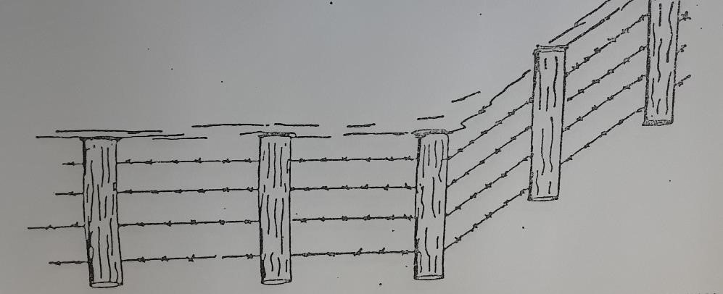
  - Identify the type of wire in the illustration. (1mk)
……………………………………………………………………………………
  - On the illustration show by drawing how the corner post should be supported. (1mk)
  - On the illustration draw, label and give the function of a dropper. (2mks)
………………………………………………………………………………………
…………………………………………………………………………………………..
  - Name the correct tool for tightening the wire during construction of the fence. (1mk)
……………………………………………………………………………………………

- Observe the tools A, B and C illustrated below then answer the questions that follow.
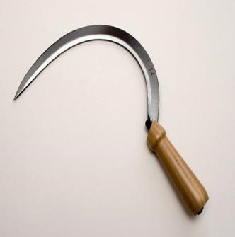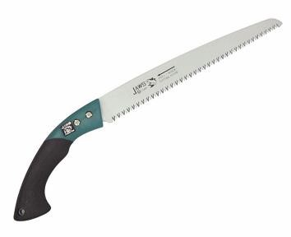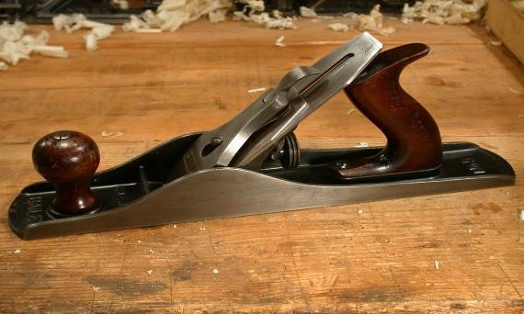
C
B
A

  - Name tools A, B and C and state the correct use of each tool. (3mks)
Tool | Identity | Function
A
B
C

  - State two maintenance practices that should be carried out to ensure that tool C is in a good working condition (2mks)
……………………………………………………………………………………
……………………………………………………………………………………
……………………………………………………………………………………...

- Below is an illustration of an activity carried out by a poultry farmer keeping layers
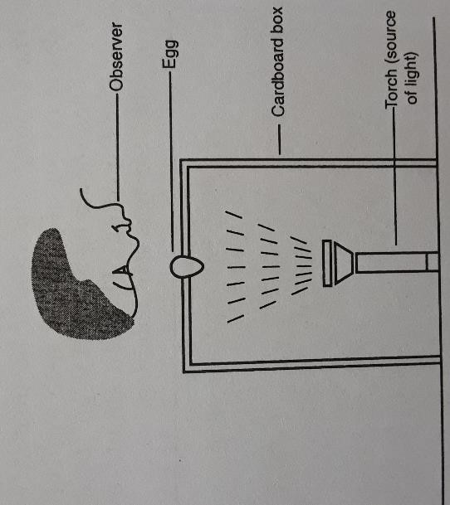
  - Identify the activity carried out using the set-up. (1mk)
……………………………………………………………………………………
  - State two abnormalities in eggs that can be detected using the set-up above. (2mks)
………………………………………………………………………………………
…………………………………………………………………………………………..……………………………………………………………………………………………..
……………………………………………………………………………………..

  - How can a farmer improve the following?
    - Hardness of egg shells. (1mk)
…………………………………………………………………………………………
    - Yellowness of the egg yolk. (1mk)
…………………………………………………………………………………………
- The diagrams K, L, M and N below show four possible ways of drawing milk from the teat of a cow during milking.
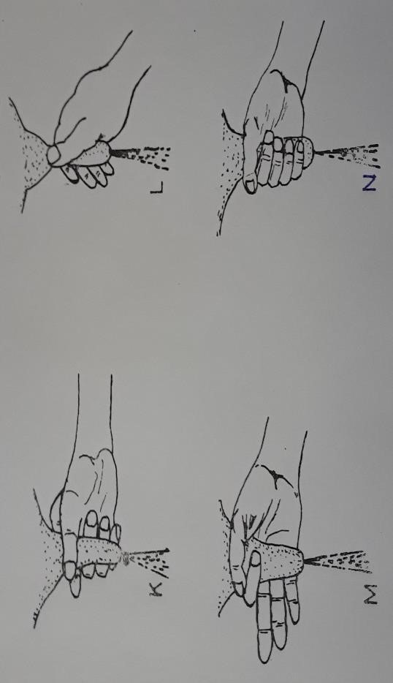
  - Which diagram shows the proper way of drawing milk. (1mk)
………………………………………………………………………………………
  - How long should it take to milk a cow from the start to the end of milking. (1mk)
……………………………………………………………………………………
  - How would a milkman ensure that no milk remains in the udder at the end of milking?
(1mk)
………………………………………………………………………………………
  - Give two practices carried out on milk immediately after milking. (2mks)
………………………………………………………………………………………………………………………………………………………………………………
………………………………………………………………………………………

SECTION C (40MARKS)
- a) Describe the advantages of battery cage system of rearing layers. (10mks)
  - State and explain five factors affecting milk production. (10mks)

- a) Explain the functions of any six parts of a plunge dip. (6mks)

  - Explain four structural and functional differences between petrol and diesel engine.(4mks)
c)Explain five mechanical methods of controlling ticks. (10mks)

- a) Describe five advantages of embryo transplant. (5mks)
  - Describe coccidiosis disease under the following sub- headings.
    - Animals attacked (2mks)
    - Causal organism (1mk)
    - Symptoms (4mks)
    - Control measures (3mks)

28) Explain Five factors affecting digestibility in livestock (5mks)
………………………………………………………………………………………………..……………………………………………………………………………………………………………………………………………………………………………
………………………………………………………………………………………..……….…… ……………………………………………………….………….…………………………………………………………………………………..………..…..…… ……………………………………………………………………………..…………..……..………………………………………………………………………………….
………………………………………………………………………..……………..………..…… …..…………………………………………………………………………..…………………………………………………………………..………………..…………..………………………………………………………………..…………………..……………..…………….……………………………………………………………………………..………………………………………………………..……………………..………………..………………………………………………………………………………………………..…………………………………………………………………………………..…………………………………………………………………………………………………………………………………………..………………………..…………………..………………………………………………………………………………….
……………………………………………..…………………………..……………………..…… ………………………………………..……………………………..………………………..…… …………………………………..………………………………..…………………………..…… ……………………………..…………………………………..……………………………..…… …………………………………………………………………………………………………………..……………………………………..………………………………..…… ………………………………………………………………………………..…………………..………………………………………..…………………………………..………………………………………………………………………………………….
……………..…………………………………………..……………………………………..……
………..……………………………………………..………………………………………..…… …..………………………………………………..…………………………………………..………………………………………………………………………………………………………………………………………………………………………………………………………………………………………………………………………………………………………………………………………………………………………………………………………………………………………………………………………………………………………………………………………………………………………………………………………………………………………………………………………………………………………………………………………………………………………………………………………………………………………………………………………………………………………………………………………………………………………………………………………………………………………………………………………………………………………………………………………………………………………………………………………………………………………………………………………………………………………………………………………………………………………………………………………………………………………………………………………………………………………………………………………………………………………………………………………………………………………………………………………………………………………………………………………………………………………………………………………………………………………………………………………………………………………………………………………………………………………………………………………………………………………………………………………………………………………………………………………………………………………………………………………………………………………………………………………………………………………………………………………………………………………………………………………………………………………………………………………………………………………………………………………………………………………………………………………………………………………………………………………………………………………………………………………………………………………………………………………………………………………………………………………………………………………………………………………………………………………………………………………………………………………………………………………………………………………………………………………………………………………………………………………………………………………………………………………………………..................................................................................................................................................................................................................................................................................................................................................................................................................................................................................................................................................................................................................................................................................................................................................................................................................................................................................................................................................................................................................................................................................................................................................................................................................................................................................................................................................................................................................................................................................................................................................................................................................................................................................................................................................

