GATUNDU JOINT EXAM 2025
Name……………………………………………………….ADM No…………………….
CLASS………………………….
Date………………………….
443/1
AGRICULTURE
PAPER 1
Time: 2 Hours
Kenya Certificate of Secondary Education (K.C.S.E
INSTRUCTIONS TO CANDIDATES
1. This paper consists of three section A,B and C
2. Answer ALL the questions in section A and B and any TWO questions in section C.
3. Answers to be written in the spaces provided only.
FOR OFFICIAL USE ONLY
SECTION | MAX. SC0RE | ACTUAL SCORE
A | 30
B | 20
C | 40
TOTAL | 90
SECTION A (30 marks)
Answer all the questions in this section in the spaces provided.
- Name three aspects of rain fall that affects agriculture. (1½ marks)
….…………………………………………………………………………………………………………………………………………………………………………………………………………………………………………………………………………………………………………………
- State four factors that determine the depth of cultivation. (2 marks)
….………………………………………………………………………………………………………………………………………………………………………………………………………………………………………………………………………………………………………………………………………………………………………………………………………………………….
- State four factors that influence the quality of farmyard manure.(2 marks)
….………………………………………………………………………………………………………………………………………………………………………………………………………………………………………………………………………………………………………………………………………………………………………………………………………………………….
- State two factors that determine national income. (1 marks)
….………………………………………………………………………………………………………………………………………………………………………………………………………………………………………………………………………………………………………………….
- State four causes of land fragmentation. (2 marks)
….…………………………………………………………………………………………………………………………………………………………………………………………………………………………………………………………………………………………………………………………………………………………………………………………………………………………………………………………………………………………………………………………………
- Differentiate between apiculture and aquaculture. (1 marks)
….……………………………………………………………………………………………………………………………………………………………………………………………………….
- State four ways in which crop pests are classified.(2 marks)
….…………………………………………………………………………………………………………………………………………………………………………………………………………………………………………………………………………………………………………………………………………………………………………………………………………………………………………………………………………………………………………………………………
- .State four agricultural practices that pollute surface water sources.(2 marks)
….…………………………………………………………………………………………………………………………………………………………………………………………………………………………………………………………………………………………………………………………………………………………………………………………………………………………………………………………………………………………………………………………………
- What is meant by the term production function? (1 marks)
….……………………………………………………………………………………………………………………………………………………………………………………………………….
- State three financial documents (1½ marks)
….…………………………………………………………………………………………………………………………………………………………………………………………………………………………………………………………………………………………………………………
- Give four reasons why livestock farmers prepare silage. (2 marks
….…………………………………………………………………………………………………………………………………………………………………………………………………………………………………………………………………………………………………………………………………………………………………………………………………………………………………………………………………………………………………………………………………
- State four reasons why agriculture is important to Kenya’s economy.(2 marks)
….…………………………………………………………………………………………………………………………………………………………………………………………………………………………………………………………………………………………………………………………………………………………………………………………………………………………………………………………………………………………………………………………………13.State four ways in which mulching conserves water.(2 marks)
….…………………………………………………………………………………………………………………………………………………………………………………………………………………………………………………………………………………………………………………………………………………………………………………………………………………………………………………………………………………………………………………………………
14.List four factors that would determine the stage at which a crop is harvested..(2 marks)
….…………………………………………………………………………………………………………………………………………………………………………………………………………………………………………………………………………………………………………………………………………………………………………………………………………………………………………………………………………………………………………………………………
- State four characteristics of shifting cultivation.(2 marks)
….…………………………………………………………………………………………………………………………………………………………………………………………………………………………………………………………………………………………………………………………………………………………………………………………………………………………………………………………………………………………………………………………………
- Give four reasons why seed propagation is encouraged in crop production. (2mks)
….………………………………………………………………………………………………………………………………………………………………………………………………………………………………………………………………………………………………………………………………………………………………………………………………………………………………………………………………………………………………………………………………
17. Give four factors that affect the quality of hay. (2 marks)
….…………………………………………………………………………………………………………………………………………………………………………………………………………………………………………………………………………………………………………………………………………………………………………………………………………………………………………………………………………………………………………………………………
SECTION B (20 marks)
Answer all the questions in this section in the spaces provided.
18.The diagrams below show certain weeds.
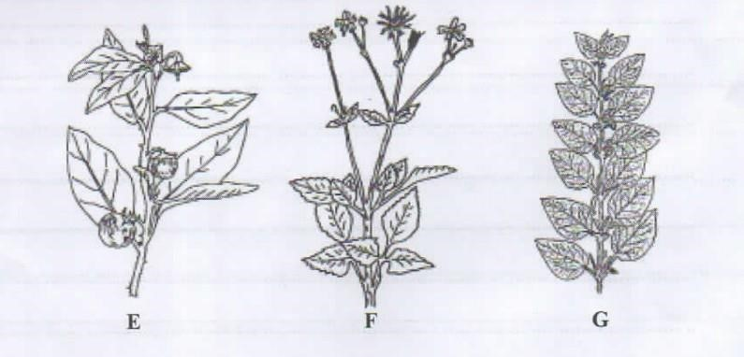

- Identify the weeds labelled F . (l mark)
….…………………………………………………………………………………………………
b)State one way in which each of the weeds labelled E and F affects the quality of livestock products.

E.……………………………………………………………………………….................(l mark)
F...............……………………………………………………………………………….....(l mark)
(c) State the main way in which the weed labelled G interferes with farm operations. (1 mark)
….……………………………………………………………………………………………………………………………………………………………………………………………………….
19.The diagram below shows a nursery practice carried out soon after tree seedlings have emerged.
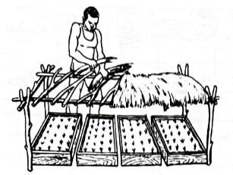
- Identify the practice.(1 mark)
….…………………………………………………………………………………………………
- Give two reasons for carrying out the above practice.(2 marks)
….………………………………………………………………………………………………………………………………………………………………………………………………………………………………………………………………………………………………………………….
- State one precaution that should be observed in the practice illustrated in relation to the direction of the sun.(1 mark)
….…………………………………………………………………………………………………………………………………………………………………………………………………………
- Name the type of nursery bed illustrated.(1 mark)
….………………………………………………………………………………………………………………………………………………………………………………………………………
- A famer is advised to apply 60kg N, 20kg P2O5 and 30kg K2O per hectare. Calculate the quantity of urea (46%N), single super phosphate (20%P2O5) and muriate of potash (50% K2O) the farmer should apply on his 10 hectares land. (5 marks)
….…………………………………………………………………………………………………………………………………………………………………………………………………………………………………………………………………………………………………………………………………………………………………………………………………………………………………………………………………………………………………………………………………………………………………………………………………………………………………………………………………………………………………………………………………………………………………………………………………………………………………………………………………………………………………………………………………………………………………………………………………………………………………………………………………………………………………………………………………………………………………………………………………………………………………………………………………………………………………………………………………………………………………………………………………………………………………………………………………………………………………………………………………………………………………………………………………………………
- Name one forms in which nitrogen is absorbed from the soil by plants. (1 marks)
….……………………………………………………………………………………………………………………………………………………………………………………………………….
- Study the diagram below then answer the questions that follow:
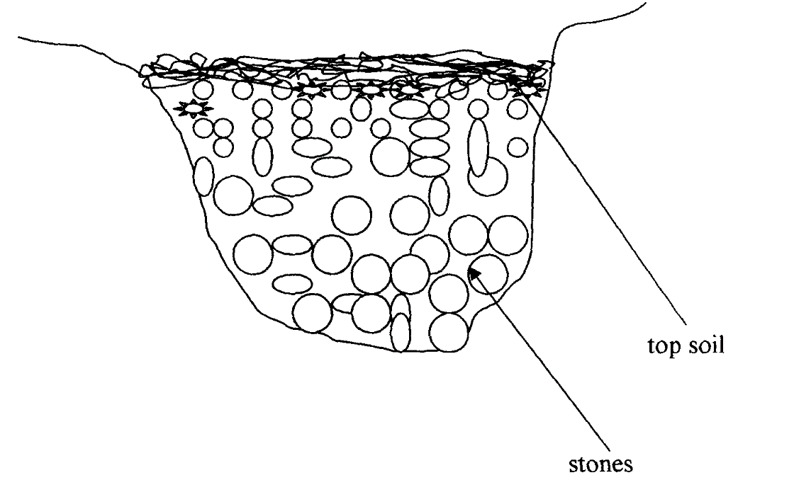
a)Identify the method of drainage above. (1mk)
………………………………………………………………………………………………………
b)State other two methods used to drain swampy areas. (2mks)
….…………………………………………………………………………………………………………………………………………………………………………………………………………………………………………………………………………………………………………………
- Give two importance of drainage. (2mks)
….…………………………………………………………………………………………………………………………………………………………………………………………………………………………………………………………………………………………………………………
SECTION C (40 marks)
- a)Describe eight methods used in water harvesting. (8 marks)
b) Describe four ways in which biotic factors influence agricultural production. (8 marks)
c) Describe the preparation of green manure. (4 marks)
23. a) Describe seven harmful effects of crop pests. (7 marks)
b) Describe eight safety measures a farmer should observe when using herbicides to control weeds. (8 marks)
c) Describe the harvesting of coffee. (5 marks)
24. a) Give five reasons why early defoliation is discouraged in pasture utilization. (5 marks)
b) Describe five characteristics of Nitrogenous fertilizer (5 marks)
c)State five disadvantages of communal land tenure system. (5 marks)
d)State five examples of variable inputs. (5 marks)

….………………………………………………………………………………………………………………………………………………………………………………………………………………………………………………………………………………………………………………………………………………………………………………………………………………………………………………………………………………………………………………………………………………………………………………………………………………………………………..….………………………………………………………………………………………………………………………………………………………………………………………………………………………………………………………………………………………………………………………………………………………………………………………………………………………………………………………………………………………………………………………………………………………………………………………………………………………………………..….………………………………………………………………………………………………………………………………………………………………………………………………………………………………………………………………………………………………………………………………………………………………………………………………………………………………………………………………………………………………………………………………………………………………………………………………………………………………………..….………………………………………………………………………………………………………………………………………………………………………………………………………………………………………………………………………………………………………………………………………………………………………………………………………………………………………………………………………………………………………………………………………………………………………………………………………………………………………..….………………………………………………………………………………………………………………………………………………………………………………………………………………………………………………………………………………………………………………………………………………………………………………………………………………………………………………………………………………………………………………………………………………………………………………………………………………………………………..
….………………………………………………………………………………………………………………………………………………………………………………………………………………………………………………………………………………………………………………………………………………………………………………………………………………………………………………………………………………………………………………………………………………………………………………………………………………………………..….………………………………………………………………………………………………………………………………………………………………………………………………………………………………………………………………………………………………………………………………………………………………………………………………………………………………………………………………………………………………………………………………………………………………………………………………………………………………………..
….………………………………………………………………………………………………………………………………………………………………………………………………………………………………………………………………………………………………………………………………………………………………………………………………………………………………………………………………………………………………………………………………………………………………………………………………………………………………………..….………………………………………………………………………………………………………………………………………………………………………………………………………………………………………………………………………………………………………………………………………………………………………………………………………………………………………………………………………………………………………………………………………………………………………………………………………………………………………..….………………………………………………………………………………………………………………………………………………………………………………………………………………………………………………………………………………………………………………………………………………………………………………………………………………………………………………………………………………………………………………………………………………………………………………………………………………………………………..
….………………………………………………………………………………………………………………………………………………………………………………………………………………………………………………………………………………………………………………………………………………………………………………………………………………………………………………………………………………………………………………………………………………………………………………………………………………………………………..
….………………………………………………………………………………………………………………………………………………………………………………………………………………………………………………………………………………………………………………………………………………………………………………………………………………………………………………………………………………………………………………………………………………………………………………………………………………………………………..….……………………………………………………………………………………………………………………………………………………………………………………………………………………………………………………………………………………………………………………………………………………………………………………………………………………………………………………………………………………………………………………………

