Gatundu joint marking scheme 2025
Agriculture paper 1
I. Name three aspects of rain fall that affects agriculture. (11/2 marks)
- Rainfall intensity
- Rainfall distribution/pattern
- Rainfall amount
- Rainfall reliability
- State four factors that determine the depth of cultivation. (2 marks)
  - The type of crop to be grown
  - Type of implement used
  - Soil moisture content
  - Presence of hard pans
  - Presence of underground obstacles
  - Type of soil
  - feed material eaten by the Animal

- State four factors that influence the quality of farmyard manure.(2 marks)
  - Species of the Animal
  - Type of bedding material/litter used
  - Method of storage
  - Age of the farm yard manure
  - Age of the Animal which produces the waste materials ➢ Type of animal
- State two factors that determine national income.(1 marks)
  - Per capita income
  - Gross domestic product
  - Gross national product
  - Household firm relationship
  - Natural resource endowment
  - Shifting cultivation
- State four causes of land fragmentation. (2 marks)
  - Inheritance of land
  - Population pressure leading to purchase of small scattered pieces.
  - Accumulation of land holdings by money lenders due to debtors failing to pay ➢ Settlement and resettlement
- Differentiate between apiculture and aquaculture
  - Apiculture – bee farming
Aquaculture – rearing fish in fish ponds. 1 mk

- State four ways in which crop pests are classified.(2 marks)
  - Field pests
  - Biting and chewing pests
  - Piercing and sucking pests
  - Rodents
  - Insect pests
  - Scientific classification
  - Stage of development
  - Stage of growth of the crop attacked

8.State four agricultural practices that pollute surface water sources.(2 marks)
  - Use of inorganic fertilizers
  - Use of excess pesticides
  - Over cultivation/ pulverisation of the soil
  - Over grazing
  - Cultivating along river banks
  - Watering animals directly in the surface water sources

- What is meant by the term production function? (1 marks)
  - It is the physical relationship between resource inputs and the corresponding output/product.
- State three financial documents (1½ marks)
- Invoice
- Receipts
- Purchase order
- Delivery note
- Statements
- Give four reasons why livestock farmers prepare silage. (2 marks
To distribute available forage throughout the year
To maximize the utilization of available land
To improve feed for the dry season
Excess forage can be sold

- State four reasons why agriculture is important to Kenya’s economy.(2 marks)
  - Source of food
  - Source of employment
  - Provision of raw materials for industries Provide market for industrial goods ➢ Source of income

13.State four ways in which mulching conserves water.(2 marks)
  - Prevents splash erosion/intercepts rain drops Reduces speed of surface run offs
  - Reduces evaporation
  - Increases water holding capacity
  - Improves water infiltration
14 Factors determining stage of crop harvesting:
- Intended use of the crop.
Chemical concentration of the produce / state of maturity / change in colour.
Prevailing weather conditions.
Market demand for the produce / market price (4x ½ mks)

15.State four characteristics of shifting cultivation.(2 marks)
    - Movement/shifting when soil loses its fertility
    - Practiced where land is plenty
    - Practicable with annual crops not with perennials
    - Agricultural output is low
    - Inputs such as pesticides, fungicides are rarely used
    - Simple hand tools are used
    - Land communally owned
    - Population is sparse
    - Low number of livestock per unit area

- Reasons why seed propagation is encouraged in crop production.
- Encourages variation hence hybrid vigour
- Easy to store and handle/ less bulky
- Easy to control pests and diseases
- (_{iv)} Planting can easily be mechanized
(_{v)} Seeds can be stored for long without losing viability. 4 x 2 marks
17. Factors that affect the quality of hay.
  - Stage of harvesting . leaf – stem ratio
  - Forage species
(_{iii)}Storage conditions
  - Weather conditions during drying/length of drying period.
  - Presence of foreign materials. 4 x marks

SECTION B
18.A) F Black jack (Biden Pilosa)
G stinging nettle (Urtica massaica)
  - E- poisons to livestock
F- contaminates wool and fur
  - it irritates farm workers
19.The diagram below shows a nursery practice carried out soon after tree seedlings have emerged.
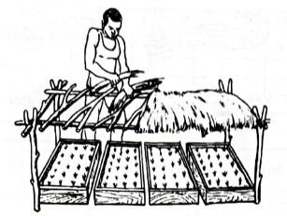
a. Identify the practice.(1 mark)
• Shading
b. Give two reasons for carrying out the above practice.(2 marks)
Protects seedlings from direct sunlight
Protects seedlings from heavy rainfall which damage seedlings
Prevents splash erosion
Conserves soil moisture/ reduces rate of water loss
c. State one precaution that should be observed in the practice illustrated in relation to the direction of the sun.(1 mark)
Should be laid along North/ South orientation
Should allow in sunlight early in the morning and later in the evening
d. Name the type of nursery bed illustrated.(1 mark)
• Raised nursery bed/ tree nursery/ containerized nursery

20.. Option I
(i) Urea
46kg N are in 100kg urea
60kg N are in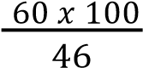
= 130.435kg Urea
1 ha = 130.435kg
10 ha = 130.435 x 10
= 1304.35kg Urea.

SSP
20kg P2O5 are in 100kg SSP.
20kg P2O5 are in 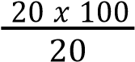
= 100kg SSP 1 ha = 100kg SSP
10ha = 100 𝑥 10
1
= 1000kg SSP

KCL
50kg K2O are in 100kg Kcl
30 K2O are in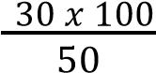
= 60kg Kcl
1 ha = 60kg Kcl
10 ha = 60 𝑥 10
1
= 600kg Kcl.

OPTION II
Urea
1 ha requires 60kg N
10 ha will require 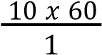
= 600kg N 46kg N are 100kg urea
600kg = 600 𝑥 100
46
= 1304.35kg Urea.

SSP
1 ha requires 20kg P2O5 10ha require 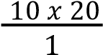
= 200kg P2O5
20kg are in 100kg SSP
200kg P2O5 are in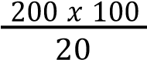
= 1000kg SSP

KCL
1 ha requires 30g K2O
10 ha requires 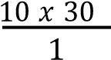
= 300kg K2O
50kg K2O are in 100kg Kcl
300 K2O are in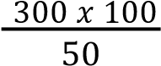
= 600kg Kcl.

(b)– Nitrate ions (NO3);
- Ammonium ions (NH4+)
- Study the diagram below then answer the questions that follow:
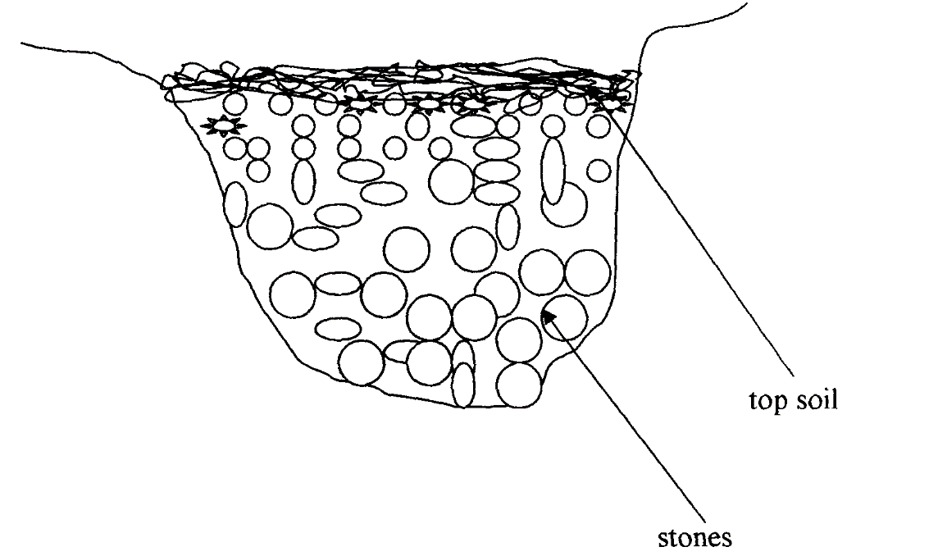
- Identify the method of drainage above. (1mk)
French drain
- State other two methods used to drain swampy areas. (2mks)
Cambered beds
Pumping
Open ditches
Planting trees
- Give two importance of drainage. (2mks)
Improve aeration
Raise soil temperature
Increase microbial activities
Remove toxic materials from soil
Reduce soil erosion

SECTION C
22.a)Describe eight methods used in water harvesting. (8 marks)
(i) – Uses of dams; These are barriers constructed across a river / valley to accumulate or hold water.
- Use of weirs; Barrier constructed across a river to raise the water level and allows water to flow over.
- Use of ponds; Natural / artificial depression which accumulates water.
- Roof catchments; Where rain water is collected from roof tops uwing gutters into tanks.
- Wells; These are holes dug into the ground below the water table where water collects.
- Rock catchment; This is a barrier constructed around a large rock where water collects and directed into a tank / reservoir.
- Micro catchment; These are ditches designed to concentrate run-off water around growing crops.
- Retention ditches / level terraces; These are trenches that accumulate surface run- off.
(1x8)
(b)) Describe nine ways in which biotic factors influence agricultural production. (8marks)
Pests -Feed on whole or parts of plants
IParasites-Suck blood from animals causing anemia
Decomposers-Act on plant and animal remains to form humus
Pathoengs-Some cause diseases
Predators-Some kill and feed on other animals
Pollinators-Some carry out cross pollination
Nitrogen fixing bacteria -Some fix nitrogen into the soil
(2x4)

c) Describe the preparation of green manure. (4 marks)

i) Plant the crop in the field
- Allow the crop to grow up to the flowering stage
- Plough the crop into the soil
- Allow the crop to decompose before planting
(1x4)

23. a) Describe seven harmful effects of crop pests. (7 marks)
- Transmit crop diseases
- - Feed on whole or parts of plants
- - Some unearth planted seeds
- - Deprive the plant of food by sucking sap
- - Lower the quality of flowers, fruits and berries
- - Eat growing points of plants causing stunted growth
- - Feed on whole or parts of seeds and lower germination percentage
- - Lower the yield expected
- Cause wilting of plants by feeding on the roots
- - Reduce the surface area for photosynthesis by feeding on leaves
- - Chemical pest control measures affect the environment (l) - Cause injuries that lead to secondary infection (m) - Increase the cost of production during control.
(1x7)
- Describe safety measures a farmer observe when using herbicides 8 marks
- Read and follow manufacturer’s instructions
  - Wear protective clothing
  - Avoid inhaling the herbicide/not spraying against the wind/wearing breathing masks/not smoking.
  - Avoid eating before bathing.
  - Bath thoroughly after handling herbicides.
  - Avoid blowing/sucking blocked nozzles.
  - Avoid contamination of animal feeds and water
  - Leftovers and empty containers should be properly disposed off and not thrown in gardens, bushes or pastures;
  - Equipment used should not be washed in water sources used by animals and humans.
  - Store the chemicals safely out of reach of children and away from food.
  - Thoroughly wash the equipment used. - Label the chemical containers well.
  - (1x8)
C describe harvesting of cofffe 4marks
– Ripe cherries are picked by hand.
  - Harvested cherries are spread on mats and sorted to remove unripe, diseased, dry and damaged berries
  - The diseased and overripe cherries are taken to factories as grade II.
  - Good quality cherries are taken to the factory as grade I.
  - Unripe, dry and overripe cherries are dried at home to form Buni.
  - Buni is taken to the factory at the end of the harvesting season.
  - Pick up at 7 – 14 days interval.
  - Deliver grade I & II to the factory same day.
24.give five reasons why early defoliation is discouraged 5 marks
(a) – High moisture content
- Low dry matter content
- Low crude protein content
- Low digestible nutrients
- Leads to gradual weakening of the forage stand.

- Describe five charactrersicts of Nitrogenous fertilizers 5 marks
- Highly soulble in water
- Easily leached
- Short residue effect
- Schorching effect
- Higly volatile
- Hygroscopic
- Higly corosive

C.disadavantages of communal land owenrship 5 marks
– Lacks incentive for land development - Low yields due to overstocking/overgrazing
  - Poor stock breeding programs/difficult to control breeding
  - Difficult to control pests, parasites and diseases
  - Soil erosion is common
  - Lowers the carrying capacity of the land.
  - Land cannot be used as security to credit.
  - Difficult to carry out sound farm planning.
  - No individual security on land ownership.
  - Encourage land disputes among family members.
D.state 5 examples of variable inputs 5 marks
- Amount of seed
- Amount of feeds
- Fertilizers
- Fuel
- Pestcides
- Livestock drug
- wages

