232/3
PHYSICS
(PRACTICAL)
FORM 4
MARCH/APRIL 2024
TIME 2 ½ Hours

Kenya Certificate of Secondary Education (KCSE)
MARKING SCHEME
QUESTION ONE
PART A
You are provided with the following
- Metre rule
- Knife edge
- 10 microscope slides
- A 50g mass
- A piece of cellotape
- A pair of vernier calipers
Proceed as follows
(a) Using the vernier calipers provided measure the length l and the width of the microscope slide
L=______7.60cm (1mk)
W=______2.43cm (1mk)
(b) Stack ten(10) slides together using a cellotape as shown below fig 1

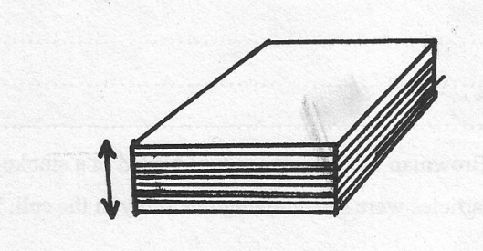
Figure 1
T
(i) Measure the thickness T of the stacked microscope slides. (1mk)
T=___1.31cm
(ii) Determine the volume v of the stack (2mk)
V=(LWT)
=___7.60x2.43x1.31 = 24.19cm³
(c) Balance the metre rule at its centre of gravity and maintain the position of the fulcrum on the centre of gravity throughout the experiment.
Place the 50g mass and the stack of slides as shown in figure 2 below

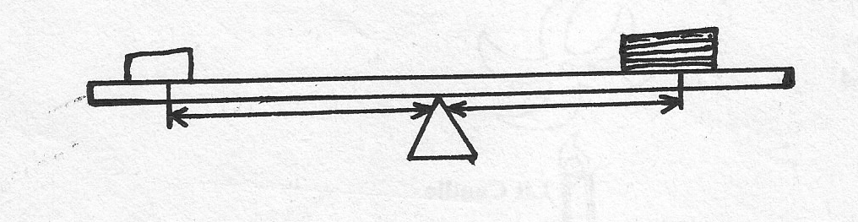
y
x
50g
Adjust the position of both the staked slides and the mass until the rule is again balanced make the distances x and y as large as possible
(i) x=___43.0cm (1mk)
y=_____35.0cm (1mk)

(ii) Calculate the mass ‘m’ in grams of the stick of slides given that (2mk)

M = 50x43/35 = 61.43
(iii) Determine the density of glass given that
Density = 61.43/24.19 = 2.54g/cm³ (2mk)

- PART B
You are provided with the following apparatus:
Resistance wire fitted on a millimeter scale labeled MN
Switch
Voltmeter
Ammeter
Two dry cells in a cell holder
Six connecting wires
Micrometer screw gauge
i. Set –up the apparatus as shown in the Figure 2 below;
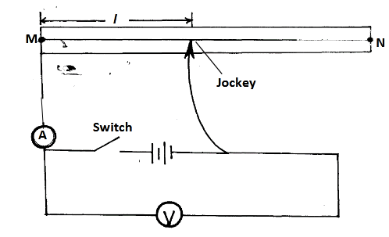
ii. Remove the crocodile clip from the resistance wire MN and close the switch. Record the voltmeter reading V0.
V0 =3.00+-0.02v ........................................ (1mark)
iii. Attach the Jockey to the resistance wire such that l = 50cm
iv. Record the voltmeter and ammeter readings as V1 and Z respectively
V1 =2.70+-0.20v.............................................. (1mark)
Z =0.17+-0.05A............................................. (1mark)
v. Determine the value of X given that (1mark)
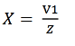
X=2.7/0.17
=15.88v/A
vi. Use the equation below to determine the value of k , where m = 2.549Ω (2marks)
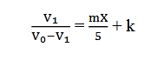
2.7/(3.0-2.7)=2.549x15.88/5 + k
K =0.9044
vii. Measure the diameter d of the of the wire on the millimeter scale using the micrometer
screw gauge
d =0.31+-0.03 ..............................mm =0.000031.....................................m (2marks)
viii. Determine the resistivity of the wire used in this experiment given that (2marks)
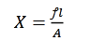
=15.88x3.142x0.00001555/50
= 1.552 x 10⁻⁵Ωm

Question 2
- You are provided with the following;
- A retort stand, boss and clamp.
- Test tube
- Piece of duplicating paper
- A thermometer
- A large beaker containing some water
- A tripod stand and wire gauze
- A cardboard with a hole in the middle
- A burner
- A rubber band
- A stop band
- A stop watch
Proceed as follows;
- Set up the apparatus as shown below.
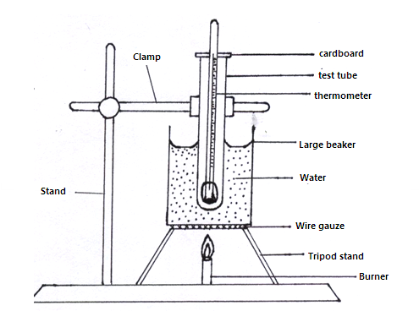
- Heat the water in the beaker provided and leave it to boil
- Wrap the given piece of duplicating paper round the bulb of the thermometer. Use rubber band to hold the paper in place.
- Place the thermometer inside in the dry test tube.
- Place the test tube in the water as shown in the diagram above. Make sure that the water does not enter the test tube. Leave the test tube in the boiling water until the thermometer indicates a steady temperature.
- Remove the thermometer and immediately start the stop watch.
- While holding the thermometer in air record the readings of the thermometer T₁ at intervals of 30seconds for 10 minutes.
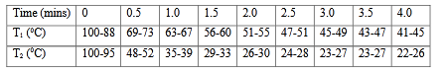
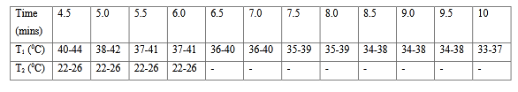 (10mrks)
- Place the wrapped thermometer directly into boiling water. Leave the thermometer in the boiling water until it indicates a steady temperature.

- Repeat procedure (f) and (g) and record the reading T₂ of the thermometer in the table at half minute intervals for 5minutes.
- Using the same axes on the grid provided, plot a graph of temperature (y-axis) against time for result obtained in (g) and (i) (label the graph T₁ and T₂)
(8mrks)
Axes labeled with units 1mrk
- Appropriate scale 1mrk
- Plotting
6 or more points 2mrks and 2mrks
3 - 5 1mrk and 1mrk
-Smooth curve through at least 6 correctly.
- Plotted points 1mrk and 1mrk
- From the graphs determine;
- For each graph the time for temperature to fall from 60⁰C to 40⁰C. (1mrk)
Reading from candidates graph 1/2mark.
- Accuracy (0.1 – 0.4) 1/2mark.
- Find the ratio of the two times in k (i) above (1mrk)
Reading from candidates graph 1/2mark.
- Accuracy (3.6-4.0) 1/2mark.

