NAME: …………………………………………. INDEX NO: ……………………………….

DATE : …………………………………..CANDIDATE’S SIGNATURE:…………………

MANGU HIGH SCHOOL TRIAL 4 MOCK 2025

Kenya Certificate of Secondary Education
Physics Paper 2
2 Hours

INSTRUCTIONS TO CANDIDATES:

- Write your name, school, admission number and index number is the spaces provided above.
- Sign and write the date of examination in the spaces above.
- Answer ALL the questions in section A and B in the spaces provided.
- All working MUST be clearly shown.
- Non-programmable silent electronic calculators and KNEC mathematical tables may be used.
- This paper consists of 12 pages.
- Candidates should check the question paper to ascertain that ALL the pages are printed and that no questions are missing.

FOR EXAMINER’S USE ONLY.

SECTION | QUESTIONS | MAX. SCORE | CANDIDATE’S SCORE
A | 1 -11 | 25
B | 12 | 8
B | 13 | 11
B | 14 | 13
B | 15 | 12
 | 16 | 11
 | TOTAL | 80

SECTION A (25MARKS)

- The figure below shows two rays drawn from an object on to the mirror.

Mirror
Object

Complete the ray diagram to show the position of the image. (2 marks)

- A small chain is often seen hanging at the back of a petrol carrying lorry. State and explain its significance. (2marks)
………………………………………………………………………………………………………………………………………………………………………………………………………………………………………………………………………………………………
- (a) Define diffraction with respect to waves. (1 mark)
………………………………………………………………………………………………………………………………………………………………………………………………………………………………………………………………………………………………
(b) The diagram below show consecutive wave fronts. If the waves are moving towards the barrier, draw the wave fronts as they appear after passing through the aperture. (2 marks)

Wave front
Barrier

- State what determines the carrying capacity of an accumulator. (1mark)

………………………………………………………………………………………………………………………………………………………………………………………………
- Sketch a displacement time graph of a wave of frequency 4HZ and amplititude 3.0cm over a time interval of 1.5 seconds (3mks)

……………………………………………………………………………………………………………………………………………………………………………………………………………………………………………………………………………………………………………………………………………………………………………………………....

- The figure below shows a set up used to study sound waves.
Metal plate
wire
cork
air
bottle

It is observed that when the bottle is shaken sound from the metal plates is heard. State and explain the observation that would be made if a little hot water is poured into the bottle and after sometime the cork is tightly replaced and the bottle shaken. (2 marks)

……………………………………………………………………………………………………………………………………………………………………………………………………………………………………………………………………………………………………………………………………………………………………………………………....

- The figure below shows a circuit diagram with cells in parallel. Each cell has e.m.f of 1.5V and internal resistance of 0.5Ω and the resistance of the bulb is 6Ω each. Determine the ammeter reading when the switch is closed. (3marks)

Bulb
A

Switch

……………………………………………………………………………………………………………………………………………………………………………………………………………………………………………………………………………………………………………………………………………………………………………………………....
- An alternating voltage of peak value 15v and frequency 25Hz is applied to the terminals of a Cathode ray oscilloscope. The Y-gain is set at 5 v/cm and the time base at 10 ms/cm. Draw the trace observed on the screen. (2 marks)
1cm
1cm

- Name all the radiations of the electromagnetic spectrum which have higher wavelengths than the visible light in their increasing wavelengths. (1 mark)

………………………………………………………………………………………………………………………………………………………………………………………………
- The figure below shows a diagram of circuit breaker .
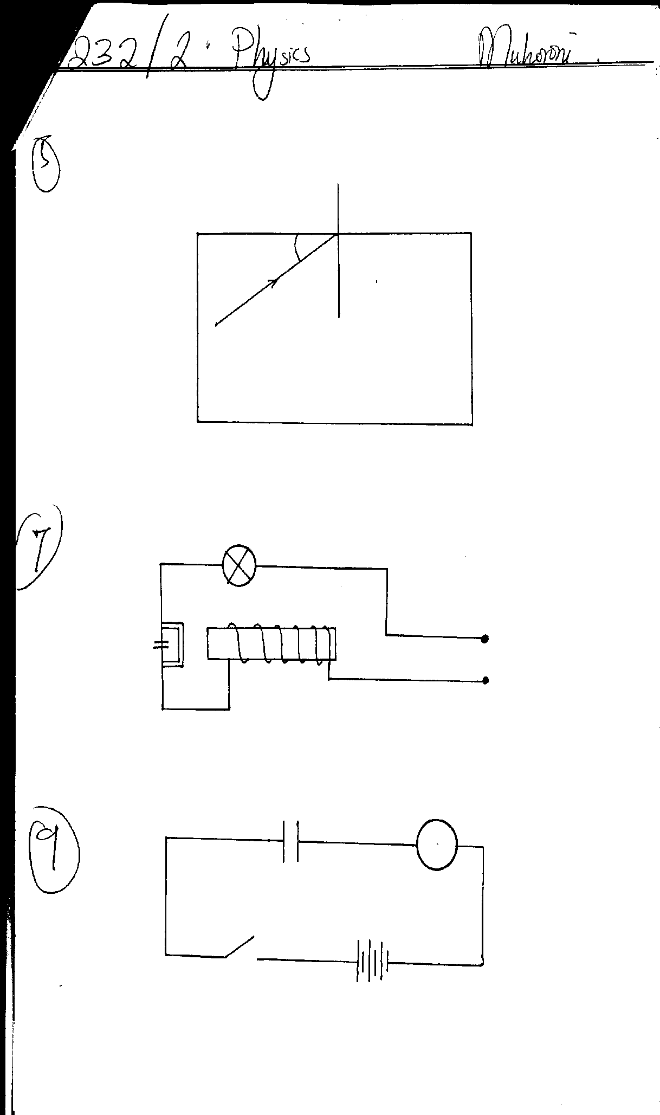
Switch
Input

Explain how it operates (3mks)
……………………………………………………………………………………………………………………………………………………………………………………………………………………………………………………………………………………………………………………………………………………………………………………………....

- A resistance wire is 2 m long and has a cross-sectional area of 0.50 mm². If its resistance is 2.6Ω, calculate its resistivity. (3 marks)

……………………………………………………………………………………………………………………………………………………………………………………………………………………………………………………………………………………………………………………………………………………………………………………………....

SECTION II (55MARKS)

- (a) The figure below shows a charged electroscope and two aluminum plates A and B arranged as shown
Earthing
A
B
d

State and explain the observations made on the leaf divergence when plate A is moved closer to B. (2 marks)

................................................................................................................................................................................................................................................................................................................................................................................................................................................................................................................................................................................................
- The figure below shows a circuit having the following components: a 20V p.d. source, a voltmeter, three switches S₁, S₂ and S₃ and two capacitors C₁ and C₂ of capacitances 13µF and 8µF respectively.

C₁
C₂
S₂
v
20 v
S₁
13µF
8µF
S₃

- Determine the charge on C₁ when switches s₂ and s₃ are closed while s₁ is open
(2 marks)
..............................................................................................................................................................................................................................................................................................................................................................................................................................

- After some time s₃ is opened and both s₁ and s₂ are closed. Find the maximum voltage,V, recorded by the voltmeter. (2 marks)

................................................................................................................................................................................................................................................................................................................................................................................................................................................
- Using the values obtained in (ii) above, calculate the energy stored in c₂. (2 marks)

................................................................................................................................................................................................................................................................................................................................................................................................................................................

- (a) Define refractive index. (1mk)

................................................................................................................................................................................................................................................................................................................................................................................................................................................................................................................................................................................................
(b) The critical angle of a certain material medium is 43.2º. Determine the refractive index of the material. (2mks)

................................................................................................................................................................................................................................................................................................................................................................................................................................................
c) A small bright object O lies at the bottom of a beaker containing water of depth h cm. A convex lens of focal length 15cm is held at the surface of water. The lens forms an image of O at 45cm from the surface of water.

Image

45cm

Lens

h

Object

Taking the refractive index of water to be 4/3, determine:
- the apparent depth of the object. (2mks)
............................................................................................................................................................................................................................................................................................................................................................................................................................................................................................................................................................................................
- the real depth h, of the object (2mks)
....................................................................................................................................................................................................................................................................................................................................................................................................................................................................................

(d). A ray of light is incident at right angles to the face AB, of a right angled isosceles prism of
Refractive index 1.6 as shown in the figure below.
Liquid
A C

Liquid Liquid

B
If the prism is surrounded by a liquid of refractive index 1.40, determine:

- The angle of incidence on the face BC. (1mk)
........................................................................................................................................
- The angle of refraction on the face BC. (3mks)
................................................................................................................................................................................................................................................................................................................................................................................................................................................
- (a) (i) What do you understand by the term accommodation? (1mk)

....................................................................................................................................................................................................................................................................................................................................................................................................................................................................................
(ii) An object is placed 40cm in front of a concave lens of focal length 20cm; determine the position of the image. (3mks)
....................................................................................................................................................................................................................................................................................................................................................................................................................................................................................
(b) The following graph shows the variation of image distance, v, with magnification, m, for a converging lens.
Image distance,V(cm)
10
Magnification, M
4
2
3
1
40
30
20

Using the graph and the equation $\frac{V}{f}=M+1$ to determine:
- The object position when the image position is 45cm. (3marks)
....................................................................................................................................................................................................................................................................................
..........................................................................................................................................
- The focal length of the lens. (1 mark)
....................................................................................................................................................................................................................................................................................
- The power of the lens. (2 marks)

..............................................................................................................................................................................................................................................................................................................................................................................................................................
(c) The following figure below shows an eye defect

Name the defect and show on the same diagram how the defect could be corrected.
(3 marks)
................................................................................................................................................
- a) What do you understand by the term mutual induction? (1 mark).
...............................................................................................................................................................................................................................................................................................................................................................................................................................................
b) State two factors that determine magnitude of e.m.f induced in a coil. (2 marks).
................................................................................................................................................................................................................................................................................................
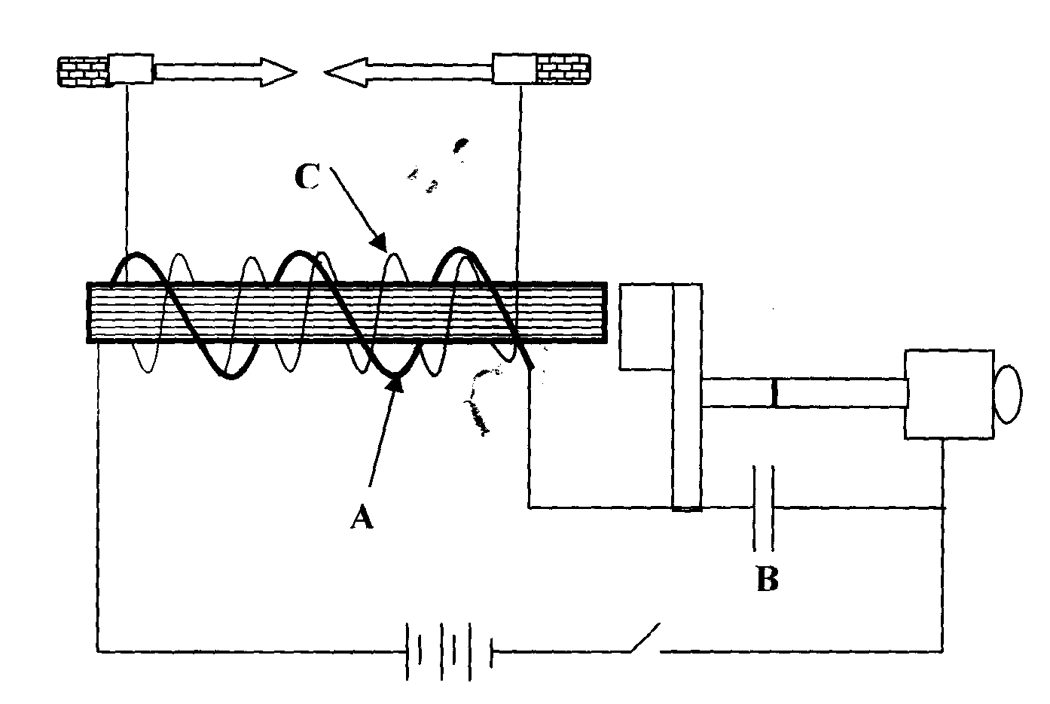
c) The diagram below shows an induction coil used to produce sparks.
armature
contact

(i) Name parts labeled A and B. (2marks)
.......................................................................................................................................................................................................................................................................................................................
(ii) Briefly explain how the induction coil works. (3 marks)
............................................................................................................................................................................................................................................................................................................................................................................................................................................................................................................................................................................................................................................................................................................................................................................................................

b) A transformer has 800 turns in the primary and 40 turns in the secondary winding.
The alternating e.m.f connected to the primary is 240V and the current is 0.5A.
- Determine
I the secondary e.m.f (2marks)

................................................................................................................................................................................................................................................................................................................................................................................................................................................................................................................................................................................................................................................

II the power in the secondary if the transformer is 95% efficient. (2mks)

................................................................................................................................................................................................................................................................................................................................................................................................................................................................................................................................................................................................................................................

- a) The mains electricity is transmitted at high voltages. State two dangers of this high voltage transmission. (2marks)

........................................................................................................................................................................................................................................................................................................................

b) What is a fuse? (1mark)
....................................................................................................................................................................................................................................................................................................................................................................................................................................................................................

c) The figure shows a section of a domestic wiring.

N bulbs

L

Fuse

- Identify two serious mistakes in the circuit. (2marks)

....................................................................................................................................................................................................................................................................................................................................................................................................................................................................................

- Explain why the circuits in domestic wiring should be connected in parallel with the main supply. (1mark)

........................................................................................................................................................................................................................................................................................................................
- Mrs. Sitima has two 2.5KW electric heater, 2.0KW electric stove, two 60W electric bulbs, 500W electric fan and 1.0Kw electric pressing box. Her power supply is 240V and main fuse 30A.
- Can she connect all the appliances to her power supply at the same time?(2marks)

................................................................................................................................................................................................................................................................................................................................................................................................................................................ II) If the cost of electricity is Ksh.6.50 per unit, calculate the cost of using electric stove and electric pressing box for 3 hours a day in the month of June. (3marks)
....................................................................................................................................................................................................................................................................................................................................................................................................................................................................................

THIS THE LAST PRINTED PAGE

