

MARANDA HIGH SCHOOL
Kenya Certificate of Secondary Education
THE MOCK EXAMINATIONS, 2025

CONFIDENTIAL

MARKING SCHEME

1. (a) What is lunar eclipse?
- Shadow of the earth cast on the moon surface when the earth lies between the sun and the moon during revolution of the earth. 1×2 = 2 marks

(b) Describe how rotation of the earth causes deflection of ocean currents.
- Force or rotation/Coriolis force deflects winds along the surface of the earth to the right and to the left of their path in the northen and the southern hemispheres respectively. Wind causes a frictional drag on the ocean surface as it moves. Ocean currents are started/ driven and deflected by the frictional drag. 3×1 = 3 marks

2. (a) The diagram below represents a rock cycle. Use it to answer question (a) (i) and (ii).
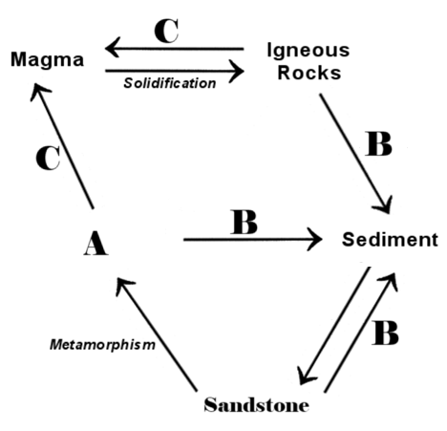
- Give the name of the rock labelled A.
Quartzite/slate. 1×1 = 1 mark
- Name the processes labelled B and C.
B – Weathering/Erosion. 1×1 = 1 mark
C – Melting 1×1 = 1 mark
(b) State the weaknesses of relative dating as a method of determining the age of a rock.
- The actual age of the rocks is not mentioned
- Folded areas may have older rocks overlying younger rock leading to wrong dating.
2×1 = 2 marks

3. (a) Define the term mass wasting.
- Displacement/ Movement of weathered materials downslopes under the influence of gravity
1×2 = 2 marks
(b) Give three characteristics of mud flows that can be used to distinguish it from earth flows
- Mud flows are faster than earth flows
- Mud flows have higher water content than earth flows
- Mud flows occur on steeper slopes than earth flows
- Mud flows involve movement of large volumes of unconsolidated materials than earth flows.
2×1 = 2 mark

4. (a) Name two crater lakes in Kenya.
- Lake Chala.
- Lake Sonanchi.
- Central Island Crater lakes/ Crocodile Lake/ Flamingo Lake/ Tilapia Lake
- Lake Simbi.
- Lake Paradise.
2×1 = 2 marks

(b) State three factors determining the permanence of a Lake.
- Availability of water drained into the basin from the sources.
- Nature of the underlying rocks – non-porous rocks limit water loss through seepage.
- Rate of evaporation: - In areas experiencing high temperatures, much water is lost through evaporation and lakes may become seasonal.
- Human activities such as diversion of water for irrigation influence a lake’s permanence.
3×1 = 3 marks

5. (a) Give three conditions necessary for formation of fog.
- There must be clear sky/absence of clouds to permit free terrestrial radiation.
- There must be sufficient moisture in the air/high humidity/saturated air
- The air must be cooled below the dew point to allow condensation.
- The wind must be calm/light.
- Presence of abundant condensation nuclei. 3×1 = 3 marks

(b) A given mass of air at 30ºC can hold 24g/m³ of water vapour when saturated. Calculate the relative humidity of air at the same temperature if it contains only 6g/m³ of water vapour.
Relative Humidity = $\frac{6}{24}×100\%=25\%$
2×1 = 2 marks
SECTION B
6. You have been provided with the map of Meru (108/3). Use it to answer question 6.
(a) (i) Give two indices to adjoining sheets to the western part of Meru map.
- Engare Ondare 107/2
- Marania 107/4
- Mount Kenya 121/2 2×1 = 2 marks

(ii) State three evidences that show that the map of Meru is a topographical map.
- Has/ 1:50000/ shows fine details of a small place/area
- Presence of grid reference system/lines
- Use of contours/trigonometrical stations to represent relief/Depicts physical features
- Has marginal information. 3×1 = 3 marks

(iii) Measure the length of Nanyuki – Isiolo road (A2). Give your answer in kilometers.
9km ± 0.1km 1×2 = 2 marks
(iv) What is the magnetic bearing of the Air photo principal point 59 (grid reference 4520) from the Air photo principal point 025 (grid reference 3826).
True/grid bearing = 130º Magnetic variation = 7/
Magnetic bearing = 130º – 7/
= 129º 53/ 3×1 = 3 marks
(b) Citing evidence from the map, identify two social services offered in Meru municipality.
- Administration – DO/DC
- Security – Police post
- Rehabilitation – Prison
- Health/Medical care – Hospital
- Education – Meru/ Kaaga school/ Meru technical institution/Kenya Methodist University
- Recreation – Stadium
- Residential services – Settlements/ National housing. 4×1 = 4 marks

(c) (i) Draw a rectangle measuring 12cm by 8cm to represent the area bound between eastings 45 and 48 and northings 21 and 23 on Meru map.
(ii) On the rectangle mark and name:
    - Ol Doinyo Sabu (Ndunyu Sabu) hill
    - River Kamarai
    - Loose surface road
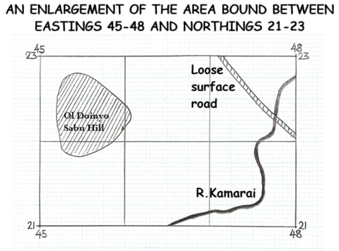
Title – 1 mark
Rectangle – 1 mark
Features – 3 x 1 = 3 marks

(d) Describe the drainage of the area covered by Meru map.
- Meru is drained by many permanent rivers e.g R. Kathita/R. Marania/ R. Kamari
- Rivers exhibit dendritic drainage patterns with their tributaries.
- Presence of seasonal rivers
- The main river is river Kathita
- Rivers in the South eastern part have several meanders
- Most rivers flow from south western direction/ Mount Kenya Forest to the northern/eastern parts
- Presence of a lake i.e Sacred lake.
- The area is also drained by seasonal swamps. 6×1 = 6 marks

- (a) (i) What is a tsunami?
- Strong ocean waves formed when earthquakes occur on the ocean bed. 1×2 = 2 marks
(ii) Give two types of surface longitudinal waves.
- Love waves
- Rayleigh waves 2×1 = 2 marks

(b) Explain the following causes of earthquakes.
(i) Vulcanicity
- Sudden displacement of crustal rock during volcanicity causes earthquake/ earth tremors.
- Voids created within the crust during volcanic eruptions may make the overlying rocks to sink/subside due to gravity causing the vibrations within crustal rocks.
- Violent volcanic explosions and emission of volcanic gases can shake or shatter rocks causing seismic waves. 1×2 = 2 marks

(ii) Energy release in the mantle
- Radioactivity in the mantle releases excessive energy which sends shock waves into the crust shaking the rocks. 1×2 = 2 marks

(iii) Construction of water reservoirs
- Weight of the water in the reservoirs exerts great pressure on the rocks beneath reactivating pre-existing faults causing earthquakes. 1×2 = 2 marks

(c) (i) Give two intrusive features of vulcanicity.
- Sill
- Dykes
- Laccoliths
- Batholiths
- Lopoliths
- Phacoliths 2×1 = 2 marks

(ii) Describe how the following features are formed.
- Geysers
- Earth movements cause of cracks or fissures.
- Rain water sinks/percolates into the crust and comes into contact with hot rocks
- The water becomes superheated and some of it turns into steam
- When high pressure is reached, hot water and steam is forced into upper layers of the crust
- Hot water and steam shoot out explosively as a geyser. 3×1 = 3 marks

- Lava plateau
- Earth movement causes cracks on the crustal rocks.
- Fluid magma is brought to the surface through a number of fissures/cracks/vents
- Due to low viscosity/basic lava spreads over a long distance before cooling and solidifying evenly covering hills and depressions
- Successive eruptions lead to more layers of lava building up thick plain/table land called lava plateau. 4×1 = 4 marks

(d) Explain the negative effects of vulcanicity.
- Lava flows can lead to loss of lives.
- Lava flows can also lead and damage to property
- Volcanic mountains act as barriers to transport and communication
- Leeward side of volcanic mountains receive less rainfall discouraging farming and settlement
- Rugged nature of some volcanic landscapes makes it difficult for agriculture and settlement. 3×2 = 6 marks

- (a) (i) Define semi-natural vegetation.
- Plant cover which grows/recovers after interference/destruction by humans or animals.
1×2 = 2 marks
(ii) Give three processes of vegetation growth influenced by temperature.
- Germination
- Flowering
- Ripening
- Shedding of leaves. 3×1 = 3 marks

(b) (i) A part from forests, identify two other vegetation regions of Kenya.
- Savanna vegetation/Savanna grassland vegetation/Savanna woodland vegetation
- Scrub and desert vegetation/ Arid and semi-arid vegetation.
- Heath and moorland vegetation.
- Swamp vegetation. 2×1 = 2 marks

(ii) State three human factors causing decline of forests in Kenya.
- Overexploitation of some tree species
- Government policy of degazetting some forests
- Forest fires induced by human beings
- Human activities such as settlement/agriculture/charcoal burning/logging. 3×1 = 3 marks

(c) The map below shows vegetation zones of the world.
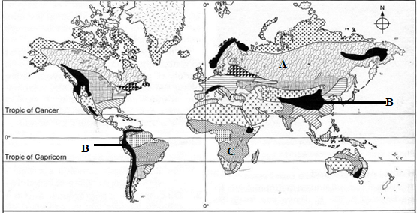
(i) Identify the zones marked A, B and C.
- A – coniferous forest
- B – mountain vegetation
- C – tropical grassland. 3×1 = 3 marks

(ii) Explain three adaptations of the tropical desert vegetation.
- Some plants like acacia have long tap roots to reach the water table
- Some trees like baobab store water in their fleshy stems
- Some trees have small and thorny leaves/few leaves to reduce water loss through transpiration
- Some plants have stomata that close during the day and open at night to reduce water loss
- Most vegetation exists in dormant state/shed their leaves during dry season and sprout when rain falls. 3×2 = 6 marks

(d) Explain three significance of vegetation to agricultural activities.
- Vegetation provide food for livestock
- Leaves from vegetation decompose to form humus which add nutrients to the soil for crop growing
- Vegetation harbours insects and pests which may spread diseases to livestock and crops
- Vegetation controls the rate of soil erosion and encourages rain water to sink supporting crop and livestock production. 3×2 = 6 marks

- (a) (i) Identify two types of springs.
- Permanent
- Intermittent/seasonal. 2×1 = 2 marks

(ii) Give three factors which influence the occurrence of ground water.
- Slope of land
- Nature of rocks
- Precipitation
- Level of ground saturation. 3×1 = 3 marks

(b) The diagram below shows different types of wells.
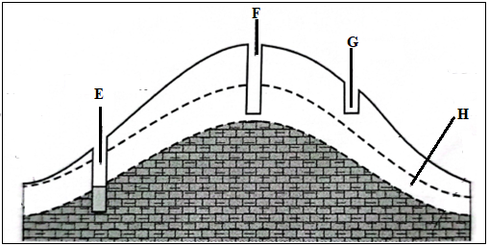
(i) Name the parts labelled G and H.
- G – dry well
- H – intermittent saturation zone. 2×1 = 2 marks

(ii) Identify the ideal well for a semi-arid area.
- E. 1×1 = 1 mark

(c) Describe how the following features are formed in a limestone region.
(i) Grikes and Clints
- Rainwater absorbs CO₂ to form weak carbonic acid
- Carbonic acid reacts with calcium carbonate in limestone to form hydrogen carbonate which is soluble in water
- Water enters the rocks through the joints and enlarges them to form deep gullies called grikes
- The gullies are separated by ridges called clints. 4×1 = 4 marks

(ii) Dolina
- Rainwater absorbs CO₂ to form weak carbonic acid
- Weak carbonic acid reacts with calcium carbonate in the joints on the surface to form small hollows
- The hollows are widened by solution process
- Solution continuous until the blocks of rocks between the hollows are completely dissolved
- The hollows merge to produce a large depression called a dolina. 5×1 = 5 marks

(d) Members of your class are planning to conduct a field study in a karst region.
(i) State two reasons why you would need a map of the area of study.
- To identify the direction
- To locate the features for study
- To estimate the budget for the study. 2×1 = 2 marks

(ii) Give three methods you’re likely to use to record data during the study.
- Photographing
- Taking notes
- Filling in questionnaires
- Field sketching. 3×1 = 3 marks

(iii) Identify three factors that would limit the field work activity in the area.
- Rocky and rugged surface hindering movement
- Hot conditions causing fatigue
- Low population hindering data collection. 3×1 = 3 marks

- (a) (i) Define the term leaching.
- This is the removal (by rainwater) of the soluble mineral matter in solution from the upper horizon of the soil to lower horizons of the soil. 1×2 = 2 marks

(ii) State two factors that contribute to the leaching of soils.
- Nature/texture of the soil/texture or solubility of minerals
- High rainfall in the rain season
- Topography of the area. 2×1 = 2 marks

(b) (i) Give three factors influencing soil formation.
- Parent rock
- Climate
- Relief
- Living organisms 3×1 = 3 marks

(ii) State three importance of soil texture.
- Determines the soil water content
- Controls the amount and rate of leaching
- Determines the extent of soil aeration
- Influences the plant root penetration 3×1 = 3 marks

(c) (i) Identify three causes of chemical degeneration in soils.
- Excessive or wrong application of fertilizers
- Monoculture
- Overcropping
- Leaching/excessive irrigation 3×1 = 3 marks

(ii) State four advantages of mulching.
- Reduces rate of evaporation from the soil
- Protects the soil from erosion
- Increases the humus content of the soil
- Increases moisture retention capacity of the soil
- The mulch provides suitable habitat for burrowing animals which improve soil texture and porosity 4×1 = 4 marks

(d) Explain the effects of soil erosion on water sources.
- Siltation of reservoirs which reduces the volume of water
- Accumulation of soils in the water reservoirs makes them shallow allowing plants to colonize them turning into swamps
- Accumulation of soils into the rivers makes them shallow causing frequent flooding
- Siltation caused by deposition of eroded soil onto the river bed may make the river shallow hence unsuitable for navigation
- Accumulation of eroded soils on the river bed may block the river forming a lake on the upstream side of the barrier. 4×2 = 8 marks

THIS IS THE LAST PRINTED PAGE

