NAME: …………………………………………. INDEX NO: ……………………………….

DATE : …………………………………..CANDIDATE’S SIGNATURE:…………………

MANGU HIGH SCHOOL TRIAL 4 MOCK 2025

233/2
CHEMISTRY
PAPER 2
TIME: 2 HOURS

Kenya Certificate of Secondary Education (K.C.S.E.)
FORM FOUR
INSTRUCTIONS TO THE CANDIDATES:
- Write your name and admission number in the spaces provided above
- Sign and write the date of examination in the spaces provided.
- Answer all the questions in the spaces provided.
- All working must be clearly shown where necessary.
- Mathematical tables and electronic calculators can be used.

For Examiners Use Only

Question | Maximum score | Candidate’s score
1 | 13
2 | 9
3 | 12
4 | 13
5 | 10
6 | 10
7 | 13
Total | 80

1 [a] The diagram below shows a set-up used to separate solid K and liquid R
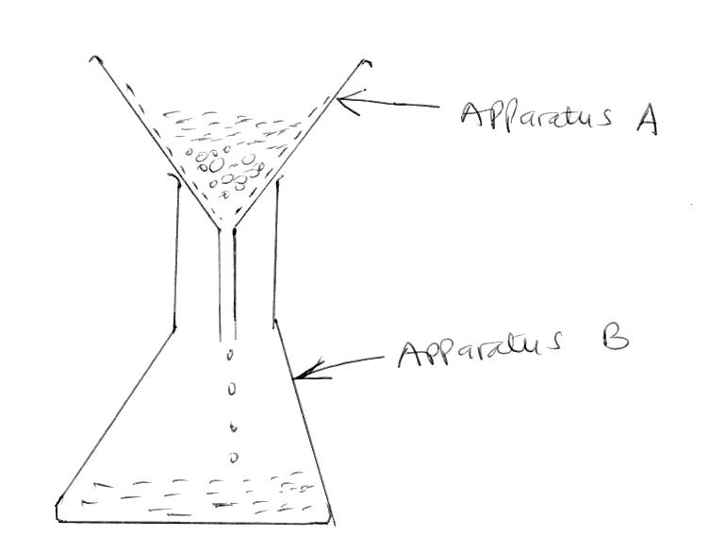

[i] What name is given to the method of separation shown above [1mk]
…………………………………………………………………………………………………………………
…………………………………………………………………………………………………………………
[ii] What physical property of solid K makes it possible to separate from the mixture as shown above [1mk]
…………………………………………………………………………………………………………………
…………………………………………………………………………………………………………………
[iii] State one example of a mixture that can be separated as shown above [2mks]
…………………………………………………………………………………………………………………
…………………………………………………………………………………………………………………
…………………………………………………………………………………………………………………
[iv] Name one other method that can be used to separate the mixture of K and L [1mk]
…………………………………………………………………………………………………………………
……………………………………………………………………………………………………………………………………………………………………………………………………………………………………
[vi] Identify apparatus A and B [2mks]
……………………………………………………………………………………………………………………………………………………………………………………………………………………………………
…………………………………………………………………………………………………………………
[vi] State two other possible uses of apparatus A, other than the one shown on the diagram
[2mks]
…………………………………………………………………………………………………………………
…………………………………………………………………………………………………………………
…………………………………………………………………………………………………………………
[b] The diagram below shows part of a set-up used to investigate the effect of heating copper(II) sulphate crystals
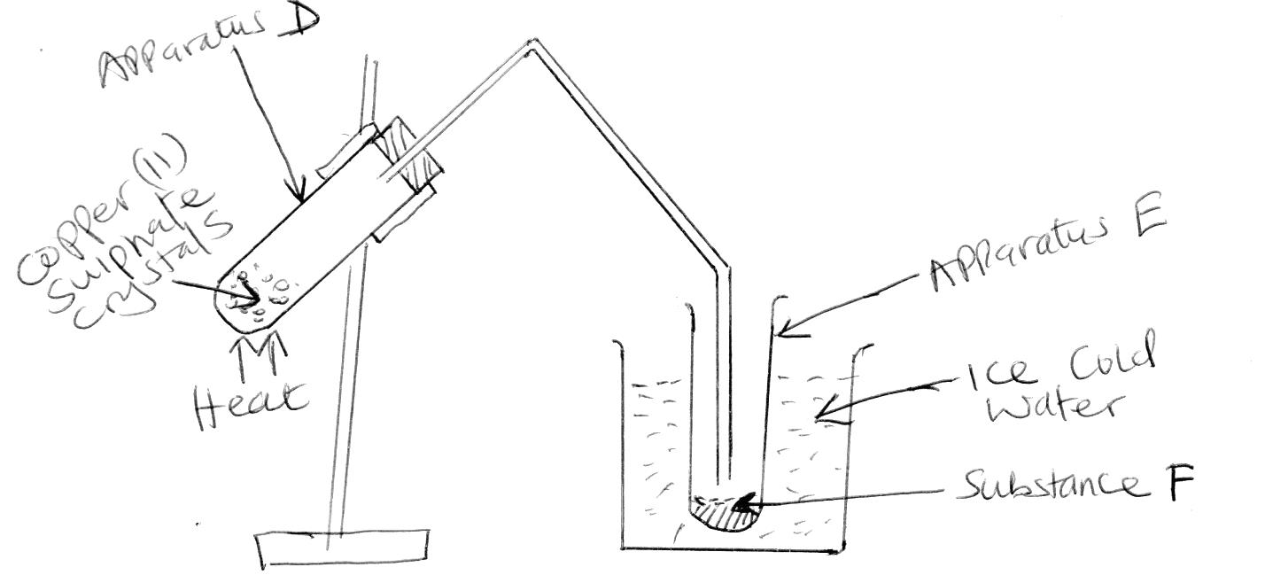

[i] State two likely observations made in apparatus D [2mks]
…………………………………………………………………………………………………………………
…………………………………………………………………………………………………………………
…………………………………………………………………………………………………………………
[ii] Identify substance F [1mk]
…………………………………………………………………………………………………………………
…………………………………………………………………………………………………………………
[iii] Was the change undergone by the copper {II} sulphate crystals temporary chemical change or permanent chemical change? Explain your answer [2mks]
…………………………………………………………………………………………………………………
…………………………………………………………………………………………………………………
…………………………………………………………………………………………………………………
…………………………………………………………………………………………………………………
2. In an experiment to determine the enthalpy of displacement when zinc is heated with copper (II)Sulphate, excess zinc powder was added to 125cm³ of 0.75M copper {II} Sulphate solution in a beaker. The temperature of the mixture changed from 24⁰Cto 29⁰C. Assuming that the density of the solution was 1g/cm³ and its specific heat capacity was 4.2KJK⁻¹K
[a] Write a chemical equation of the reaction that occurred [1mk]
…………………………………………………………………………………………………………………
…………………………………………………………………………………………………………………
[b] Why was it necessary to use excess zinc powder [1mk]
…………………………………………………………………………………………………………………
…………………………………………………………………………………………………………………
[c] State and explain one observation made by the end of the experiment [2mks]
…………………………………………………………………………………………………………………
…………………………………………………………………………………………………………………
[d] Determine the enthalpy change in the reaction that occurred [3mks]
…………………………………………………………………………………………………………………
…………………………………………………………………………………………………………………
…………………………………………………………………………………………………………………
…………………………………………………………………………………………………………………
[e] Determine the molar enthalpy of displacement of copper (II) ions by zinc [3mks]
…………………………………………………………………………………………………………………
…………………………………………………………………………………………………………………
…………………………………………………………………………………………………………………
…………………………………………………………………………………………………………………
[f] Represent the reaction on an energy level diagram [2mks]
…………………………………………………………………………………………………………………
…………………………………………………………………………………………………………………
…………………………………………………………………………………………………………………
…………………………………………………………………………………………………………………
…………………………………………………………………………………………………………………
…………………………………………………………………………………………………………………
…………………………………………………………………………………………………………………
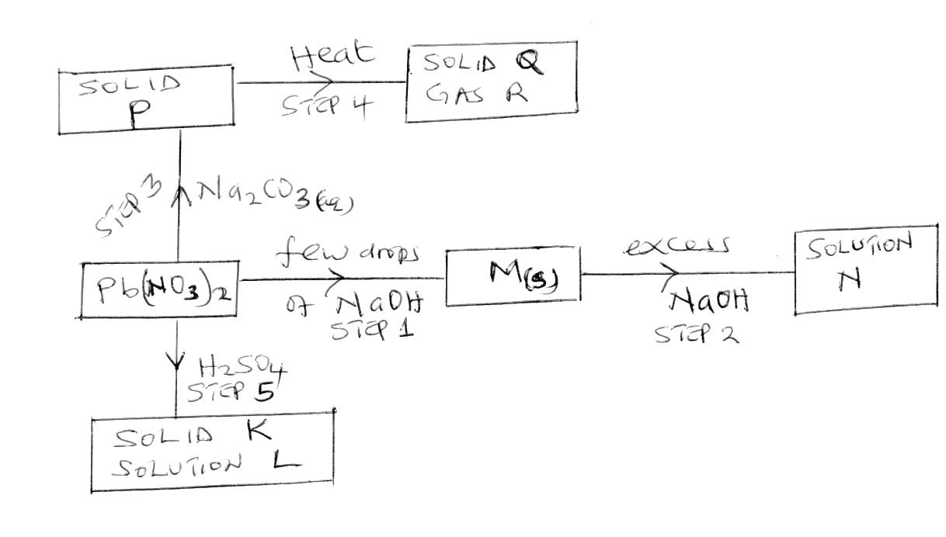
3. (i) Study the diagram below and answer the questions that follow;

[a] Identify the following [4mks]
[i] Substance M
…………………………………………………………………………………………………………………
[ii] Solid P
…………………………………………………………………………………………………………………
[iii] Gas R
…………………………………………………………………………………………………………………
[Iv] Solution L
…………………………………………………………………………………………………………………
[b] Write the ionic equation of the reaction occurring at step
[i]Step 2 [1mk]
…………………………………………………………………………………………………………………
[ii]Step 3
…………………………………………………………………………………………………………………

[c] State the observation made when ammonia solution is added to lead {II} nitrate solution drop wise till excess [2mks]
…………………………………………………………………………………………………………………
…………………………………………………………………………………………………………………
…………………………………………………………………………………………………………………
[ii] The equation below shows a reversible reaction
H₃O⁺_{(aq)} + HSO⁴⁻ _{(aq)} H₂O_{[l]} + H₂SO_{4[aq]}

[a] Identify the acid in the fowards reaction [1mk]
…………………………………………………………………………………………………………………
…………………………………………………………………………………………………………………
[b] Identify the base in the reverse reaction [1mk]
…………………………………………………………………………………………………………………
…………………………………………………………………………………………………………………
…………………………………………………………………………………………………………………

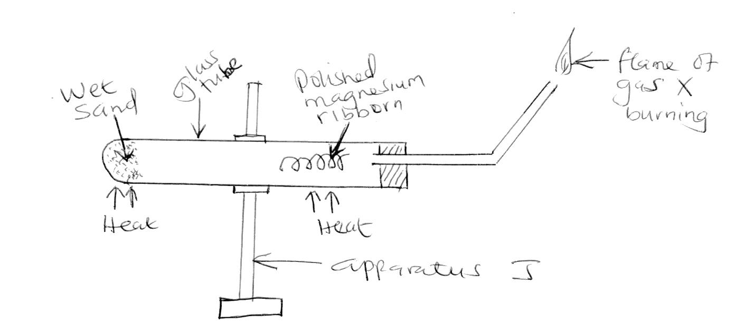
4. The diagram below shows a set-up used to investigate the reaction of magnesium and steam

[a] Identify gas X [1mk]
…………………………………………………………………………………………………………………
…………………………………………………………………………………………………………………
[b] Write a chemical equation of the reaction;
[i] Occurring in the glass tube [1mk]
…………………………………………………………………………………………………………………
…………………………………………………………………………………………………………………

[ii] Leading to the flame of the burning gas X [1mk]
…………………………………………………………………………………………………………………
…………………………………………………………………………………………………………………
[c] Explain why it was necessary to;
[i] Polish the magnesium ribbon [1mk]
…………………………………………………………………………………………………………………
…………………………………………………………………………………………………………………
[ii] Heat the wet sand before heating the magnesium ribbon [1mk]
…………………………………………………………………………………………………………………
…………………………………………………………………………………………………………………
[d] Identify apparatus J [1mk]
…………………………………………………………………………………………………………………
…………………………………………………………………………………………………………………
[e] How does the mass of the magnesium compare before and after the experiment. Explain.
[2mks]
…………………………………………………………………………………………………………………
…………………………………………………………………………………………………………………
[f] State two physical properties of gas X [2mks]
…………………………………………………………………………………………………………………
…………………………………………………………………………………………………………………
[g] State two uses of gas X [2mks]
…………………………………………………………………………………………………………………
…………………………………………………………………………………………………………………
[h] State the role of the wet sand [1mk]
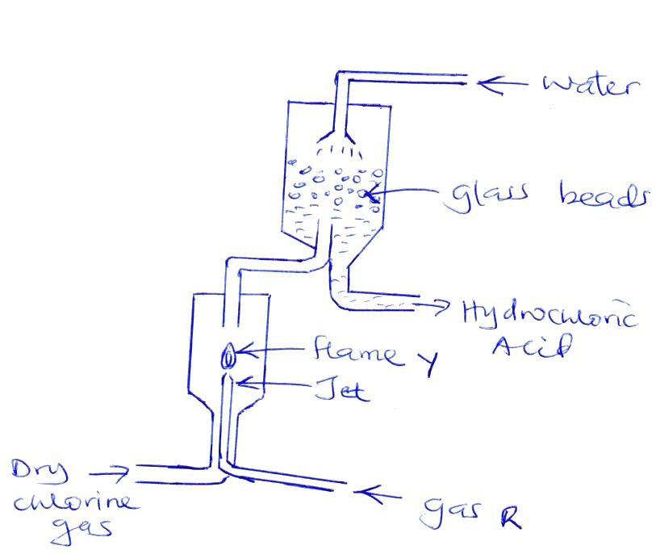
…………………………………………………………………………………………………………………
5. The diagram below shows a flow chart representing process used in the industrial manufacture of hydrochloric acid

[a] Identify gas R [1mk]
…………………………………………………………………………………………………………………
[b] Write a chemical equation for the reaction between gas R and chlorine gas [1mk]
…………………………………………………………………………………………………………………
……………………………………………………………………………………………………………………………………………………………………………………………………………………………………
[c] State one possible role of the glass beads [1mk]
…………………………………………………………………………………………………………………
…………………………………………………………………………………………………………………
[d] State one possible source of;
[i] Gas R [1mk]
…………………………………………………………………………………………………………………
…………………………………………………………………………………………………………………
[ii] Chlorine gas [1mk]
…………………………………………………………………………………………………………………
…………………………………………………………………………………………………………………
[e] Explain why it’s necessary to allow only small amount of gas R to burn in excess chlorine gas in the above process [1mk]
…………………………………………………………………………………………………………………
…………………………………………………………………………………………………………………
…………………………………………………………………………………………………………………
[f] State two uses of hydrochloric acid [2mks]
…………………………………………………………………………………………………………………
…………………………………………………………………………………………………………………
…………………………………………………………………………………………………………………
[g] Describe a confirmatory test for hydrogen chloride gas [2mks]
…………………………………………………………………………………………………………………
…………………………………………………………………………………………………………………
…………………………………………………………………………………………………………………
…………………………………………………………………………………………………………………
…………………………………………………………………………………………………………………
6 [a] Name the following hydrocarbon [3mks]
[i] CH₃CH₂CH₃
…………………………………………………………………………………………………………………
[ii] CH₃CHCHCH₃
…………………………………………………………………………………………………………………
[iii] CH₃CHCHCH₂CH₂Br
…………………………………………………………………………………………………………………
[b] Study the reaction below;
CH₂CH₂ + HBr substance T

[i] Name substance T [1mk]
……………………………………………………………………………………………………………………………………………………………………………………………………………………………………
[ii] Draw the structural formulae of substance T [1mk]

[iii] Draw the structural formulae and name the compound that would be formed if chlorine gas was used in place of HBr [1mk]

[c] State one domestic use of ethane [1mk]
……………………………………………………………………………………………………………………………………………………………………………………………………………………………………
[d] State two natural sources of alkanes [2mks]
………………………………………………………………………………………………………………………………………………………………………………………………………………………………………………………………………………………………………………………………………………………
7. The grid below show a section of the periodic table. The letters are not the actual chemical symbols
A |  |  | B |  | C |  | D
 | E |  | F |  |  | G | H | J
K | L
[a] Which letter represents the
[i] Most reactive non metal. Explain your answer [2mks]
……………………………………………………………………………………………………………………………………………………………………………………………………………………………………
[ii] Most reactive metal. Explain your answer [2mks]
………………………………………………………………………………………………………………………………………………………………………………………………………………………………………………………………………………………………………………………………………………………
[b] What name is given to the family into which element E belongs [1mk]
……………………………………………………………………………………………………………………………………………………………………………………………………………………………………
[c] Write the formulae of the compound formed between
[i] F and G [1mk]
……………………………………………………………………………………………………………………………………………………………………………………………………………………………………
[ii] K and oxygen [1mk]
……………………………………………………………………………………………………………………………………………………………………………………………………………………………………
[d] How does the atomic radius of F and G compare? Explain [2mks]
……………………………………………………………………………………………………………………………………………………………………………………………………………………………………
[e] In terms of structure and bonding, explain why the oxide of F has a high melting point [2mks]
……………………………………………………………………………………………………………………………………………………………………………………………………………………………………
[f] State one possible use of
[i] Element J [1mk]
…………………………………………………………………………………………………………………
[ii] Element E [1mk]
…………………………………………………………………………………………………………………

