JULY/AUGUST 2025
231/3
BIOLOGY
PAPER 3
MARKING SCHEME

1. You are provided with a specimen labeled K and hydrogen peroxide
(a) (i) What part of plant is specimen K? (1mk)

Tuber
(ii) Give a reason for your answer in a (i) above (1mk)

Presence of auxiliary buds/scale leaves
(b) Cut three equal cubes whose sides are about 1cm from specimen K. place one of the cubes in a boiling tube labeled A; boil the second cube for about 15 minutes and then place it into a boiling tube labeled B; Cut the third cube into small pieces and place the pieces in a boiling tube labeled C
To each boiling tube add 5ms of hydrogen peroxide
(i) Record your observations in the table below (3mks)
Tube | Observations
A | Bubbles formed/effervescence occured
B | No effervescence
C | A lot of bubbles formed

(ii) Account for your observations in tubes B and C (2mks)
B Boiling denatured the enzyme catalase,hence could not breakdown hydrogen peroxide,thus no oxygen gas is produced

C Cutting increased the surface area ,thus exposing more enzymecatalase to breakdown more hydrogen peroxide to oxygen gas (2mks)

(c) (i) Write a chemical equation for the reaction that occurs in test tube A (1mk)

2 H₂O_{2(l)} 2H₂O_{(l)} + O_{2(g)}
(ii) What is the significance of the reaction to living organisms (1mk)

Detoxification

(iii) Name the organ in mammals where the above reaction occurs at the highest rate (1mk)

Liver

- You are provided with photographs A, B and C, use them to answer questions that follow.

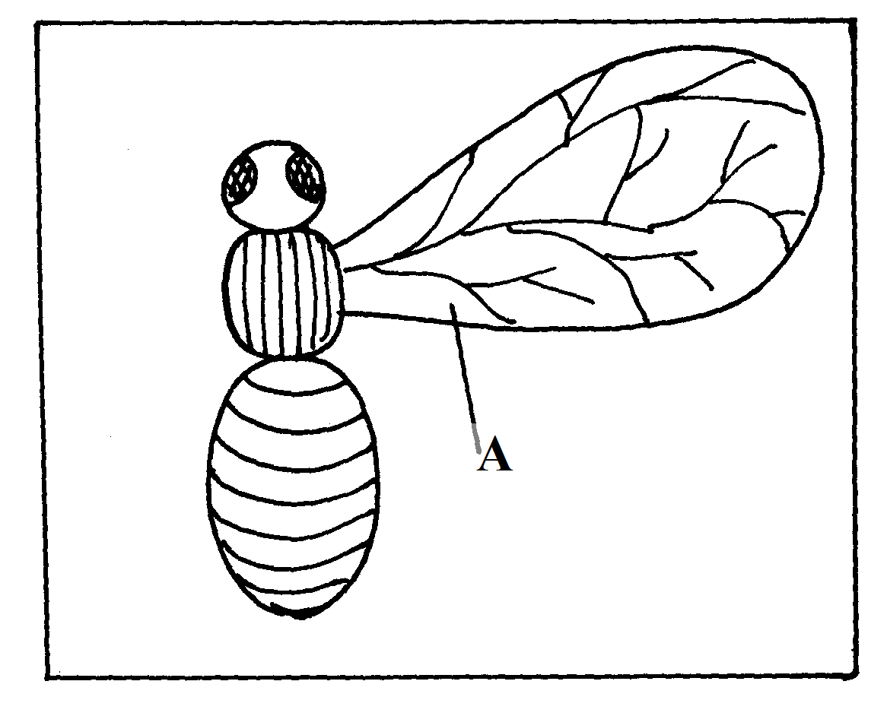

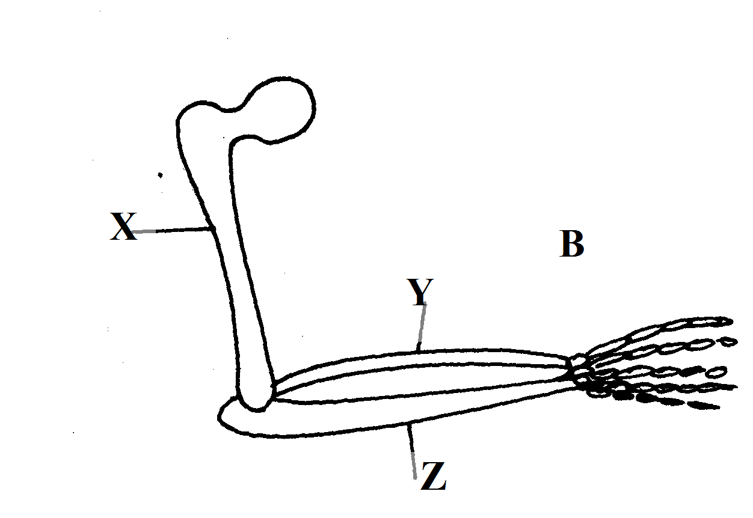

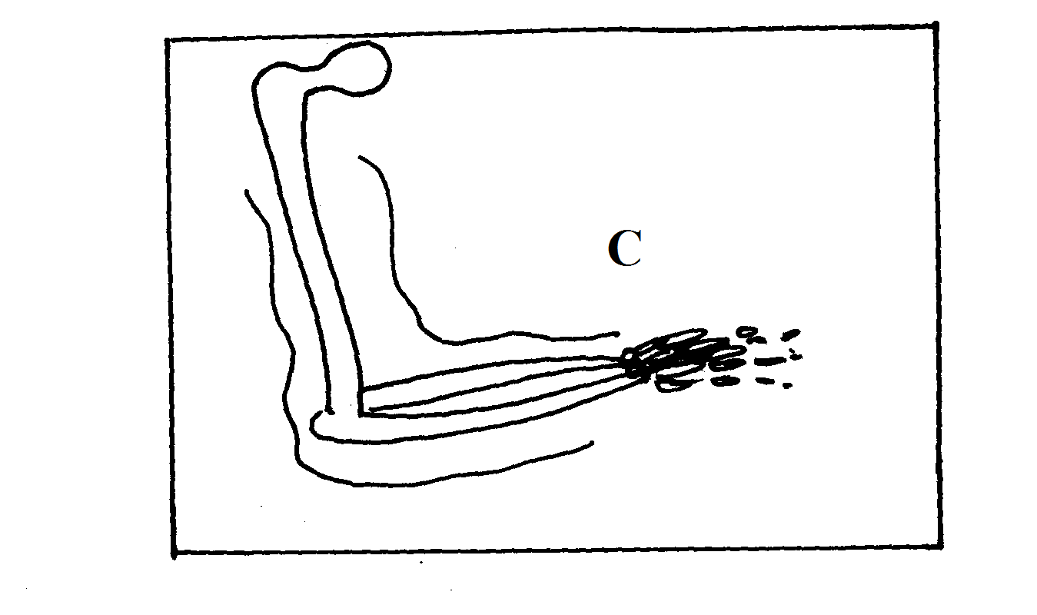
(a)Identify the parts labeled X,Y and Z. (3mks)
X…….. Humerus
Y……….Radius
Z………..Ulna
(b)What common name is given to structure ref?
(i)A and C…………………Analogous (1mk)

(ii)B and C…………………Homologous (1mk)

(c)Give a reason for your answer in b (i) and (ii) above. (2mks)
(i)A and C have different embryonic origin but have been modified to perfome same function
(ii) B and C have common embryonic origin but have been modified to perfome different functions
d) State the type of evolution that leads to emergence of structures named in 2 b (i) and (ii) above. (2mks)
(i)A and C………….Convergent evolution

(ii) B and C……….Divergent evolution
e)Identify two differences between structures A and C. (2mks)

A | C
Has no pentadactyl | Has pentadactyl
Originate from exoskeleton | Originate from endoskeleton

f) (i)What is a vestigial structure? (1mk)
Structures that become functionless and reduces in size with time

(ii)Give two examples of vestigial structures in human being (2mks)

Coccyx
Caecum and appendix
Body hairs
Ear muscles

- Study photographs C and D and answer the questions.

PHOTOGRAPH C
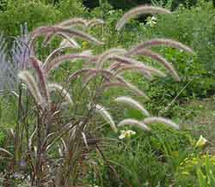

PHOTOGRAPH D

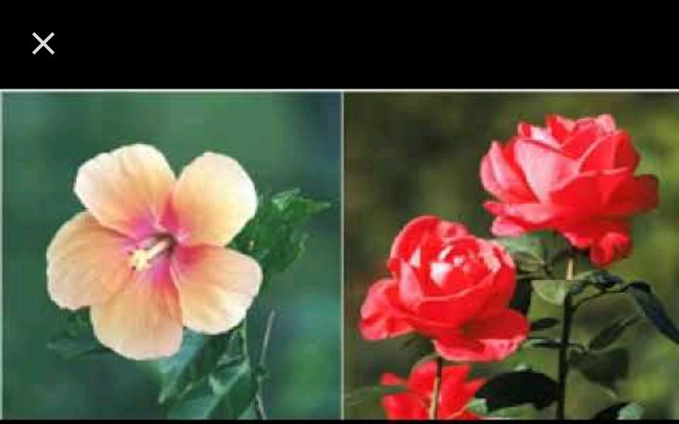

- With a reason state the agent of pollination of each of the flowers. (4mks)

Flower | Agent of pollination | Reason
C | Wind | .Inconpicuous petals  .Long featherly stigma hanging outside flower.  .Large anthers loosely attached to flexible filaments
D | Insect | .Brightly coloured petal  .Large and conspicuous petals

- Classify the plants in photograph D using the taxonomic units below and reasons for your answer. (4mks)

Taxonomic unit |  | Reason
Division | Spermaphyta | .flowering plant
Class | Dicotyledonae | .Broad leaves  .Net venation  Has petiole

- The diagrams below shows a type of cell division occurring in organisms above. Identify each of the stages A to D giving reasons for your answer. (4mks)
A B

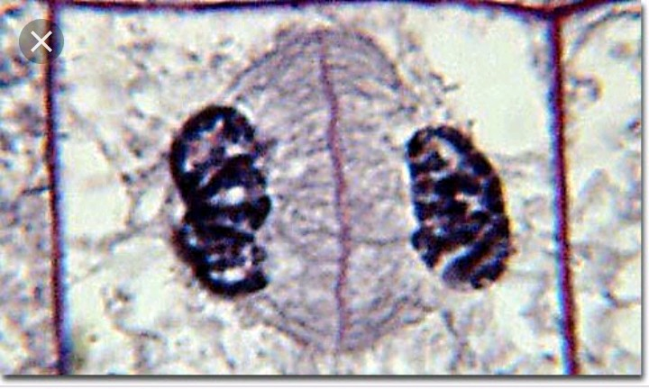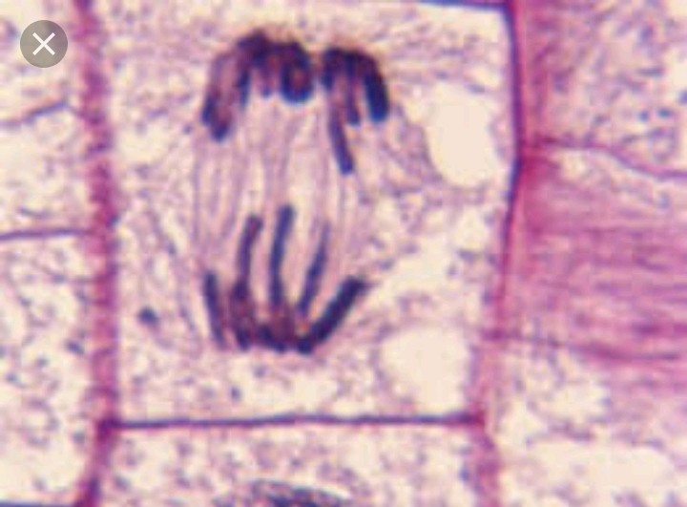

C D
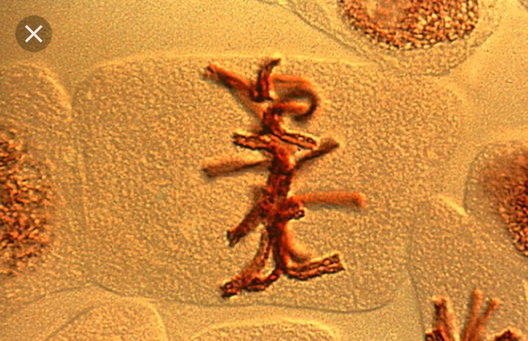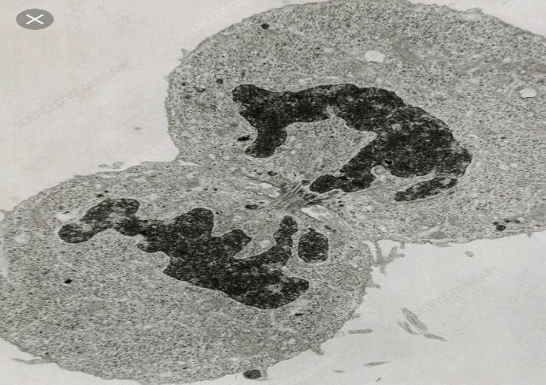

DIAGRAM | STAGE | REASON
A | Telophase | .Cell plate forms at the middle  .Chromatid collects at opposite poles
B | Anaphase | .Chromatids separates at centromere and migrates to opposite poles
C | Metaphase | .Chromosomes align at the equator
D | Telophase | .Cell constrict at the middle  Chromatid collects at opposite poles

(d). Giving reason, identify the kingdom to which the cell in stages A and B belongs. (2mks)

Kingdom……Plantae

Reason …Presence of cell wall
Formation of cell plate in cell A

