Name: ………………………………………………………….... Adm. No………………

Index No………………………. Class…………… Signature……………....……….

**232/3**

**PHYSICS**

**PRACTICAL**

**KASSU JET**

**JUNE 2024**

**TIME: 21/2 HRS**

**KASSU-JET EXAMINATION**

**Kenya Certificate of Secondary Education**

**PHYSICS PAPER 3**

**PRACTICAL**

**Instruction to Candidates**

* Write your name, admission number, class and signature in the spaces provided at the top of this page.
* Answer all the questions in the spaces provided
* You are supposed to spend the first 15 minutes of the 21/2 hours allowed for this paper reading the whole paper carefully before you start.
* Marks shall be awarded for clear record of observations actually made, for their suitability and accuracy and the use made of them.
* Candidates are advised to record their observations as soon as they are made.
* Electronic calculators and mathematical tables may be used
* This paper consists of **8 pages.**

**FOR EXAMINER’S USE ONLY**

|  |  |  |
| --- | --- | --- |
| **Question** | **Maximum Score** | **Candidate’s Score** |
| **1** | **20** |  |
| **2 Part A** | **9** |  |
| **2 Part B** | **11** |  |
| **TOTAL** | **40** |  |

**Question 1**

You are provided with the following:

* Triangular glass prism
* Soft board
* 4 optical pins
* At least 2 thumb tucks / pins
* A sheet of plain paper

Procedure:

Proceed as follows:

1. (a) Place the plain sheet of paper on the soft board and fix it there using

thumb pins provided. Do not detach this sheet of paper from the soft

board.

Place the prism near the centre of the paper. Use a pencil to trace the outline of the rectangle in contact with the paper. Remove the prism and use a ruler to extend the three sides of the outline. Label the vertices of the outline A, B and C.

(b) Mark a point N on side AB and draw a normal ON at this point. Draw lines at angles i = 300, 350, 400, 450, 500 and 600. See the figure below.

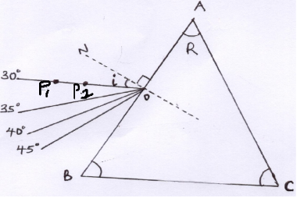

1. (a) Replace the prism on the outline. Fix two pins, P1 and P2 vertically

on the 300 line such that they are about 2 cm apart.

By viewing the images of the pins P1 andP2 through AC, fix two other pins P3 and P4 in line with those images. Remove the prism. Draw a line joining P3 and P4 an extend into the outline. Now extend the 300 line so that it intersects with extended line of P1 and P2 pins.

See the following figures (NB. This worksheet must be collected and attached on the question paper).

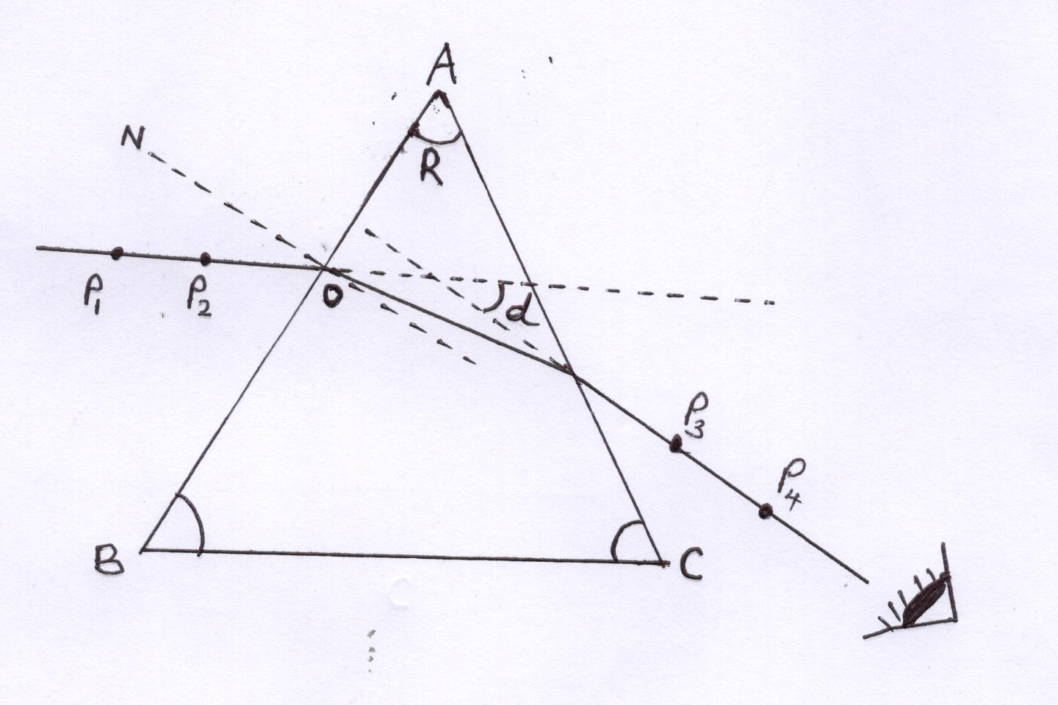



(b) Use a protractor to measure the angle R of the prism.

R = ........................................... (1 mk)

(c) Measure and record the acute angle **d** in the table below. (6 mks)

|  |  |  |  |  |  |  |
| --- | --- | --- | --- | --- | --- | --- |
| Angle, **i** (degrees) | 30 | 35 | 40 | 45 | 50 | 60 |
| Angle, **d** (degrees) |  |  |  |  |  |  |

(d) Repeat the procedure in (c) for other angles of **i** shown in the table. (5 mks)

(e) On the grid provided, plot graph of **d** (y-axis) against **i**. (5 mks)



1. From the graph, determine the minimum value of

**d** min ..................................................... (2 mks)

1. Determine the constant **K**, given that K = $\frac{\left(\sin{30+\frac{d min}{2}}\right)}{\sin{30}}$ (3 mks)
2. State the significance of K. (1 mk)

**Question 2**

Part A

You are provided with the following apparatus.

* A metre rule
* One stopwatch , one stand, clamp and boss
* One spring
* Two pieces of wood
* A beam balance / electric balance (to be shared.
* One mass labeled

Procedure

Proceed as follows:

1. Hang the spring vertically by clamping one end as shown in the following figure (use the small pieces of wood to clamp the spring)

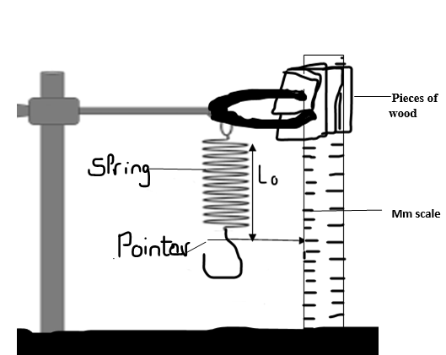

1. Measure the length of the unloaded spring Lo and record it.

Lo = ...................m (1 mk)

1. Hang the mass M at the lower end of the spring. Measure the length, L1 of the loaded spring.

L1 = ........................m (1 mk)

1. Find the values of L1 - Lo

L = L1 – Lo = ........................m (1 mk)

1. Using the beam balance determine the mass M of the object

M = .........................kg (1 mk)

1. Hang the mass M from the lower end of the spring. Displace it by a small vertical distance and release so that the spring makes vertical oscillations. Measure and record the time for 10 oscillations.

|  |  |
| --- | --- |
| Oscillations N | 10 |
| Time t (s) |  |
| Q = |  |
| Q2 (S2) |  |

Complete the table (3 mks)

Determine the constant, K given that

K = $\frac{MP}{13L}$ where P = $\frac{Q^{2}}{10}$ (3 mks)

Part B

You are provided with:

* A cell and a cell holder
* Six connecting wires with crocodile clips each
* A voltmeter (0 – 3V)
* A switch
* A resistance wire PQ mounted on a millimeter scale
* An Ammeter (0 – 1A)
* A micrometer screw gauge (to be shared)

1. (i) Measure diameter of the wire at two different points using micrometer screw

gauge (2 mks)

d1 = .................................

d2 = .................................

(ii) Calculate the average diameter **d** in metres. (2 mks)

1. Connect the cell, the ammeter and the 1.0m length of resistance wire PQ in series.

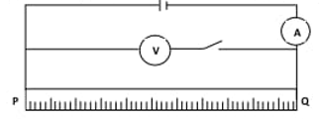

1. Close the switch S.
2. Measure the p.d. (vo) across 1.0 m length resistance wire and the current Io­

(2 mks)

Vo = .............................

Io = .............................

1. Calculate the resistance of the wire Ro (1 mk)

Ro = .............................

1. Calculate the cross-section area of the wire (2 mks)

A = π ${\left(\frac{d}{2}\right)}^{2}$

1. Determine the value of quantity K of the wire given the relation K = $\frac{R_{o}A}{L}$, where L is the length of the wire PQ. (2 mks)

***THIS IS THE LAST PRINTED PAGE***