**232/3**

**PHYSICS**

**PAPER 3**

**PRACTICAL**

**KASSU JET**

**JUNE 2024**

**INSTRUCTIONS TO SCHOOLS**

1. The information contained in this paper is to enable the head of the school and the teacher in charge of physics to make adequate preparations for the physics practical examinations. **NO ONE ELSE** should have access to this paper or acquire knowledge of its content. Great care **must** be taken to ensure that the information herein does **not** reach the candidates either directly or indirectly.
2. The apparatus required by each candidate for the physics practical examination are set out. It is expected that the ordinary apparatus of a physics laboratory will be available.
3. The physics teacher should note that it is his / her responsibility to ensure that each apparatus acquired for this examination agrees with the specifications given.
4. The question paper will **not** be opened in advance.
5. **The physics teacher** is **not** expected to perform the experiment.

NB:

* The **physics teacher** must ensure that the laboratory is set up a day before the date of the examination.
* Any use of apparatus other than the ones specified may lead to candidates being penalised.
* The requirements for each question should not be written on the chalkboard on the day exanimation.

Question One

* Each candidate will require the following:
* Equilateral triangular glass prism of dimensions 38 mm by 38 mm by 38mm +2mm
* 4 optical pins
* At least 2 thumb pins
* A sheet of plain paper
* A soft board

Question Two

* A metre rule
* A stop watch
* One stand, boss and clamp
* One spiral hooked helical spring of length 75mm and diameter 15 mm (75mm x 15mm) respectively

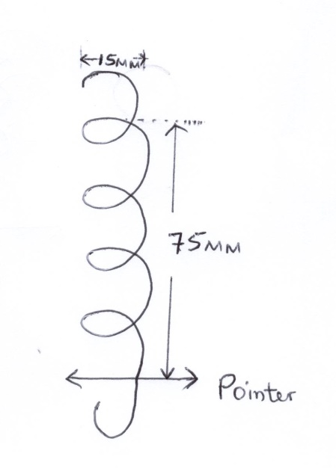

* Two pieces of wood
* Beam balance (To be shared)
* One mass labelled M = 100g with a hooke
* One new size D dry cell.
* A cell holder.
* Six connecting wires with crocodile clips
* A voltmeter (0 – 3v)
* An ammeter (0 – 1A)
* A switch
* A resistance nichrome wire labelled PQ of diameter 0.28mm + 0.01mm mounted on a mm scale.
* A micrometer screw gauge (to be shared)

***THIS IS THE LAST PRINTED PAGE***