Name: ……………………………………………………….. Adm No: ………………..

Index No: …………………………….. Class: ……………… Signature: ……………..

**232/2**

**PHYSICS THEORY**

**PAPER 2**

**JUNE 2024**

**TIME: 2 Hours**

**KASSU- JET EXAMINATION**

**Kenya Certificate of Secondary Education**

**PHYSICS PAPER 2**

***Instructions to candidates***

* Write your name, admission no, index no and class in the spaces provided above.
* Sign in the space above.
* This paper consists of **TWO** sections; **A** and **B**.
* Answer **ALL** questions in section **A** and **B** in spaces provided.
* **All** working **must** be clearly shown in the spaces provided in this booklet.
* Non- programmable silent electronic calculators may be used.
* This paper consists of 15 pages.
* Candidates should check the question paper to ascertain that all the pages are printed as indicated and that no questions are missing.
* Candidates should answer the questions in English.

**FOR EXAMINER’S USE ONLY**

|  |  |  |  |
| --- | --- | --- | --- |
| SECTION | QUESTION | MAXIMUM SCORE | CANDIDATE’S SCORE |
| A | 1-13 | 25 |  |
| B | 14 | 11 |  |
| 15 | 12 |  |
| 16 | 11 |  |
| 17 | 9 |  |
| 18 | 12 |  |
| **TOTAL SCORE** |  | 80 |  |

**SECTION A [25 marks]**

Answer **ALL** the questions in this sectionin the spaces provided.

1. State how the quality of an X-ray beam can be increased. (1mk)

2. State why repulsion is the sure test for polarity in magnetism. (1mk)

3. The figure below shows an attempt to supply each of the three lamps **L1**, **L2** and **L3**with a switch.

L3

1

L2

S1

S2

S3

L1

To Mains

1. Explain why this is a poor connection. (1mk)
2. Re-draw the diagram to show the correct connection in (a) above. (1mk)

4. Pure silicon can be changed to a P-type semi-conductor by adding an impurity. Explain how this can be achieved. (2mks)

5. Explain how an increase in cross sectional area of a metallic conductor reduces its electrical resistance. (1mk)

6. Figure show a human eye with a certain defect.

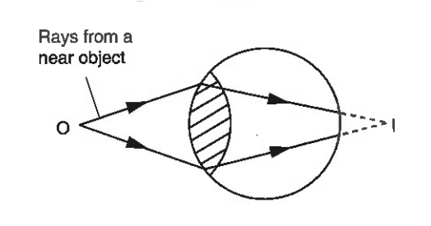

1. Name the defect. (1mk)
2. State the cause of the defect named above. (1mk)
3. On the same diagram, sketch the appropriate lens to correct the defect and the rays to show the effect of the lens. (2mks)

7. A ray of light is incident on a plane mirror as shown below

**500**

**O**

When the mirror is rotated clockwise about **O**, the angle between the reflected ray and the new reflected ray is **1200**. Determine the angle of rotation of the mirror. (2mks)

8. Two light bulbs rated at **100W**, **240V** and **150W**, **240V** are connected to 240V mains in turn. Which of the two bulbs will light brightly if they are connected in series? (2mks)

9. A car battery is rated 60Ah and supplies a constant current for 1,200 minutes. Calculate the amount of current that can be circulated. (2mks)

10. An **a.c** voltage display on a C.R.O whose vertical sensitivity was set at **20V / cm** appeared as shown below.

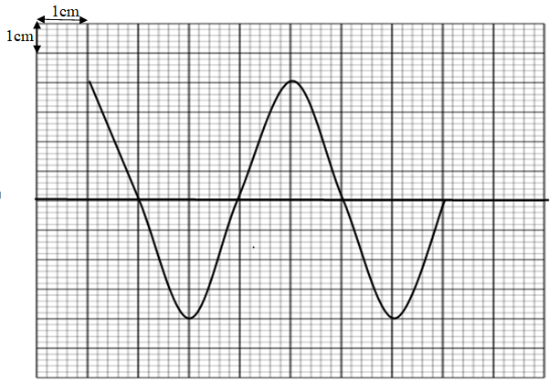

(a) Determine the peak value of the voltage. (1mk)

(b) If the time base was set at **25 ms/cm**, determine the frequency of the electrical wave.

(2mks)

11. The diagram drawn to scale shows longitudinal waves from a slinky spring produced at a frequency of 3Hz. Calculate the speed of the waves. (2mks)

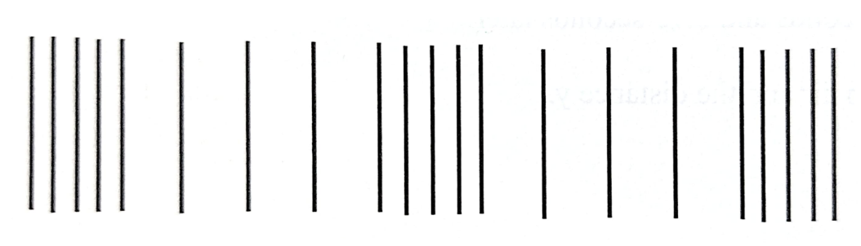

12 .The diagram shows a positively charged electroscope. A neutral rod is brought near the cap of the electroscope. State and explain the observation made. (2mks)

13.The figure below a decay curve for a certain element. The diagram is drawn to scale.

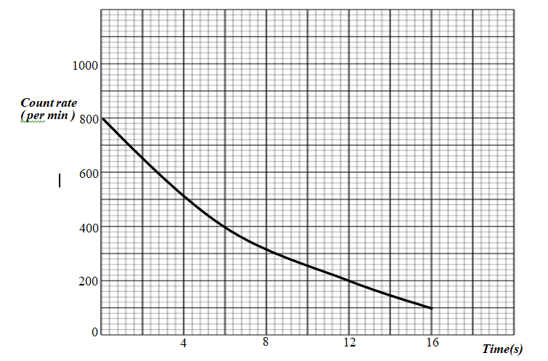

From the graph determine the half-life of the element . (1mk)

+ + + +

**SECTION B [55 marks]**

Answer **ALL** the questions in this section in the spaces provided below

14. (a) State the Lenz’s law of electromagnetic induction. (1mk)

(b) The figure below shows circuit that can be used to demonstrate mutual induction.

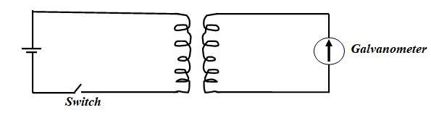

(i) State what is observed when the switch is closed. (1mk)

(ii) Explain why when the switch is closed then opened the deflection of the pointer is greater than during closing. (2mks)

(c) The figure below shows a demonstration transformer used to step down **240V** mains supply to **6V** **a.c** for use in a power pack supply.

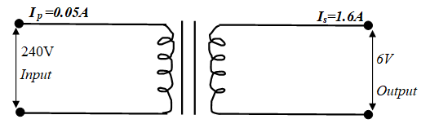

(i) If the number of turns in primary coil is **240**. Determine the number of turns in the secondary. (2mks)

(ii) Determine the efficiency of the transformer. (3mks)

(iii) Power losses in the transformer be by copper losses and hysteresis loss among other causes. State one other cause of power losses. (1mk)

(iv). Explain how the power losses stated in (iii) above is minimized. (1mk)

15. (a) State **TWO** factors that affect the capacitance of a parallel plate capacitor. (2mks)

(b) The figure below shows three capacitors **1.5µF**, **4.5µF** and **3µF** connected to **9V** supply as shown.

1.5µF

3µF

4.5µF

**9V**

Determine;

(i) The total capacitance of the circuit. (3mks)

(ii) The total charge stored in the capacitors. (2mks)

(iii) The charge stored in **3µF** capacitor. (2mks)

(c) The voltage across 4.5µ capacitor. (2mks)

(d) State **ONE** application of capacitors. (1mk)

16. (a) Distinguish between stationary waves and progressive waves. (1mk)

(b) In an experiment to observe interference of light a double slit is placed close to the monochromatic source of light as shown in the figure below

***Double slit***

***Monochromatic source***

***Screen***

**S**

**S2**

**S1**

X

***Central bright fringe***

(i) State the function of the double slit **S1** and **S2** (1mk)

(ii) State and explain what is observed on the screen. (2mks)

(iii) State what is observed on the screen if white light is used in place of monochromatic light. (2mks)

(iv) Given that **X** is the first dark fringe above the central bright fringe and **S1X=40.00mm** and **S2X=40.0009mm.** Determine the wave length of light used. (2mks)

(c) Two men **A** and **B** were standing **200m** apart and **324m** each from a vertical cliff. Man **A** shots a gun and **B** heard the second gunshot being an echo from the cliff after **2 seconds**. Use the information to determine the velocity of sound in air. (3mks)

17. (a) State Snell’s law. (1mk)

(b)The figure shows a graph of apparent depth against real depth for a given liquid.

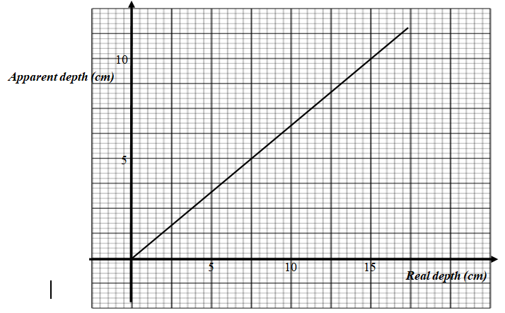

From the graph determine the:

1. The refractive index of the liquid . (3mks)
2. The velocity of light in the liquid if the speed of light in air is **3×108 m/s**.

(2mks)

(c) One of the conditions for total internal refraction to occur is that angle of incidence must be greater than the critical angle of the medium, state the other condition. (1mk)

(d) State any **TWO** applications of prisms. (2mks)

18. (a) State **TWO** factors that determine the speed of photo electrons emitted from a metal

surface. (2mks)

(b) Define work function (1mk)

(c) Figure shows a graph of maximum kinetic energy (**K.Emax**) of photo electrons against the frequency of the incident radiation of caesium metal

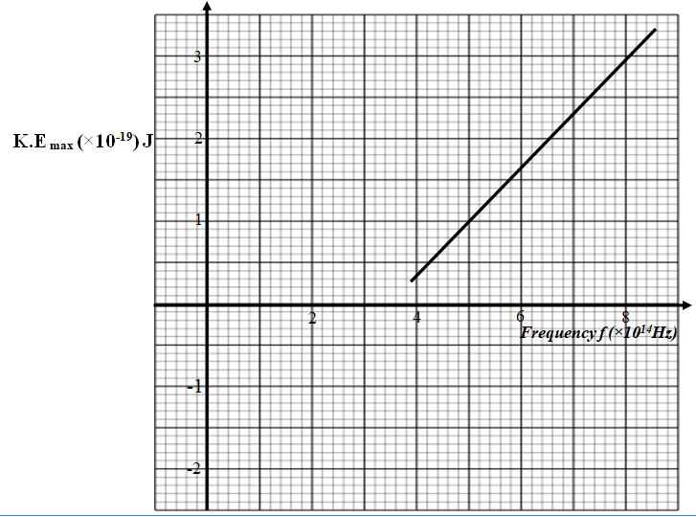

(d) Given that **hf = Q+ K.E max** where **h** and **Q** are constant, use the graph to determine:

1. The threshold wave length. ( c= 3 x 108 m/s) (2mks)
2. The value of **h**  (3mks)
3. The value of **Q** (3mks)
4. Lithium metal has a higher work function than caesium . On the same axes, sketch the graph for lithium. (1mk)