**NAME……………..…………………………… ADM NO……........……. CLASS ……………….**

**232/2**

**PHYSICS (THEORY)**

**PAPER 2**

**MARCH/APRIL 2024**

**TIME: 2 HOURS LANJET CLUSTER JOINT EVALUATION – 2024**

**Kenya Certificate of Secondary Education**

**INSTRUCTIONS TO CANDIDATES:**

(a) Write your **Name** and **Index Number** in the spaces provided **above**.

(b) **Sign** and write the **date** of examination in the spaces provided **above**.

(c) This paper consists of **two** Sections; **A** and **B**.

(d) Answer **ALL** the questions in sections **A** and **B** in the spaces provided.

(e) All workings must be clearly shown.

(f) Non-programmable silent electronic calculators and KNEC Mathematical tables **may be** used.

**Constants**

i) Density of water = 1g/cm3 or 1000kg/m3.

ii) Gravitational acceleration = 10m/s2.

**FOR EXAMINER’S USE ONLY:**

|  |  |  |  |
| --- | --- | --- | --- |
| **Section** | **Question** | **Maximum**  **Score** | **Candidate’s**  **Score** |
| **A** | **1 – 13** | **25** |  |
|  | **14** | **10** |  |
|  | **15** | **13** |  |
| **B** | **16** | **12** |  |
|  | **17** | **8** |  |
|  | **18** | **12** |  |
| **Total Score** | | **80** |  |

**SECTION A (25 MARKS)**

1. A ray is incident on two mirrors inclined at 600 as shown in the diagram below. (3mks)

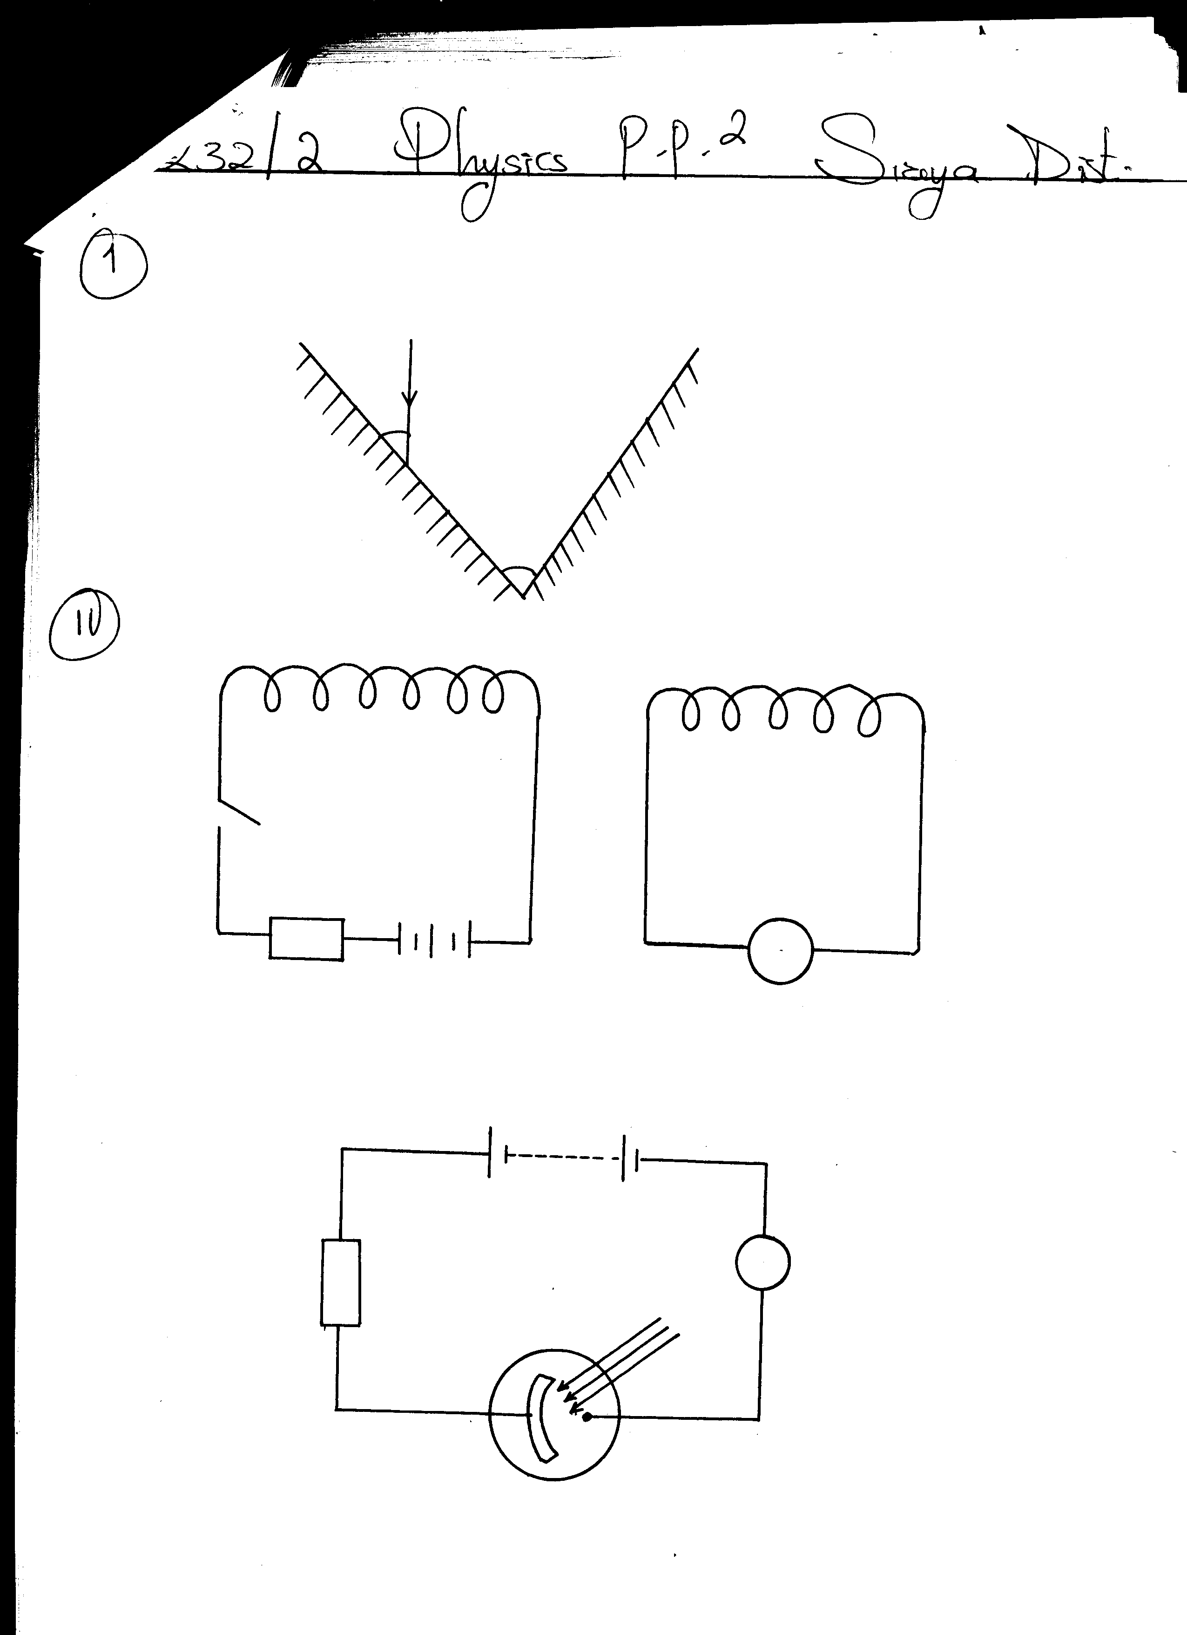

**400**

**600**

**Mirror B**

**Mirror A**

Determine the angle of reflection on mirror **A**, hence trace the path of the ray as it leaves mirror **B.**

1. a) The coils **P** and **S** are connected as shown below. **P** is connected to a battery, rheostat and a switch **K**. **S** is connected to a galvanometer **G**.

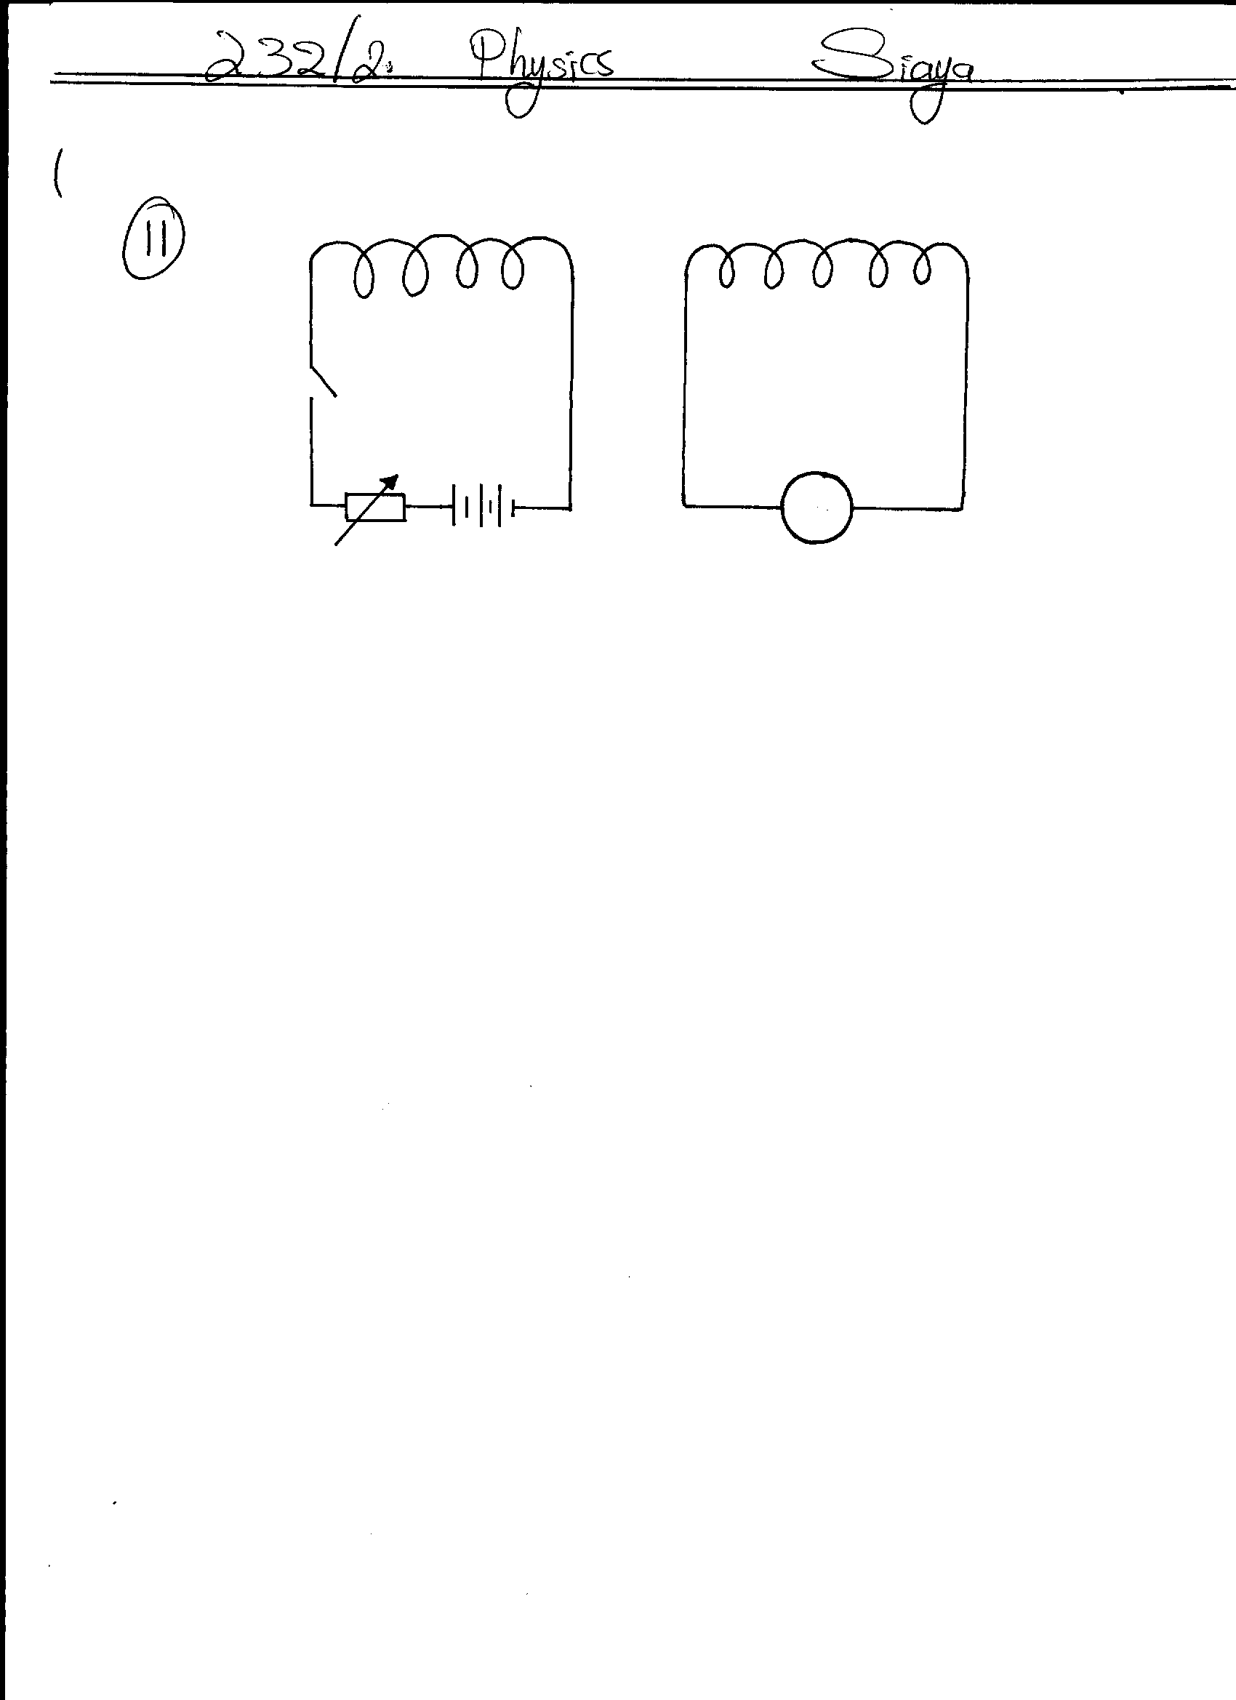

**K**

**P**

**G**

**S**

State the behavior of the pointer on **G** in the following cases;

1. When **K** is switched on (closed) (1mk)

II) When **K** is opened. (1mk)

b) A transformer has 200 turns in the primary coil and 1000 turns in the secondary coil. If the transformer is 100% efficient and the current in the secondary coil is 0.15A, determine the current in the primary coil. (3mks)

1. Figure below shows a simple experiment using a permanent magnet and two metal bars **A** and **B**

Put close to the iron filings.

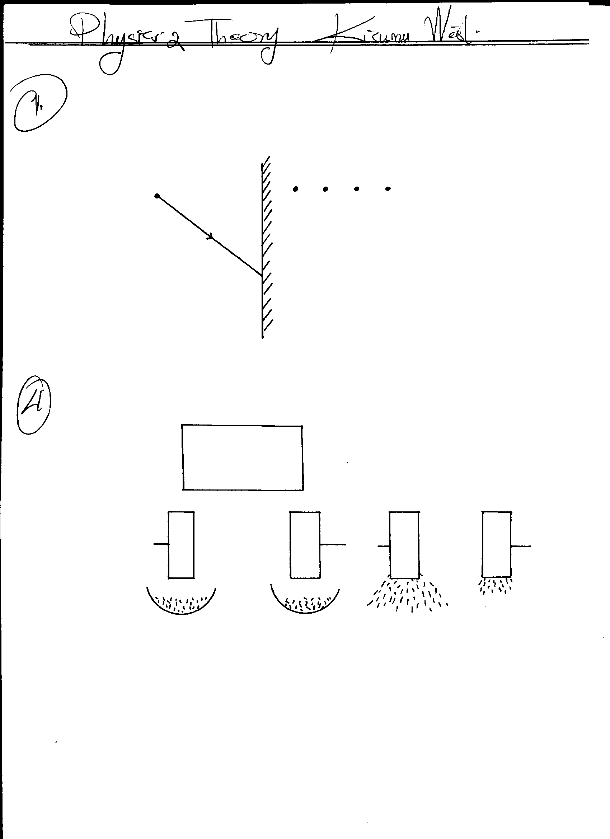

**S**

**N**

**A**

**B**

**A**

**B**

**After**

**During attraction**

State with a reason which bar is made from a soft magnetic material. (2mks)

1. The diagram below shows a ray of light **xy** traveling through a glass block of critical 420 to point **A**

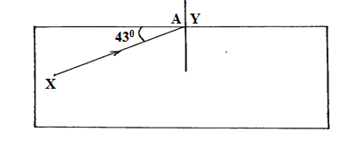

1. Calculate the refractive index of the glass block. (3mks)
2. On the same diagram, draw the path of the ray as it travels past point **A**. (1mks)
3. The photoelectrons liberated from an illuminated metal surface constitute a photoelectric current. What is the effect of decreasing the intensity of illumination on the magnitude of the photoelectric current? (1mk)
4. Figure below shows a battery of e.m.f 3.0v connected in series will two capacitors.

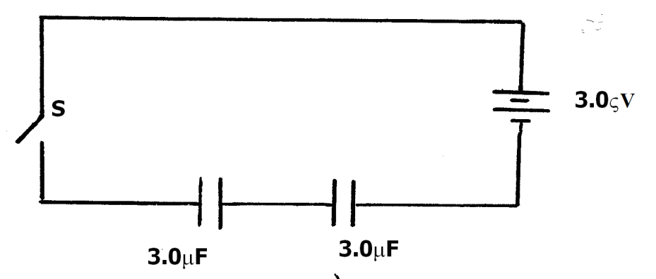

Determine the energy stored in the combined capacitors when the switch is closed. (3mks)

1. The figure below shows a meter rule in equilibrium with the magnet and weight W. The Soft iron core is fixed to the bench.

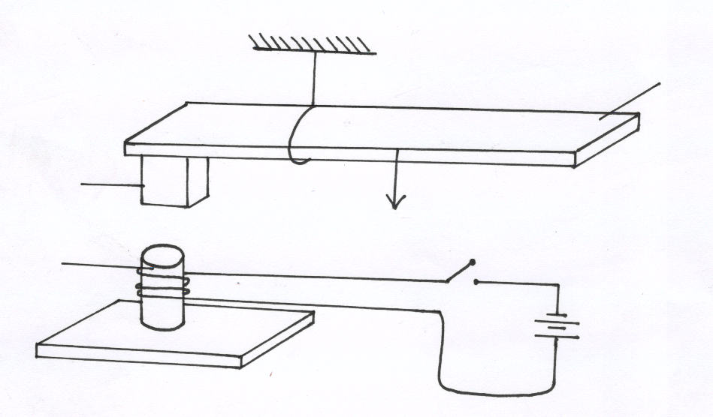

**Metre rule**

**s**

**Magnet**

**Soft Iron core**

**Fixed on bench**

**N**

**Bench top**

**W**

State and explain the effect on the meter rule when the switch S is closed (2mks)

1. State how polarization is reduced in a dry cell. (1mk)
2. State two differences between the cathode ray tube (CRT) of a T.V and the cathode ray oscilloscope (CRO). (2mks)
3. Distinguish between a P-type and a N-type extrinsic semiconductors. (2mks)

**SECTION B (55 MARKS)**

1. (a) Students set up a mass attached to a spring such that when it oscillates it taps on water surface in a wide shallow tank as in figure 11 below.

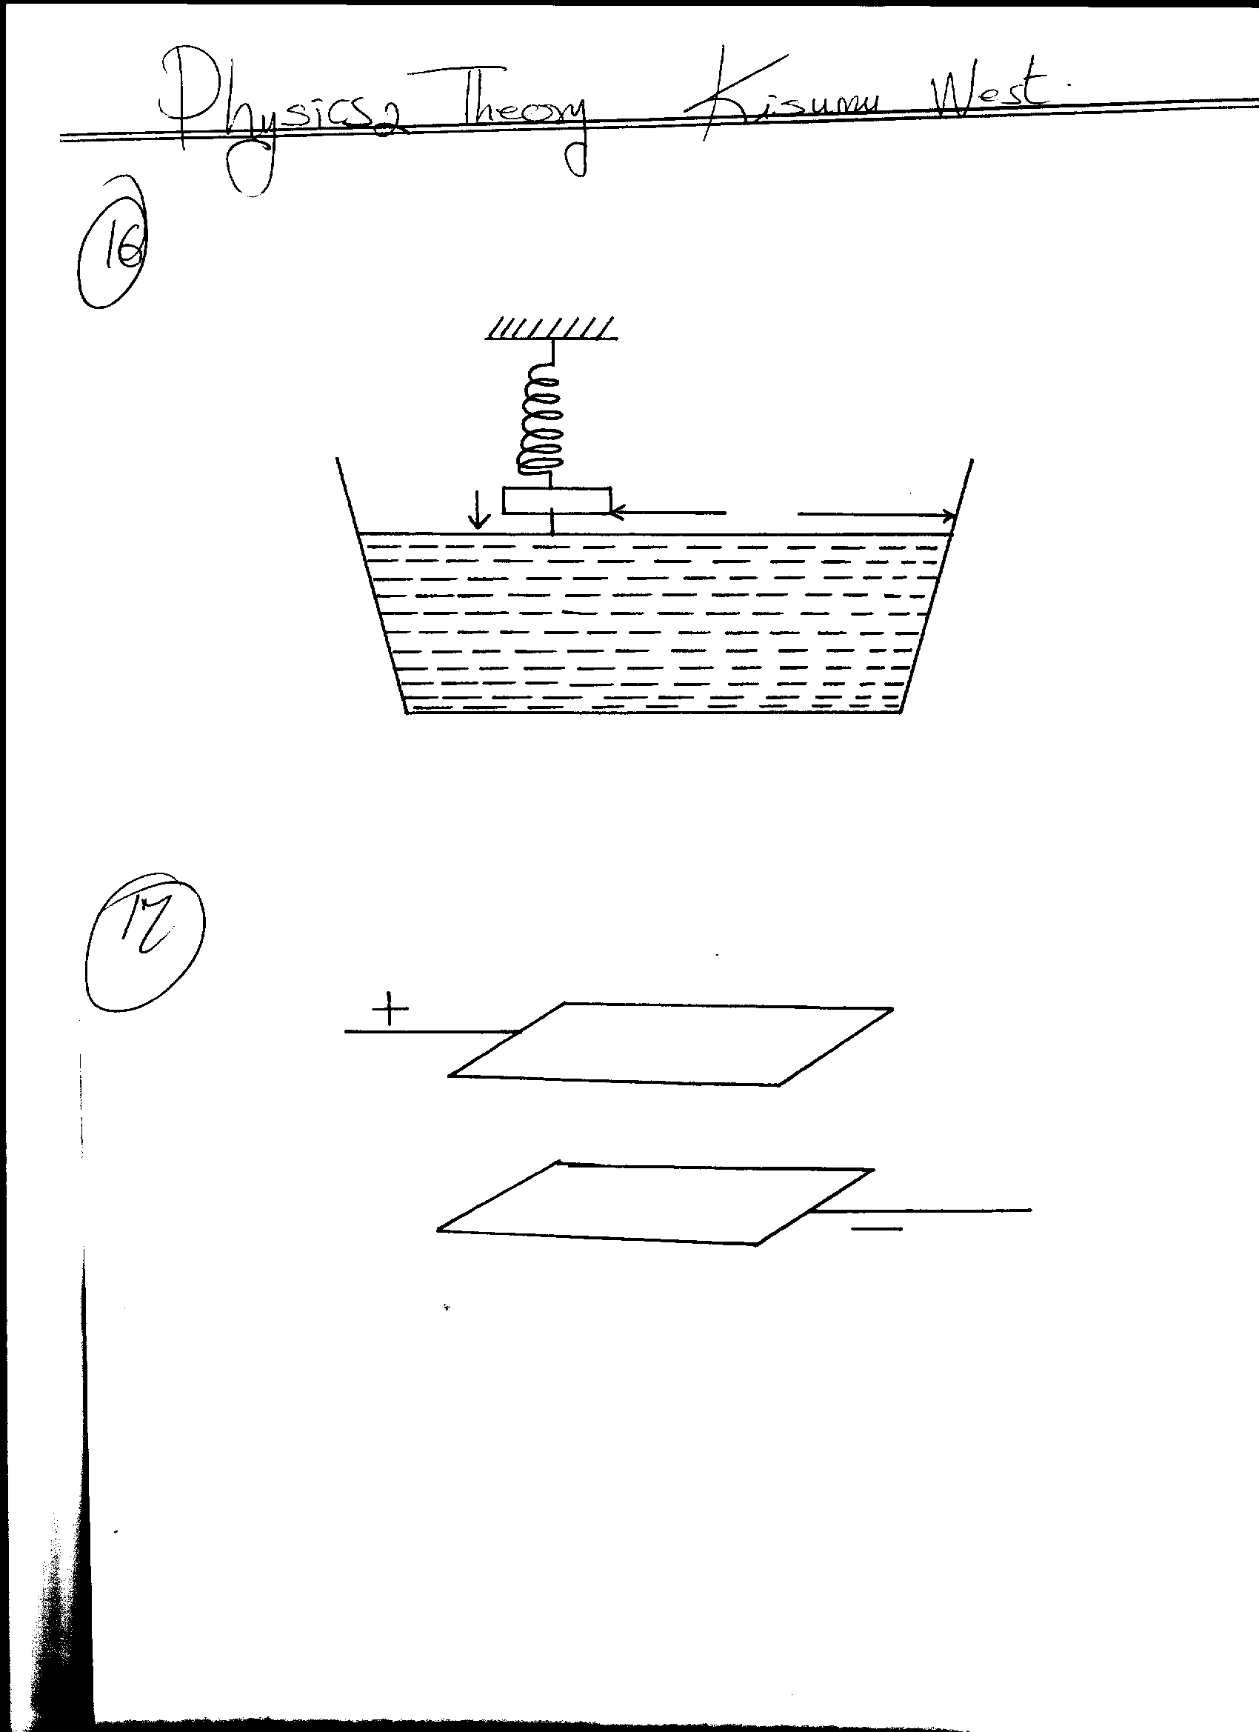

**Spring**

**Mass**

**800m**

**B**

**Water**

**Direction of**

**oscillation**

**Fig. 11**

The students measured time for 20 oscillations and found that the mass takes 36 seconds.

Determine:

1. The periodic time of the mass (2mks)

(ii) The frequency of the waves produced on the water surface (2mk)

(iii) The speed of the waves if the students counted four ripples between the mass and

end **B** of the tank (3mks)

(b) State any **two** factors that would increase the speed of sound in air (2mks)

(c) An echo sounder of a ship received the reflected waves from a sea bed after 0.20s.

(i) Determine the depth of the sea bed if the velocity of sound in water is 1450m/s (2mks)

(ii) When the ship above passes over a sunken reef, the echo sounder receives an echo after 0.16s. Determine the height of the sunken reef (2mks)

12.(a) An experiment was performed in the laboratory in the sequence described

I. Brought a positively charged plastic ruler near to the cap of an uncharged leaf electroscope

II. Touched the cap momentarily with the finger

III. Removed the ruler

Draw diagram to show charge distribution on the cap and leaf of the electroscope and the position of the leaf after each of the above procedure. (3mks)

(b) What will be the effect observed if the ruler is removed before removing the finger? (1mk)

…………………………………………………………………………………………………………

(c) In a separate experiment, the charged plastic ruler was allowed to touch the cap of electroscope. State giving a reason whether or not there will be any difference in the results obtained in (a) above (2mks)

…………………………………………………………………………………………………………

…………………………………………………………………………………………………………

(d) In a nylon manufacturing factory heavy rubber units were put under the spinning machines which were made of metal to absorb the noise. The following effects were observed

A. Workers sometimes received electric shock when there was no leakage of charge from the main cable.

B. Small pieces of nylon stuck to the thread but whenever the room was moist this did not occur

(i) State and explain the reasons for the observation in **A and B** above. (4mks)

…………………………………………………………………………………………………………

…………………………………………………………………………………………………………

(ii) How would the effect in **(d) A** be corrected (1mk)

…………………………………………………………………………………………………………

13. a) The figure below shows a method of magnetization used in making magnets.



i) Name the method. (1 mark)

___________________________________________________________________________________

ii) Identify the polarities A and B of the magnet produced. (2 marks)

A ­­­­­­­­____________________________

B ­­­­­­­­____________________________

iii) Apart from this method, state any other method used in magnetization. (1 mark)

­­­­­­­­___________________________________________________________________________________

b) In demagnetization by electrical method:

i) State the type of current used. (1 mark)

___________________________________________________________________________________

ii) Explain your answer in (i) above. (2 marks)

___________________________________________________________________________________

_________________________________________________________________________________________________________________________________________________________________________________________________________________________________________________________

1. Explain why when demagnetizing a magnet, the magnet should be held in the East-West direction. (2 marks)

___________________________________________________________________________________

_________________________________________________________________________________________________________________________________________________________________________________________________________________________________________________________

14. a) State Ohm’s Law. (1mk)

b) The figure below shows a circuit that can be used to verify Ohm’s law

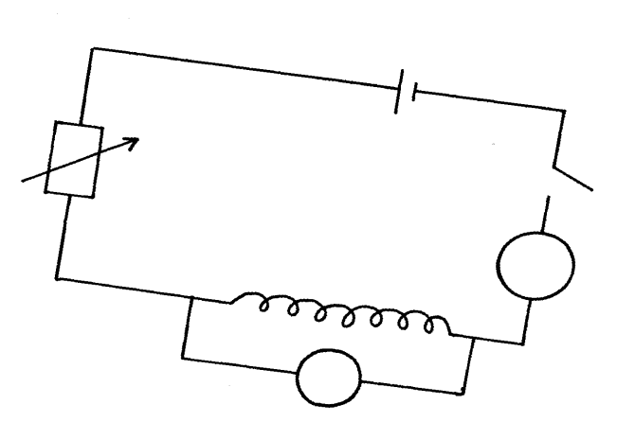

**S**

**A**

**nichrome wire**

**Rheostart**

**Ammeter**

**V**

Explain briefly how the setup can be used to verify ohm’s law (3mks)

1. The graph below was obtained from experiment to determine the effective resistance of two resistors connected in parallel. If the value of one resistor is 50 ohms. determine the value of the other resistor.

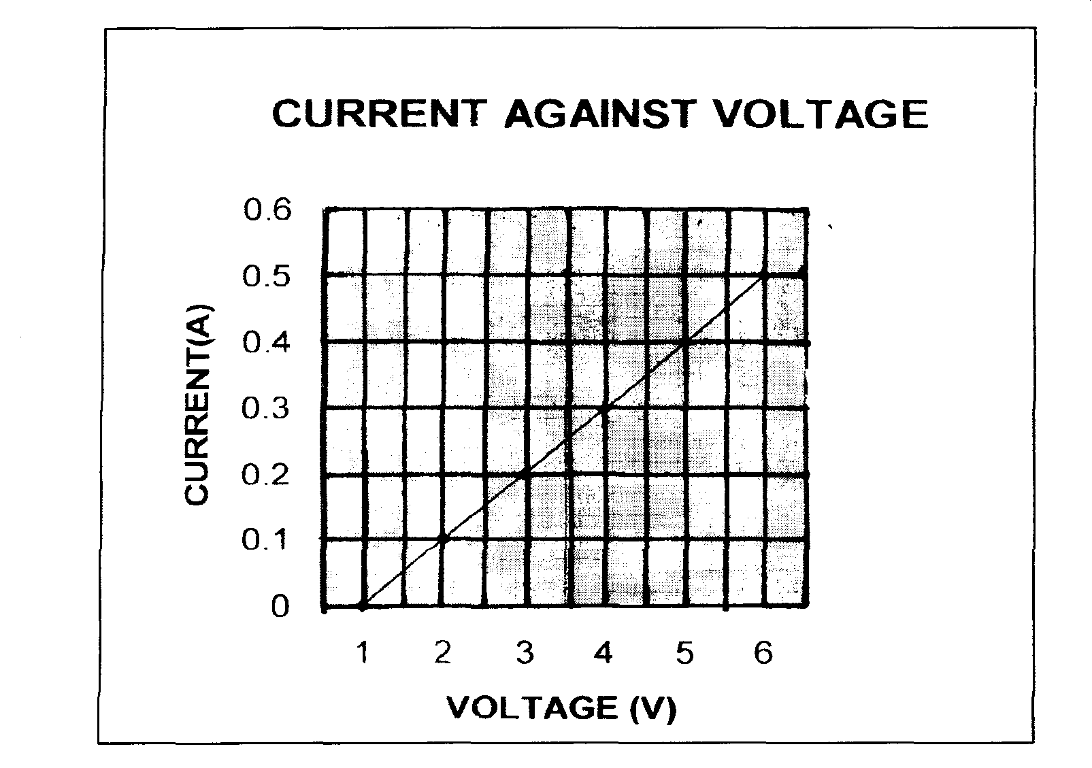

From the graph, determine

1. effective resistance of the two resistors (2mk)
2. the value of the other resistor (3mks)
3. (a) An object **O** stands on the principal axis of a concave mirror as shown in figure 9 below.

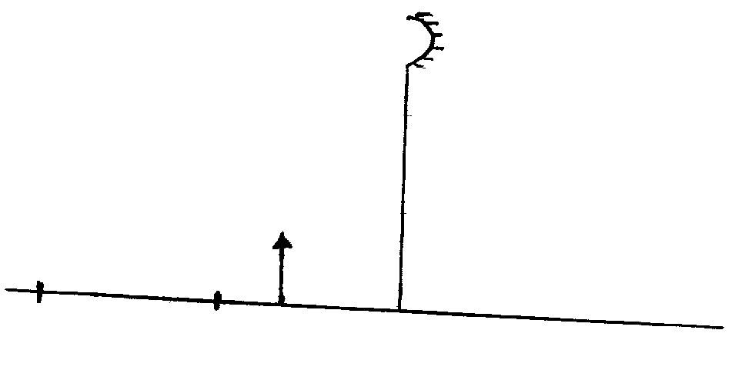

**C**

**F**

**O**

**Fig. 9**

(i) By drawing suitable rays, show the position of the image (3mks)

(ii) Determine the magnification of the image formed (2mks)

(b) In an experiment to determine the focal length of a converging lens, a group of form four students collected some data and used the results to plot the graph shown in figure below.

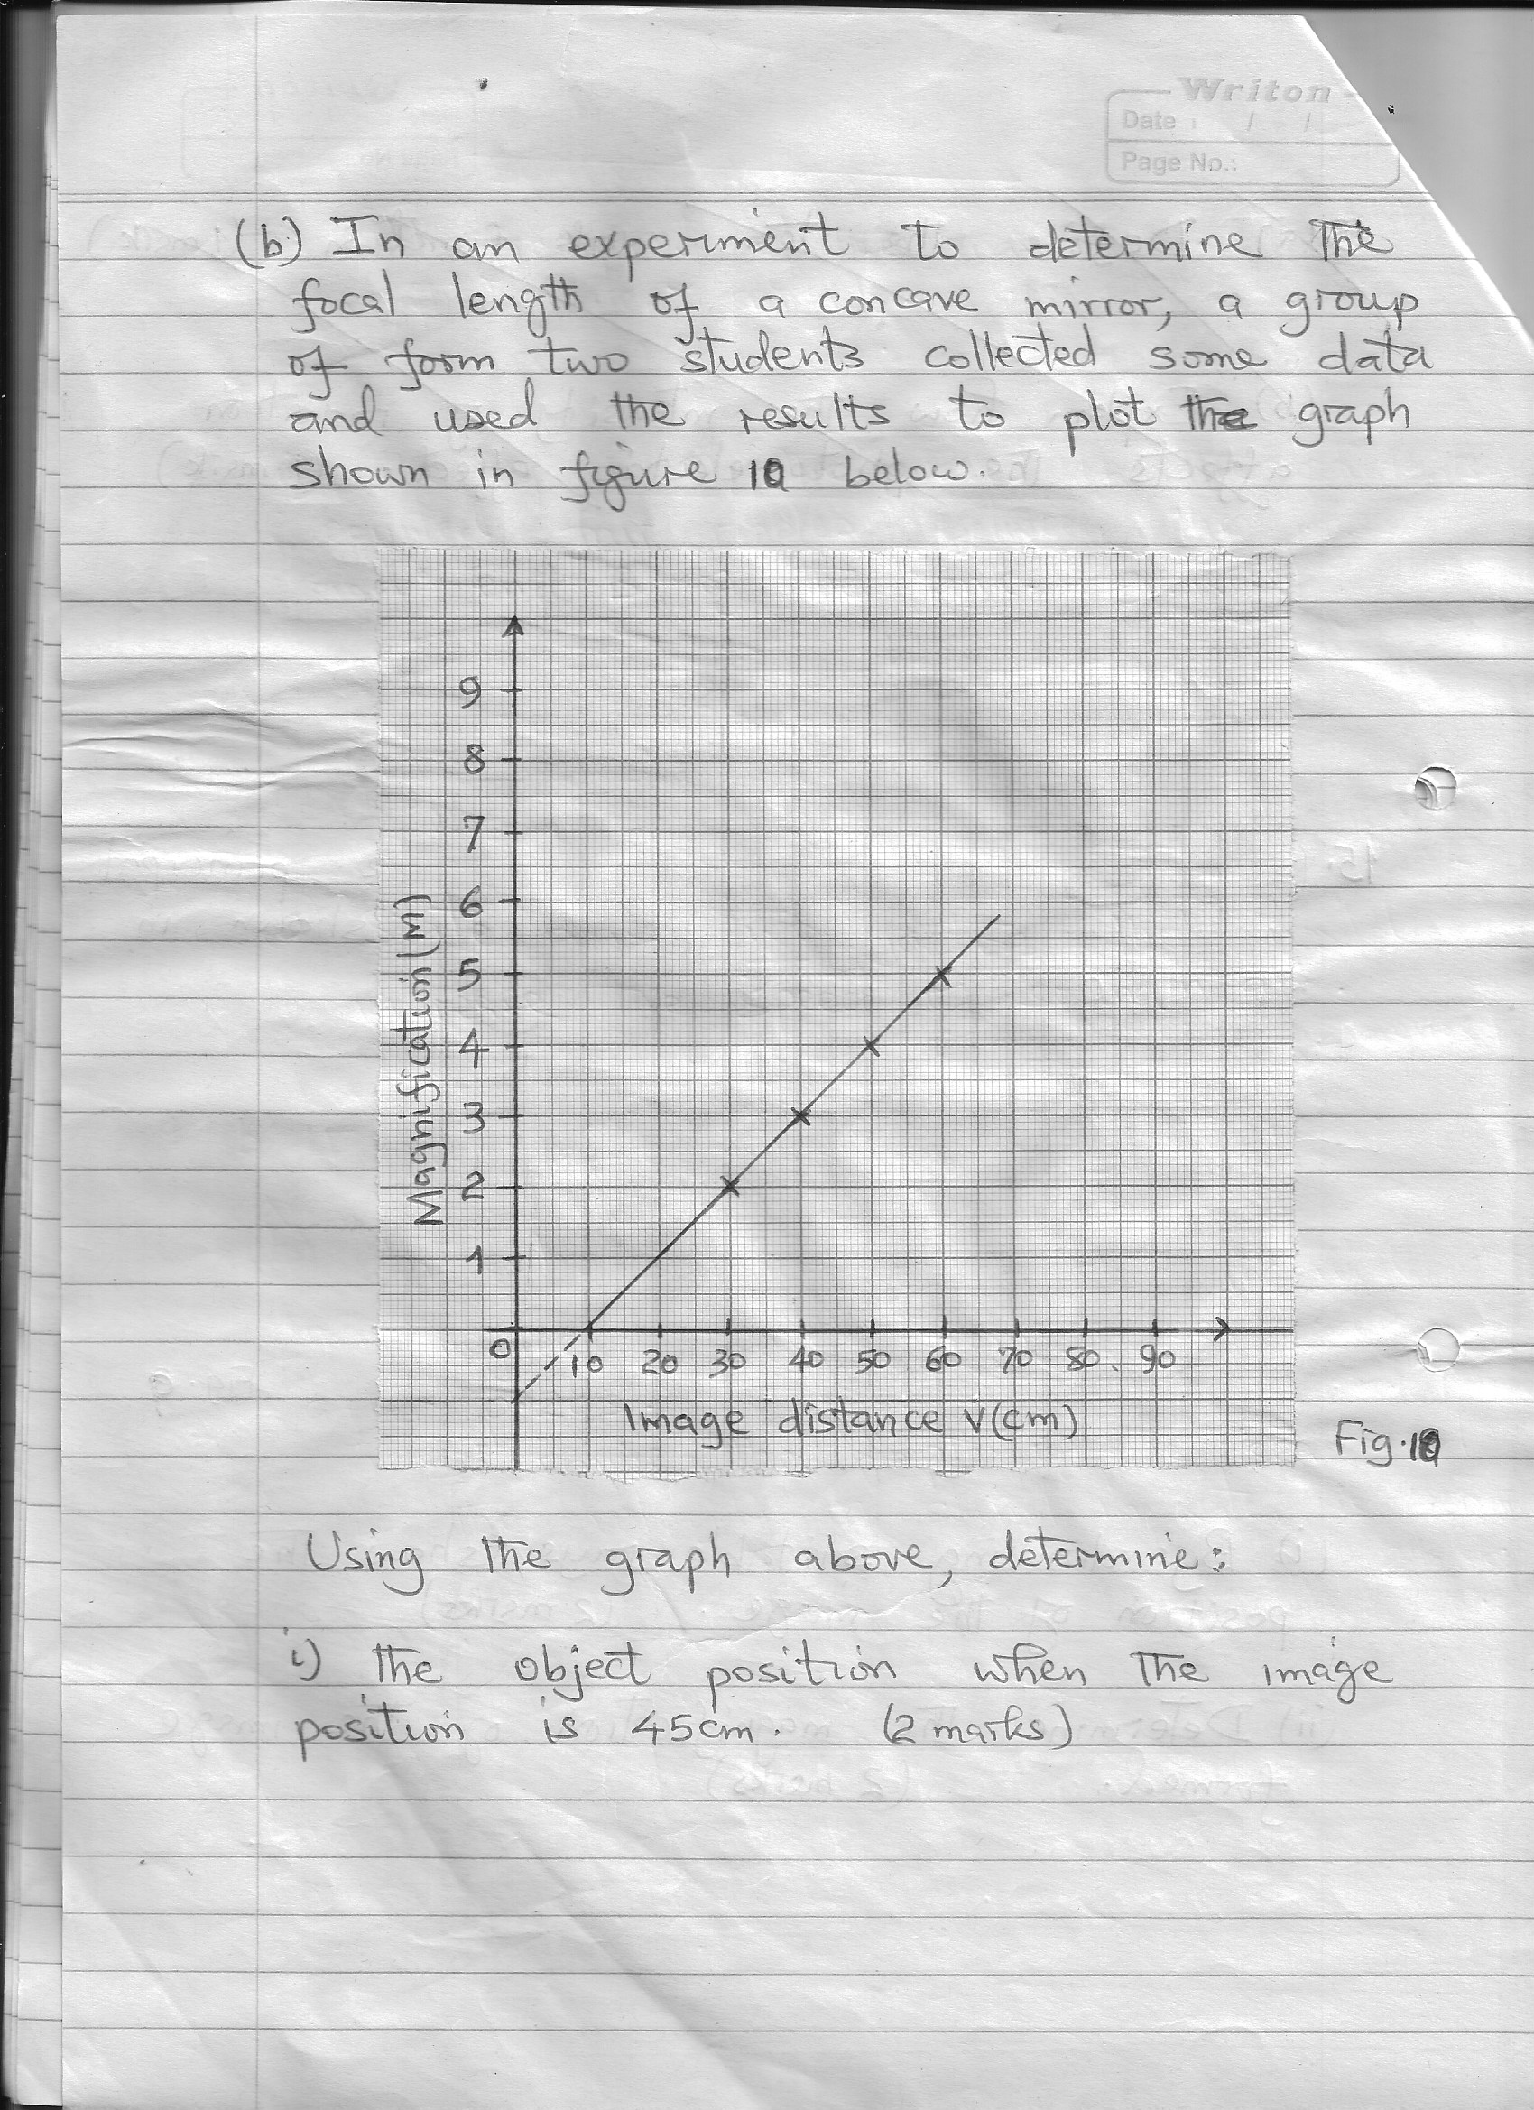

Using the graph above, determine:

(i) The object position when the image position is 45 cm (2mks)

(ii) Slope of the graph. (2mks)

(iii) The focal length of the lens given **m = $\frac{v}{f}$- 1**