**Name.....................................................Index No..........................Adm. No..................................**

**Class .............................Sign .............................................Date.....................................................**

**232/1**

**PHYSICS**

**PAPER 1**

**JULY, 2024**

**TIME: 2 HOURS**

**NAKURU NORTH SUB -COUNTY JOINT MOCK 2024**

***Kenya Certificate of Secondary Education***

**232/2**

**PHYSICS**

**PAPER 1**

**JULY/AUGUST 2024**

**TIME: 2 HOURS**

***INSTRUCTION TO CANDIDATES***

*a) Write your name, index number/Admission number in the spaces provided above.*

*b) This paper consists II sections: A & B.*

*c) Attempts all the questions in the spaces provided.*

*d) Silent Non Programmable electronic calculator may be used*

*e) All working must be clearly shown.*

**For examiners Use only**

|  |  |  |  |
| --- | --- | --- | --- |
| **SECTION** | **QUESTION** | **Maximum Score** | **Candidates Score** |
| A | 1 – 13 | 25 |  |
| B | 14 | 10 |  |
| 15 | 12 |  |
| 16 | 10 |  |
| 17 | 11 |  |
| 18 | 12 |  |
| **Total Score** |  | **80** |  |

***This paper consists of 9 printed pages. Candidates should check to ascertain that all pages are printed as indicated and that no questions are missing.***

**SECTION A: (25 MARKS)**

***Answer all the questions from this section.***

1. (a) A body in circular motion moving at constant speed is said to be accelerating. Explain this. (1mk)

(b) A stone of mass 450g is rotated in a vertical circle at 3 revolutions per second. If the string has a length of 1.5m, determine its linear velocity. (2mks)

1. A steel ball of mass 0.05kg was placed on top of a spring on a level ground. The spring was then compressed through a distance of 0.2m.

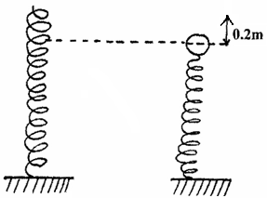

If the spring constant is 15N/m. Calculate the maximum height reached when the spring is released. (3mks)

1. The figure below shows part of the main scale of vernier calipers.

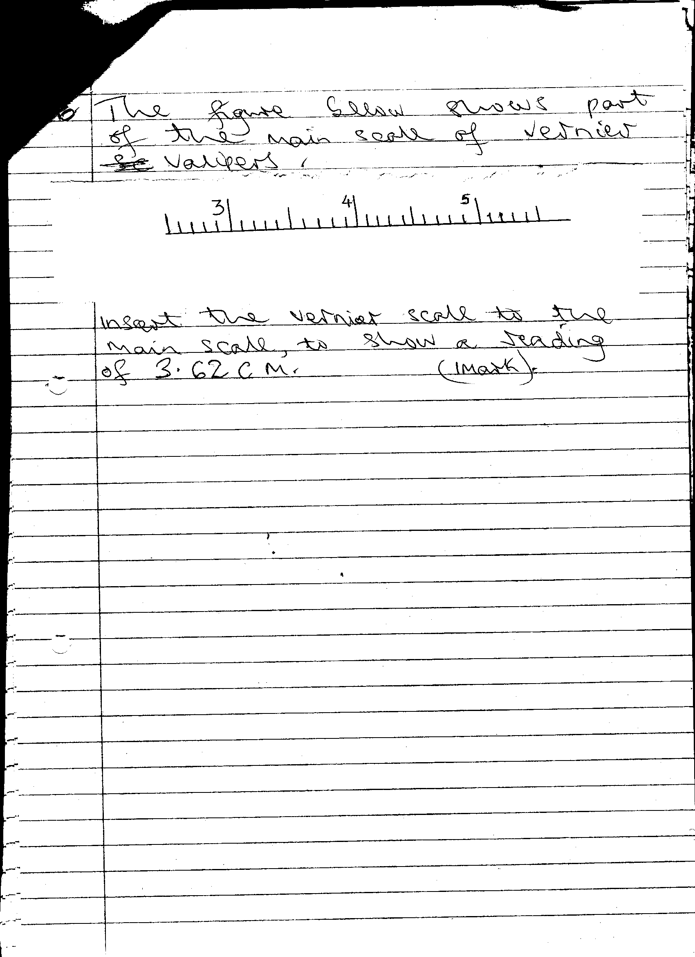

Insert the vernier scale to the main scale, to show a reading of 3.62 cm (1 Mk)

1. A liquid flows into a pipe of varying cross sectional area. The inlet cross section is 10cm in diameter. If the liquid leaves the pipe at 0.5m3/s find the inlet velocity of the liquid. (3 mks)
2. Explain the reason why a dropping dust particle in a still room does not trace a straight vertical path. (1mk)
3. Sketch a velocity-time graph for an object thrown vertically upwards until it gets back to it’s initial position (2mks) (2mks)
4. In the figure below, U-tube contains two immiscible liquids P and Q. If the density of Q is 900kg/m³ and that of P is 1200kg / m³, Calculate the height of liquid Q. (3 marks)

1. The diagram shows a solid cylinder standing on a horizontal surface. The cylinder is in stable equilibrium.



  On the horizontal space provided, sketch the cylinder in neutral equilibrium (1 mark)

1. In terms of intermolecular forces, explain the difference between liquid and gaseous state. (1 mark)
2. State and explain why it would be advisable to use hollow bricks in place of normal building stones in countries which experience winter. ( 2marks)
3. Sketch on the axis, a graph of mass per unit volume of water against temperature from 00C to 100C. (2mks)
4. A student dropped a drop of oil and water respectively on a clean glass surface as shown in

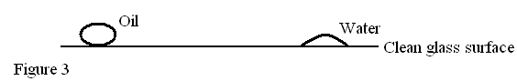

Explain the difference in the shapes formed on the surface of glass (2mks)

1. What does mechanics as a branch of physics entail? (1mk)

**SECTION B: 55 MARKS**

**Answer all the questions from this section.**

1. (a) State Newton’s second law of motion in terms of in momentum. (1mk)
2. A trolley of mass 5kg travelling to the right at 2m/s collides heads on with another trolley of mass 3kg travelling at 4m/s to the left. Find their velocity after collision if the collision is perfectly inelastic.(3mks)
3. A bullet of mass 2g is fired with a velocity of 300m/s into a wooden block of mass 5kg suspended from a long string. The bullet sticks into the wood and the two move together.
   1. Find the velocity of the block and the bullet immediately after collision took place. (3mks)

(ii) Calculate the height to which both swing upwards. (3mks)

1. (i) Define specific latent heat of fusion (1mk)

(ii)300g of ice at 00c is dropped into a copper calorimeter containing warm water of mass 60g at 600c. it’s observed that only 80% of ice melted.

(Take: Specific heat capacity of water = 4200 Jkg-1k-1

Heat capacity of copper = 400 JK-1)

1. Determine the final temperature of the mixture. (1 mk)
2. Determine the heat lost by calorimeter. (2 mks)
3. Determine the heat lost by warm water. (2 mks)
4. Determine the specific latent heat of fusion of ice. (3 mks)
5. It’s observed that if the temperature of warm water used was 800c, then all the ice could have melted. What would be the final temperature of the mixture?

Use the value of specific latent heat of fusion obtained in (d) above. (3 mks)

1. (a)Draw a single pulley arrangement with a velocity ratio of 2. (2mks)

(b) Figure shows a wheel and axle being used to raise a load W by applying an effort F. the radius of the large

wheel is R and of the small wheel r as shown.

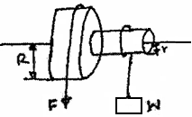

1. Show that the velocity ratio (V.R) of this machine is given by R/r. (3mks)
2. Given that r = 5cm, R = 8cm, determine effort required to raise a load of 20N if the efficiency of the machine is 80%. (4mks)
3. It is observed that the efficiency of the machines increases when it is used to lift large loads. Give a reason for this. (1mk)
4. (a) State the Archimedes principles. (1 mk)

(b) A rubber envelope of a hydrogen filled balloon having volume of 2m³ is held in position by a vertical string as shown

 below.

The mass of the balloon is 1.3kg. Given that density of hydrogen is 0.1kg/m³ density of air is 1.3kg/m³. Find

1. total weight of the balloon including the hydrogen gas. (2 marks)
2. the upthrust. (2 marks)
3. the tension in the string. (2 marks)

  (c) A solid weighs 50N in air and 44N when completely immersed in water. Calculate

1. relative density of the solid. (2 marks)

(ii) density of the solid. (2 marks)

1. (a)Two identical containers A and B are placed on a bench, container A is filled with oxygen gas and B with hydrogen gas such that the two gases have equal masses. If the containers are maintained at the same temperature, state with a reason the container which pressure is higher. (2 mks)

b) The fig below shows a set-up of an experiment used to investigate Charles’s law

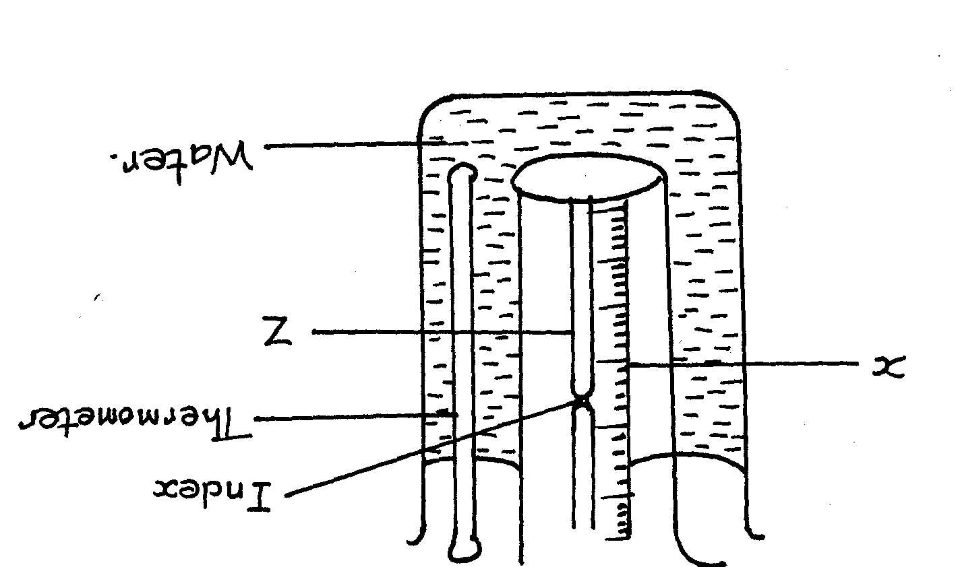

(i) Name the parts labeled X and Z (1mk)

X………………………………………..Z………………………………………….

(ii) State the measurements to be taken in this experiment (2mk)

(iii) Explain how the readings taken in (ii) above may be used to investigate Charles law (2mks)

1. State two purposes of mercury index (2mks)

v) A constant mass of hydrogen gas occupies a volume of 4.0cm3 at a pressure of 2.4x 105 Pa and temperature of 288K. Find its volume at a pressure of 1.6xl05Pa when the temperature is 293K (3mks)