**MARKING SCHEME**

**232/2**; **PHYSICS**

**PAPER 2**

**JULY2024**

**TIME: $2$ HRS**

**MOKASA II JOINT EXAMINATION.**

***Kenya Certificate of Secondary Education (K.C.S.E.)***

**INSTRUCTIONS TO CANDIDATES**

* Write your name and index number in the spaces provided.
* Mathematical tables and non-programmable calculators may be used.
* h= 6.63 x 10-34Js, c = 3.0 x 108m/s ; e = 1.6 x 10-19C.
* Attempt all the questions in the spaces provided.
* ALL working MUST be clearly shown.

**For Examiners Use**

|  |  |  |  |
| --- | --- | --- | --- |
| **SECTION** | **QUESTIONS** | **MAXIMUM SCORE** | **CANDIDATE’S SCORE** |
| **A** | 1 – 10 | 25 |  |
| **B** | 12 | 08 |  |
| 13 | 10 |  |
| 14 | 08 |  |
| 15 | 06 |  |
| 16 | 09 |  |
|  | 17 | 08 |  |
|  | 18 | 06 |  |
|  | **TOTAL** | **80** |  |

***This paper consists of 12 printed pages. Candidates should check to ascertain that all pages are printed as indicated and that no questions are missing.***

**SECTION A (25 MARKS)**

***Answer all the questions in this section in the spaces provided.***

1.The diagram below shows a pin hole camera and an object **O.**.

O

**-correct rays**

-**small image**

Using two rays on the same diagram show how the image is formed on the screen.(2mks)

2.The diagram below shows a circuit breaker rated 5A.

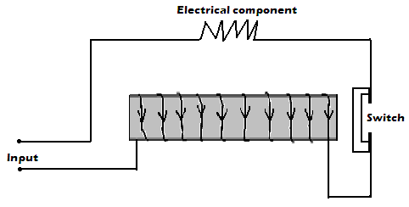

Briefly explain how it works when the current exceeds 5A. (2 mks)

**When excess current flows,increased magnetic power of the electromagnet attracts and opens the switch stopping current flow.**

3.The diagram in the figure below shows paths taken by three radiations K, J and L from a radioactive source through an electric field.

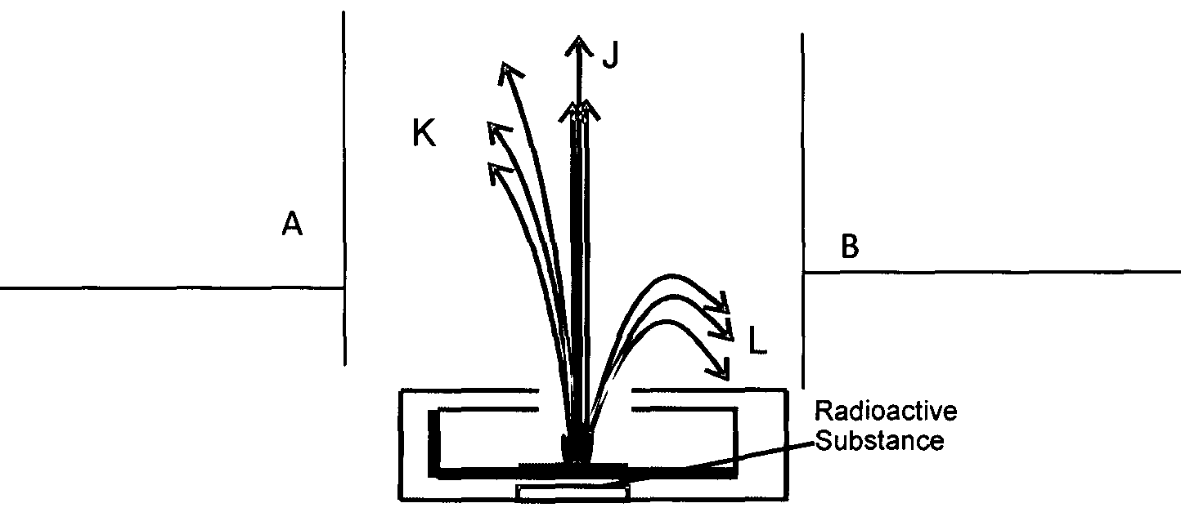

I)State the charge on plate A giving a reason .(2mks)

**Negative charge.It attracts positively charged alpha particle(radiations) K**

4.State two reasons why in determining the depth of an ocean using an echo sounder ,ultra *sound* is preferred to ordinary sound. (2mks)

**-it penetrates deepest**

**-it is easily deflected by tiny grains/objects**

5.You are provided with 2 diodes, a resistor, a centre tapped step-down transformer ,a capacitor and enough connecting wires.In the space provided below, sketch the circuit diagram for a full wave rectifier . (3mks)

**Any of the two diagrams in the text book (KLB)**

6.The figure below shows regions of the electromagnetic spectrum arranged in order of decreasing wavelenght. D is the region of visible light

|  |  |  |  |  |  |  |
| --- | --- | --- | --- | --- | --- | --- |
| A A | B B | C C | D D | E E | F F | G G |

Decreasing wave length

Indicate the region for ; ( 3 mks )

i)X - rays …**B**

ii)Name one detector of radiation A;**Cloud chambers/Geiger muller tube/Photographic plates/photographic emulsions**

iii)Which part of the spectrum is applied in greenhouse…**infrared region E**

7. Ra decays into $\begin{matrix}219 \\ 86\end{matrix}$ Rn by emission of an alpha particle and neutrons. Write a nuclear equation for the decay. (2mks)

**22688 Ra 21986 Rn + 42 He+ 3(10 n)**

8.An object is placed on the axis of a concave mirror of focal length 200mm.If the object is 100mm tall and is placed 300mm from the mirror by scale drawing and using rays determine its image position hence state its nature. (3mks)



**-image is REAL,inverted, magnified and formed beyond C.**

**-correct rays and suitable scale**

9.Define the direction of the magnetic field. (1mk)

**-is the direction which a free north pole would move if placed at that point in the field**

10.The sketch below is a displacement –time graph of a wave travelling at 300m/s

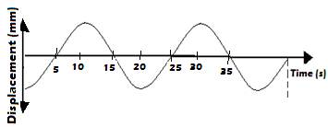

Determine the wavelength of the above wave. (3mks)

**T = 20s**

**f = 1/T = 0.05Hz**

**λ =v/f ;λ = 6000m**

11.State two differences between human eye and a simple camera. (2mks)

**-focal length of the eye lens is variable while that of a camera is fixed**

**-camera can take one photograph at a time when its shutter opens while the eye forms constantly changing pictures when it is opened.**

**-camera can vary image distance while the eye has constant image distance**

**SECTION B(55 MARKS)**

12.a)State the Faradays law of electromagnetic induction . (1mk)

**-the magnitude of the induced emf is directly proportional to the rate of change of magnetic flux linkage**

b) The figure shows a cross- section of a bicycle dynamo. The wheel is connected by an axle to a permanent cylindrical magnet and is rotated by the bicycle tyre

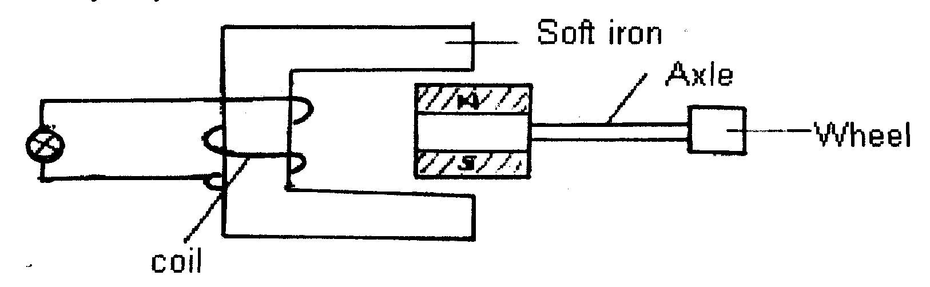

i) Explain why the bulb lights (2mks)

**-rotation of the magnet changes magnetic flux which induces emf on the coil causing current to flow lighting the bulb**

ii) State one way in which the bulb can be made brighter. (1mk)

**-increasing speed of rotation of the wheel**

**-using a stronger magnet**

**-increasing number of turns in the coil**

c)An hair dryer rated 1000W,240V runs for 3hours everyday for seven days.Calculate;

i)the number of kilowatt hour used during that period (2mks)

**number of kilowatt hour = 1Kw x 3 hours x 7 days = 21kWh**

ii)the cost of electrical energy during the period if cost per unit is shs 5.50 per unit. (2mks)

**cost =21kWh x 5.50 = shs 115.50**

13.a)Below is a figure of a simple cell.

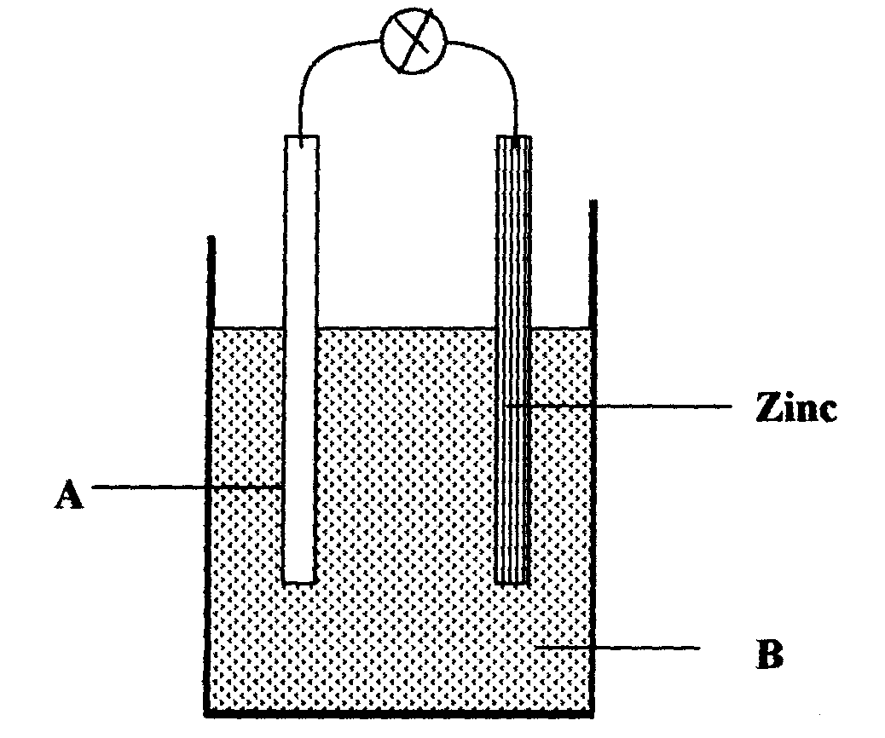

Name;

i)electrode A. **copper** (1mk)

ii)solution B **dilute sulphuric acid** .(1mk)

iii) name the defect that takes place in electrode A and how it can be minimized.

**Polarization.Minimised by adding potassium dichromate,a depolarizer**

(2mks)

b)Figure below shows circuit diagrams (i) and (ii) containing identical bulbs.

1. ii

X

X

X

X

State the observation on the brightness of the bulbs in i) and ii) giving a reason. **Bulbs in (ii) light equally brighter than bulbs in (i) because their total resistance is lower** (2mks)

c)A battery of emf X volts drives a current of 0.42A through a 11Ω resistor.When the same resistor is replaced with a 5Ω resistor the current flowing becomes 0.86A.Determine;

i) the internal resistance of the battery. (3mks)

**E= I(R + r)**

**0.42(11+ r)**

**0.86(5+r)**

**R = 0.7273Ω**

ii)the value of X. (1mk)

**X = 4.925V**

14.a)(i)The minimum energy required to cause a photoelectron to be emitted from a clean zinc surface is 4.0eV.Light with a frequency of 1.2 x 1015Hz is irradiated onto the zinc surface.Show by calculation whether the photons of this light will cause photoelectric effect to occur. (3 mks)

**WO = 4.0eV = 6.4 x 10-19J**

**fo=**

**= 9.6531 x 1014Hz**

**f > fo thus photoelectric effect will take place**

ii)If the light source above is now replaced with a light source which produces light of frequency 1.5 x 1015Hz,find the energy of the emitted photoelectrons.. (3mks)

**KE = hf – wo**

**= 6.63 x 10-34 x 1.5 x 1015– 6.4 x 10-19**

**= 3.545 x 10-19J**

b) The diagram below was used by Valkim to investigate photoelectricity.

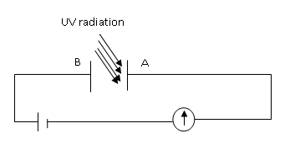

i) Explain how milliammeter reading is affected when the intensity of the UV light above is decreased. (1mk)

-**reading decreases; less photoelectrons reach B**

ii) Explain why there is no reading on the milliammeter when red light is used instead of UV light. (1mk)

**-red light does not have sufficient frequency to cause emission of photoelectrons**

15.a)The figure below shows water waves fronts approaching a boundary between a shallow and deep region.

Shallow Deep

**-waves change direction**

**Upwards**

* **Wavelength increase**

On the same diagram complete the figure to show the wave fronts after crossing the boundary. (2 mks)

b)Explain why light wave diffraction by a width slit of approximately 1mm is unnoticeable. (1mk)

**wavelength of light is very much smaller than the width of the slit.(λ = 5.5 x 10-4mm)**

c)The diagram below shows a ray of light travelling from a medium Z into air.

21

Z

air 30

Determine the refractive index of medium Z.(n of air = 1.000). (3mks)

**n1sin α1 = n2sinα2**

**n sin 21= 1 sin 30**

**n of medium Z = 1.395**

16.a)The diagram below shows an uncharged gold leaf electroscope.

X

i)Name part X ; **brass cap**

II)Why is part X usually circular in shape. (1mk)

**-to ensure uniform distribution of charges on the cap/uniform charge density**

b) The diagram below shows a network of capacitors in a circuit

2 μ F

2μ F

1μ F

3.0 V

Determine;

i)Effective capacitance in the circuit. (2mks)

**CT =3 x 2**

**=1.2µF**

ii)The charge across the 1μF capacitor. (2mks)

**QT = 1.2x 3 =3.6µC**

**Vin 2 and 1µF= 1.2V**

**Qin 1µF = 1.2µC**

iii)The energy in the 1μF capacitor. (3mks)

**E = CV2**

**= 0.5 x 1 x 10-6x1.22**

**= 7.2 x 10-5J**

17.a)Define thermionic emission. (1mk)

**-the process of emissions of electrons due to heat energy**

b)The diagram below shows cathode rays directed into a magnetic field (the magnetic field is out of the paper).

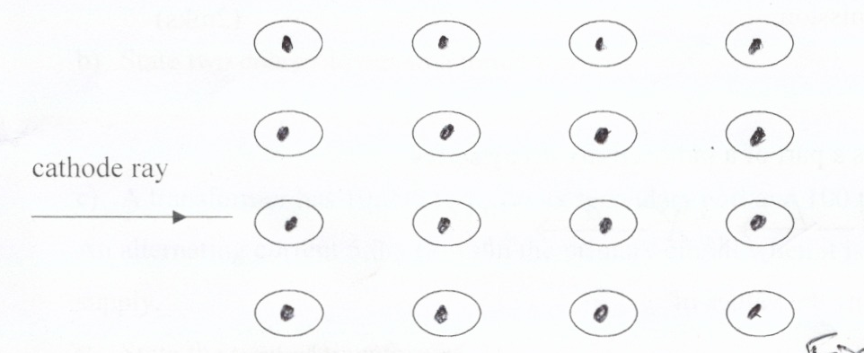

**-ray curves upwards**

Complete the diagram to show the path of the cathode ray. (1mk)

c)The diagram below is an X-ray tube .

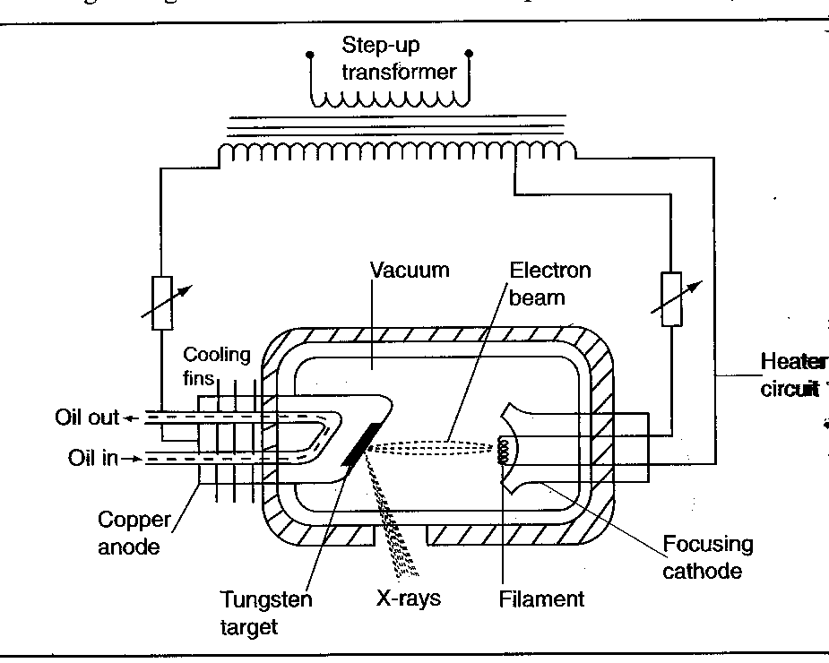

i)Give a reason why the anode target rotates during operation. (1mk)

**-to change point of impact,reducing wear and tear on it**

ii)What metal is suitable as an anode give a reason for it. (2mks)

**-copper;a good conductor of heat/good thermal conductor/efficient dissipater of heat**

iii)The X-ray tube above produces electrons which are accelerated by a potential difference of 120kv.Assuming all energy is used to produce X-rays,determine the minimum wavelength of X-rays produced. (3mks)

**λ = hc/eV**

**= 6.63 x 10-34x 3 x108/1.6 x 10-19 x120000**

**= 1.036 x 10-11m**

18.a)Define the term principal focus of a converging lens. (1mk)

**-is the point on the principal axis to which rays parallel and close to the principal axis converge after refraction by the lens**

b)Figure below shows an image **I** formed by a concave lens.**F** **and F**1 are the principal foci.

F F1

**-correct rays**

-**correct object position**

Complete the diagram using rays to show object position. (2mks)

c)An object 1cm tall stands on the principal axis of a convex lens 10cm from it. A virtual image of the object 2.5cm tall is formed by the lens. Determine the focal length of this lens. (3mks)

**u = 10cm,M = 2.5,M = v/u**

**v = -25cm**

**f = 16.67cm**