**Name: ……………………………………………… Index No.: ……………....................**

**School: …………………………Candidate’s Signature: ………………Date: …………**

**232/1**

**PHYSICS**

**(THEORY)**

**PAPER ONE**

**JULY 2024**

**TIME: 2 HOURS**

**MOKASA II JOINT EXAMINATION-2024**

***Kenya Certificate Of Secondary Education (KCSE)***

**Instructions to Candidates**

* This paper consists of sections: **A** and **B.**
* Answer **ALL** the questions in section **A** and **B** in the spaces provided.
* **ALL** working **MUST** be clearly shown in the spaces provided.
* Mathematical tables and electronic calculators may be used.

**For Examiner’s Use Only**

|  |  |  |  |
| --- | --- | --- | --- |
| **SECTION** | **QUESTION** | **MAXIMUM SCORE** | **CANDIDATE’S SCORE** |
| **A** | 1 – 10 | 25 |  |
| **B** | 11 | 09 |  |
| 12 | 07 |  |
| 13 | 09 |  |
| 14 | 08 |  |
| 15 | 10 |  |
| 16 | 12 |  |
| **TOTAL SCORE** |  | **80** |  |

***This paper consists of 14 printed pages. Candidates should check the question paper to ascertain that all the pages are printed as indicated and no questions are missing***

**SECTION A (25 Marks)**

1. A student measured the diameter of a nichrome wire as 0.36mm. On the space provided, draw the micrometer screw scale reading. **(2mks)**
2. (a) The diagram below shows a wire loop with a thread tied across it. The loop is dipped into a soap solution such that the soap film covers it as shown.

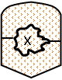

Region **X** is punctured. On the space alongside the diagram sketch the resulting shape of the wire loop. Give a reason for the shape. **(2mks)**

………………………………………………………………………………………………………………………………………………………………………………………………………………………………………………………………………………………………………………………………………………

(b) Diana placed her finger on water as shown in the diagram below.

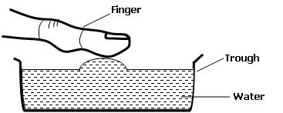

Name the force that lifts the water to the finger. **(1mk)**

………………………………………………………………………………………………………………

1. The diagram below shows a cuboid with dimensions **20cm by 20cm by 40cm** of mass **5kg.**

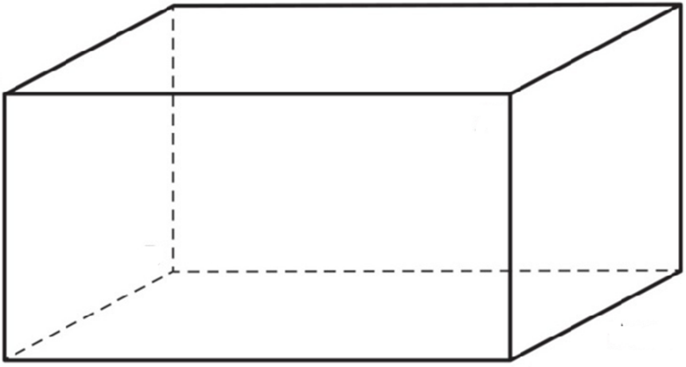

**20cm**

**20cm**

**40cm**

State and explain how it should be placed on a flat surface in order to exert minimum pressure on the surface. **(2mks)**

………………………………………………………………………………………………………………………………………………………………………………………………………………………………………………………………………………………………………………………………………………

1. Explain the formation of steam at **1000C** using the particulate nature of matter. **(2mks)**

………………………………………………………………………………………………………………………………………………………………………………………………………………………………

1. The figure below shows a simple bimetallic strip used for detecting fire.

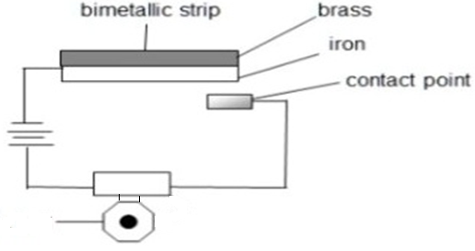

**Siren**

Describe how the fire alarm works. **(3mks)**

………………………………………………………………………………………………………………………………………………………………………………………………………………………………………………………………………………………………………………………………………………………………………………………………………………………………………………………………

1. Jane stirred hot tea using a metal spoon and observed that the handle of the spoon soon becomes warm. State two ways through which the heat is conducted to reach the hand. **(2mks)**

………………………………………………………………………………………………………………………………………………………………………………………………………………………………………………………………………………………………………………………………………………

1. The diagram below shows a uniform metal bar of mass 150g balanced horizontally by a force, **F.**

F

**125cm**

**75cm**



1. Determine the value of the force, **F**. **(2mks)**
2. Calculate the reaction force on the pivot. **(1mk)**
3. The diagram below shows an arrangement of two identical light springs. Each spring has a length of **5cm** when unstretched. The total length of the two springs is **15cm** when supporting a load of **2N.**



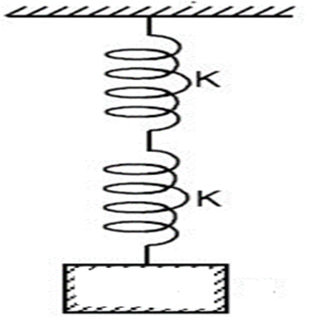



Calculate:

1. The extension on each spring **(1mk)**
2. The combined spring constant **(2mks)**
3. The diagram below shows an aerofoil moving in the direction shown in air at a high velocity.

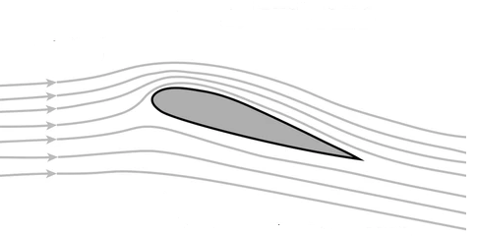



State and explain the direction of the force acting on the aerofoil. **(2mks)**

………………………………………………………………………………………………………………………………………………………………………………………………………………………………………………………………………………………………………………………………………………………………………………………………………………………………………………………………

1. The diagram below shows a variation of force acting on an object over a distance of 20 metres

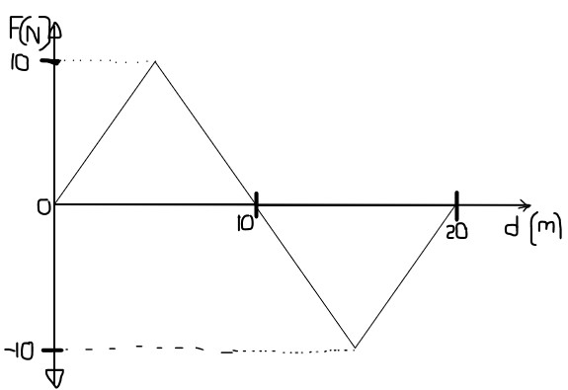

Find the total work done on the object. **(3mks)**

**SECTION B (55 Marks)**

1. (a) The set up below shows a ticker timer used to determine acceleration due to gravity at Moi Girls’ High School - Eldoret.

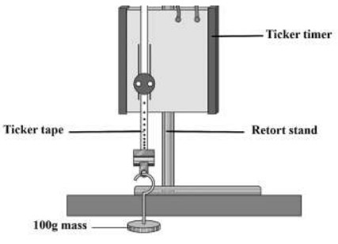

Briefly describe how the set up can be used to determine the value of acceleration due to gravity at the school. **(3mks)**

………………………………………………………………………………………………………………………………………………………………………………………………………………………………………………………………………………………………………………………………………………………………………………………………………………………………………………………………………………………………………………………………………………………………………………………………………………………………………………………………………………………………………………………………………………………………………………………………………………………………………………………………………………………………………………………………

(b) A block of wood of mass **40kg** is pulled along a horizontal rough surface with a force of **150N.** Given that the coefficient of friction between the block and the horizontal rough surface is **0.2.** Calculate:

1. The frictional force between the block and the surface. **(3mks)**
2. The acceleration of the block. **(2mks)**
3. (a) Define work and state it’s SI Unit. **(2mks)**

………………………………………………………………………………………………………………………………………………………………………………………………………………………………

(b) The diagram below shows a wheel and axle as a machine used to lift a load of **600N** using an effort of **60N.**

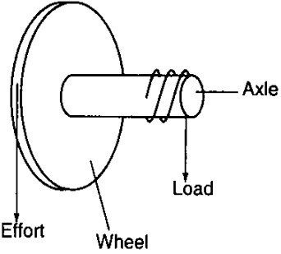

**60N**

**600N**

If the radius of the wheel is **20cm** and that of axle is **2cm**, determine the machine’s:

1. Mechanical advantage **(1mk)**
2. Velocity Ratio **(2mks)**
3. Efficiency **(2mks)**
4. (a) Define specific heat capacity **(1mk)**

………………………………………………………………………………………………………………………………………………………………………………………………………………………………

(b) Figure below shows a set up in an experiment to determine specific heat capacity of water.

**Thermometer**

**Electric Heater**

The data below was obtained from the experiment.

* Voltage (V) across the heater =**12V**
* Current (I) in the circuit  **= 1.4A**
* Time (t) for heating **= 600s**
* Mass (m) of water **= 0.4kg**
* Change in temperature ΔT **= 6ºC**

Determine:

1. The electrical heat energy **(2mks)**
2. Use the above results to determine the specific heat capacity of water. **(3mks)**
3. The power of the electrical heater. **(2mks)**
4. (a) If the volume of a fixed mass of a gas is tripled at constant temperature, what happens to its pressure. **(1mk)**

………………………………………………………………………………………………………………………………………………………………………………………………………………………………

(b) The diagram below shows apparatus used to verify Charles’ Law.

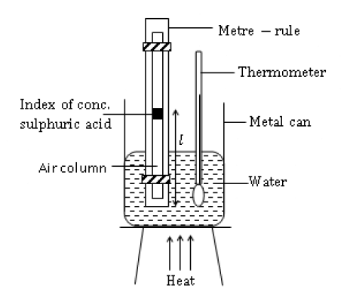

1. State the measurements to be taken from the apparatus **(2mks)**

………………………………………………………………………………………………………………………………………………………………………………………………………………………………

1. Describe how apparatus can be used to verify the law **(3mks)**

……………………………………………………………………………………………………………………………………………………………………………………………………………………………………………………………………………………………………………………………………………………………………………………………………………………………………………………………………………………………………………………………………………………………………………………………………….………………………………………………………………………………………………………………………………………………………………………………………………………………………………………………………………………………………………………………….………………………………………………………………………………………………………………

(c) A gas has a volume of **20cm3** at **270C** and at normal atmospheric pressure. Calculate the new volume of the gas if it is heated to **540C** at the same pressure. **(2mks)**

1. (a) State Archimedes Principle **(1mk)**

………………………………………………………………………………………………………………………………………………………………………………………………………………………………………………………………………………………………………………………………………………

(b) The system below is in equilibrium and balanced at the centre of gravity.

**X**

**40cm**

**50g**

**90g**

**Water**



**Block**



1. When the temperature of the water is raised, the system is observed to tilt to the right. State the reason for this observation. **(2mks)**

………………………………………………………………………………………………………………………………………………………………………………………………………………………………

1. Given that the block is half **(1/2)** immersed and its dimensions are **2.0cm by 2.0cm by 6.0cm.** Calculate the volume of the water displaced by the block. **(2mks)**
2. Calculate Upthrust and hence the apparent weight of the block. ***(Given the density of water is 1000kg/m3)***  **(2mks)**
3. Determine the value of distance X. **(3mks)**
4. A mass of **100g** is whirled in a vertical plane using a string of radius **50cm** as shown below in the clockwise at a speed of **2m/s.**

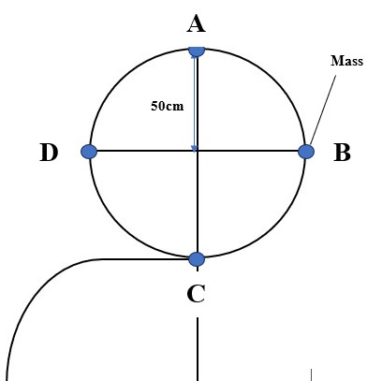



1. Determine:
2. The angular velocity. **(2mks)**
3. The tension, **T** on the string at point C. **(3mks)**
4. If the string snaps at point C, **50cm** above the ground. Determine:
5. The time taken for the mass to hit the ground. **(2mks)**
6. The horizontal distance travelled before hitting the ground. **(2mks)**
7. Explain how a centrifuge may be used to separate cream from milk. **(2mks)**

………………………………………………………………………………………………………………………………………………………………………………………………………………………………………………………………………………………………………………………………………………………………………………………………………………………………………………………………………………………………………………………………………………………………………………………………………………………………………………………………………………………………

**THIS IS THE LAST PRINTED PAGE**

**SUCCESS IN THE EXAMS!!!**