LANJET PRE MOCK EXAMINATION - 2024

**PAPER 2**

**MARKING SCHEME**

|  |  |  |  |
| --- | --- | --- | --- |
|  | **MAIN SCHEME** | **MARKS** | **COMMENTS** |
| 1 | Perimeter = 2(l + w)  Absolute error for both length and width = 0.5  Max perimeter = 2(80.5 + 60.5)  = 282  Actual perimeter = 2(80 + 60)  = 280  Percentage error = $\frac{282-280}{280}$ x 100  = 0.714 $≅$ 0.7 | B1  M1  A1 | For either max, actual or min perimeter |
|  |  | 03 |  |
| 2 | Det (Δ) = (4 x -2) – (3 x 5)  = -8 – 15 = -23 $$-\frac{1}{23}\left(\begin{matrix}-2 & -3 \\ -5 & 4\end{matrix}\right)$$ = $\left(\begin{matrix}\frac{+2}{23} & \frac{3}{23} \\ \frac{5}{23} & \frac{-4}{23}\end{matrix}\right)$ = $-\frac{1}{23}\left(\begin{matrix}-2 & -3 \\ -5 & 4\end{matrix}\right)\left(\begin{matrix}4 & 3 \\ 5 & -2\end{matrix}\right)\left({x \atop y}\right)$ $$= -\frac{1}{23}\left(\begin{matrix}-2 & -3 \\ -5 & 4\end{matrix}\right)\left({18 \atop 11}\right)$$ $$\left({x \atop y}\right)= \left({+3 \atop +2}\right)$$ x = 3, y = 2 | B1  B1  M1  A1 |  |
|  |  | 04 |  |
| 3 | 5(5x)2 – 15(5x) + 10 = 0  Let 5x be A  5A2 – 15A + 10 = 0  (A – 2) (A – 1) = 0  A = 2 **or**  1  5x = 2 **or** 5x = 1  x = $\frac{\log{2}}{\log{5}}$**or** x = 0 | M1  M1  A1  B1 | For ✓quad equation formed  Or subst in quadration formula  For both |
|  |  | 04 |  |
| 4 | x + 3x – 30o = 90o  1  2  30  4x = 120  x = 30  tan 30o = | B1  B1  B1 |  |
|  |  | 03 |  |

|  |  |  |  |
| --- | --- | --- | --- |
| 5 | ∠WXZ = 180 – 60o  = 120o  ∠ZWX = 180 – (50 + 120)  = 10o  ∠YZW = 10o alternate angles to ZWX | B1  B1 |  |
|  |  | 02 |  |
| 6 | 1. Cost of the mixture $$\frac{120 ×6+200 ×5}{11}$$  = $\frac{720+1000}{11}$ = $\frac{1720}{11}$ = 156.36 $≅$ 156/- to the nearest shilling   1. % profit = ?   250 – 156  = 94 $∴ \frac{94}{156}$ x 100 $$=60.26\%$$ | M1  A1  M1  A1 | To the nearest shilling  2 d.p |
|  |  | 04 |  |
| 7 | $$\frac{\left(\sqrt{2}+2 \sqrt{5}\right)\left(\sqrt{5}+ \sqrt{2}\right)}{\left(\sqrt{5}- \sqrt{2}\right)\left(\sqrt{5}+ \sqrt{2}\right)}$$ $$\frac{\sqrt{10}+4+10+2 \sqrt{10}}{3}$$ $$\frac{3\sqrt{10}+14}{3}$$ $$\sqrt{10}+\frac{14}{3}$$ | M1  M1  A1 |  |
|  |  | 03 |  |
| 8 | 3.1522 = 9.9351  3 x 0.1540 + 4 x 0.1007  0.462 + 0.4028  = 0.8648 | B1  M1  M1  A1 | For both and square |
|  |  | 04 |  |
| 9 | M =  P = m + mk2  m = P – mk2  h = | M1  M1  A1 |  |
|  |  | 03 |  |

|  |  |  |  |
| --- | --- | --- | --- |
| 10 | $$\frac{a}{\sin{A}}=\frac{b}{\sin{B}}=\frac{c}{\sin{C}}=2R$$ Let one of the sides be a $$∴\frac{a}{\sin{60 }}= 2 ×R$$ $$→\frac{a}{\sin{60 }}= \frac{2 ×9}{T}$$ $$→a=18\sin{60}$$ $a$ = 18 x 0.8660  = 15.588  = 15.59 cm | M1  A1 |  |
|  |  | 02 |  |
| 11 | $$\frac{\left(3x+1\right)\left(3x-1\right)}{\left(3x-1\right)\left(x+1\right)}$$ = $\frac{\left(3x+1\right)}{x+1}$ | B1  B1  B1 | For num  For deno |
|  |  | 02 |  |
| 12 | y1 = 0, y2 = 3, y3 = 4, y4 = 3, y5 = 0  Area = ½ x (1 x 1 (0 + 0) + 2 (3 + 4 + 3)  ½ (2 x 10)  = 10 | B1  M1  A1 | All values✓ |
|  |  | 03 |  |
| 13 | (x + 3)2 + (-y – 2)2 = 32  x2 + 6x + 9 + y2 + 4y + 4 = 9  x2 + y2 + 6x + 4y + 4 = 0 | M1  M1  A1 |  |
|  |  | 03 |  |
| 14 | y = (x2 + 1) (x – 2)  y = x3 – 2x3 + x – 2  = 3x2 – 4x + 1  When x = 2;  M = 3 x 4 – 4 x 2 + 1  = 5  M1 =  when x = 2 y = 0  5y = -x + 2  **Or** y = $\frac{-1}{5}x+\frac{2}{5}$ | M1  M1  M1  A1 | For |
|  |  | 04 |  |

|  |  |  |  |
| --- | --- | --- | --- |
| 15 | 1. 1 + + 5 +   1 - -   1. 1 - (0.04) + (0.04)2 - (0.04)3   1 – 0.1 + 0.004 – 0.00008  = 0.90392 | B1  M1  A1 | ✓Substitution  CAO |
|  |  | 03 |  |
| 16 | x + 60 + x = 180o  2x + 60 = 180  2x = 120  x =  = 60o | M1  A1 | For eqn |
|  |  | 02 |  |
|  | **SECTION II** |  |  |
| 17 | 1. i) Taxable income   21200 + 12000 + 1100 + 2000  = 36,300  ii) Payee  First $\frac{8400}{20} ×2$ = 840/-  Next $\frac{9600}{20} ×3$ = 1440/-  Next $\frac{12000}{20} ×4$ = 2400/-  Next $\frac{6000}{20} ×5$ = 1500/-  Remaining $\frac{300}{20} ×6$ = 90/-  Tax payable 6,270/-  Less personal relief 1,240  Net payee = 5,030/-   1. Net salary   36,300 (5030 + 250 + 120 + 4500 + 1800)  Net salary = 36,300 – 11700  = 24,600/- | M1  A1  B1  B1  B1  M1  A1  M1  M1  A1 | Subtract relief from Tot.Tax. |
|  |  | 10 |  |

18.

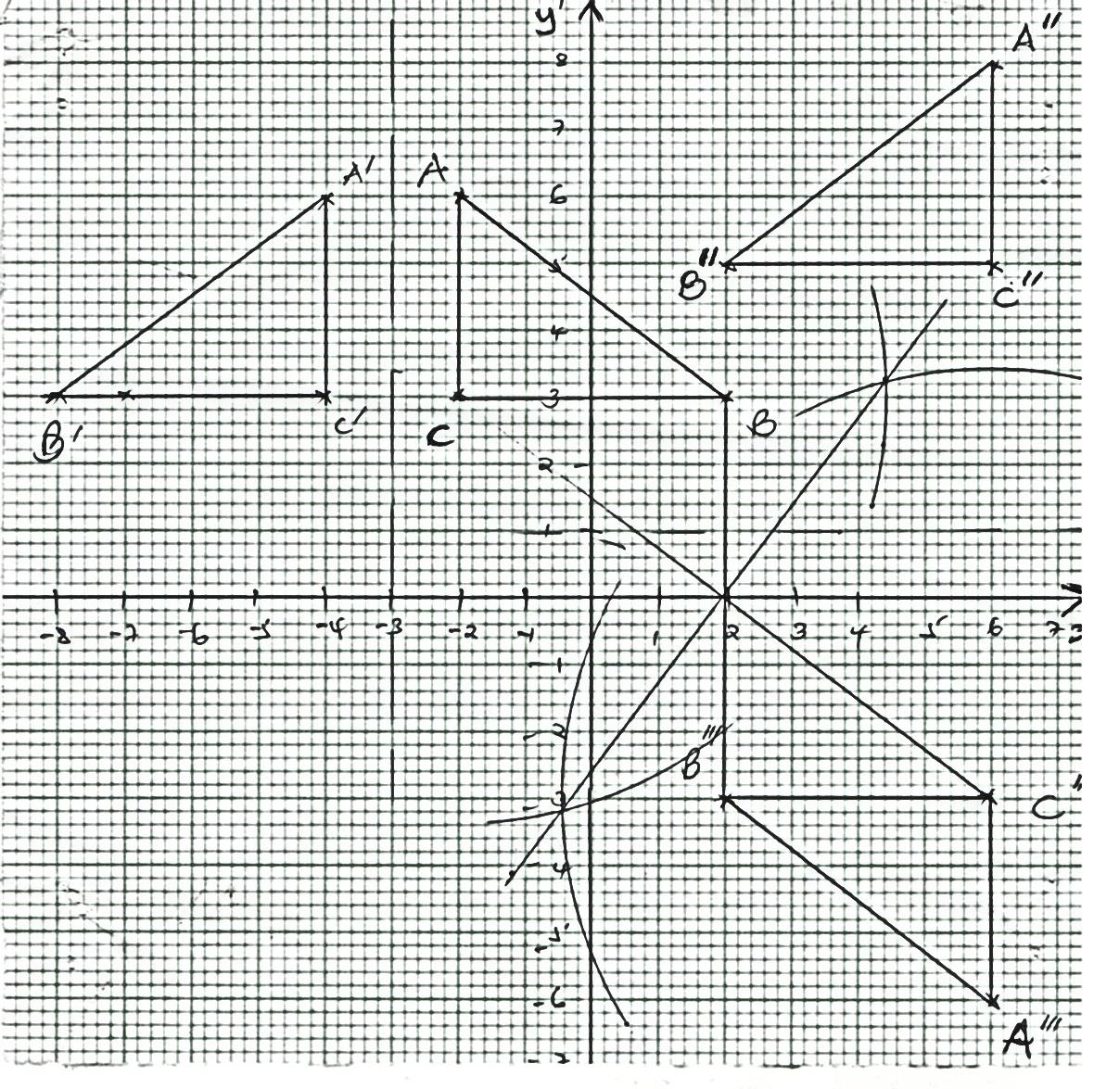

B1 object ABC

B1 image A1B1C1

B2 A11B11C11

B1 Identifying centre

B1 Drawing A111B111C111

B1 Describing int transformation

Ref. in the line y =0

B1 Joining corresponding points

B1 all construction and angle identification

B1 describing the transformation (Rotation of 1800 about (2,0)

|  |  |  |  |
| --- | --- | --- | --- |
|  |  | 10 |  |
| 19 | 1. Prime No 2, 3, 5, 7   Multiple of 3 3, 6, 9 but 3 cannot be selected twice  P(Prime number or multiple of 3)  =   1. i)  |  |  |  |  |  | | --- | --- | --- | --- | --- | |  | 1 | 2 | 3 | 4 | | H | H1 | H2 | H3 | H4 | | T | T 1 | T 2 | T 3 | T 4 |   ii) P (at least 2 and a head)  P(H2 or H3 or H4)  =   1. i) P(B) =   5x = 3x + 18  2x = 18  x = 9  No of members = 9 + 6 = 15  ii) P(W and B) or P(B and W)  = P(W) x )P(B) + P(B) x P(W)  = $\frac{6}{15} ×\frac{3}{5}+\frac{3}{5} ×\frac{6}{15}$ = $\frac{6}{25}+\frac{6}{25}=\frac{12}{25}$ | B1  B1  B1  B1  B1  M1  A1  B1  M1  A1 | Or equivalent  Or equivalent |
|  |  | 10 |  |
| 20 | C:\Users\Main\AppData\Local\Microsoft\Windows\Temporary Internet Files\Content.Word\003.jpg   1. i) 140o   ii) PQ dist 4.2cm → 4.2 km $±$ 0.1km  RY Dist 2.6 cm → 2.6 km $±$ 0.1km | S1  B1  B1  B1  B1  B1  B1  B1  B1  B1 | ✓Scale  For locating Q from Y  For locating x from y  ✓Location of X  For locating P  For locating R from Y  For locating R from Q  ✓location of R |
|  |  | 10 |  |
| 21 | C:\Users\Main\AppData\Local\Microsoft\Windows\Temporary Internet Files\Content.Word\004.jpg  h =  =  = 4.03cm  FH =  =  = 19.7cm  AH =  =  = 20.11cm  C:\Users\Main\AppData\Local\Microsoft\Windows\Temporary Internet Files\Content.Word\004.jpg  →63.61o  C:\Users\Main\AppData\Local\Microsoft\Windows\Temporary Internet Files\Content.Word\004.jpg  12.62o   1. V = Cross section area x l   = ½ x (8 + 10)4.03 x 18  = 652.86cm3 | M1  M1  M1  M1  A1  M1  A1  M1  A1  M1  A1 | For h  For FH  For expression |
|  |  | 10 |  |

22.a)

|  |  |  |  |  |  |  |  |  |  |  |  |  |  |
| --- | --- | --- | --- | --- | --- | --- | --- | --- | --- | --- | --- | --- | --- |
| x | 0 | 30 | 60 | 90 | 120 | 150 | 180 | 210 | 240 | 270 | 300 | 330 | 360 |
| 2 sin x | 0 | 0.25 | 0.43 | 0.5 | 0.43 | 0.25 | 0 | -0.25 | -0.43 | -0.5 | -0.43 | 0.25 | 0 |
| Sin x | 0 | 0.5 | 0.87 | 1 | 0.87 | 0.5 | 0 | -0.5 | -0.86 | -1.0 | -0.87 | -0.5 | 0 |

B2 for all correct

B1 for at least 5 correct

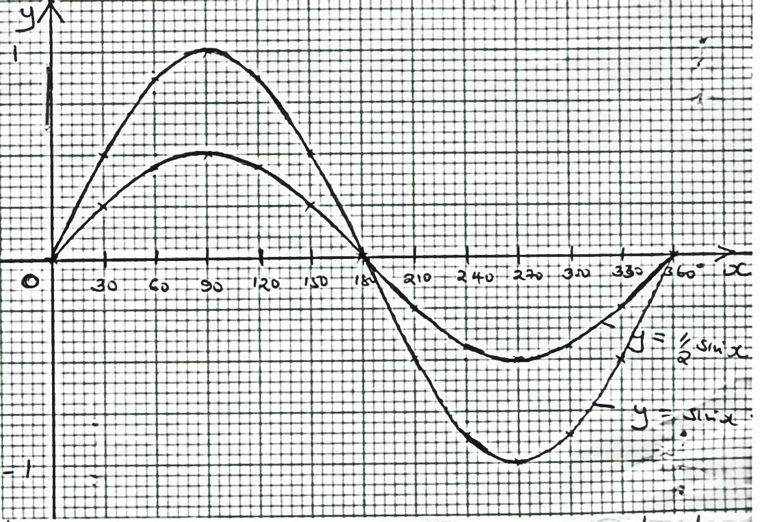b)

S1

P1

C1

P1

C1

|  |  |  |  |
| --- | --- | --- | --- |
| 22 | c) Range 0 180o  or x between 0 and 180o  d) Period = 360o  Amplitude = 0.5cm | B1  B1  B1 |  |
|  |  | 10 |  |
| 23 | 1. S = 2t3 + t2 + 3t + 4   = V = -6t2 + 3t + 3  When t = 0  a = -12 (0) + 3  = 3 ms-2   1. i) The particle is at rest when v = 0   -6t2 + 3t + 3 = 0  -6t2 + 6t – 3t + 3 = 0  (-6t – 3) (t – 1) = 0  t = - ½ ; t = 1  The particlewasatrestat t = 1  ii) Particle at rest at t = 1  S = -2(1)3 + (1)2 + 3(1)  D = 6 ½ m   1. maximum velocity is at a = 0   0 = -12t + 3  t = ¼ sec  V = -6t2 + 3t + 3, at t = ¼  -6 (¼)2 + 3(¼) + 3  = 3 m/s | M1  M1  A1  M1  M1  A1  M1  A1  M1  A1 | For expression |
|  |  | 10 |  |

|  |  |  |  |
| --- | --- | --- | --- |
| 24 | 1. x + y 100   2x + 6y $≤$ 480  x + 3y $≤$ 240  x $≥$ 10  y $≥$ 20 | B1  B1  B1  B1 |  |

b)

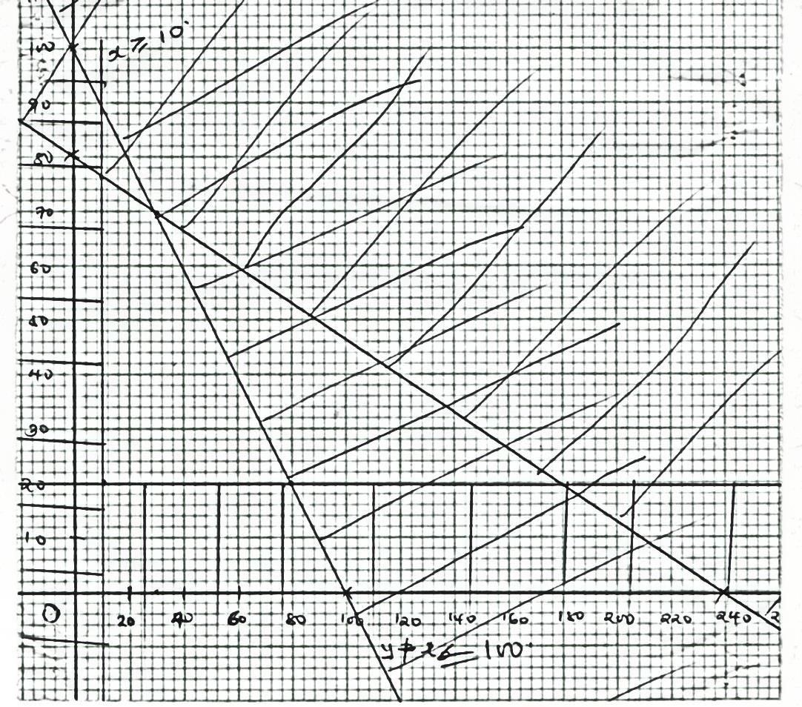

|  |  |  |  |
| --- | --- | --- | --- |
|  | x + y $≤$ 100 → (0, 100) and (100, 0)  x + 3y $≤$ 240 → (0, 80) and (240, 0)  x $≥$ 10  y $≥$ 20  c) 200x + 300y = profit  Taking (30, 40)  2x + 3y = 180  Max profit = (200 x 30) + (300 x 70)  = 27,000/- | B1  B1  B1  B1  B1  M1  A1 | drawn and shaded  drawn and shaded  drawn and shaded  drawn and shaded |
|  |  | 10 |  |