**KASSU JET**

**Kenya Certificate of Secondary Education**

**MOCK EXAMINATIONS 2024**

**121/1 Mathematics Alt A Paper 1**

**June 2024 Time: 2½ Hours**

**Name**: ………………………………………….…….…… **Adm** **No**:……….

**Class**: ………………**Candidate’s** **Signature**: ……….…….. **Date: ­­­­………………**

**School…………...........Index number……………………..**

***Instructions to Candidates***

1. *Write your name, admission number class and index number in the spaces provided above.*
2. *Sign and write the date of examination in the spaces provided above.*
3. *This paper consists of* ***two*** *sections****; Section I*** *and* ***Section II.***
4. *Answer* ***all*** *the questions in* ***Section I*** *and any* ***five*** *questions from* ***Section II***
5. ***Show all the steps in your calculations, giving your answers at each stage in the spaces provided below each question***
6. *Marks may be given for correct working even if the answer is wrong.*
7. *Non-programmable silent electronic calculators and KNEC Mathematical tables may be used, except where stated otherwise.*

**FOR EXAMINER’S USE ONLY**

**Section I**

|  |  |  |  |  |  |  |  |  |  |  |  |  |  |  |  |  |
| --- | --- | --- | --- | --- | --- | --- | --- | --- | --- | --- | --- | --- | --- | --- | --- | --- |
| **1** | **2** | **3** | **4** | **5** | **6** | **7** | **8** | **9** | **10** | **11** | **12** | **13** | **14** | **15** | **16** | **TOTAL** |
|  |  |  |  |  |  |  |  |  |  |  |  |  |  |  |  |  |

**Section II**

|  |  |  |  |  |  |  |  |  |
| --- | --- | --- | --- | --- | --- | --- | --- | --- |
| **17** | **18** | **19** | **20** | **21** | **22** | **23** | **24** | **TOTAL** |
|  |  |  |  |  |  |  |  |  |

**Grand Total**

**SECTION I (50 MARKS)**

**Answer all questions in this section**

1. Evaluate without using tables or calculator:  correct to 3 decimal places (3 marks)
2. Two of the exterior angles of a polygon are each 63o. The remaining exterior angles are each 260. Determine the number of sides of the polygon and hence the name. (3 marks)

1. Koech and Kigen began a 10000 m race together at the starting line. Koech and Kigen took 36 seconds and 48 seconds respectively to run a 400 m lap. The two athletes were together again at the starting line after some time. Determine the number of laps that Kigen had to run to complete the race after they were together. (3 marks)
2. In the figure below ABF is a uniform cross section of a solid. AB, BC and BF are some of the visible edges of the solid. Complete the sketch showing the hidden edges with broken lines. (3 marks)

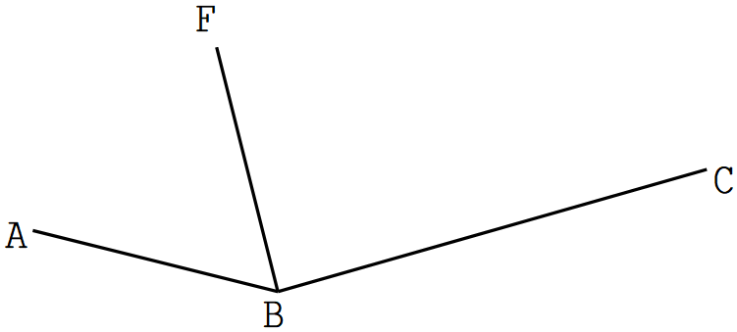

1. A Kenyan bank bought and sold Japanese Yen when the rate are as shown below.

Buying (Ksh) Selling (Ksh) 100 Japanese Yen 84.00 85.50

A Kenyan businessman travelled to Japan and converted Ksh. 1 613 760 to Japanese Yen. He spends 75% of the amount and then converted the balance into Kenyan shillings at the bank when buying rate increased by 1.4% and selling rate increased by 1.3%. Calculate the amount of money in Kenyan shilling that he received.

(3 marks)

1. (a) Line PQ given below is one of side of a parallelogram PQRS. Using a ruler and a pair of compass only, construct the parallelogram given that ∠SPQ = 75° (2 marks)



(b) Drop a perpendicular from R to PQ produced at T. Measure RT. (2 marks)

1. Six tractors each working 8 hours a day can plough a field in 5 days. Calculate the number of days that four tractors working 10 hours a day would take to plough the field. (3 marks)
2. Rina has several buses, each with a driver and a conductor. All her drivers earn the same wage and all conductors earning are also equal. Any three drivers and four conductors earn a total of Ksh. 7 500 per day and the difference in driver’s earning and conductor’s earning per day is Kshs. 400. Calculate the daily wage of a driver. (3 marks)
3. From a point Mary notices that the angle of elevation of the top of a tree is 280 , she then walks 10m towards the tree and finds that the angle of elevation of the top of the tree is now 340. Calculate the height of the tree to 1 decimal place given that Mary is 1.5m tall. (3marks)
4. Under an enlargement with scale factor -1.5, the point R (2, -8) is mapped onto R’ (10, 5). By calculation, determine the coordinates of the center of enlargement.

(3marks)

11. Use tables of squares, square roots and reciprocal to find the value of x if its given that

x= $\frac{2}{\sqrt{0.4278}}$ + $\frac{1}{{6.04}^{2}}$ (4marks)

12. The number line below represents the solution for some given inequalities



Form the two inequalities represented above and write them as a compound statement

(3 marks)

1. The coordinate of A (-2,5) and B(x, 0), calculate the value of x if the magnitude of AB is 13 units

(3 marks)

1. Simplify completely ${\left[\frac{{\left(m+5n\right)}^{2}+{\left(m-5n\right)}^{2}}{3m^{2}+75n^{2}}\right]}^{-1}$

(3 marks)

1. Calculate the values of x and a in the equation $\frac{4^{2x}-2^{2x}}{2^{2x}-2^{x}}=20$

(3 marks)

1. Find the equation of the normal to the curve $y=x^{3}+2x^{2}-4x$ when x = -1

(3 marks)

**SECTION II (50 MARKS)**

*Answer any* ***FIVE*** *questions in this section*

1. During a surveying exercise to establish a housing of affordable houses units, a surveyor marked out four points P, Q, R and S to represent an area to be left out for other social amenities. Point Q is 480m on a bearing of N75°E from P. Point R lie on a bearing of 150° at a distance 600m from Q. S is directly south of P a distance of 640m.
2. Draw a scale drawing to represent the relative position of the area under survey (Scale: 1cm represents 80 m).

(4 marks)

1. Using the scale in (a) above, determine
2. the compass bearing of point R from S

(1 mark)

1. the distance of point S from point Q

(2 marks)

1. An emergency water point is located within the area marked such that it is equal in distance from line QR and RS. Locate the water point and measure its distance from point P.

(3 marks)

1. The histogram below is drawn from marks obtained by students

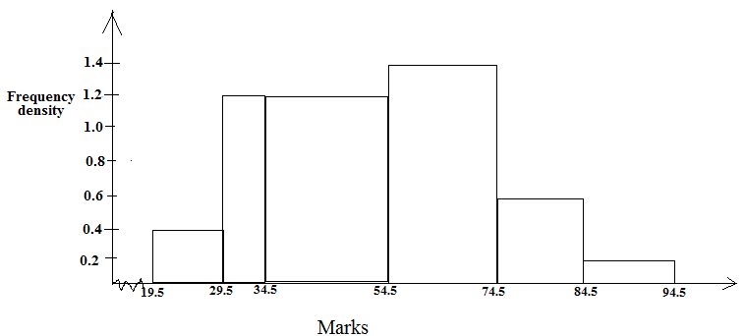

(a) Use it to fill the table below

(4 marks)

|  |  |  |
| --- | --- | --- |
| Classes | Midpoint | Frequency |
|  |  |  |
|  |  |  |
|  |  |  |
|  |  |  |
|  |  |  |
|  |  |  |

(b) Calculate the mean mark.

(3 marks)

(c) Calculate the median mark

(3 marks)

1. (a) A Nissan travelling at a speed of 90 km/h left Nairobi for Nakuru at 9.00 a.m. Half an hour later, a bus left Nakuru for Nairobi at a speed of x km/h. The two vehicles met at a point 180 km from from Nakuru at 11.00 am. Find the value of x

(4 marks)

(b) Given that the bus had a puncture that lasted 20 minutes to repair, determine which vehicle arrived at its destination first and by how long

(4 marks)

(c) Find the distance between town A and B

(2 marks)

.

1. (a) Given that **A-1** = , find matrix A

(2 marks)

(b) A student bought 16 exercise books and 10 pens at a total cost of Kshs. 1018. If she had bought 12 exercise books and 8 pens, she would have spent Kshs. 242 less.

1. Form a matrix equation to represent the information above (2 marks)
2. Using the inverse of A in (a) above, determine the price of each item (4 marks)

(c) Find the total cost of 4 books and 5 pens by using matrices of orders $1×2$ and $2×1$ respectively

(2 marks)

1. ABCD is a parallelogram with A(1,1) and C(8,10). The equation of AB is $4x-5y=-1$ and the equation of BC is $5x-2y=20$. Determine
   1. The coordinates of M, where M is the point of intersection of the diagonals

(2 marks)

* 1. The coordinates of the vertices of B and D

(6 marks)

* 1. The length of AB correct to 3 significant figures

(2 marks)

22. A1(-1,0) B1(-1,2) and C1(-4,0) is the image of A(2,1), B(4,1) and C(2,4) respectively under a rotation



1. Plot the two triangles on the grid provided (2 marks)
2. By construction find the center and angle of rotation

(3 marks)

1. $A^{''}B^{'' }C^{''}$ is the image of A1B1C1 under enlargement, center (-2,-1) and scale factor -2. Plot $A^{''}B^{'' }C^{''}$ and state its coordinates

1. 111B111C111 is the image of $A^{''}B^{'' }C^{''}$ under reflection in the line . Plot 111B111C111 on the same grid and state its coordinates

23. A bucket is in the shape of a frustum of a cone. The base radius of the bucket is 30 cm and it is filled with water to a height of 60 cm. The radius of the water level in the bucket is 40 cm. Taking 𝜋 to be 3.142;

1. Calculate:
2. The quantity of water in the bucket in litres. (3 marks)
3. The surface area of the bucket in contact with water. (4 marks)
4. Find the volume of water that if added into the bucket, would give a 20 cm rise in the water level.

(3 marks)

1. The displacement of a particle is given as  metres. Determine;
2. the displacement of the particle when *t* = 2 seconds.

(2 marks)

1. the velocity of the particle when *t* = 4

(2 marks)

1. the acceleration of the particle when *t* = 5.

(2 marks)

1. the time when the particle is at rest.

(2 marks)

1. the minimum velocity

(2 marks)