** MARANDA HIGH SCHOOL**

**Kenya Certificate of Secondary Education**

**MOCK EXAMINATIONS 2024**

**312/2 Geography Paper 2**

**May, 2024 Time: 2½ Hours**

**Name**: ………………………………………….…….…… **Adm** **No**: ………………

**Class**: ………………**Candidate’s** **Signature**: ………..…….. **Date:………………..**

***Instructions to candidates***

1. *Write your name, admission number and class in the spaces provided above.*
2. *This paper has two sections* ***A*** *and B*
3. *Answer* ***all*** *the questions in* ***SECTION******A****.*
4. *Answer* ***question 6*** *and any other two questions from* ***SECTION B.***
5. *All answers must be written in English.*
6. ***This paper consists of 15 printed pages.***
7. ***Candidates should check the question paper to ascertain that all the pages are printed as indicated and that no questions are missing.***

**For Examiner’s Use Only**

|  |  |  |  |
| --- | --- | --- | --- |
| **Questions** | **Candidate’s**  **Score** | **Maximum**  **Score** | |
| **1 -5** |  | **25** | |
| **6** |  | **25** | |
|  |  | **25** | |
|  |  | **25** | |
| **Total Score** |  | **100** |

**SECTION A**

**Answer all questions in this section**

1. (a) Define the term environment? (2 marks)

(b) List three sub branches of human geography. (3 marks)

1. (a) Apart from dot maps,name any other type of statistical map (1 mark)

(b) Study the dot map below and use it to answer question 2(b).

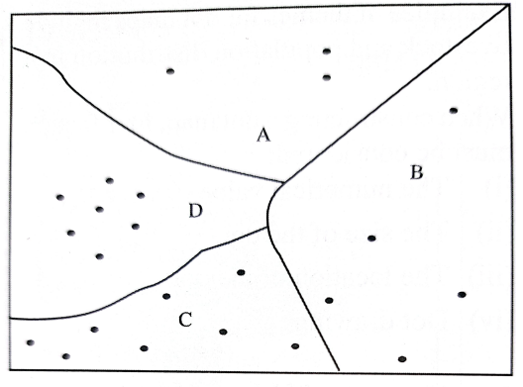

Dot value.1 dot represent 31,000 cows

Area of division C is 25,531.23km2

Calculate the population density of division C. (3 marks)

1. (a) Name **two** major varieties of wheat grown in Kenya. (2 marks)

(b) Give **three** reasons for using a combine harvester in wheat harvesting. ( 3 marks)

1. (a) Define the term urbanization. (2 marks)

(b) State **four** factors that lead to development of dispersed settlement (4 marks)

1. (a) Identify **two** categories of energy sources (2 marks)

(b) The sketch map below shows Hydro electric power stations along river Tana. Use it to answer question b (i) and (ii) (3 marks)

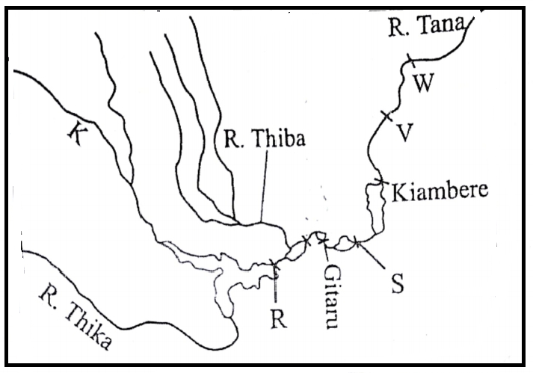

(i) Name the river marked K ( 1 mark)

(ii) Name the power station marked R and S (2marks**)**

**SECTION B**

*Answer* ***question******6*** *and any other* ***two*** *questions from this section.*

1. (a) The table below shows displaced persons by floods in Kenya in April to May 2024 long rain season in different counties. Study it and use it to answer question 6 (a) (i) and (ii)

|  |  |
| --- | --- |
| **County** | **Number of displaced persons** |
| Kisumu | 41923 |
| Busia | 16645 |
| Nairobi | 34125 |
| Tanariver | 18678 |
| Garissa | 62890 |

(i) Draw a divided rectangle measuring 12cm to represent the above data. (8 marks)

(ii) State **two** conclusions that can be made from the divided rectangle drawn above. (2 marks)

(b (i) A part from floods, mention t**wo** other climatic hazards experienced in Kenya. (2 marks)

(ii) Name **two** rivers in Western Kenya that cause large scale flooding (2 marks)

(iii) Explain **three** human factors that lead to frequent flooding in Kenya. (6 marks)

(c) (i) What is water pollution? ( 2 marks)

(ii) Identify **three** legislative actions that have been taken by the Kenyan government to

combat pollution of water sources. (3 marks)

7. (a) (i) Differentiate between population and demography. (2marks) (ii) Give **three** factors that influence population growth. (3 marks)

(b) Study the figure below and use it to answer questions b(i) and (ii)

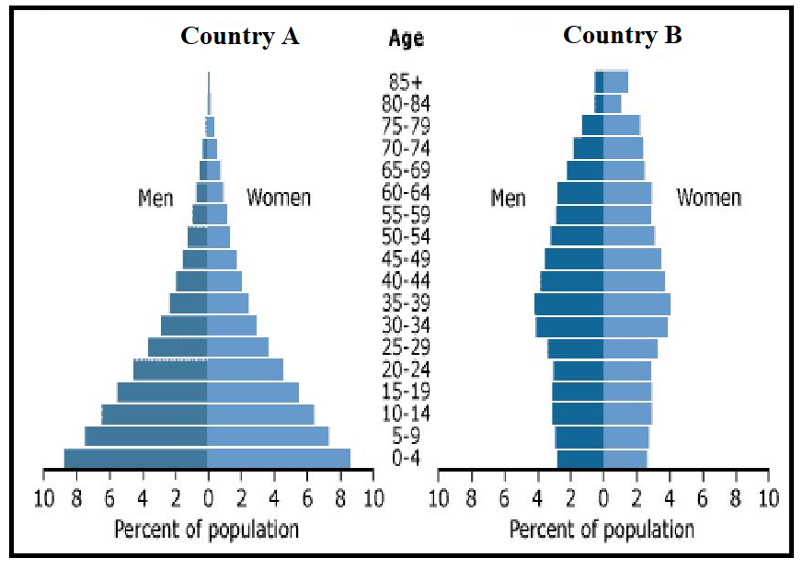

1. Identtify the stages of demographic transition for country A and country B. (2 marks)
2. State **three** characteristics of the population representated by pyramid B. (3 marks)

(c) (i) Differentiate between emigration and immigration (2 marks)

(ii) Explain **three** factors that cause urban to rural migration in Kenya (6 marks)

(d) Explain how the following factors have influenced population distribution in Kenya and Sweden

* Mountains (2 marks)
* Mining (2 marks)

(e) Give **three** differences between population trends in Kenya and Sweden. (3 marks)

1. (a) (i) Name **two** forms of internal trade in Kenya. . (2 marks)

(ii) Name **two** major imports to Kenya from European Union. ( 2 marks)

(b) Explain how the following factors influence trade in Kenya.

* Transport (2 marks)
* Demand for goods (2marks)

(c) State **three** problems facing internal trade in Kenya. (3 marks)

(d) Explain **four** ways in which Kenya will benefit from the renewed East African Community.

( 8 marks)

(e) Explain how trade restrictions have influenced external trade in Kenya. (6 marks)

1. (a) Define the term industralisation. ( 2 marks)

(b) (i) Identify **two** industries located in the Ruhr region of Germany. (2marks)

(ii) Explain how the following factors that led to the growth of industries named in b(i) above.

* Availability of capital (2 marks)
* Central geographical location. (2marks)

(c) Explain **three** ways in which Kenya has benefitted from assembling vehicles locally. ( 6 marks)

(d) State **three** problems that face industrial development in Kenya. ( 3 marks)

(e) You intend to carry out a field study on jua kali sheds in Kisumu;

(i) Construct a one day work schedule for the study. (4 marks)

(ii) State **two** reasons why you would conduct a pre- visit. (2 marks)

(ii) State **two** characteristics of jua kali industries you are likely to identify. (2 marks)

1. (a) (i) Define communication? (2 marks)

(ii) State **three** recent developments that have taken place to improve mobile phone services in

Kenya. (3 marks)

(b) (i) Apart from canals, give other **three** waterways in Africa. (3marks)

(ii) Give **three** reasons why the suez canal is commonly used waterway in africa. (3 marks)

(c) Study the map of the Great Lakes and the St.Lawrence Sea way below and name features marked **J**, **M** and **N**. ( 3 marks)

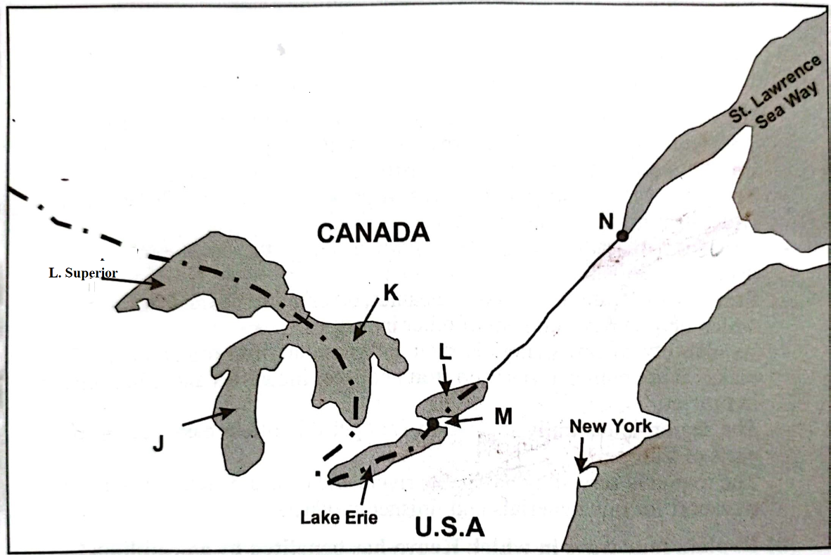

(d) Explain **three** ways in the Great Lakes andSt.Lawrence Sea way route has contributed to industrial development in the region (6 marks)

(e )State **five** measures the government has takento reduce road accidents in Kenya. (5 marks)

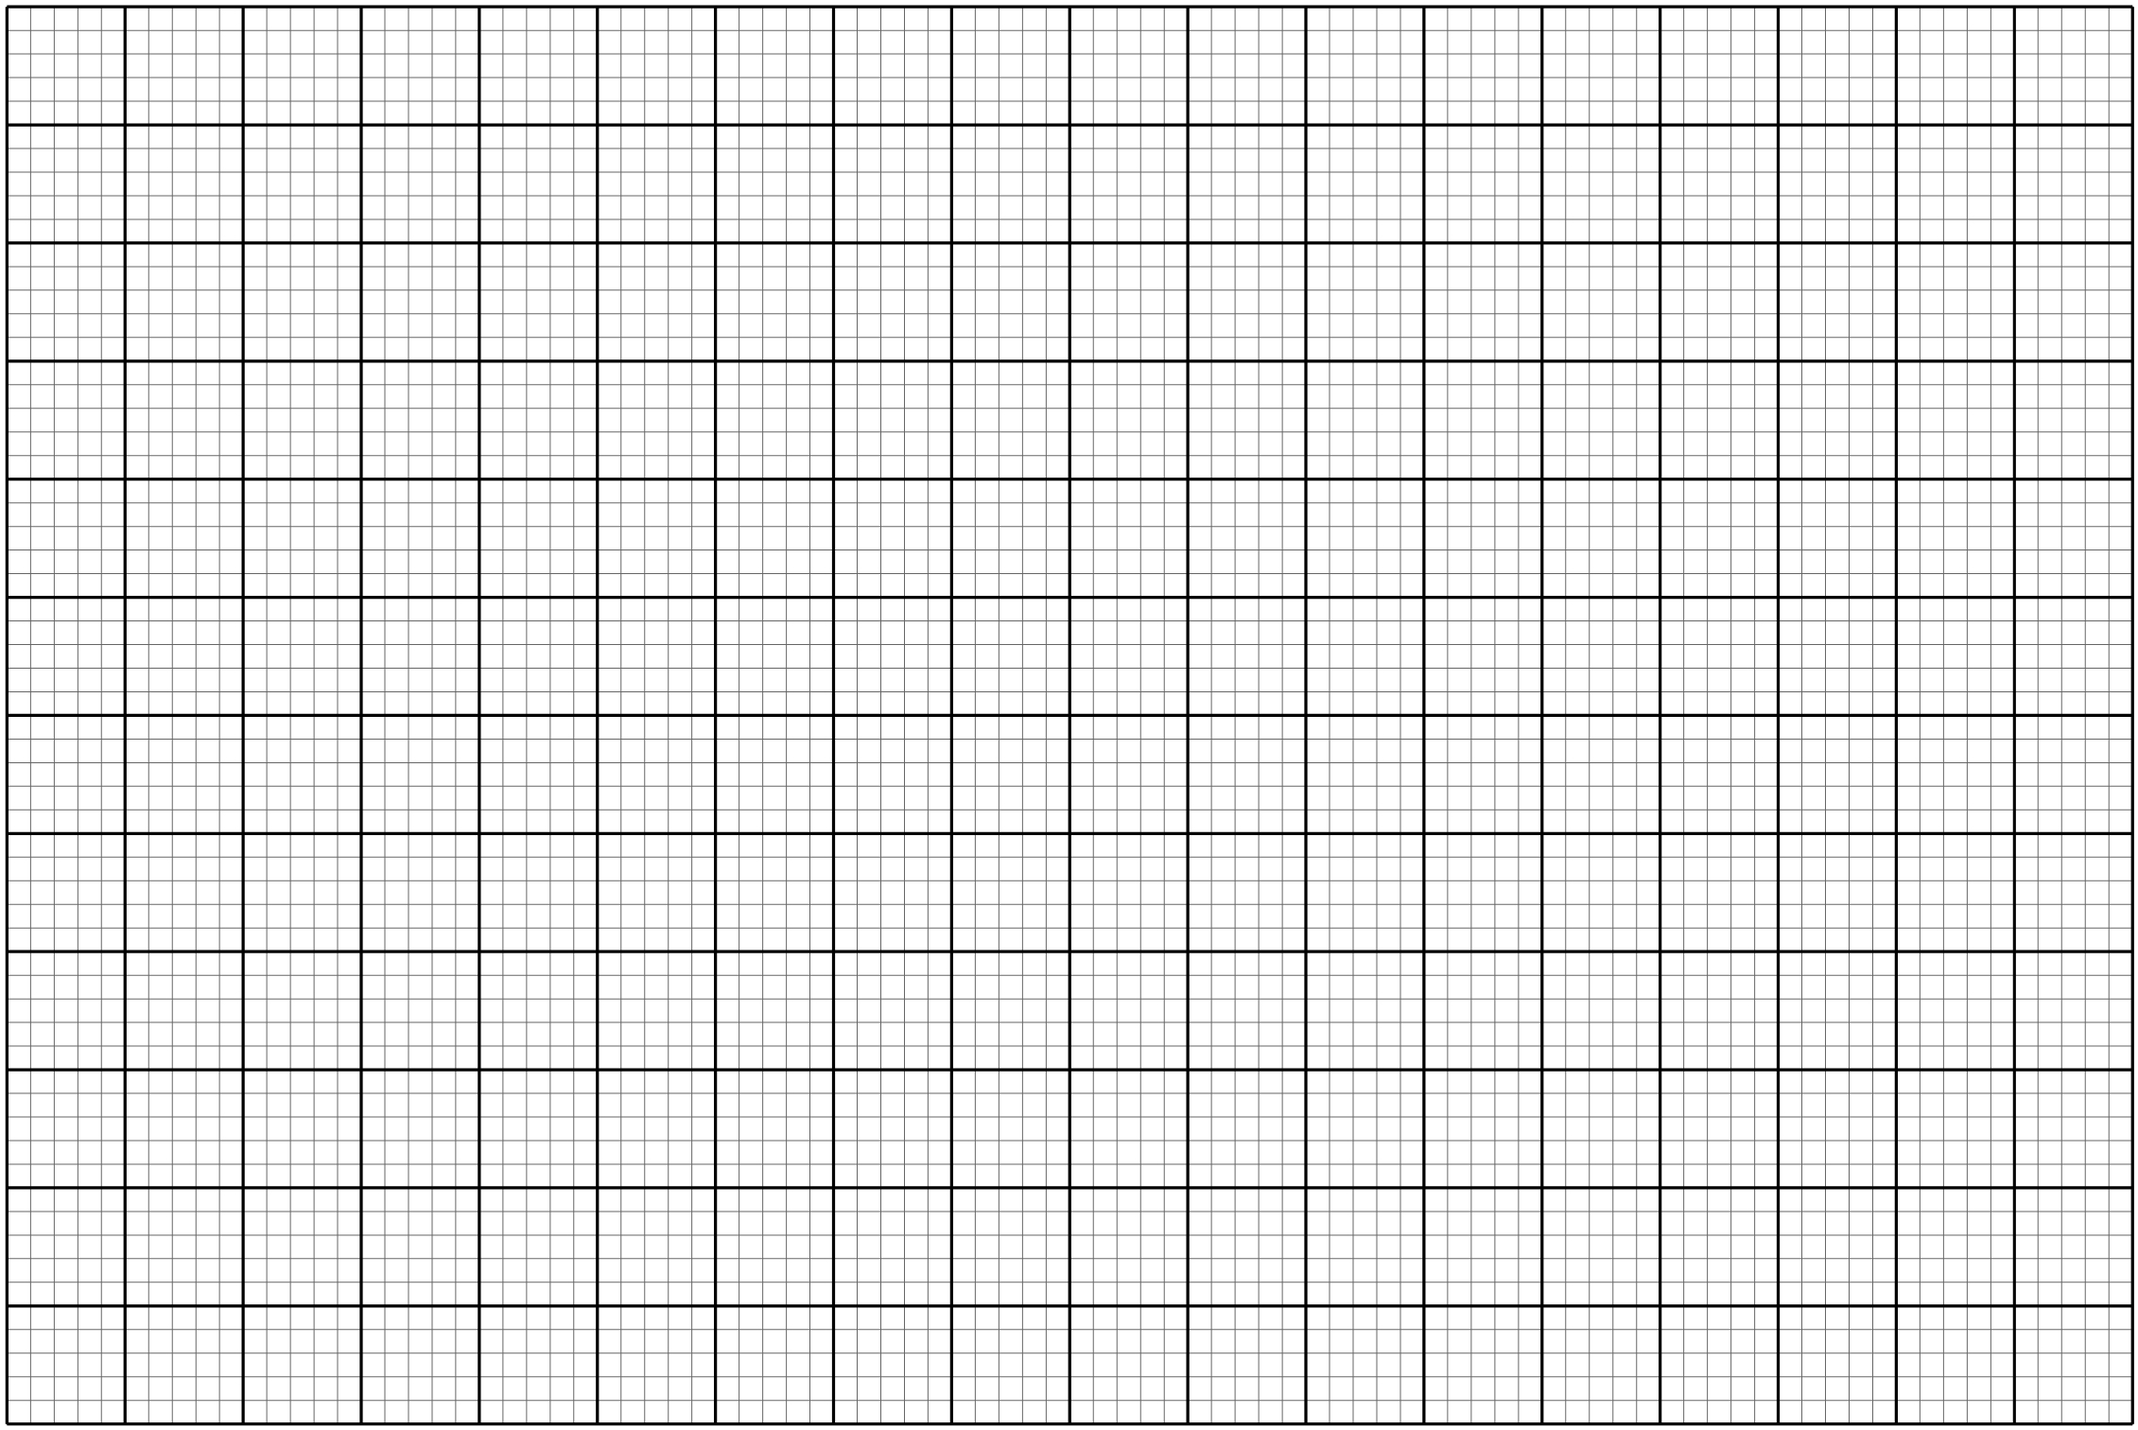

……………………………………………………………………………………………………………………………………………………………………………………………………………………………………………………………………………………………………………………………………………………………………………………………………………………………………………………………………………………………………………………………………………………………………………………………………………………………………………………………………………………………………………………………………………………………………………………………………………………………………………………………………………………………………………………………………………………………………………………………………………………………………………………………………………………………………………………………………………………………………………………………………………………………………………………………………………………………………………………………………………………………………………………………………………………………………………………………………………………………………………………………………………………………………………………………………………………………………………………………………………………………………………………………………………………………………………………………………………………………………………………………………………………………………………………………………………………………………………………………………………………………………………………………………………………………………………………………………………………………………………………………………………………………………………………………………………………………………………………………………………………………………………………………………………………………………………………………………………………………………………………………………………………………………………………………………………………………………………………………………………………………………………………………………………………………………………………………………………………………………………………………………………………………………………………………………………………………………………………………………………………………………………………………………………………………………………………………………………………………………………………………………………………………………………………………………………………………………………………………………………………………………………………………………………………………………………………………………………………………………………………………………………………………………………………………………………………………………………………………………………………………………………………………………………………………………………………………………………………………………………………………………………………………………………………………………………………………………………………………………………………………………………………………………………………………………………………………………………………………………………………………………………………………………………………………………………………………………………………………………………………………………………………………………………………………………………………………………………………………………………………………………………………………………………………………………………………………………………………………………………………………………………………………………………………………………………………………………………………………………………………………………………………………………………………………………………………………………………………………………………………………………………………………………………………………………………………………………………………………………………………………………………………………………………………………………………………………………………………………………………………………………………………………………………………………………………………………………………………………………………………………………………………………………………………………………………………………………………………………………………………………………………………………………………………………………………………………………………………………………………………………………………………………………………………………………………………………………………………………………………………………………………………………………………………………………………………………………………………………………………………………………………………………………………………………………………………………………………………………………………………………………………………………………………………………………………………………………………………………………………………………………………………………………………………………………………………………………………………………………………………………………………………………………………………………………………………………………………………………………………………………………………………………………………………………………………………………………………………………………………………………………………………………………………………………………………………………………………………………………………………………………………………………………………………………………………………………………………………………………………………………………………………………………………………………………………………………………………………………………………………………………………………………………………………………………………………………………………………………………………………………………………………………………………………………………………………………………………………………………………………………………………………………………………………………………………………………………………………………………………………………………………………………………………………………………………………………………………………………………………………………………………………………………………………………………………………………………………………………………………………………………………………………………………………………………………………………………………………………………………………………………………………………………………………………………………………………………………………………………………………………………………………………………………………………………………………………………………………………………………………………………………………………………………………………………………………………………………………………………………………………………………………………………………………………………………………………………………………………………………………………………………………………………………………………………………………………………………………………………………………………………………………………………………………………………………………………………………………………………………………………………………………………………………………………………………………………………………………………………………………………………………………………………………………………………………………………………………………………………………………………………………………………………………………………………………………………………………………………………………………………………………………………………………………………………………………………………………………………………………………………………………………………………………………………………………………………………………………………………………………………………………………………………………………………………………………………………………………………………………………………………………………………………………………………………………………………………………………………………………………………………………………………………………………………………………………………………………………………………………………………………………………………………………………………………………………………………………………………………………………………………………………………………………………………………………………………………………………………………………………………………………………………………………………………………………………………………………………………………………………………………………………………………………………………………………………………………………………………………………………………………………………………………………………………………………………………………………………………………………………………………………………………………………………………………………………………………………………………………………………………………………………………………………………………………………………………………………………………………………………………………………………………………………………………………………………………………………………………………………………………………………………………………………………………………………………………………………………………………………………………………………………………………………………………………………………………………………………………………………………………………………………………………………………………………………………………………………………………………………………………………………………………………………………………………………………………………………………………………………………………………………………………………………………………………………………………………………………………………………………………………………………………………………………………………………………………………………………………………………………………………………………………………………………………………………………………………………………………………………………………………………………………………………………………………………………………………………………………………………………………………………………………………………………………………………………………………………………………………………………………………………………………………………………………………………………………………………………………………………………………………………………………………………………………………………………………………………………………………………………………………………………………………………………………………………………………………………………………………………………………………………………………………………………………………………………………………………………………………………………………………………………………………………………………………………………………………………………………………………………………………………………………………………………………………………………………………………………………………………………………………………………………………………………………………………………………………………………………………………………………………………………………………………………………………………………………………………………………………………………………………………………………………………………………………………………………………………………………………………………………………………………………………………………………………………………………………………………………………………………………………………………………………………………………………………………………………………………………………………………………………………………………………………………………………………………………………………………………………………………………………………………………………………………………………………………………………………………………………………………………………………………………………………………………………………………………………………………………………………………………………………………………………………………………………………………………………………………………………………………………………………………………………………………………………………………………………………………………………………………………………………………………………………………………………………………………………………………………………………………………………………………………………………………………………………………………………………………………………………………………………………………………………………………………………………………………………………………………………………………………………………………………………………………………………………………………………………………………………………………………………………………………………………………………………………………………………………………………………………………………………………………………………………………………………………………………………………………………………………………………………………………………………………………………………………………………………………………………………………………………………………………………………………………………………………………………………………………………………………………………………………………………………………………………………………………………………………………………………………………………………………………………………………………………………………………………………………………………………………………………………………………………………………………………………………………………………………………………………………………………………………………………………………………………………………………………………………………………………………………………………………………………………………………………………………………………………………………………………………………………………………………………………………………………………………………………………………………………………………………………………………………………………………………………………………………………………………………………………………………………………………………………………………………………………………………………………………………………………………………………………………………………………………………………………………………………………………………………………………………………………………………………………………………………………………………………………………………………………………………………………………………………………………………………………………………………………………………………………………………………………………………………………………………………………………………………………………………………………………………………………………………………………………………………………………………………………………………………………………………………………………………………………………………………………………………………………………………………………………………………………………………………………………………………………………………………………………………………………………………………………………………………………………………………………………………………………………………………………………………………………………………………………………………………………………………………………………………………………………………………………………………………………………………………………………………………………………………………………………………………………………………………………………………………………………………………………………………………………………………………………………………………………………………………………………………………………………………………………………………………………………………………………………………………………………………………………………………………………………………………………………………………………………………………………………………………………………………………………………………………………………………………………………………………………………………………………………………………………………………………………………………………………………………………………………………………………………………………………………………………………………………………………………………………………………………………………………………………………………………………………………………………………………………………………………………………………………………………………………………………………………………………………………………………………………………………………………………………………………………………………………………………………………………………………………………………………………………………………………………………………………………………………………………………………………………………………………………………………………………………………………………………………………………………………………………………………………………………………………………………………………………………………………………………………………………………………………………………………………………………………………………………………………………………………………………………………………………………………………………………………………………………………………………………………………………………………………………………………………………………………………………………………………………………………………………………………………………………………………………………………………………………………………………………………………………………………………………………………………………………………………………………………………………………………………………………………………………………………………………………………………………………………………………………………………………………………………………………………………………………………………………………………………………………………………………………………………………………………………………………………………………………………………………………………………………………………………………………………………………………………………………………………………………………………………………………………………………………………………………………………………………………………………………………………………………………………………………………………………………………………………………………………………………………………

**THIS IS THE LAST PRINTED PAGE**