** MARANDA HIGH SCHOOL**

**Kenya Certificate of Secondary Education**

**PRE-MOCK EXAMINATIONS 2024**

**312/2 Geography Paper 2**

**March, 2024 Time: 2½ Hours**

**Name**: ………………………………………….…….…… **Adm** **No**: ………………

**Class**: ………………**Candidate’s** **Signature**: ………..…….. **Date:………………..**

***Instructions to candidates***

1. *Write your name, admission number and class in the spaces provided above.*
2. *This paper has two sections* ***A*** *and B*
3. *Answer* ***all*** *the questions in* ***SECTION******A****.*
4. *Answer* ***question 6*** *and any other two questions from* ***SECTION B.***
5. *All answers must be written in English.*
6. ***This paper consists of 15 printed pages.***
7. ***Candidates should check the question paper to ascertain that all the pages are printed as indicated and that no questions are missing.***

**For Examiner’s Use Only**

|  |  |  |  |
| --- | --- | --- | --- |
| **Questions** | **Candidate’s**  **Score** | **Maximum**  **Score** | |
| **1 -5** |  | **25** | |
| **6** |  | **25** | |
|  |  | **25** | |
|  |  | **25** | |
| **Total Score** |  | **100** |

1. (a) What is fish farming? (2 marks)

(b) State **three** reasons fish farming should be encouraged in Kenya. (3 marks)

1. (a) Differentiate between transport and communication. (2 marks)

(b) State **three** physical factors that influence development of transport and communication in Kenya.

(3 marks)

1. (a) Name **two** marine parks in the coast region of Kenya. (2 marks)

(b) State **three** ways in which marine parks are conserved. (3 marks)

1. (a) Study the map below and use it to answer question 4(a)(i) and (ii)

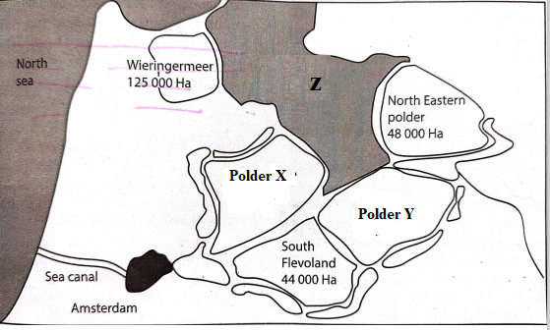

(i) Identify the polders marked X and Y (2 marks)

(ii) The drainage feature marked Z (1 mark)

(b) State **two** objectives of the delta plan project. (2 marks)

1. (a) Differentiate between horticulture and market gardening. (2 marks)

(b) State challenges that horticultural farmers experience in marketing their produce in Kenya. (3 marks)

**SECTION B**

*Answer* ***question******6*** *and any other* ***two*** *questions from this section.*

1. The table below shows composition of pastoral cattle herds’ structure in Kenya between 2012 to 2015. Study it and use it to answer question 6(a).

|  |  |  |  |  |
| --- | --- | --- | --- | --- |
|  | **YEAR** | | | |
| **CATTLE TYPE** | **2012** | **2013** | **2014** | **2015** |
| Milk Cows | 1 430 000 | 1 350 000 | 1 330 000 | 1 410 000 |
| Non Milk Cows | 1 994 000 | 1 800 000 | 1 700 000 | 1 900 000 |
| Bulls | 400 000 | 430 000 | 390 000 | 440 000 |
| Heifers And Steers | 3 100 000 | 2 800 000 | 2 600 000 | 2 900 000 |
| Calves | 1 370 000 | 1 300 000 | 1 250 000 | 1 310 000 |
| **TOTAL** | **8 294 000** | **7 680 000** | **7 270 000** | **7 960 000** |

1. Using a scale of 1 centimeter to represent 1,000,000 cattle, draw a compound bar graph to represent the data. (8 marks)
2. (i) Name two potential sites for geothermal energy production in Kenya. (2 marks)

(ii) Give four reasons that have limited exploitation of geothermal energy in Kenya. (4 marks)

1. (i) State two causes of high oil prices in Kenya? (2 marks)

(ii) Explain three effects of high oil prices to the economy of Kenya. (6 marks)

(iii) State three measures the government of Kenya has taken to reduce effects of high oil prices

(3 marks)

1. (a) (i) Differentiate between minerals that occur as veins and reefs. (2 marks)

(ii) Name a mineral mined in each of the following counties in Kenya. (3 marks)

* Kwale
* Taita taveta
* Kisii

(b) Explain how the following factors influenced exploitation of diamond in South Africa

* Capital ( 2 marks)
* Transport (2 marks)

(c) Describe how stripping mining method is used to mine limestone in Bamburi in Kenya.

(5 marks)

(d) Explain three problems facing gold mining in south Africa (6 marks)

(e) Maranda high school students carried out a field study on the mining of soda ash in Lake magadi

(i) Identify **two** methods they may have used in recording data. (2 marks)

(ii) State **three** benefits that accrue to the local community as a result of the mining that they may have observed. (3 marks)

1. (a) (i) apart from Nigeria, name two countries in western Africa where oil palm is grown (2 marks). (ii) Name two regions in Nigeria where oil palm is grown (2 marks)

(b) Explain three human factors that favour growing of oil palm in Nigeria. (6 marks)

(c) The photograph below shows an oil palm. Study it and sue it to answer question c (i) and (ii)

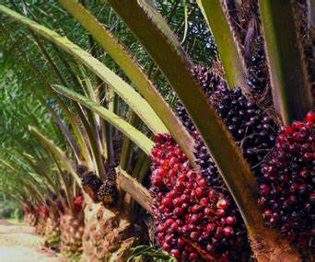

(i)describe the processing of the oil palm from the stage shown in the photograph ( 6 marks)

(ii) Give three uses of the parts of the palm oil shown above (3 marks)

(d) Explain three economic problems facing oil palm growing in Nigeria (6 marks)

1. (a) (i) Define Agro-forestry (2marks)

(ii) Explain **two** ways how human activities influence distribution of forests (4 marks)

1. State **five** characteristics of planted forest (5 mark)
2. Name **two** major forest reserves in Kenya (2 marks)

Other than creation of foest reserves give **four**  other ways of managing forests in Kenya

1. State **two** problems that affect forestry in Canada

Diffentiate between softwood forests in Kenya and Canada under the following sub headings

* Logging
* Growing areas
* Transport

1. a) (i) What is an industrial inertia? (2 marks)

(ii) state two causes of industrial inertia (2 marks)

State two reasons why some industries are located near market of their produce

1. Other than water, give two factors that favoured the location of pan paper mills at Webuye (2 marks)

State three likely reasons for the closure of pan paper mills at Webuye

1. (i) Name **two** automobiles companies in Japan (2 marks)

(ii) Explain **three** factors that favoured the growth of car and electronics industry in Japan. 6 marks)

(d) Explain three measures taken to curb environmental pollution as a problem associated by industrialization in Kenya

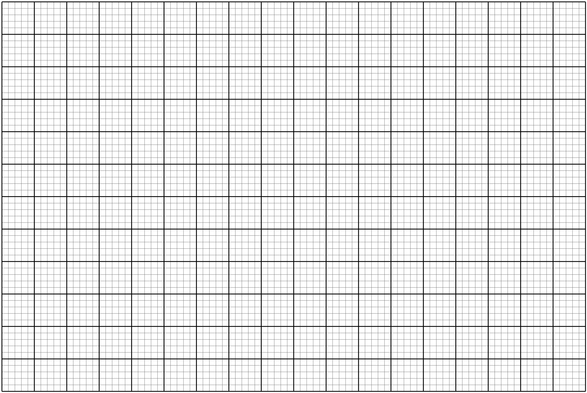

……………………………………………………………………………………………………………………………………………………………………………………………………………………………………………………………………………………………………………………………………………………………………………………………………………………………………………………………………………………………………………………………………………………………………………………………………………………………………………………………………………………………………………………………………………………………………………………………………………………………………………………………………………………………………………………………………………………………………………………………………………………………………………………………………………………………………………………………………………………………………………………………………………………………………………………………………………………………………………………………………………………………………………………………………………………………………………………………………………………………………………………………………………………………………………………………………………………………………………………………………………………………………………………………………………………………………………………………………………………………………………………………………………………………………………………………………………………………………………………………………………………………………………………………………………………………………………………………………………………………………………………………………………………………………………………………………………………………………………………………………………………………………………………………………………………………………………………………………………………………………………………………………………………………………………………………………………………………………………………………………………………………………………………………………………………………………………………………………………………………………………………………………………………………………………………………………………………………………………………………………………………………………………………………………………………………………………………………………………………………………………………………………………………………………………………………………………………………………………………………………………………………………………………………………………………………………………………………………………………………………………………………………………………………………………………………………………………………………………………………………………………………………………………………………………………………………………………………………………………………………………………………………………………………………………………………………………………………………………………………………………………………………………………………………………………………………………………………………………………………………………………………………………………………………………………………………………………………………………………………………………………………………………………………………………………………………………………………………………………………………………………………………………………………………………………………………………………………………………………………………………………………………………………………………………………………………………………………………………………………………………………………………………………………………………………………………………………………………………………………………………………………………………………………………………………………………………………………………………………………………………………………………………………………………………………………………………………………………………………………………………………………………………………………………………………………………………………………………………………………………………………………………………………………………………………………………………………………………………………………………………………………………………………………………………………………………………………………………………………………………………………………………………………………………………………………………………………………………………………………………………………………………………………………………………………………………………………………………………………………………………………………………………………………………………………………………………………………………………………………………………………………………………………………………………………………………………………………………………………………………………………………………………………………………………………………………………………………………………………………………………………………………………………………………………………………………………………………………………………………………………………………………………………………………………………………………………………………………………………………………………………………………………………………………………………………………………………………………………………………………………………………………………………………………………………………………………………………………………………………………………………………………………………………………………………………………………………………………………………………………………………………………………………………………………………………………………………………………………………………………………………………………………………………………………………………………………………………………………………………………………………………………………………………………………………………………………………………………………………………………………………………………………………………………………………………………………………………………………………………………………………………………………………………………………………………………………………………………………………………………………………………………………………………………………………………………………………………………………………………………………………………………………………………………………………………………………………………………………………………………………………………………………………………………………………………………………………………………………………………………………………………………………………………………………………………………………………………………………………………………………………………………………………………………………………………………………………………………………………………………………………………………………………………………………………………………………………………………………………………………………………………………………………………………………………………………………………………………………………………………………………………………………………………………………………………………………………………………………………………………………………………………………………………………………………………………………………………………………………………………………………………………………………………………………………………………………………………………………………………………………………………………………………………………………………………………………………………………………………………………………………………………………………………………………………………………………………………………………………………………………………………………………………………………………………………………………………………………………………………………………………………………………………………………………………………………………………………………………………………………………………………………………………………………………………………………………………………………………………………………………………………………………………………………………………………………………………………………………………………………………………………………………………………………………………………………………………………………………………………………………………………………………………………………………………………………………………………………………………………………………………………………………………………………………………………………………………………………………………………………………………………………………………………………………………………………………………………………………………………………………………………………………………………………………………………………………………………………………………………………………………………………………………………………………………………………………………………………………………………………………………………………………………………………………………………………………………………………………………………………………………………………………………………………………………………………………………………………………………………………………………………………………………………………………………………………………………………………………………………………………………………………………………………………………………………………………………………………………………………………………………………………………………………………………………………………………………………………………………………………………………………………………………………………………………………………………………………………………………………………………………………………………………………………………………………………………………………………………………………………………………………………………………………………………………………………………………………………………………………………………………………………………………………………………………………………………………………………………………………………………………………………………………………………………………………………………………………………………………………………………………………………………………………………………………………………………………………………………………………………………………………………………………………………………………………………………………………………………………………………………………………………………………………………………………………………………………………………………………………………………………………………………………………………………………………………………………………………………………………………………………………………………………………………………………………………………………………………………………………………………………………………………………………………………………………………………………………………………………………………………………………………………………………………………………………………………………………………………………………………………………………………………………………………………………………………………………………………………………………………………………………………………………………………………………………………………………………………………………………………………………………………………………………………………………………………………………………………………………………………………………………………………………………………………………………………………………………………………………………………………………………………………………………………………………………………………………………………………………………………………………………………………………………………………………………………………………………………………………………………………………………………………………………………………………………………………………………………………………………………………………………………………………………………………………………………………………………………………………………………………………………………………………………………………………………………………………………………………………………………………………………………………………………………………………………………………………………………………………………………………………………………………………………………………………………………………………………………………………………………………………………………………………………………………………………………………………………………………………………………………………………………………………………………………………………………………………………………………………………………………………………………………………………………………………………………………………………………………………………………………………………………………………………………………………………………………………………………………………………………………………………………………………………………………………………………………………………………………………………………………………………………………………………………………………………………………………………………………………………………………………………………………………………………………………………………………………………………………………………………………………………………………………………………………………………………………………………………………………………………………………………………………………………………………………………………………………………………………………………………………………………………………………………………………………………………………………………………………………………………………………………………………………………………………………………………………………………………………………………………………………………………………………………………………………………………………………………………………………………………………………………………………………………………………………………………………………………………………………………………………………………………………………………………………………………………………………………………………………………………………………………………………………………………………………………………………………………………………………………………………………………………………………………………………………………………………………………………………………………………………………………………………………………………………………………………………………………………………………………………………………………………………………………………………………………………………………………………………………………………………………………………………………………………………………………………………………………………………………………………………………………………………………………………………………………………………………………………………………………………………………………………………………………………………………………………………………………………………………………………………………………………………………………………………………………………………………………………………………………………………………………………………………………………………………………………………………………………………………………………………………………………………………………………………………………………………………………………………………………………………………………………………………………………………………………………………………………………………………………………………………………………………………………………………………………………………………………………………………………………………………………………………………………………………………………………………………………………………………………………………………………………………………………………………………………………………………………………………………………………………………………………………………………………………………………………………………………………………………………………………………………………………………………………………………………………………………………………………………………………………………………………………………………………………………………………………………………………………………………………………………………………………………………………………………………………………………………………………………………………………………………………………………………………………………………………………………………………………………………………………………………………………………………………………………………………………………………………………………………………………………………………………………………………………………………………………………………………………………………………………………………………………………………………………………………………………………………………………………………………………………………………………………………………………………………………………………………………………………………………………………………………………………………………………………………………………………………………………………………………………………………………………………………………………………………………………………………………………………………………………………………………………………………………………………………………………………………………………………………………………………………………………………………………………………………………………………………………………………………………………………………………………………………………………………………………………………………………………………………………………………………………………………………………………………………………………………………………………………………………………………………………………………………………………………………………………………………………………………………………………………………………………………………………………………………………………………………………………………………………………………………………………………………………………………………………………………………………………………………………………………………………………………………………………………………………………………………………………………………………………………………………………………………………………………………………

**THIS IS THE LAST PRINTED PAGE**