** MARANDA HIGH SCHOOL**

**Kenya Certificate of Secondary Education**

**MOCK EXAMINATIONS 2024**

**312/2 Geography marking scheme Paper 2 Marking Scheme**

1. **(a) Define the term environment? (2 marks)**

*Environment is a set of external conditions that surround a living organism*

**(b) List three sub branches of human geography. (3 marks)**

* *Economic geography*
* *Demography/population geography*
* *Agricultural geography*
* *Historical geography*
* *Medical geography*

1. **(a) Apart from dot maps,name any other type of statistical map ( 1 mark)**

* *Choropleth maps*

**(b) Study the dot map below and use it to answer question 2(b)**

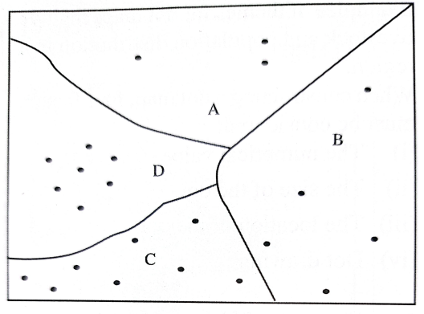

Dot value.1 dot represent 31,000 cows

Area of division A is 25,531.23km2

**Calculate the population density of division C. (3 marks)**

$\frac{8 dots x 31000}{2531.23}$**= 9.71 cows/km2/9cows/ km2**

1. **(a) Name two major varieties of wheat grown in Kenya. (2 marks)**

* *Triticale*
* *Durum wheat*

**(b) Give three reasons for using a combine harvester in wheat harvesting. ( 3 marks)**

* *Reduces labor requirements*
* *It reduces wastage*
* *Wheat harvested is free from dirt/high quality*
* *It saves time/it is fast*

1. **(a) Define the term urbanization. (2 marks)**

*Urbanization is the growth and spread of towns and town life*

**(b) State four factors that led to development of dispersed settlement (3 marks)**

* + *Availability of large tracts of land for settlement and cultivation.*
  + *Land tenure systems that allows large acreage holdings*
  + *Availability of evenly distributed water resources..*
  + *Availability of security*
  + *Presence of pests/diseases which discourage settlements.*
  + *Infertile soils which attract few people.*
  + *Mountains and forested areas which attract few settlements.*
  + *Harsh climate/extreme weathe/arid/semi-arid conditions which may attract few people.*

1. **(a) Identify two categories of energy sources (2 marks)**

* *Renewable*
* *Non renewable*

**(b) The sketch map bellows shows Hydro electric power stations along river Tana, Use it to answer b (i) and (ii) (3 marks**

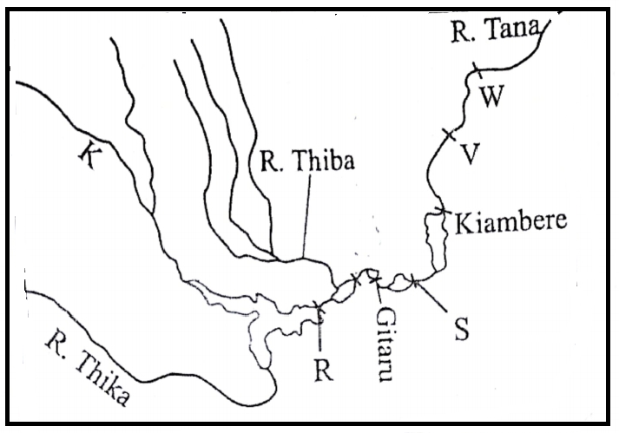

**Name the river marked K ( 1 mark)**

* *River Mathioya*

**Power station R and S ( 2 marks)**

* *R Masinga*
* *S Kindaruma*

**SECTION B**

*Answer* ***question******6*** *and any other* ***two*** *questions from this section.*

6 (**a) The table below shows displaced persons by floods in Kenya in April to May 2024 long rain season in different counties. Study it and use it to answer question 6 (a) (i) and (ii)**

|  |  |
| --- | --- |
| **County** | **Number of displaced persons** |
| Kisumu | 41923 |
| Busia | 16645 |
| Nairobi | 34125 |
| Tanariver | 18678 |
| Garissa | 62890 |

1. **Draw a divided rectangle measuring 12cm to represent the above data.(8 marks)**

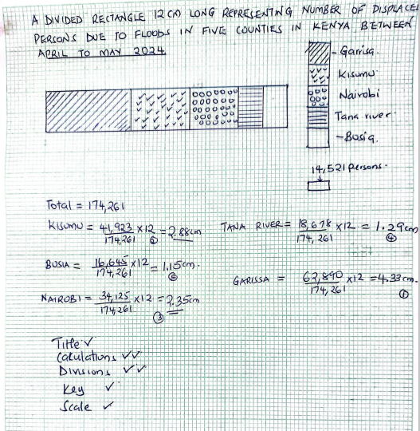

**(ii) State two conclusions that can be made from the divided rectangle drawn above. (2 marks)**

* *The most affected county is Garissa with the longest length of the rectangle*
* *Least affected is Busia/Tana River with the shortest length of the rectangle*

(b) (i**) A part from floods, mention any other climatic hazards to the Kenyan Environment (2 marks)**

* *Lightning*
* *Drought*
* *windstorms*

(ii**) Name two rivers in Western Kenya that cause large scale flooding. (2 marks)**

* *River Nyando*
* *River Nzoia*

(iii) **Explain three human factors that lead to frequent flooding in Kenya ( 4 marks)**

* *Deforestation exposes the soil to the agents of erosion increasing surface run off that carries materials downhill into rivers, the deposited materials raise the level of river channel causing spills over the banks/siltation of rivers*
* *Cultivation along river banks leaves the ground bare/ soil loose, during heavy rains this soil is easily carried into the river channel where it blocks the channel resulting into floods*
* *Poor urban planning and blocked drainage systems retains rain water*

**(c) (i) What is water pollution ( 2 marks)**

* *Pollution refers to the introduction of harmful substances into the water bodies that interfere with aquatic life.*

(**ii) Identify three legislative efforts that have been established to conserve the environment ( 5 marks.**

* *The public health act to prevent and suppress infectious diseases*
* *The water act to protect water catchment areas*
* *The plant protection act to prevent and control the spread of pests and diseases*
* *The Grass fires act that prohibit the burning of any vegetation*
* *Environmental management and coordination act for a clean and healthy environment*
* *River authorities act*
* *Radiation protection act*

7.  **(a) Differentiate between population and demography. (2 marks)**

*Population is the total number of people living in an area while demography is the study of population*

(c) **Give three factors that influence population growth (3 marks)**

* *Fertility*
* *Mortality*
* *Migration*

(d) **Study the figure below and use it to answer questions d(i) and (ii)**

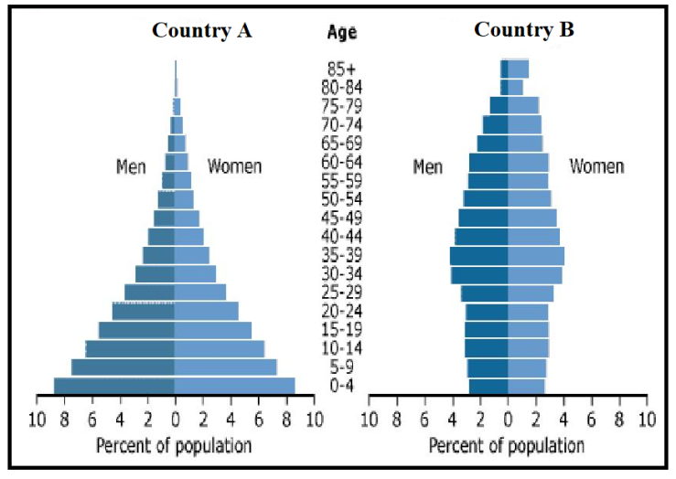

1. **Identtify the stages of demographic transition for country A and country B. (2 marks)**

* *Country A stage 1*
* *Country B Stage 4*

1. **State three characteristics of the population represented by pyramid B. (3 marks)**

* *low birth rate shown narrow base*
* *High life expectancy shown by relatively long bars from age 60 and above*
* *Low dependency ratio shown by broad belly/wide chest*
* *Low death rate shown by relatively similar length of bars for each cohort*

(b) (i) **Differentiate between emigration and immigration (2 marks)**

* *Emigration is the movement of a person/ people from your country to another while immigration is the movement of a person /people from other countries into another country*

**(ii) Explain three factors that cause urban to rural migration in Kenya (6 marks)**

* *It can be due to job transfers when persons areas moved from urban areas to rural areas*
* *Search for employment due to decentralization of industries that are established in rural areas,*
* *Retirement/ retrenchment in urban areas thus relocating to rural areas with a lower living expenses*
* *High cost of living in urban areas forcing people to relocate to rural areas*
* *Pollution/sound/air in urban centers forcing people to seek cleaner environments in rural areas*
* *Stressful urban life/congestion*

**(c) Explain how the following factors have influenced population distribution in Kenya and Sweden**

* **Mountains (2 marks)**

*On the windward slopes/on the foot of Mt. Kenya there is high density of population because of high rainfall and deep/well drained soils while in Sweden mountainous areas are sparcely populated because of steep slopes/thin soils/frozen soils which hinder settlement /cultivation*

* **Mining (2 marks)**

*In Kenya, mining towns like Magadi and Sweden mining towns like Grangesbery/ Dennemora are densely populated because of laborers who seek employment hence settle*

**(d) Give three differences between population trends in Kenya and Sweden. (3 marks)**

* *Kenya has a relatively high population (about 40 million) while Sweden has low population (about 9 million)*
* *Kenya has a high rate of natural population increase (high population growth rate) while Sweden has a low rate of natural population increase (low population growth rate)*
* *Kenya experiences low life expectancy while Sweden experiences high life expectancy*
* *In Kenya, there is low adoption of birth control measures while in Sweden population embraces high use of birth control measures*
* *In Kenya, most of the population is in the rural areas while in Sweden the majority is in urban.*
* *Kenya population has many young people while Sweden has an aging population.*
* *In Kenya, the dependency ratio is high while in Sweden, the dependency ratio is low.*

**8. (a)(i) List two types of trade ( 2 marks)**

* *External trade/foreign trade/international trade/regional trade*
* *Internal trade* /*domestic/home trade*

**(ii) Name two major imports to Kenya from European Union ( 2 marks)**

* *Electronics*
* *Pharmaceuticals*
* *Motor vehicles*

1. **Explain how the following factors influence trade in Kenya (4 marks)**

**Availability of transport**

* *Areas with well-developed roads allow for easy/ cheaper movement of goods/people thus more trade*

**Demand for goods**

* *Highly demanded goods lead to higher sales thus more trade involving these goods*

1. **State three problems facing internal trade in Kenya (3 marks)**

* *The high tariffs/multiple license fees charged by county and national governments reduce profits thus discourages trade*
* *Inadequate capital/high interest charged on borrowed capital discourages expansion of trade due to the low returns*
* *Scarcity of goods e.g. agricultural goods that are affected by drought hinders trade*
* *Production of similar goods from different regions limits trade*
* *Preference for imported goods by Kenyans reduces market for locally produced goods*
* *Tribal crashes/civil strife/insecurity reduce investments in some parts of the country*
* *Potholed roads/impassable roads make movement of goods slow and expensive discouraging trade*
* *Illegal importation and smuggling of goods into the country gives locally produced goods unfair competition*
* *Low purchasing power among Kenyans making then offer a very small internal market*

1. **(i)Explain four ways in which Kenya will benefit from the renewed East African Community (3 marks)**

* *There will be exchange of research findings and training which will help in economic development*
* *There will be improved transport links which will facilitate faster /easy movement of goods and people*
* *There will be increased employment opportunities because of free movement of people within the region improving living standards*
* *Reduction of tariffs makes goods cheaper in the region hence affordable creating a larger market*
* *There will be improved access to raw materials thus accelerating industrial development*
* *Expanded market will attract new investments from the local and foreign sources which wil lead to the expansion of industries*

1. **Explain how trade restrictions have influenced external trade in Kenya (6 marks)**

* *Imposition of tariffs by trading partners make our exports expensive thus reducing volume of exports*
* *Quotas imposed by trading partners limits exports/reduces volume of exports*
* *Ban imposed by some countries on Kenyan goods limits their exports for instance a ban on beef products to the middle east*
* *More trade agreements signed by Kenya and many countries have increased volume of trade*

1. **a Define the term industrialization ( 2 marks)**

*Industrialization is process of establishing manufacturing industries.*

**b (i)Identify two industries located in the Ruhr region of Germany (2marks)**

* *Iron and steel industry*
* *Chemical and engineering industries*

**(ii) Explain how the following factors that led to the growth of these industries (4 marks)**

* **Availability of capital**
* *Adequate Capital from export of coal by companies like Ruhr Kohle AC and Krupp group for expansion and development of the industries*
* **Central geographical location**
* *Central location allows easy/cheaper connection to many parts of the world through rail/air/road/ ports for easy exportation thus wide market*

**c)Explain three ways in which Kenya has benefitted by assembling vehicles locally ( 6 marks)**

* *It has stimulated development of other related industries eg tyres promoting industrialisation*
* *The industry has enabled Kenya to establish links with her neighbors hence promoting regional cooperation*
* *Kenya saves foreign exchange by importing parts of motor vehicles instead of assembled vehicle and the savings are used in developing other sectors/improving balance of payments*
* *This industry plus related industries have created employment opportunities thus rising their income*
* *The industry has led to the development of skills among Kenyans hence high productivity*

**d) State three problems that face industrial development in Kenya ( 3 marks)**

* *Shortage of raw materials*
* *Foreign exchange restriction*
* *Competition from synthetics*
* *Shortage of Capital*
* *Mismanagement due to use of unskilled labour*

**e) You intend to carry out a field study on jua kali sheds in Kisumu**

**(i) Construct a one day work schedule for the study (4 marks)**

* *Time to depart to study area/ Time to report to study area*
* *Time to begin data collection*
* *Time to depart back to school*
* *Time to arrive back to school*

**(ii) State two reasons for conducting a pre- visit ( 2 marks)**

* *It acquaints the researcher to the study area’s authorities and respondents.*
* *It assists the researchers to determine how suitable the study area is*
* *It assists in budgeting for the study / estimating cost of the study.*
* *It helps the researcher in identifying problems that are likely to be experienced during the field study and suggest their possible solutions.*
* *It helps the researchers in developing a working schedule.*

**(ii)State two characteristics of jua kali industries you are likely to identify (2 marks)**

* *Rely on locally available raw materials, tools and machinery.*
* *They require little capital base to establish.*
* *Their products target local market.*
* *Their main activity is to reprocess old materials into useful products.*
* *They are labour intensive*

1. **a) (i) Define communication? (2 marks)**

* *Communication is the process of relaying information from one person to another or from one group to the other through a certain medium*

(**ii) State three recent developments that have taken place to improve mobile phone services in Kenya**  **(3 marks)**

* *Expanding mobile banking services such as borrowing money*
* *Construction of more satelites/booster stations*
* *Reducing taxation on mobile phone gargets*
* *Integration of ICT in the curriculum*

**(i) A part from canals, give other three waterways in Africa (3 marks)**

* *Navigable rivers*
* *Lakes*
* *Seas/oceans*

**(ii) Give three reasons why suez canal is commonly used waterway in Africa (3 mark**

* *The route is free from traffic/congestion*
* *There is easy loading and offloading of goods by cranes*
* *Provides smooth flow of vesssels*
* *Cheaper for carrying bulky goods*
* *It shortened distance between Europe and north Africa making it cheaper/reduced travel time/reduced costs*
* *It is wide and deep /can handle very large ships*

1. **Study the sketch map of the Great Lakes and the St.Lawrence Sea way provided .Use it to answer question c (i),(ii) and (iii)**

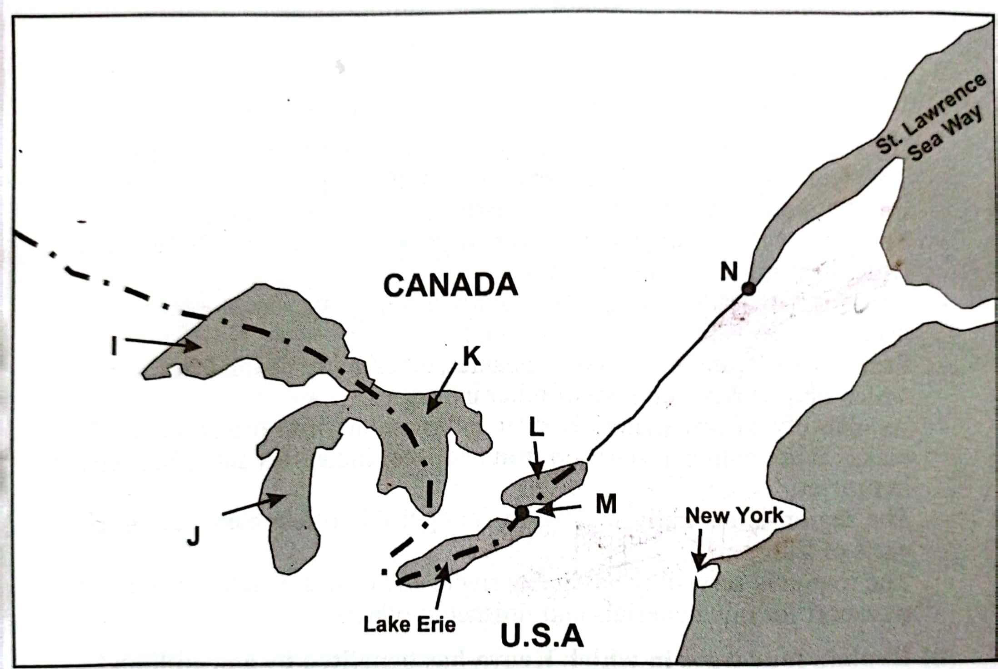

**(c)(i) Name the port marked N ( 1 mark)**

* *Quebec*

**(ii)The lake marked J (1 mark)**

* *Lake Michigan*

**(iii)Name the canal marked M ( 1 mark)**

* *Welland canal*

**(d) Explain three ways in the Great Lakes andSt.Lawrence Sea way route has contributed to industrial development in the region. (6 marks)**

* *The dams along the course produce hydro electric power for industrial use*
* *The route provides easy movement of raw materials and finished goods has led to extensive industrial development*
* *The rivers and lakes provide water for industrial use*

**(e) State five measures the government has taken to reduce road accidents in Kenya (5 marks)**

* *Introduction of speed governors on public vehiclesto regulate speed*
* *Construction of bumps to control speed*
* *Repair and maintance of roads to get rid of potholes*
* *Installation of road signs/traffic light*
* *Legislation to prohibit overloading*
* *Expansion of narrow roads*
* *Carrying out road safety education through mass media*