**LANJET PRE MOCK CLUSTER JOINT EVALUATION**

***Kenya Certificate of Secondary Education***

**312/2 GEOGRAPHY Paper 2**

**MARCH/APRIL 2024 MARKING SCHEME**

1a**. Define forestry 2mks**

Forestry is the science of developing and managing forests including cultivating them

**b.Give 3 factors that determine the type and distribution of forests 3mks**

temperature

aspects

precipitation

soil

2a.**Name two rivers that supply water to mwea Tebere irrigation scheme 2mks**

River Thiba

R nyamindi

Murubara

b**. State the significance of an irrigation scheme 3mks**

Resettlement of landless people e.g. in Mwea.

It has made barren land reproductive.

Enables farmers to earn an income when they sell farm produce.

Provision of employment opportunities which has alleviated poverty and improved the standard of living.

Creation of settlement for landless

3 **a .Define the term fishing 2mks**

The act of catching fish and other aquaticanimals

b**.State any 3 factors influencing fishing 3mks**

relief

presence of planktons

convergence of cold and warm ocean currents

nature of the coastline

4a **What is a game sanctuary 2mks**

Is a special area set aside to give protection to specific plants and animal species which are threatened with extinction

b**. Name three marine national park at the coast of kenya 3mks**

Malindi

Kisite

watamu

**5a What is land dereliction 2mks**

Is the wate land abandoned after mineral resource has been exhausted

b **State 3 measures that the kenya government has undertaken to rehabilitate derelict land in the country 3mks**

planting of trees

covering pits and mines with soil

landscaping of abandoned land

pits converted into dumpsites

introduction of aquaculture

6. SECTION B

**ANSWER QUESTION 6 AND ANY OTHER TWO QUESTIONS FROM THIS SECTION**

1. **The table below shows the production of maize in tones between 2010 and 2014 in four divisions of Baringo County.**

|  |  |  |  |  |  |
| --- | --- | --- | --- | --- | --- |
| Division | 2010 | 2011 | 2012 | 2013 | 2014 |
| Bartabwa | 200 | 240 | 250 | 280 | 285 |
| Barwesa | 116 | 135 | 138 | 170 | 275 |
| Kabartonjo | 100 | 80 | 60 | 50 | 45 |
| kipsaraman | 40 | 30 | 45 | 30 | 25 |

(a)(i) Calculate the percentage increase of the total maize production in the four divisions between 2012-2013. 2mks

* **530-493=37**

**%increase ${37}/{493}$ x 100= 7.51%**

(ii) What is the difference in kilograms between the highest production and the lowest in five years. 2mks

* **630,000-456,000=174,000kg**

(b)(i) Using a vertical scale of 1cm represents 50 tonnes, draw a group line graph to represent the data above. 7mks

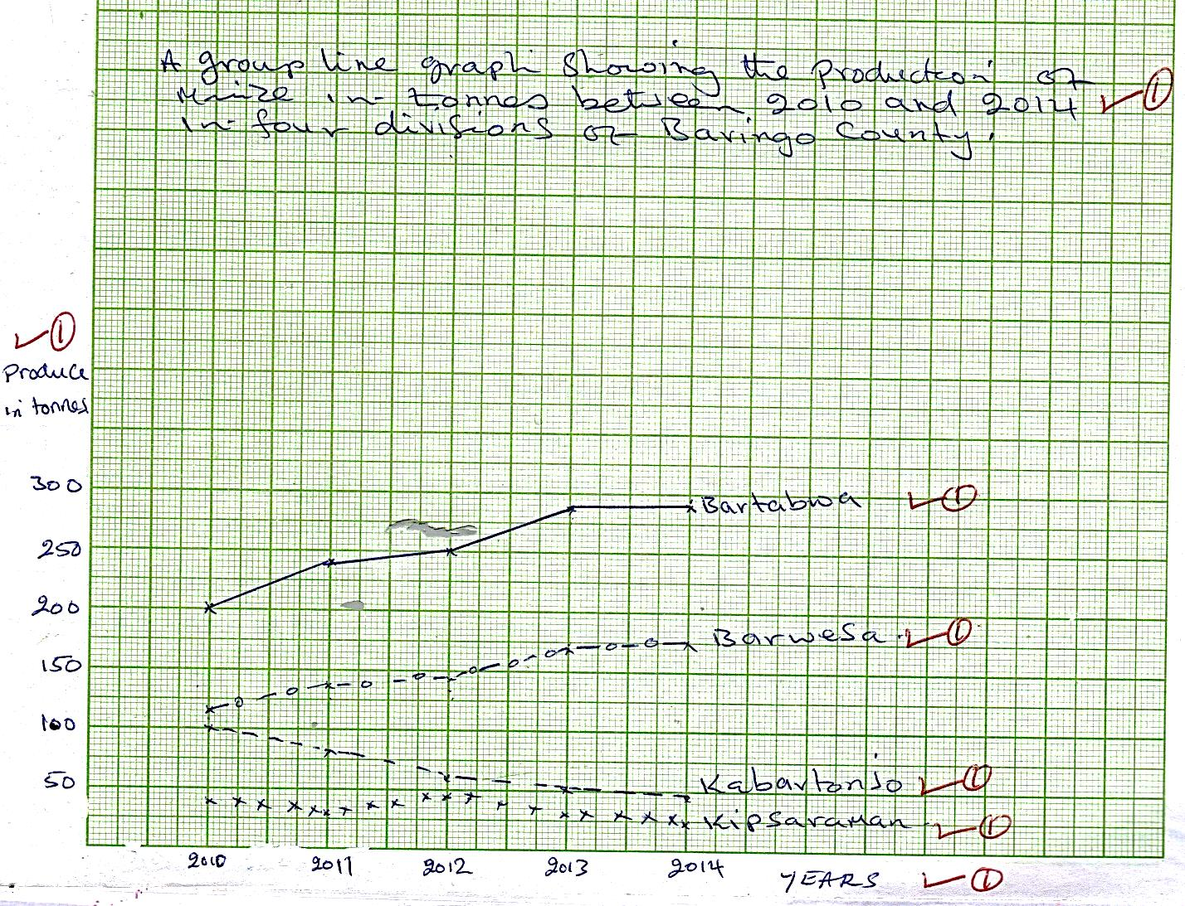

ii**) state three advantages of using group line graph. 3mks**

Easy to construct/draw

Easy to read

Easy to interpret

Easy to compire

Gives clear impression

(c) **State three climatic conditions favoring the growing of maize.** 3mks

High rainfall/1200-2500mm annually

High temperatures/18ᴼc-30ᴼc

High humidity for growth/maturity

Dry sunny conditions during harvesting

Well-distributed rainfall throughout the year

(d**) Explain four problems facing small scale maize farmers in Kenya. 8mks**

Shortage of rainfall/ inadequate rainfall reducing the production of maize

Attack by pests eg. Army warms and stalk borers destroying maize thus lowering yields.

High cost of inputs eg fertilizer, maize seeds thus increasing the cost of production

Importation of cheap maize that floods the market reducing the farmers morale

Diseases eg maize streak, and leaf rust that attack the crop thus reducing the production

Heavy rainfall during harvesting period destroying maize

7. **a I what are derived forests 2mks**

Are forests which are in the process of **recovering from** interference by *man.*

ii state the characteristics of planted forests 4mks

They consist of similsr species

Trees are planted in rows

Trees take short time to mature

There is little or no undergrowth

b**..Explain 4 the similarities between soft wood forests in kenya and Canada 8mks**

Soft wood forests in both countries experience the problems of pests and diseases, fires, soil erosion and overexploitation.

Softwood forest products are similar e.g. sawn timber, wood pulp, paper, poles, etc.

Softwood forests in both countries grow in places with heavy rainfall, cool temperatures, heavy rainfall and rugged terrain.

Forest products earn foreign exchange in both countries.

Tree species are similar e.g. there is pine in both countries

C .**Explain 4 preblems facing forestry in both kenya and canada 8mks**

Forest fires which destroy large tracts of land where in Canada the greatest number of fires are caused by lighting while in Kenya they are caused by illegal loggers, poachers, etc.

Pests and diseases e.g. aphids which destroyed cypress in 1980s.

Overexploitation leading to soil erosion as trees takes long time to mature and provide sufficient cover to the soil after planting.

Canada’s trees take long time to mature (50-60 years due to severe winters which slow their growth. In Kenya they take 12-35 years.

In Canada there is problem of inaccessibility of forests in the northern part in winter and due to rugged terrain while in Kenya they are planted and easily accessible.

Comparison of softwood forests in Kenya and Canada

d.**state measures taken by the government of kenya to conserve forests 3mks**

Creation of forest reserves

Agroforestry

Creation of buffer zones

Enacting laws to protect forests

8. **The map below shows the location of some minerals in East Africa**.

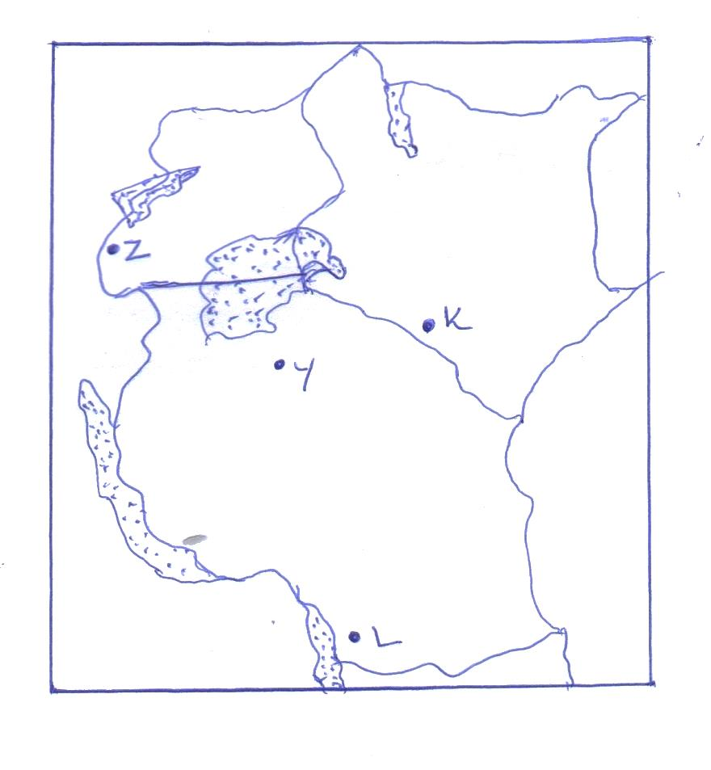

1. N**ame the minerals mined in the areas marked K,L,Y. and Z. 4**mks

K- Soda ash/Trona

L- Coal

Y- Diamond

Z- Copper

1. (i) **State two conditions that are necessary for the formation of petroleum.** 2mks

Presence of porous rock

Presence of non-porous rock

Presence of pressure to compress the organic remains

Presence of sedimentary rocks

Presence of organic remains or fossils

Any 2x1=2mks

(ii**) List three ways in which open cast mining affects the environment. 3mks**

it leaves behind ugly open pits

water in the open pits provide breeding grounds for mosquitoes which spread malaria

the heaps of rock waste litters the surrounding area

Destruction of biodiversity. Ie plants and animals

cause air, water and noise pollution

soil erosion /degradation of the soil

it leads to land dereliction/ waste of agricultural land/ industrial land.

Any 3x1=3mks

1. (i) **Give two uses of diamond. 2mks**

Making jewellery

Polishing metals

Making cutting instruments

Any 2x1=2mks

(ii) **Explain three ways in which mining promotes industrialization in Kenya. 6mks**

Some minerals provide essential raw materials for some manufacturing industries

Minerals are exported to earn the country foreign exchange which is used for development of industries

Mining stimulates development of roads/ railways which promotes industrial growth/ ease movement of finished products

Mining attracts growth of towns which attract industrial development.

Mining creates employment raising the standards of living of people, hence creating a greater demand for industrial products thus promoting industrial growth.

Stimulates growth of the related industries that supply inputs.

Any 3x2=6mks

1. **Apart from industrialization, explain four ways in which mining contributes to the economy of Kenya. 8mks**

Mining and related industries provide employment for many Kenyans

Mining stimulates the development of transport links like roads and railway lines to places which were previously inaccessible

Mining has led to development of social amenities such as schools,electricity,water and hospitals in the mining regions

Minerals are exported to other countries to earn foreign exchange

Mining led to development of settlement and towns such as magadi, kakamega and macalder

Any 4x2=8mks

9**. Define industrial inertia 2mks**

it is a tendency of industry to remain in a particular place even when the location factors are no longer relevant

b**. Explain 5 importance of industrialization to the economy of the country 10mks**

kenya exports manufactured goods earning foreign exchange used to develop other sectors of the economy

many kenyans are employed in industries hence improving their living standards

of transport network in places where the industries have sprung up making the area accessible for trade/exploitation of other resources

the government taxes industries earning revenue used to develop other sectors of the economy –diversification of economy reduces over reliance on agriculture

development of towns e.g. thika has provided market /encourage trading-it fosters good international relations so as the enable the country to sell excess products

improvement of agricultural production skills since the industries provide market for agricultural raw materials

production of goods hence earning direct income

led to the reduction in importation of some goods saving the country’s foreign expenditure-formulation of cooperative societies enables saving/credit facilities or loans

building industries led to improvement of road network hence increases volume of trading opportunities

provides employment earning workers income to improve their living standards­­-growth of settlement which necessitates improvement of social amenities

improved balance of trade since it reduces overreliance on imported products industrial exports help in maintaining a balance of trade between kenya and her trading partners by reducing over reliance on imports.

industries based on locally available materials encourage utilization of resources which would be otherwise be idle.

C.**Explain any 4 negaive effects of industrialization 8mks**

environment pollution that results from industrialization causes deaths diseases or destruction of environment

industrialization may lead to unemployment due to technological enhancement that performs work initially done by man

industrialization may bring tendency of neglecting agricultural production leading to food shortage

it may lead to rural –urban migration hence congesting towns

d **Your class intends to have a field study in one of the industries,outline ways in which you will prepare for the study 5mks**

making a reconnaissance

seeking permission

organising for transport

assembying tools

making a work schedule

preparing a questionnaire

formulating objectives

drawing a route map

10.**a i. Define Agriculture 2mks**

The practice of cultivating crops and rearing of livestock

ii**. Give the characteristics of dairy farming 5mks**

Dairy cattle are reared.

It’s usually practiced in areas with good economy i.e. developed infrastructure for quick transportation of milk and good ready market because dairy products are perishable.

Employment of high modern technology of processing, packaging because milk is a perishable product which should be processed short time after it is milked.

High milk yielding cows are reared e.g. Friesian, Ayrshire, Guernsey, Jersey, Alderney, Sahiwal.

Kenya

The main breeds are Friesian and Ayrshire and cross breeds between indigenous and exotic breeds.

Farmers use AI administered by veterinary extension officers or bulls directly to sire calves and keep the herd ‘in milk.

In the past the government used to provide the services but they have been privatised making them inaccessible to many Kenyans.

iii**. state the advantages of mixed farming 3mks**

When crop fails or prices fluctuate the farmer can depend on livestock and vice versa.

The farmer gets income continually.

Income is larger.

Farmer is busy throughout the year.

Using crop residue as fodder saves money for buying it.

Using manure from animals ensures sustained crop production and also saves money that would be used to buy manure.

b**. Explan how the following factors influence Agriculture 8mks**

***Variation inTemperature***

Some domestic animals do well in hot and warm areas e.g. goats and camels while others do well in cool areas e.g. exotic breeds of cattle such as Guernsey.

Some crops do well in cool areas e.g. tea and wheat while some others do well in warm areas e.g. sisal and cotton.

High temperatures increase the rate of evaporation of moisture which causes crops to wither and eventually die.

Night frosts damage tender leaves of some crops e.g. tea and bananas.

**Sunshine**

Needed for photosynthesis process in which plants manufacture food for growth and formation of fruits and seeds.

Sufficient sunshine is required during ripening of crops to ensure that they have high sugar content.

Sunshine is required during harvesting to prevent crop from rotting and also for drying harvested crops.

**Winds**

Winds accelerate evaporation and transpiration which may cause crops to wither and eventually die.

Hot and dry winds damage crops such as cocoa by causing them to ripen prematurely.

Wind is important for pollination necessary for fruit and seed formation.

Violent wind may cause falling of tall varieties of crops like maize and bananas.

**Variation in rainfall**

Inadequate moisture causes failed germination and retarded growth of crops.

Too much water causes root and fruit rot.

Livestock rearing is realized in areas which receive moderate to abundant rainfall

Insufficient rainfall leads to shortage of pasture for animals causing poor quality and low production

Very high rainfall floods destroying both crops and animals

Very high rainfall may result to surface run-off which erodes soil reducing crop productivity

b**. Describe the cultivaton of cocoa 7mks**

A piece of land in the forest is cleared of all trees leaving a few to provide shade for the crop.

The vegetation is then cleared and set on fire for ashes to enrich the soil.

The seeds are planted in nurseries where there is light shade.

After 4-5 months the seedlings are transplanted during short rains. Cuttings can also be grown.

Crops such as cassava, yams and bananas are inter-planted with young plants to provide shade for the crop.

Manuring and weeding are done regularly while tending the crops.

Fruiting begins after 5 years with abundant production being reached being attained after 10 years.

Pruning is constantly done to rid the plant of any branches that may grow to allow good quality pods to form on the branches.