** MARANDA HIGH SCHOOL**

**Kenya Certificate of Secondary Education**

**PRE-MOCK EXAMINATIONS 2024**

**312/2 Geography MS Paper 2**

**SECTION A**

***Answer all questions in this section***

1. **(a) What is fish farming? (2 marks)**

*Fish farming is the keeping/rearing of fish in ponds for commercial purposes.*

**(b) State three reasons fish farming should be encouraged in Kenya. (3 marks)**

* *Fish farming occupies less space compared to other especially agricultural activities.*
* *It is free from territorial disputes and conflicts*
* *It leads to the development of related industries e.g. fish processing, canning, fertilizer making and boat construction.*
* *Creation of job/employment opportunities – building and management of the fish ponds/farms*
* *Fish is a source of food/supplement animal protein.*
* *Some fish in the ponds e.g. trout are exported hence earn foreign exchange.*
* *Allows better and maximum utilization of land and water resources especially swamps/dams with no agricultural use.*
* *It is less exposed to dangers of deep sea or lake fishing-storms, drowning.*
* *It assists in the conservation of rare fish species, which might face the danger of depletion or extinction.*

1. **(a) Differentiate between transport and communication. (2 marks)**

*Transport is the physical carriage and* ***movement of people/goods*** *from one place to another while*

*Communication is the process of* ***transmitting/exchanging information from one person to another****/between persons.*

**(b) State three physical factors that influence development of transport and communication in Kenya. (3 marks)**

* *Relief features/mountains/escarpments/hills / valleys/rugged landscape that make it expensive/difficult to establish modern transport lines*
* *Earth movements like faulting that destroy existing roads/cracks on roads,*
* *Wet climate/high rainfall resulting to many bridges being washed away and roads becoming impassable*
* *Drainage features/rivers/lakes make it expensive to establish transport lines*

1. **(a) Name two marine parks in the coast region of Kenya. (2 marks)**

* *Malindi Marine National park*
* *Watamu*
* *Kisite*

(b) **State three ways in which marine parks are conserved. (3 marks)**

* *Gazzement of the parks to avoid encroachment*
* *Encouraging eco-tourismto reduce pollution*
* *Employing of guards eg KWSto protect the sites*
* *Creation of awareness on importance of protecting the wildlife*
* *Setting up wildlife protection agencies eg KWS,coast guards*
* *Out lawing illegal fishing in these parks*

1. **(a) Study the map below and use it to answer question 4(a)(i) and (ii)**

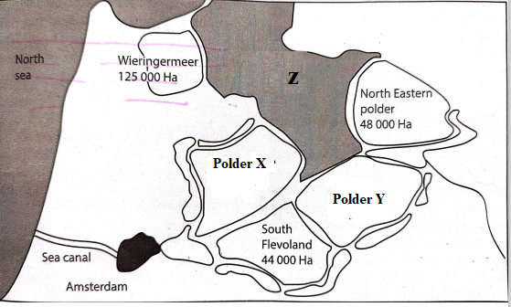

**(i) Identify the polders marked X and Y (2 marks)**

*X Markerwaad*

*Y Eastern Flevoland*

**(ii) The drainage feature marked Z (1 mark)**

*Lake Yessel*

**(b) State two objectives of the delta plan project. (2 marks)**

* *To provide land for settlement/towns and establishing social/public utilities e.g. schools, hospitals, . suitable for growing of crops*
* *To shortened the coastline distance by about 320km*
* *To reduce tidal flooding on the coastline after construction of the protective dykes*
* *To attract tourist thus earned Holland foreign exchange which is used for developing other sector of the economy.*

1. **(a) Differentiate between horticulture and market gardening. (2 marks)**

* *Horticulture refers to the intensive cultivation of vegetables, fruits and flowers for* ***sale and export*** *while Market gardening is an intensive cultivation of vegetables and fruits for* ***sale in the nearest urban centre***

**(b) State challenges that horticultural farmers experience in marketing their produce in Kenya. (3 marks)**

* *Impassable roads during rainy seasons leading to delay*
* *Inadequate/poor refrigenation facilities leading to rotting*
* *Fluctuation of prices in the world market discourages farmers*
* *Stringent quality standards required at the international market increases cost of production lowering profits*
* *Reliance on middle men who exploit farmers*
* *High cost of transporting produce by air lowers profit margin*
* *Competition from other producing countries lowers the market*

**SECTION B**

*Answer* ***question******6*** *and any other* ***two*** *questions from this section.*

1. The table below shows sources of installed electricity capacity in megawatts in Kenya between 2015 to 2019. Study it and use it to answer question 6(a).

|  |  |  |  |  |  |
| --- | --- | --- | --- | --- | --- |
|  | **YEAR** | | | | |
| **Electricity source** | **2015** | **2016** | **2017** | **2018** | **2019** |
| Hydro sources | 799 | 797 | 805 | 807 | 826 |
| Thermal oil | 693.2 | 762 | 765 | 768 | 710 |
| Geothermal | 558 | 644 | 644 | 663 | 816 |
| Others | 26.5 | 51 | 53 | 358 | 370 |

1. **Using a scale of 1 centimeter to represent 75 megawatts, draw a comparative line graph to represent the data. (8 marks)**

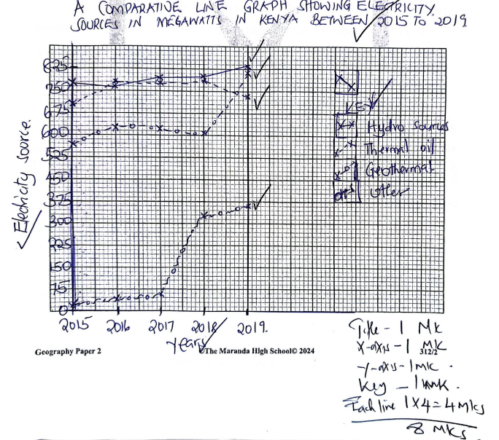

1. **(i) Name two potential sites identified for geothermal energy production in Kenya. (2 marks)**

* *Olkaria II*
* *Eburu*
* *Homa hills*

**(ii) Give four reasons that have limited exploitation of geothermal energy in Kenya. (4 marks)**

* *Limited number of potential sites/potential sites are also settled*
* *Scarcity of local skilled labour/experts*
* *Inadequate capital*
* *High costs of setting up geothermal plants*
* *Some experts question its sustainability/fear that steam may run out if not well managed*
* *Construction of very large geothermal plants may cause surface instability*
* *Challenges with long distance transmission leading to loss of energy*
* *Government control/Inadequate legal and regulatory framework that hinders its exploitation by private companies*

1. **(i) State two causes of high oil prices in Kenya? (2 marks)**

* *Currency exchange fluctuations/strengthening of the dollar/weakening of the kenya shilling*
* *Removal of fuel subsidies*
* *Increased taxation VAT fom 8% to 16%*
* *Conflicts in oil producing countrie/Russia-ukraine war/middle east wars/reduced supply*
* *Increased demand of oil in the world market*
* *High prices of crude oil from the source markets*

**(ii) Explain three effects of high oil prices to the economy of Kenya. (6 marks)**

* *Increase in oil prices triggers* ***increase in prices of commodities****/ inflation leading to* ***low standards of livin****g/ high cost of living.*
* *Increase in oil prices leads to* ***rise in the cost of farm inputs*** *which in turn leads to low agricultural production/* ***food shortage****.*
* *Increase in prices of crude oil makes* ***Kenya spend a lot of foreign exchange*** *in importation* ***lowering foreign currency******reserves****/ brings about imbalance of trade/ slows down the rate of economic growth.*
* *Increase in oil prices leads to* ***high cost of production*** *leading to* ***slow industrial growth****.*
* *Oil scarcity leads to* ***scarcity of by-products of oil*** *leading* ***the scarcity of raw materials*** *in some industries.*
* *Increase in fuel prices leads to an* ***increase in transport costs*** *which triggers price increase in in price commodities/* ***inflation****/ reduced tourism activities.*
* *Increase in oil prices leads to high demand for wood fuel leading to* ***deforestation****.*
* *Increase in oil prices has led to the* ***development of alternative sources of energy*** *to reduce overdependence of oil.*
* *Increase in oil prices lead to* ***high cost of goods*** *thus lowering their consumption.*

**(iii) State three policy measures the government of Kenya has taken to reduce effects of high oil prices. (3 marks)**

* *Stabilization of Currency exchange /strengthening of the Kenya shilling*
* *Introduction of fuel subsidies/stabilization programs to lower the prices*
* *Retail price regulation/fuel price controls*
* *Reduction in fuel taxes/VAT*
* *Government to government agreements on wholesale importation of fuel to reduce prices*
* *Targeted income support to vulnerable groups*
* *Agricultural subsidies/fertilizer subsidies to farmers*

1. **(a) (i) Differentiate between minerals that occur as veins and reefs. (2 marks)**

*A vein is a crack or a crevice in a mass of rock containing minerals deposited in crystalline form within the earth’s crust while a reef is a crack or a crevice in a mass of a rock containing minerals exposed on the surface*

**(ii) Name a mineral mined in each of the following counties in Kenya. (3 marks)**

* *Kwale – Tiomin/Titanium*
* *Taita Taveta -Ruby*
* *Kisii - Soapstone*

**(b) Explain how the following factors influenced exploitation of diamond in South Africa**

* **Capital ( 2 marks)**
* *Large British mining companies like De Beers /Petra diamonds… have large capital base that help them expanded/modernize/sustain diamond mining*

*.*

* **Transport (2 marks)**
* *South Africa has modern* ***port of Durban****/ port Elizabeth/electric rails between Kimberley and Johannesberg/ Durban and port elizabet/Kimberley airport/ Oliver Tambo international airport in johannseburg that are* ***efficient/*** *allow fast export of mineral products to overseas markets*

1. **Describe how stripping mining method is used to mine limestone in Bamburi in Kenya. (5 marks)**

* *The site with sufficient* ***limestone is identified***
* *The overburden or* ***unwanted material are removed*** *by bulldozers*
* *The limestone is* ***dug out if it is less resistant*** *by digging using power shovels/excavators*
* *If the limestone ore is* ***more resistant, explosives*** *are employed to dislodge the rocks*
* *Huge power shovels are then employed to dig the mineral deposits*
* *The ore is then* ***loaded into trucks*** *and transported to bamburi cement factory for processing*

**(d) Explain three problems facing gold mining in South Africa (6 marks)**

* *The costs of production have greatly increased due to the* ***deepening of the mines leading to reduced profits***
* *Gold is a* ***non-renewable*** *mineral thus it gets depleted/exhausted in some mines leading to their abandonment*
* ***Collapse of mines*** *due pressure bursts as a result of heavy weights above as the mines become deeper leading to loss of lives*
* ***Shortage of local labour*** *leading to workers being sourced from the neighboring southern African countries who demand higher wages and provision of better social amenities lowering profit margins*
* ***Decline in gold-grade quality*** *that fetch low prices hence marginal profits*
* ***Deepening of mines*** *making it expensive to mine leading to marginal profits*
* ***Frequent industrial unrests/strikes*** *hinders mining process leading to losses*

**(e) Maranda high school students carried out a field study on the mining of soda ash in Lake Magadi.**

**(i) Identify two methods they may have used in recording data. (2 marks)**

* *Note taking*
* *Taking photographs*

**(ii) State three benefits that accrue to the local community as a result of the mining that they may have observed**.  **(3 marks)**

* *It has contributed to the development of Magadi town and of social amenities such as hospitals and schools improving living standards of the local community*
* *It has stimulated the development of road and rail transport e.g. the Konza – Magadi Railway, Nairobi-Magadi road, electricity and water supply. These have opened up the area for further development./easen movement*
* *Some locals are employed earning them income thus raising the living standards*
* *It has promoted industrial growth by providing raw materials in the following industries: oil refining, paper making, glass making*
* *Earning the government revenues through taxations and tarrifs – the money is used locally for the development of the country*

1. **(a) (i) Apart from Nigeria, name two countries in West Africa where oil palm is grown. (2 marks)**

* *Ghana*
* *Senegal*
* *Guinea*
* *Liberia*
* *Cameroon*
* *Sierra Leone*
* *Benin*
* *Ivory Coast*

**(ii) Name two regions in Nigeria where oil palm is grown (2 marks)**

* + *Port Harcourt*
  + *Calabar*
  + *Sapele*

**(b) Explain three human factors that favour growing of oil palm in Nigeria. (6 marks)**

* *Availability of* ***adequate capital*** *from Nigerian banks and other lenders to* ***expand/maintain farm operations*** */maintain roads/*
* *Nigeria has* ***well developed road network*** *comprising of feeder roads in palm growing farms and trunk roads to* ***ease movement*** *of oil palm to factories*
* *Availability of* ***cheap skilled****/ semiskilled labour provided by Nigerians dense population that help in* ***farm clearing****/weeding/harvesting/management*

(**c) The photograph below shows an oil palm. Study it and use it to answer question c (i) and (ii)**

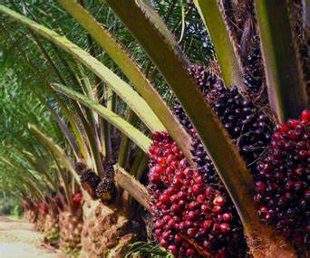

**(i) Describe the processing of the oil palm from the stage shown in the photograph. (6 marks)**

* *The ripe fruits are* ***cut using a sharp curved knife***
* ***The fruits are Loaded into lorries*** *immediately and taken to the factory*
* *At the factory, the fruits are* ***sterilize****d by passing through hot steam to arrest acid development.*
* *The sterilized fruits are then passed through stripper where the individual fruits are* ***stripped*** *of the stalks and other unwanted materials.*
* *The fruits are then put in digesters for further* ***cooking*** *to soften them into pulp.*
* *The pulp is then separated from the kernel and then* ***pressed*** *to extract oil by the oil extractors.*
* *Extracted oil is then kept in settling tanks to allow unwanted material to settle.*
* *The oil is then* ***packed*** *in containers ready for marketing*

**(ii) Give three uses of the parts of the palm oil shown above. (3 marks)**

* *The* ***leaves are used for roofing****/making baskets/brooms*
* *The* ***stems are used as building****/fencing poles*
* *The* ***fruit is used for making palm oil****, cosmetics, soap and candles*
* *Crushed nut is used for animal feeds and fertilizers*

**(d) Explain three economic problems facing oil palm growing in Nigeria. (6 marks)**

* *Attack by pests/diseases that lower yield leading to losses to farmers*
* *Inadequate capital by small scale farmers limiting expansion thus low yields*
* *Impassible roads in some areas leading to delays in delivery hence fruits go bad causing losses*
* *government policy that emphasizes growing of food crops leading to abandoning of oil palm/reduction of area under oil palm*
* *fluctuation of prices in the world market lead to marginal profits*

1. **(a) (i) Define Agro-forestry. (2 marks)**

*Agroforestry is the cultivation of trees ,crops and rearing of livestock on the piece of land at the same time*

**(ii) Explain two ways human activities influence distribution of forests. (4 marks)**

* *Deforestation –clearing of forests to give land for agriculture and settlement reduces large acreage of forests.*
* *Creation of forest reserves increases the land under forests*
* *Afforestation leads to creation of new forests*
* *Forest fires destroy large acreage of forests*

1. **State five characteristics of planted forests in Kenya. (5 marks)**

* *Planted forests have little or no under growth*
* *Trees grow in uniform/pure stands*
* *Trees mature at the same time*
* *Trees are easy to exploit*
* *Trees grow in linear patterns*

1. **(i) Name two major forest reserves in Kenya. (2 marks)**

* *Mau*
* *Kakamega*
* *Arabuko sokoke*

**(ii) Other than creation of forest reserves give four other ways of managing forests in Kenya.**

**(4 marks**)

* *Introduction of faster maturing trees of high commercial value*
* *Improve tree cutting practices through selective harvesting and rotational felling of trees followed by replanting*
* *Establishment of forest training institutions to oversee management measures of forest*
* *Establishing training and research institutions dealing with forests*
* *Introduction and promotion of energy saving stoves/jikos to reduce the amount of wood fuel being used*
* *Setting up forest guards within the forest to protect forests against illegal tree felling*
* *Encouraging use of alternative energy sources to minimize overdependence on wood fuel*
* *Creating awareness on the importance of forests through public campaigns in mass media and related organizations*
* *Conducting research on soil requirements for different tree species to enable establishment of forests in suitable areas*

1. **State two problems that affect forestry in Canada. (2 marks)**

* *Periodic forest fires destroy large areas of forests.*
* *Pests and diseases attack (Aphids) also destroy forests*
* *The forests in northern parts are not accessible in winter because of snow.*
* *The harsh and cold climatic conditions do not allow trees to mature quickly. This slow growth had led to overexploitation.*
* *The north has a rugged terrain which hinders its accessibility.*
* *Periodic forest fires destroy large areas of forests.*
* *Pests and diseases attack (Aphids) also destroy forests*
* *The forests in northern parts are not accessible in winter because of snow.*
* *The harsh and cold climatic conditions do not allow trees to mature quickly. This slow growth had led to overexploitation.*
* *The north has a rugged terrain which hinders its accessibility.*

1. **Differentiate between softwood forests in Kenya and Canada under the following sub headings;**

* **Logging (4 marks)**
* *In Kenya logging is done throughout the year whereas in Canada logging done during winter*
* *In Kenya logging is done indiscriminately while in Canada logging done selectively*
* **Transport (2 marks)**
* *In Kenya logs are transported by tractors/ lorries/trucks while in Canada logs are transported by floating on rivers and skidding over snow.*

1. **(a) (i) What is an industrial inertia? (2 marks)**

* *Industrial inertia is the tendency of an industry to remain in a particular place even when the original locational factors*

**(ii) Outline three causes of industrial inertia. (3 marks)**

* *An industry may remain in a place due to the availability of experienced workers*
* *Sometimes it is very expensive to move to a new site*
* *Well-developed transport network*

**(b) State two ways in which availability of skilled manpower influence location of industries in Kenya. (2 marks)**

* *Towns like Nairobi have* ***high number of skilled managers*** *leading to successful establishment management of many industries there*
* *Rural areas have fewer industries because it is* ***expensive to hire skilled mangers***
* *Use of expartriates in managing industries may lead to high wage bills reducing profitability*

**(c) Explain two likely reasons for the closure of Pan Paper Mills at Webuye. (4 marks)**

* *Mismanagement/corruption of the industries led to its collapse*
* *Inadequate raw materials/trees due to encroachment*
* *High labour costs may have reduced profitability*
* *High costs of energy led to reduced profits*
* *Stiff competition from cheap imported pulp from Canada and china*
* *Inadequate capital to modernize/diversify and expand operations*

**(d) (i) Name two automobiles companies in Japan. (2 marks)**

* *Mitsubishi*
* *Nissan*
* *Honda*
* *Suzuki*
* *Mazda*
* *Toyota*

**(ii) Explain how historical factors favoured the growth of car and electronics industry in Japan.**

* *Post war reconstruction where japan abandoned its military aggressions and concentrated on industrial development*
* *The rise of emperor Meiji who was an industrial addict who gave immense government support to the industries and this was continued by the son Taisho led to increased production*
* *A rich history of producing cars and electronics products ensured availability of skilled Japanese from one generation to the next ensuring quality products*
* *Its non-aligned friendly policies gave it access to overseas markets in Europe and USA ensured high profitability of the industries leading to their expansion*

1. **Explain three measures taken to curb environmental pollution as a problem associated by industrialization in Kenya.** (6 marks)

* *Manufacturing industries must ensure effluent is treated before being discharged into the environment*
* *The government should formulate and implement policies against environmental pollution*
* *Government /stakeholders should create awareness among industrialists on the importance of the environment*
* *Manufacturing industries should conduct research into raw materials which are non pollutant*

**THIS IS THE LAST PRINTED PAGE**