KASSU - JET JOINT EXAMINATIONS 2024

Kenya Certificate of Secondary Education

312/1 Paper 1
GEOGRAPHY

June. 2024 – 2³/₄ hours

Name ………………………………………………………Admission Number ………………….

Class …………………………Date ……………Candidate’s Signature…………………………...

Instructions to candidates

- Write your name and Admission Number in the spaces provided above.
- Write your class, date of examination and sign in the spaces provided above.
- This paper consists of two sections; A and B.
- Answer all the questions in section A.
- Answer question 6 and any other two questions from section B.
- Answers must be written in the spaces provided at the end of question
- This paper consists of 5 printed pages.
- Candidates should check the question paper to ascertain that all the pages are printed as indicated and that no questions are missing.
- Candidates should answer the questions in English.

For Examiner’s Use Only
Section | Question | Maximum Score | Candidate’s Score
A | 1 - 5 | 25
B | 6 | 25
B |  | 25
 |  | 25
 | Total Score

SECTION A: (25 MARKS)
Answer all questions.
1 (a) Give two areas studied under practical geography ( 2 marks )
(b) Describe the relationship between geography and the following disciplines
- Biology ( 2 marks )
- Medicine ( 2 marks )
2 . Describe the passing star theory ( 5 marks )

3 . (a) ( i ) Give two examples of plutonic rocks ( 2 marks )
(b) State three ways in which rocks are classified (3 marks)
4 . Study the diagram of the flood plain provided and answer the questions that follow
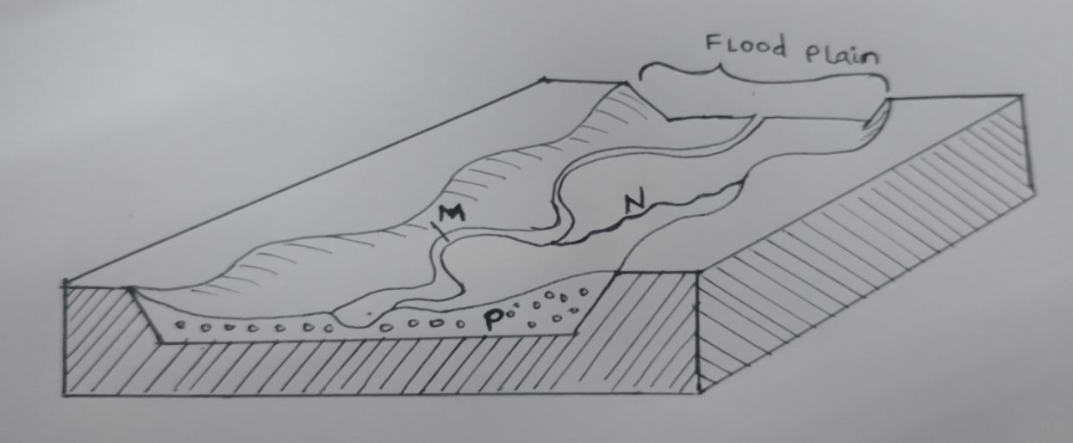
( a) Identify the parts labelled M,N and O ( 3 marks )
( b) Apart from a flood plain name three other river depositional features
( 2 marks )
5 . Study the map of the world provided and answer the questions that follow
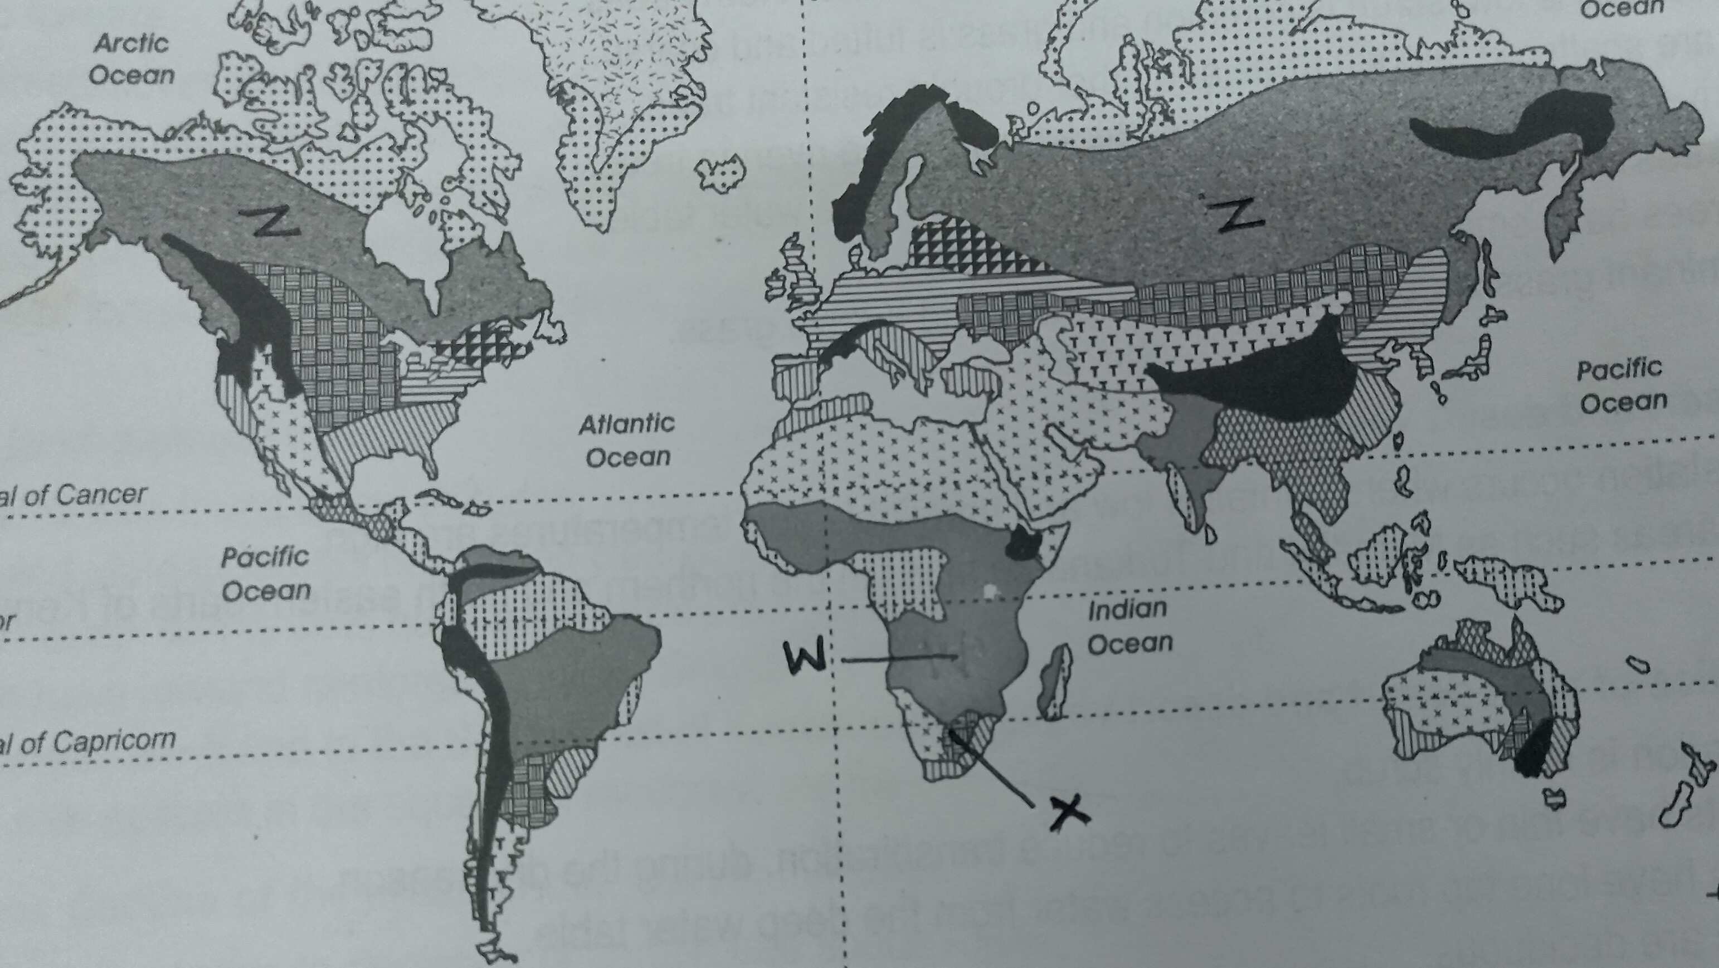
( i ) Name the vegetation types marked W , X and Z ( 3 marks )
( ii ) State two characteristics of desert vegetation ( 2 marks )

SECTION B: (75 MARKS)
Answer question 6 and any other two questions from this section
6. Study the map of Mumias 1: 50,000 ( Sheet 101/2 ) provided and answer the following questions .

  - (i) What information is contained on the sheet title (2 marks )
(ii) Measure the distance of river Lusimu from the junction of river Nzoia to the bridge. Give your answer in kilometres and metres. (2 marks )
(iii) Name two drainage patterns found in the area covered by the map.
(2 marks )
(iv) Identify two types of natural vegetation to the south of northing 36
(2 marks )

  - Describe the distribution of settlement in the area covered by the map ( 6 marks )
  - Citing evidence explain three factors that would favour cattle rearing in Mumias.
( 6 marks )

  - Describe the relief of the area covered by the map ( 5 marks )

7 (a) (i) Apart from the rift valley name two other resultant features of faulting.
( 2 marks )
(ii) State three characteristics of Gregory rift valley. ( 3 marks )

(b) Explain four ways in which faulting influences drainage. ( 8 marks )

(c ) Within the aid of a well labeled diagram describe how a block mountain is formed due to compressional forces. (7 marks )

(d) Students at MEC School intends to carry out a field study on a section of Rift valley

( i ) State three preparation they will make before the study. ( 3 marks )

( ii ) State two follow up activities that they would engage in after the study.
(3marks)

8. (a) Distinguish between vulcanicity and volcanicity. ( 2 marks )

(b) (i) A part from a plug volcano, name three other extrusive volcanic features
(2 marks)
(ii) With the aid a well labeled diagram describe the formation of a plug dome
( 8 marks)

(c) (i) What are fumaroles? ( 2 marks )

(ii) Describe how a hot spring is formed ( 6 marks )

  - Explain two ways in which volcanic features may influence the climate
( 4 marks )

9 . ( a ) ( i ) Distinguish between a swash and backwash ( 2 marks )

( ii ) The diagram shows the parts of a wave

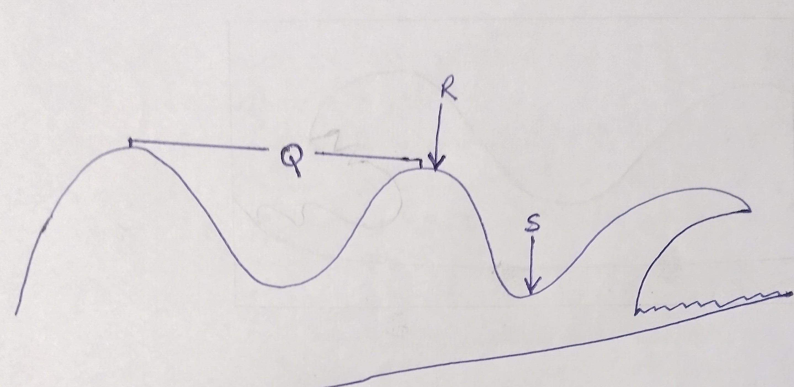
Name the parts labelled Q , R ,S and T ( 4 marks )

( b ) ( i ) State four factors that determine the size of a wave ( 4 marks )

( ii ) Using a well labelled diagram describe the formation of a cuspate foreland
( 7 marks )

( c ) Describe four factors that influence wave erosion along the coast ( 8 marks )

10. (a) The diagram below shows an artesian basin. Use it to answer question (a).

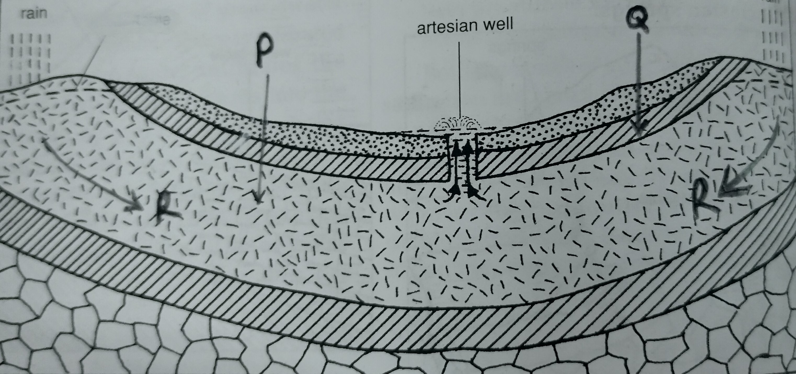

(a) Identify ;
- the part marked P. ( 1 mark )
- the layer marked Q ( 1 mark )
- the process marked R ( 1 mark )
- Describe how artesian basin forms ( 3 marks )

- State three ways springs form ( 3 marks )
(c ) Explain four factors that influence the existence of underground water
( 8 marks )

(d) (i) What is karst Scenery? ( 2 marks )
(ii) State reasons why there are few settlements in karst regions. ( 3 marks )
(iii) Name three underground karst features ( 3 marks )

THIS IS THE LAST PRINTED PAGE.

