**MARANDA HIGH SCHOOL**



**Kenya Certificate of Secondary Education**

**FORM 4 CYCLE II EXAMINATIONS**

**312/1 GEOGRAPHY Paper 1**

**February 2024 - TIME: 2½Hours**

**Name**: …………………………………………………**ADM** **No**:……….…**Stream**: …………

***Instructions to candidates***

1. *Write your name, admission number and class in the spaces provided above.*
2. *This paper has* ***two*** *sections:* ***A*** *and* ***B***
3. *Answer* ***all*** *the questions in section* ***A***
4. *Answer* ***question 6*** *and any other* ***two*** *questions from section* ***B***
5. *All answers must be written in the spaces provided after Question 10.*
6. ***This paper consists of 14 printed pages.***
7. ***Candidates should check the question paper to ascertain that all the pages are printed as indicated and that no questions are missing.***

**For Examiner’s Use Only**

|  |  |  |  |
| --- | --- | --- | --- |
| **Section** | **Questions** | **Candidate’s**  **Score** | **Maximum**  **Score** |
| **A** | **1 – 5** |  | **25** |
| **B** | **6** |  | **25** |
|  |  | **25** |
|  |  | **25** |
|  | **Total Score** |  | **100** |

**SECTION A**

*Answer* ***all*** *the questions in this section.*

1. (a) Define the solar system. (2 marks)

(b) State **three** characteristics of the sun. (3 marks)

1. (a) The diagram below shows a feature of wind erosion in an arid area. Use it to answer the questions that follow.

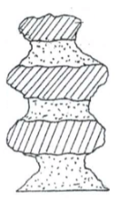

1. Name the feature. (1 mark)
2. Give **two** processes of wind erosion responsible for the formation of the feature. (2 marks)

(b) State **three** characteristics of an arid area. (3 marks)

1. (a) Explain how the following factors cause movement of crustal rocks:
2. Gravitative pressure (2 marks)
3. Magma movement (2 marks)

(b) Name **one** major tectonic plate of the earth. (1 mark)

1. Give **four** ways of soil conservation. (4 marks)
2. (a) Name **two** composite cones in East Africa. (2 marks)

(b) State **three** negative influences of composite cones to human environment. (3 marks)

**SECTION B**

Answer ***question 6*** and any other ***two*** questions in this section.

1. Study the map of Kisumu East 1: 50,000 (sheet 116/2) provided and answer the following questions.
2. (i) Give **two** scales used in the map extract. (2 marks)

(ii) What is the altitude of the lowest point covered by the map? (2 marks)

1. Give the approximate position of Chiga in terms of latitudes and longitudes (2 marks)
2. (i) Name **four** relief features found in the area covered by the map. (4 marks)

(ii) Calculate the area of the sugar plantation between the provincial boundary and the road C 543/1in square kilometres. (2 marks)

1. Describe the drainage of the area covered by the map. (4 marks)
2. (i) Reduce by 50% the area bound by easting 03 and northing 90 to the edges of the map on the eastern and northern parts (2 marks)

(ii) On the frame, mark and name the following:

* Railway line; (1 mark)
* Boundary of Kisumu Municipality; (1 mark)

1. Citing evidence from the map, identify **five** social activities offered in Kisumu Town. (5 marks)
2. (a) (i) Apart from the Rift Valley, name **two** other relief features that were formed as result of faulting. (2 marks)

(ii) With the aid of a well labeled diagram, describe how a Rift Valley is formed by compressional forces. (8 marks)

(b) Explain **four** effects of faulting. (8 marks)

(c) Students are planning to carry out a field study of an area affected by faulting

1. State **four** reasons why it is important for the students to have a pre-visit of the area. (4 marks)
2. One of the ways they would use to collect data is through direct observation. State **three** disadvantages of direct observation in the study of such an area. (3 marks)
3. (a) (i) Define the term glaciation. (2 marks)

(ii) Give **three** ways in which ice moves outwards from its area of accumulation. (3 marks)

(b) State **three** factors that influence glacial erosion. (3 marks)

(c) The diagram below shows some features of glaciation erosion. Use it to answer the questions that follow.

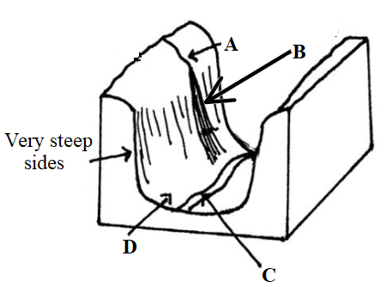

1. Name the parts labeled **A**, **B** and **C**. (3 marks)
2. Describe how the part labeled **D** is formed. (5 marks)

(d) List **three** depositional features of glaciation in lowland areas. (3 marks)

(e) Explain **three** problems of glaciation to the environment. (6 marks)

1. (a) (i) Define the term weather forecasting. (2 marks)

(ii) State **four** problems facing weather forecasting in Kenya. (4 marks)

(b) The diagrams below show some instruments that are used to measure temperature. Use them to answer the questions that follow.

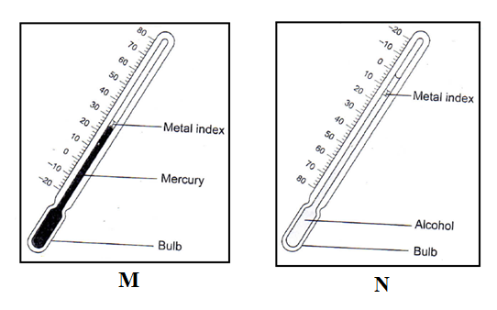

Describe how the instruments are used to measure the weather element stated. (5 marks)

(c) The map below shows some climatic regions of Africa. Use it to answer the questions that follow.

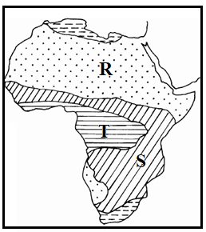

1. Name the climatic types labeled **R** and **S**. (2 marks)
2. Describe the characteristics of climatic type marked **T**. (5 marks)

(d) (i) Name the regions associated with the following vegetation types;

* Pampas (1 mark)
* Veldts (1 mark)

(ii) State **five** significance of vegetation. (5 marks)

1. (a) (i) Name **two** fresh water lakes that are found in Kenya. (2 marks)

(ii) State **three** reasons why some lakes in Kenya have fresh water. (3 marks)

(b) (i) Describe the formation of an oxbow lake. (7 marks)

(ii) Name **two** oxbow lakes in Kenya. (2 marks)

(c) Explain **three** negative effects of lakes to human activities. (6 marks)

(d) Members of your class plan to conduct a field study on Lake Victoria.

1. Other than Kisumu County, name **two** other counties they may visit for the study. (2 marks)
2. State **three** significance of studying lakes through fieldwork. (3 marks)

………………………………………………………………………………………………………………………………………………………………………………………………………………………………………………………………………………………………………………………………………………………………………………………………………

…………………………………………………………………………………………………………………………………………………………………………………………………………………………………………………………………………………………………………………………………………………………………………………………………………………………………………………………………………………………………………………………………………

………………………………………………………………………………………………………………………………………………………………………………………………………………………………………………………………………………………………………………………………………………………………………………………………………

…………………………………………………………………………………………………………………………………………………………………………………………………………………………………………………………………………………………………………………………………………………………………………………………………………………………………………………………………………………………………………………………………………

………………………………………………………………………………………………………………………………………………………………………………………………………………………………………………………………………………………………………………………………………………………………………………………………………

…………………………………………………………………………………………………………………………………………………………………………………………………………………………………………………………………………………………………………………………………………………………………………………………………………………………………………………………………………………………………………………………………………

………………………………………………………………………………………………………………………………………………………………………………………………………………………………………………………………………………………………………………………………………………………………………………………………………

…………………………………………………………………………………………………………………………………………………………………………………………………………………………………………………………………………………………………………………………………………………………………………………………………………………………………………………………………………………………………………………………………………

………………………………………………………………………………………………………………………………………………………………………………………………………………………………………………………………………………………………………………………………………………………………………………………………………

…………………………………………………………………………………………………………………………………………………………………………………………………………………………………………………………………………………………………………………………………………………………………………………………………………………………………………………………………………………………………………………………………………

………………………………………………………………………………………………………………………………………………………………………………………………………………………………………………………………………………………………………………………………………………………………………………………………………

…………………………………………………………………………………………………………………………………………………………………………………………………………………………………………………………………………………………………………………………………………………………………………………………………………………………………………………………………………………………………………………………………………

………………………………………………………………………………………………………………………………………………………………………………………………………………………………………………………………………………………………………………………………………………………………………………………………………

…………………………………………………………………………………………………………………………………………………………………………………………………………………………………………………………………………………………………………………………………………………………………………………………………………………………………………………………………………………………………………………………………………

………………………………………………………………………………………………………………………………………………………………………………………………………………………………………………………………………………………………………………………………………………………………………………………………………

…………………………………………………………………………………………………………………………………………………………………………………………………………………………………………………………………………………………………………………………………………………………………………………………………………………………………………………………………………………………………………………………………………

………………………………………………………………………………………………………………………………………………………………………………………………………………………………………………………………………………………………………………………………………………………………………………………………………

…………………………………………………………………………………………………………………………………………………………………………………………………………………………………………………………………………………………………………………………………………………………………………………………………………………………………………………………………………………………………………………………………………

………………………………………………………………………………………………………………………………………………………………………………………………………………………………………………………………………………………………………………………………………………………………………………………………………

…………………………………………………………………………………………………………………………………………………………………………………………………………………………………………………………………………………………………………………………………………………………………………………………………………………………………………………………………………………………………………………………………………

………………………………………………………………………………………………………………………………………………………………………………………………………………………………………………………………………………………………………………………………………………………………………………………………………

………………………………………………………………………………………………………………………………………………………………………………………………………………………………………………………………………………………………………………………………………………………………………………………………………………………………………………………………………………………………………………………………………………………………………………………………………………………………………………………………………………………………………………………………………………………………………………………………………………

………………………………………………………………………………………………………………………………………………………………………………………………………………………………………………………………………………………………………………………………………………………………………………………………………

…………………………………………………………………………………………………………………………………………………………………………………………………………………………………………………………………………………………………………………………………………………………………………………………………………………………………………………………………………………………………………………………………………

………………………………………………………………………………………………………………………………………………………………………………………………………………………………………………………………………………………………………………………………………………………………………………………………………

…………………………………………………………………………………………………………………………………………………………………………………………………………………………………………………………………………………………………………………………………………………………………………………………………………………………………………………………………………………………………………………………………………

………………………………………………………………………………………………………………………………………………………………………………………………………………………………………………………………………………………………………………………………………………………………………………………………………

……………………………………………………………………………………………………………………………………………………………………………………………………………………………………………………………………………………………………………………………………………………………………………………………………………………………………………………………………………………………………………………………………………………………………………………………………………………………………………………………………………

………………………………………………………………………………………………………………………………………………………………………………………………………………………………………………………………………………………………………………………………………………………………………………………………………

…………………………………………………………………………………………………………………………………………………………………………………………………………………………………………………………………………………………………………………………………………………………………………………………………………………………………………………………………………………………………………………………………………

………………………………………………………………………………………………………………………………………………………………………………………………………………………………………………………………………………………………………………………………………………………………………………………………………

…………………………………………………………………………………………………………………………………………………………………………………………………………………………………………………………………………………………………………………………………………………………………………………………………………………………………………………………………………………………………………………………………………

………………………………………………………………………………………………………………………………………………………………………………………………………………………………………………………………………………………………………………………………………………………………………………………………………

…………………………………………………………………………………………………………………………………………………………………………………………………………………………………………………………………………………………………………………………………………………………………………………………………………………………………………………………………………………………………………………………………………

………………………………………………………………………………………………………………………………………………………………………………………………………………………………………………………………………………………………………………………………………………………………………………………………………

…………………………………………………………………………………………………………………………………………………………………………………………………………………………………………………………………………………………………………………………………………………………………………………………………………………………………………………………………………………………………………………………………………

………………………………………………………………………………………………………………………………………………………………………………………………………………………………………………………………………………………………………………………………………………………………………………………………………

…………………………………………………………………………………………………………………………………………………………………………………………………………………………………………………………………………………………………………………………………………………………………………………………………………………………………………………………………………………………………………………………………………

………………………………………………………………………………………………………………………………………………………………………………………………………………………………………………………………………………………………………………………………………………………………………………………………………

…………………………………………………………………………………………………………………………………………………………………………………………………………………………………………………………………………………………………………………………………………………………………………………………………………………………………………………………………………………………………………………………………………

………………………………………………………………………………………………………………………………………………………………………………………………………………………………………………………………………………………………………………………………………………………………………………………………………

…………………………………………………………………………………………………………………………………………………………………………………………………………………………………………………………………………………………………………………………………………………………………………………………………………………………………………………………………………………………………………………………………………

………………………………………………………………………………………………………………………………………………………………………………………………………………………………………………………………………………………………………………………………………………………………………………………………………

………………………………………………………………………………………………………………………………………………………………………………………………………………………………………………………………………………………………………………………………………………………………………………………………………………………………………………………………………………………………………………………………………………………………………………………………………………………………………………………………………………………………………………………………………………………………………………………………………………

………………………………………………………………………………………………………………………………………………………………………………………………………………………………………………………………………………………………………………………………………………………………………………………………………

…………………………………………………………………………………………………………………………………………………………………………………………………………………………………………………………………………………………………………………………………………………………………………………………………………………………………………………………………………………………………………………………………………

………………………………………………………………………………………………………………………………………………………………………………………………………………………………………………………………………………………………………………………………………………………………………………………………………

…………………………………………………………………………………………………………………………………………………………………………………………………………………………………………………………………………………………………………………………………………………………………………………………………………………………………………………………………………………………………………………………………………

………………………………………………………………………………………………………………………………………………………………………………………………………………………………………………………………………………………………………………………………………………………………………………………………………

……………………………………………………………………………………………………………………………………………………………………………………………………………………………………………………………………………………………………………………………………………………………………………………………………………………………………………………………………………………………………………………………………………………………………………………………………………………………………………………………………………

………………………………………………………………………………………………………………………………………………………………………………………………………………………………………………………………………………………………………………………………………………………………………………………………………

…………………………………………………………………………………………………………………………………………………………………………………………………………………………………………………………………………………………………………………………………………………………………………………………………………………………………………………………………………………………………………………………………………

………………………………………………………………………………………………………………………………………………………………………………………………………………………………………………………………………………………………………………………………………………………………………………………………………

…………………………………………………………………………………………………………………………………………………………………………………………………………………………………………………………………………………………………………………………………………………………………………………………………………………………………………………………………………………………………………………………………………

………………………………………………………………………………………………………………………………………………………………………………………………………………………………………………………………………………………………………………………………………………………………………………………………………

…………………………………………………………………………………………………………………………………………………………………………………………………………………………………………………………………………………………………………………………………………………………………………………………………………………………………………………………………………………………………………………………………………

………………………………………………………………………………………………………………………………………………………………………………………………………………………………………………………………………………………………………………………………………………………………………………………………………

…………………………………………………………………………………………………………………………………………………………………………………………………………………………………………………………………………………………………………………………………………………………………………………………………………………………………………………………………………………………………………………………………………

…………………………………………………………………………………………………………………………………………………………………………………………………………………………………………………………………………………………………………………………………………………………………………………………………………………………………………………………………………………………………………………………………………

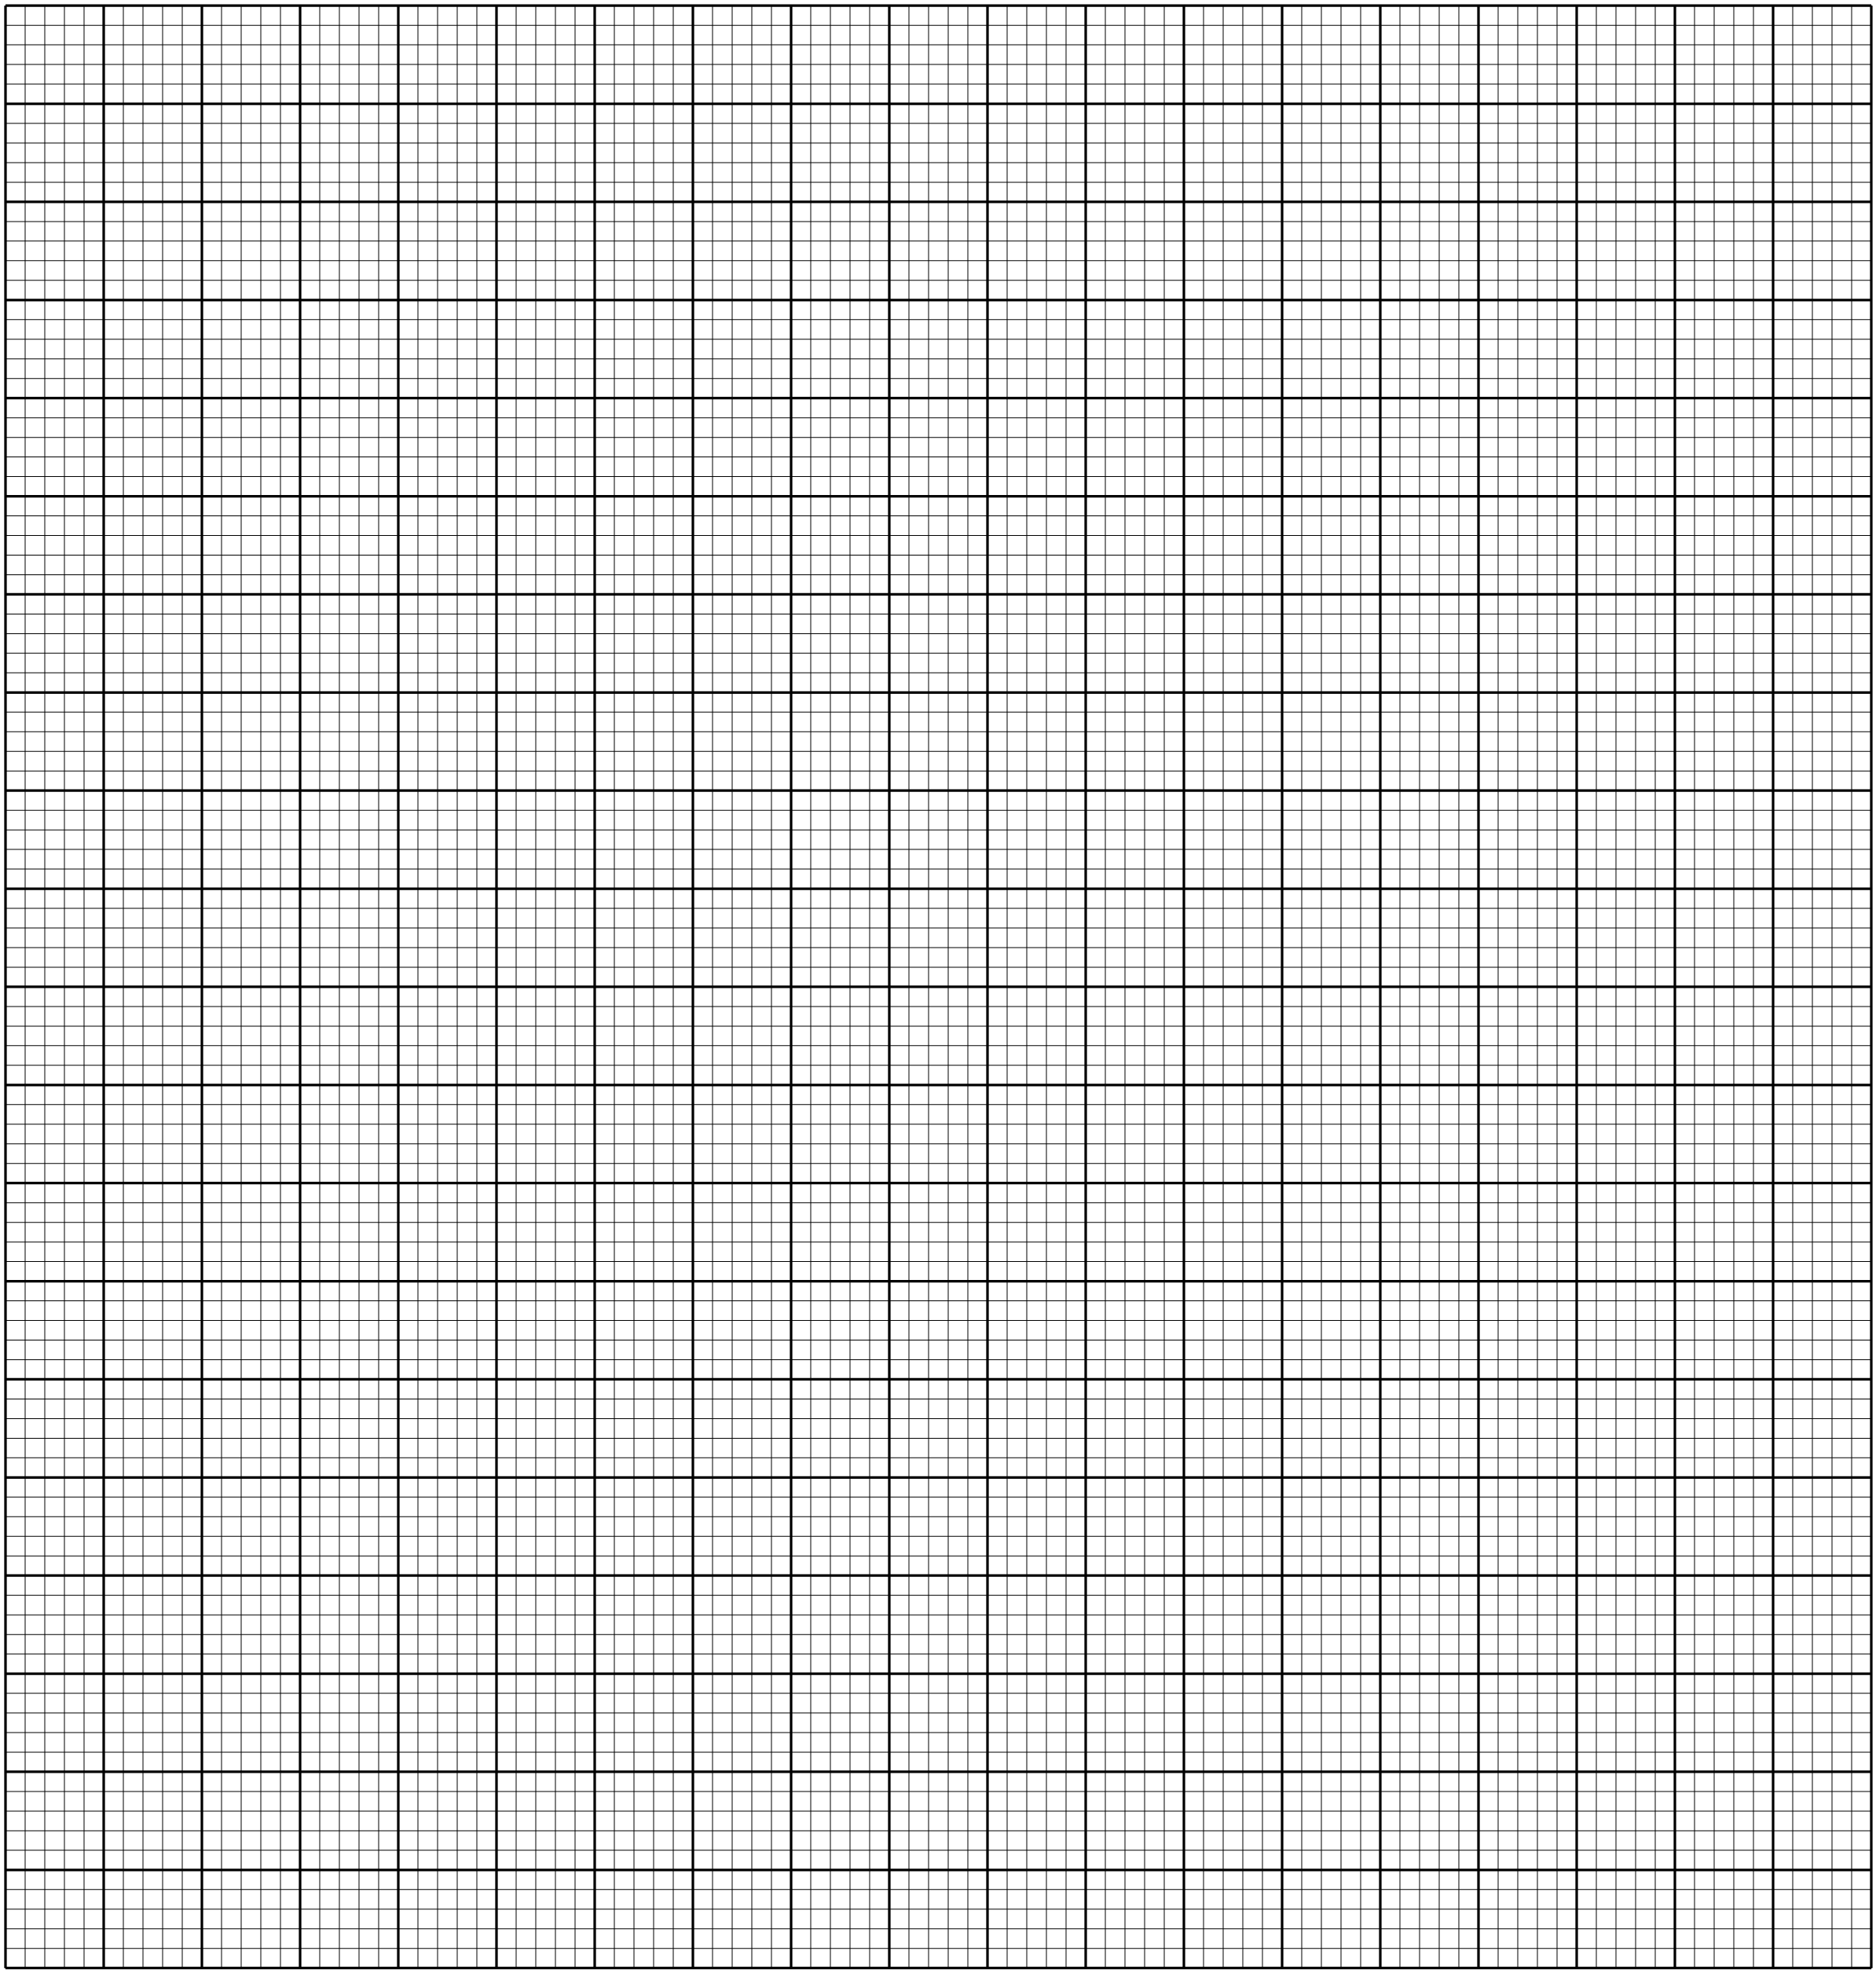

**THIS IS THE LAST PRINTED PAGE**