KASSU - JET JOINT EXAMINATIONS 2024
Kenya Certificate of Secondary Education

312/1 Paper 1
GEOGRAPHY

MARKING SCHEME

SECTION A: (25 MARKS)
Answer all questions.
1 (a) Give two areas studied under practical geography ( 2 marks)
- Map work
- Field work
- Photograph work
- Statistical methods
( b) Describe the relationship between geography and the following disciplines
- Biology ( 2 marks)
- Biology is the study of plants and animals while geography attempts to explain their distribution on the earth surface
- Biology is the scientific study of organisms, focusing on their anatomy, physiology and behavior while Geography explains the distribution of organisms and factors influencing their distribution on the earth’s surface.
- Medicine ( 2 marks)
Medicine deals with the diseases,their diagnosis and cures while geography focuses on factors that influence their spread/distribution of pests and diseases
2 . Describe the passing star theory ( 5 marks)
- The sun existed earlier than other planets
- A star with a greater gravitational pull than that of the sun passed by
- It attracted large quantities of gaseous materials from the sun
- The materials were in form of hot gases
- The materials split into portions,
- They cooled and condensed to form planets
- Smaller materials cooled to form heavenly bodies like the moon; larger materials formed the earth
- The planets were set in orbit by
- During cooling, the dense/heavy materials collected at th center to form the core while the lighter /the less dense collected around the core to form the mantle and the crust

3 . (a) ( i ) Give two examples of plutonic rocks ( 2 marks )
- Granite,
- Diorite,
- Gabbro
- Peridotite
- Syenite
- Trachyte
( b) State three ways in which rocks are classified (3 marks)
- Their mode of formation
- The age of the rocks
- The chemical composition of rocks
4 . Study the diagram of the flood plain provided and answer the questions that follow
( a) Identify the parts labelled M,N and P ( 3 marks)
- Meander/river meander
- Differed tributary
P - Alluvium
( b) Apart from a flood plain name three other river depositional features ( 2 marks)
- Alluvial fans
- Meanders
- Ox - bow lakes
- River braids
- Natural levees
- Deltas
5 . Study the map of the world provided and answer the questions that follows
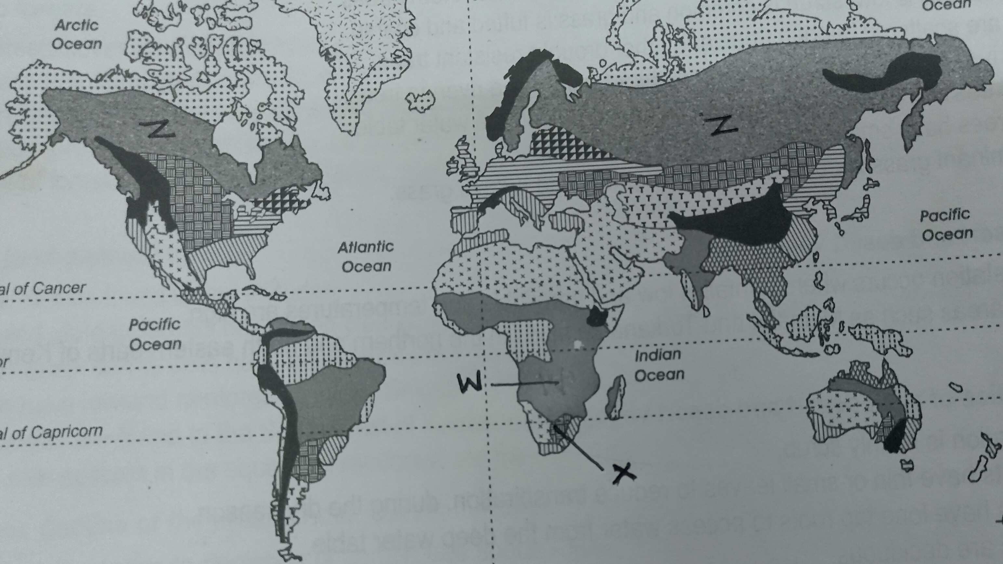
( i ) Name the vegetation types marked X , W and Z ( 3 marks )
X - High veldt/ veldt
W - Tropical continental/ Savanna grass land
Z - Coniferous forest
( ii ) State two characteristics of desert vegetation ( 2 marks )
- The vegetation is mainly scrub
- Some plants have thick/fleshy/succulent leaves/barks
- Some plants have long roots
- Some plants have no leaves /have thin/spiky/waxy/needle-like leaves
- Some plants wilt in the absence of moisture but have quick recovery ability
- Some plants have thick /hard barks
- Some plants have underground bulbs/bulbous roots
- Most plants are stunted /dwarf like
- Desert scrub /camiphora and acacia are dominant and scattered

SECTION B: (75 MARKS)
Answer question 6 and any other two questions from this section
6. Study the map of Mumias 1: 50,000 ( Sheet 101/2 ) provided and answer the following questions .
- (i) What information is contained on the Mumias sheet title (2 marks)
- Region i.e East Africa
- The ratio scale i.e 1:50000
- The country i.e Kenya
(ii) Measure the distance of river Lusimu from the junction of river Nzoia to the bridge in kilometres and metres. (2 marks)
- 9km 400m ( 9km 300m - 9km 500m )
(iii) Name two drainage patterns found in the area covered by the map. (2 marks)
- Dendritic drainage pattern
- Trellis drainage pattern
- Centripetal drainage pattern
(iv) Identify two types of natural vegetation found to the south of northings 36 (2 marks)
- Woodland
- Scrub
- Scattered trees
- Riverine trees
- Papyrus swamp vegetation
- Thicket
- Describe the distribution of settlement in the area covered by the map. (6 marks)
- There are many settlements in the Eastern part of the area covered by the map
- There are few settlement along river Nzoia
- There are no settlements on seasonal swamp areas
- There are linear settlement patterns along all-weather road loose surface
- There are few/no settlement along several rivers
( c) Citing evidence explain three factors that would favour cattle rearing in Mumias. (6 marks)
- Presence of scrub vegetation /scattered trees in the south suggest that there is natural pasture for livestock
- The presence of many rivers/source of water suggest that there is adequate water for livestock
- Availability of transport network as shown by the roads/motorable tracks for movement of livestock/livestock products
- The area has high altitude ( 1200m -1368m) which provides cool conditions suitable for cattle rearing
- Dense settlements to provide market for livestock/livestock

( d) Describe the relief of the area covered by the map ( 5 marks )

- The land rises from S.W TO S.E /N.E/ slopes from N.E/S.E TO S.W
- The landscape is generally dissected by many river valleys/ narrow river valleys
- The land along river Nzoia is generally low/wide river valley
- There are islands/eyots/isles along river Nzoia
- The highest point/altitude is 1368 metres
- The lowest altitude is 1200 metres
- There is a col
- There are several spurs
- The land is gently sloping
- There are many hills
7 a) Apart from the rift valley name two other resultant features of faulting. (2 marks )
- Rift valleys / graben
- Block mountains / fault blocks / Horst blocks
- Escarpment / fault scarps / scarp slope
- Tilt blocks
- Fault steps
ii) State three characteristics of Gregory rift valley. ( 3marks )
- Height / altitude of the rift valley floor is uneven i.e. 600m a.s.l at Lake Magadi, 1000m a.s.l at Suguta valley and 1800m a.s.l around Nakuru
- Has numerous extensive and fairly level surfaces of the rift valley floor.
- Has depressions, some of which are occupied by lakes called Rift valley lakes.
- Has an average width of about 60-75km
- Is bounded by escarpment associated with block mountains, fault steps, tilt blocks and volcanoes.
- Has some fault guided drainage i.e River Kerio, South of Ewaso Nyiro.
- Large areas of the rift valley's floor exhibit a series of minor faults crossing it.

b) Explain four ways in which faulting influences drainage. (8mks)
- Faulting causes depression which may filled with water to form Rift valley lakes.
- Faulting causes cracks/faults that may form fault-guided drainage pattern i.e. River Kerio.
- Faulting causes cracks/faults where the oozing of water to form springs.
- Faulting causes cracks /fault lines which may causes rivers to disappear underground.
- Faulting may cause rivers to change the direction of flow / causes reversed drainage.
- Vertical faulting across a river may cause a waterfall.
c) within the aid of a well labeled diagram describe how a block mountain is formed due to compressional forces. (6 marks)
- Layers of crustal rocks are subjected to compressional forces;
- Lines of weaknesses known as reverse faults develop.
- Continued compressional forces results in the middle ground being raised relative to the side block/uplifted as the the side block subsides.
- The raised block of land bordered by steep slopes is known as a block mountain.
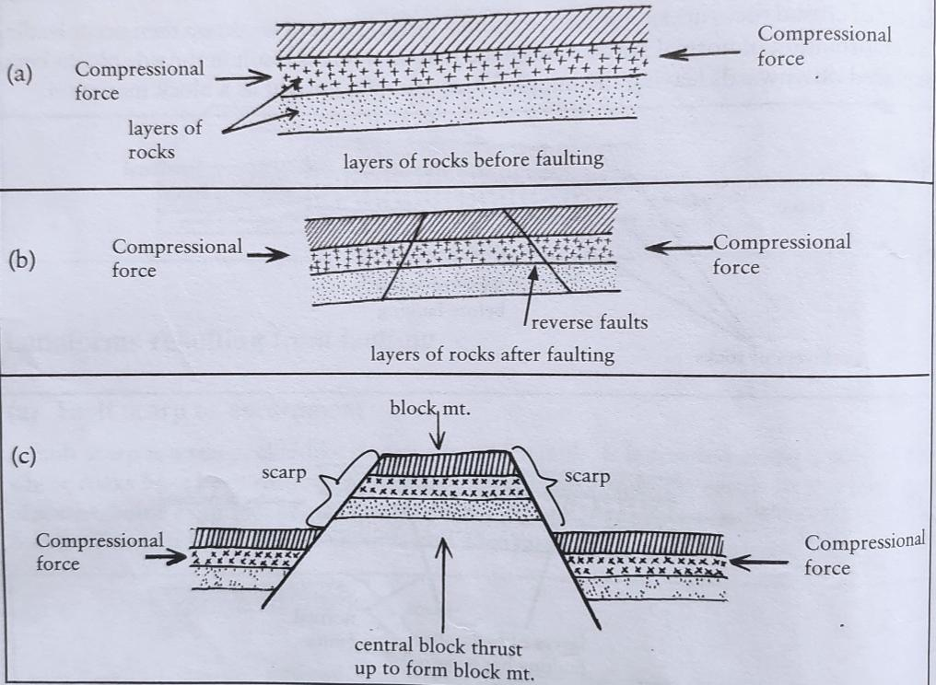

d) (i)Students at MEC High School intends to carry out a field study on a section of Rift valley state three preparation they will make before the study. ( 3marks )
- Seeking permission from relevant authorities
- Conducting a reconnaissance/pre-visit
- Holding discussions in class
- Preparing a questionnaire
- Organize students into groups
- Preparing necessary documents
- Reading through relevant literature/reading from secondary sources
- Preparing a working schedule
- Selection of important tools
- Drawing a route map
- Writing objectives
- Writing hypothesis

ii)State three follow up activities that they would engage in after the study. ( 3 marks )
- Reading more on the topic
- Display photographs/items collected
- Drawing diagrams
- Write reports/presenting reports
- Discussing with the rest of the class
- Analyse /access the information collected against the hypothesis
- Model the area of study
- Confirming/rejecting of the hypothesis based on the findings
- Discussing the findings in class giving reports through group leaders
- Writing reports in essay form
- Calculation of percentages, means, medians and modes
- Presentation of data using methods such as graphs, pie charts, etc.

8. (a) Distinguish between Vulcanicity and Volcanicity. (2 marks )
- Vulcanicity is the processes where liquid, gaseous, and solid materials form the earth’s interior are forced into the rocks of the earth’s crust while Volcanicity is the processes where melted rock materials from the earth’s interior releases the surface of the earth forming volcanic features.
(b) (i) A part from a plug volcano, name three other extrusive volcanic features (2marks)
- Acidic lava dome
- Basic lava dome/ shield volcano
- Composite volcano/parasitic cone
- Ash and cinder cone
- Volcanic plug / volcanic neck
- Lava plain/lava plateau
- Crater / caldera
- Hot spring
- Geysers / stream jets.
(ii) With the aid a well labeled diagram describe the formation of a plug above (8marks)

- Rocks in the earth's crust are subjected to high temperatures and pressure which changes them into a semi-solid state.
- When pressure decreases, the rocks become semi-molten.
- Earth movements due to tectonic forces result in vertical cracks/vents/fissures in the crustal rocks.
- During explosive volcanic eruptions, acidic magma pushes its way to the surface through a vent and the pyroclasts are thrown out due to the high pressure.
- The lava cools rapidly and solidifies around the vent to form a pillar of rocks which is dome shaped.
- The feature is known as a plug dome
- Because the lava cools and solidifies quickly, the rocks are not highly resistant to denudation hence plug domes are easily disintegrated.

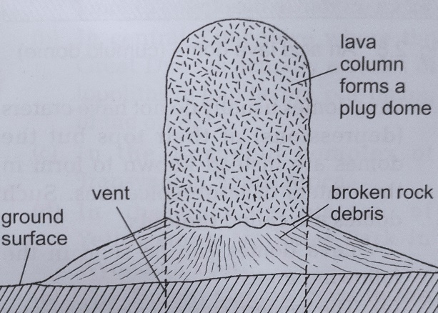

(c) (i) What are fumaroles? ( 2 marks )
- They are small vents/holes on the ground or on volcanoes emitting steam and other gases as powerful jets.
(ii) Explain two the formation of a hot spring ( 6 marks )
- Rain water percolates the crustal rocks through cracks/fissures underground
- The water reaches a zone of hot igneous rocks/hot magma underground where it becomes superheated
- The superheated water changes to water vapour/steam
- The water vapour collects in chambers underground called sumps
- The superheated steam builds up pressure and that forces it upwards through the cracks/fissures
- The steam/water vapour heats the ground water near the surface and forces it to flow out to the surface.
- The superheated water under pressure flows out continuously to the surface forming hot springs.

(d) Explain two ways in which volcanic features may influence the climate of surrounding ( 4 marks )
- Volcanic Mountain have windward slopes receiving high relief rainfall.
- Volcanic mountains whose side faces the sun receives plenty of sunshine /warm.
- Volcanic mountains summit of high altitude may receive snow fall/low temperatures.

9 . ( a ) ( i ) Distinguish between a swash and backwash ( 2 marks )
- Swash is water that moves forward up the beach after a wave break while a back wash is the backward movement of water towards the sea after a wave breaks
( ii ) The diagram shows the parts of a wave
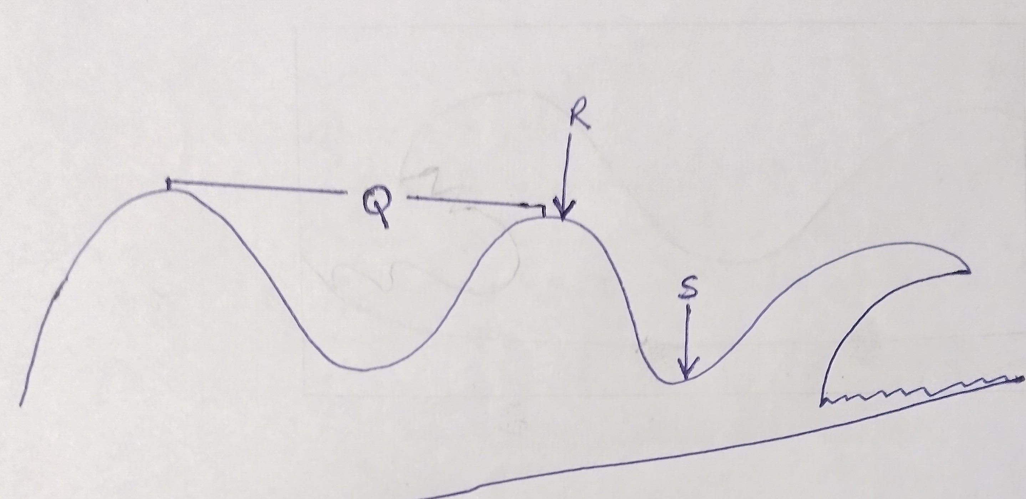
Name the parts labeled Q , R ,S and T ( 4 marks )
Q - length of the wave
R - crest
S - trough
T - breaking wave
( b ) ( i ) State four factors that determine the size of a wave ( 4 marks )
- Height and length,
- Energy - determined by height length and fetch,
- Steepness – ratio of height of wave toils length,
- The period – time a wave has taken to form and move.
( ii ) Using a well labelled diagram describe the formation of a cuspate foreland ( 7 marks )
- The longshore drift deposits sand and shingles from two opposite headlands on a shallow coast.
- Continued deposition of sand and shingle by the longshore drift lead to accumulation of sand seawards forming spit.
- The longshore drift continues to deposit materials and the spits extend towards each other.
- eventually the spits join in the sea enclosing a lagoon eventually leading to formation of triangular shaped ridge of sand and shingle called a cuspate foreland.

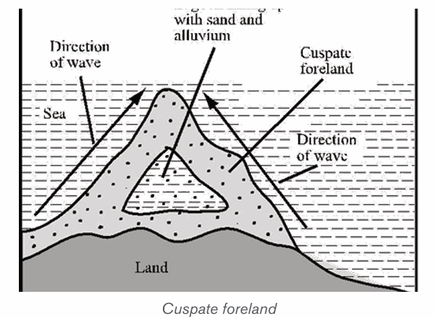
Text - 4 marks
Diagram - 3 marks
( c ) Describe four factors that influence wave erosion along the coast ( 8 marks )
- The degree of exposure of the coast to wave erosion; the exposed coasts are eroded more than the sheltered coasts which reduce the rate of erosion
- The duration of exposure of the coast to waves; the longer the exposure to the coastal waves, the higher the rate of erosion
- Nature / supply of materials; heavy materials /boulders have a higher erosive power than the fine materials/hard rocks carried by the waves hit against the coast hence increasing erosion/ the coast made up of soft rocks wears away easily when subjected to sea waves
- Nature/structure of the coastal rocks; a coast made up of soft rocks /has well jointed/fractured rocks are easily eroded when subjected to the sea waves
- The nature /strength of the destructive waves; strong waves will cause greater erosion by hydraulic action and abrasion proces

10. (a) The diagram below shows an artesian basin. Use it to answer question (a).

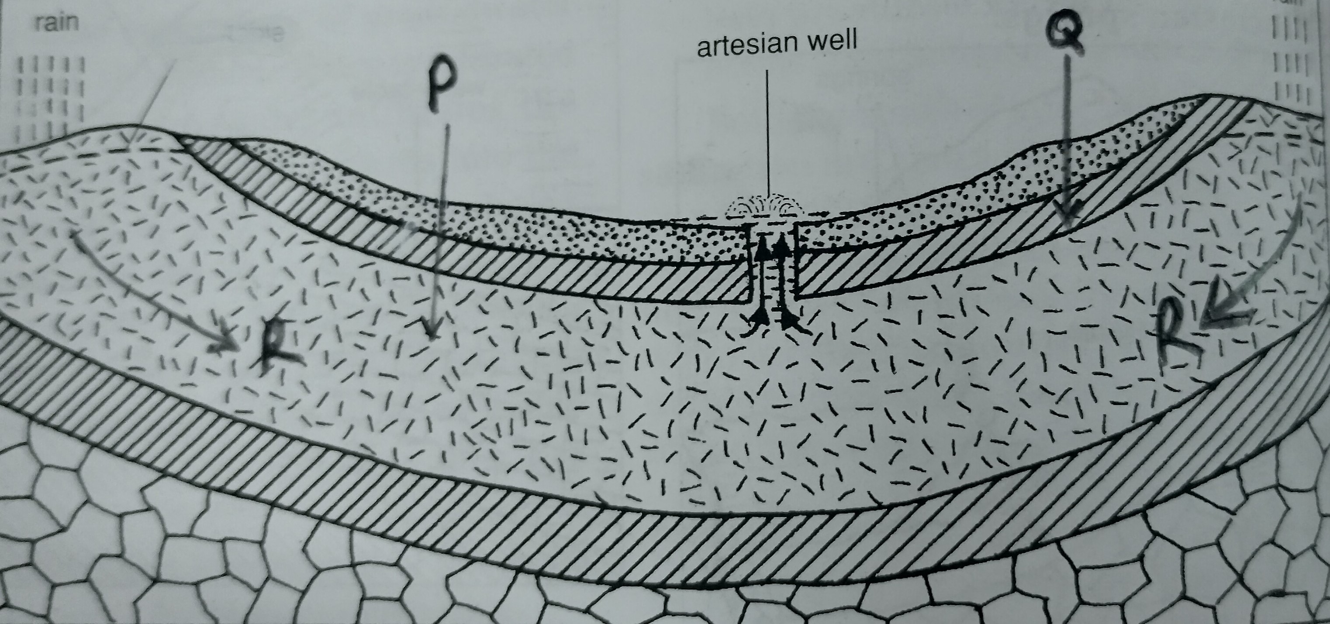

(a)Identify ;

(i) the part marked P. ( 1 mark )
- An aquifer / permeable rock

(ii) The layer marked Q ( 1 mark )
- An impermeable rock layer

(iii) The process marked R ( 1 mark )
- Percolation/ infiltration

(iv) Describe how artesian basin forms (3 marks )
- This is a saucer shaped depression consisting of a layer of permeable rock lying between two layers of impermeable rocks,
- With part of the permeable rock exposed to the surface along the edges of the basin.
- As the rainwater percolates into the permeable rock layer, it eventually gets saturated aquifer.
- This is an artesian basin

- State three ways springs may form ( 3 marks )
- When a permeable rock overlies an impermeable rock
- When water enters well jointed rocks on a hill and saturates them
- When an aquifer lies on the upper side of a dyke which outcrops
- Where a limestone escarpment is underlain by an impermeable layer
(d ) Explain four factors that influence the existence of underground water ( 8 marks )
- The melting process is slow, the water stays in one place for a long time, giving it a chance to infiltrate.
- Light rain which falls over a long period infiltrate more than a heavy downpour which is short lived.
- Heavy downpours saturate the surface thus blocking the passages that the water would us to get into the ground. this reduces the rate of infiltration and increases surface run off.
- Little rainfall only wet the surface without infiltrating into the ground.
- Some of the little rain may evaporate before entering the ground thus reducing chances of infiltration.
- Infiltration is greater on flat areas since water is likely to remain in one place for a long time given that other factors are favourable.
- On steep slopes a lot of water is lost through surface run off with little infiltrating in the ground.
- The rate of infiltration/percolation depends on the permeability of the rock. the more permeable the surface rocks are the higher the rate of infiltration.
- Impermeable rocks are impenetrable and discourages infiltration
- Porous rocks absorb water, expand thus narrowing the air spaces between them. With more absorption of water, the pores close, preventing further percolation of water downwards.
- Presence of vegetation increase rate of infiltration. This is because plants break the speed of falling raindrops such that they hit the ground gently thus more water infiltrate.
- Thick cover of grass slows down the speed of surface run off causing water to be held in one place longer than it would if there was no vegetation giving most of it a chance to infiltrate.
- On bare surfaces, most of the precipitation flows away as surface run off.
- The rate of water infiltration is high when the ground is very dry because all the air spaces in it are wide open.
- A high rate of evapo-transpiration increases infiltration of water because there is space in the ground for water to occupy.

- (i) What is karst Scenery? ( 2 marks )
- Karst scenery refers to an area of limestone chalk or dolomite rock with uniquely developed features and has been affected much by underground water.
(ii) State reasons why there are few settlements in karst regions. ( 3 marks )
- Inadequate water supply,
- Rugged surface,
- Thin soils,
- Poor vegetation,
- The areas are rocky.
(iii) Name three underground karst features ( 3 marks )
- Caves/caverns
- Stalactites
- Stalagmites
- Limestone pillar

THIS IS THE LAST PRINTED PAGE.

