**MARANDA HIGH SCHOOL**

**CYCLE I TERM ONE – 2024**

**Kenya Certificate of Secondary Education (KCSE)**

**312/1 GEOGRAPHY Paper 1**

**February 2024**

**MARKING SCHEME**

1. **(a) Define the solar system.**

* *This refers to the sun, the planets and all the heavenly bodies that orbit around and between the planets.* ***1×2mks=2mks***

**(b) State three characteristics of the sun.**

* *It’s the nucleus/centre of the solar system*
* *It produces its own light*
* *It has all the planets and heavenly bodies orbit/revolve around it*
* *Radiates/produces solar energy*
* *Rotates on its own axis in an anticlockwise direction.* ***3×1mk=3mks***

1. **(a) The diagram below shows a feature of wind erosion in an arid area. Use it to answer the questions that follow.**

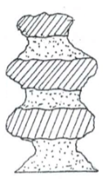

1. **Name the feature.**

* *Rock pedestal/gour* ***1×1mk=1mk***

1. **Give two processes of wind erosion responsible for the formation of the feature.**

* *Abrasion*
* *Deflation* ***2×1mk=2mks***

**(b) State three characteristics of an arid area.**

* *It has little or no rainfall*
* *Vegetation is scanty/may be lacking/bear surfaces with patches of vegetation*
* *High/very high temperatures*
* *Land surface characterized by sand, rocks and stones* ***3×1mk=3mks***

1. **(a) Explain how the following factors causes earth movements of crustal rocks:**
2. **Gravitative pressure**;

* *Voids/hollows left after a volcanic eruption are acted upon by force of gravity, causing the overlying crustal rocks to crumble inwards to fill the cavities below leading to vertical displacement of crustal rocks* ***1×2mks=2mks***

1. **Magma movement**

* *Molten rock from the mantle may intrude into the crustal rocks through cracks, joints and fissures. During such movements, the magma occupies spaces within the rocks, displacing them vertically and/or laterally.* ***1×2mks=2mks***

**(b) Name one major tectonic plates of the earth.**

* *Eurasia*
* *Africa*
* *Antarctica*
* *North America*
* *South America*
* *Pacific* ***1×1=1mk***

1. **Give four ways of soil conservation.**

* *Crop rotation*
* *Cover cropping*
* *Mixed farming*
* *Mulching*
* *Contour ploughing*
* *Afforestation*
* *Regulation of livestock numbers*
* *Controlling bush fires*
* *Intercropping*
* *Proper land preparation methods* ***4×1mk=4mks***

1. **(a) Name two composite cones in East Africa.**

* *Mount Kenya*
* *Longonot*
* *Suswa*
* *Elgon*
* *Kilimanjaro*
* *Mare*
* *Ol Donyo Lengai* ***2×1mk=2mks***

**(b) State three negative influences of composite cones to human environment.**

* *Leeward sides of composite cones experience rain shadow effect leading to aridity and desertification*
* *Gases emitted during the eruption of composite cones may be harmful, cause respiratory complications and lead to air pollution.*
* *Rugged terrain difficult for development and maintenance of transport and communication lines.*
* *Poorly developed soils to support agricultural activities.* ***3×1mk=3mks***

1. **Study the map of Kisumu East 1: 50,000 (sheet 116/2) provided and answer the following questions.**
2. **(i) Give two scales used in the map extract.**

* *Linear*
* *Ratio/Representative fraction* ***2×1mk=2mks***

**(ii) What is the altitude of the lowest point covered by the map?**

* *1140 metres* ***1×2mks=2mk***

1. **Give the approximate position of Chiga in terms of latitudes and longitudes.**

* *340 50’ East, 00 05’ South* ***1×2mks=2mk***s

1. **(i) Name four relief features found in the area covered by the map.**

* *Steep slopes*
* *Gentle slopes*
* *River valleys*
* *Nyando escarpment*
* *Plains* ***4×1mk=4mks***

**(ii) Calculate the area of the sugar plantation** **between the provincial boundary and the road   
 C 543/1 in square kilometres.**

* *Complete squares = 5*
* *Incomplete squares = 19×½=9.5*
* *Total squares = 5+9.5=14.5*
* *Area =14.5×1km2=14.5 km2 ±0.5 km2* ***1×2mks=2mks***

1. **Describe the drainage of the area covered by the map.**

* *There is a lake to the south-western parts of the map*
* *Seasonal swamps are found to the western and eastern parts of the mapped area*
* *There are many rivers e.g. Ombeyi, Luanda, Mayenya, Nyamasaria, Awach, etc.*
* *The rivers are permanent*
* *The rivers flow to the south western parts of the maps*
* *Centripetal and dendritic drainage patterns are evident of the rivers* ***4×1mk=4mks***

1. **(i) Reduce by 50% the area bound by easting 03 and northing 90 to the edges of the map on the eastern and northern parts**.

A FRAME MEASURING 7 cm by 10 cm REPRESENTING THE AREA BOUND BY EASTING 03 AND NORTHING 90 TO THE EASTERN AND SOUTHERN EDGES



***Frame 8cm by 10cm – 1mk***

***Title – 1mk***

**(ii) On the frame, mark and name the following:**

* *Railway line;*
* *Boundary of Kisumu Municipality.* ***2×1mk=2mks***

1. **Citing evidence from the map, identify five social activities offered in Kisumu Town.**

* *Education – schools e.g. Kasagam, Nyabera, etc.*
* *Rehabilitation – Prison*
* *Medical/health care – Hospitals*
* *Religion – Churches, mission*
* *Recreation – Stadium* ***5×1mk=5mks***

1. **(a) (i)** **Apart from the Rift Valley name two other relief features that were formed as result of faulting**.

* *Block mountain/horst*
* *Tilt block*
* *Fault scarp* ***2×1mk=2mks***

**(ii) With the aid of a well labeled diagram, describe how a Rift Valley is formed by compressional forces.** (8 marks)

* *When sections of crustal rocks are subjected to forces of compression, adjacent normal faults occur.*

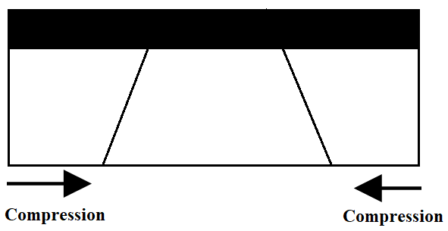

* *Continued compression cause the side blocks to thrust/rise over the middle block to form the floor of the rift valley.*

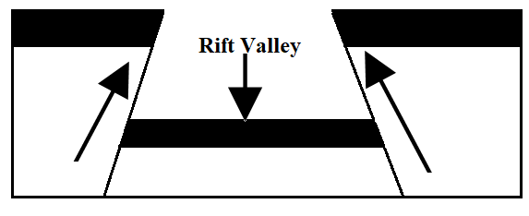

* *The steep fault scarps on either side of the outer blocks are further worn out by denudation (erosion, mass wasting, and transportation) to form gentle slopes.*

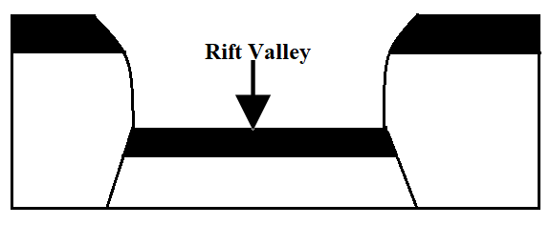

**(b) Explain four effects of faulting. (8 marks)**

* *Faulting leads to formation of beautiful scenery such as the fault scarps, rift valleys, block mountains which attract tourists and in turn earns foreign exchange.*
* *At the base of fault scarps, springs may develop and provide water for domestic uses thus attracting human settlements.*
* *Depressions in the Rift Valley floor may fill up with water to form lakes. Such lakes are useful in terms of fishing, irrigation, and mining and transport e.g. Baringo, Naivasha, and Magadi.*
* *The windward slopes of a block mountain may be forested and hence act as a source of rivers which provide water for domestic use, industries and irrigation farming.*
* *Step faulting results in the formation of scarp slopes which provide natural waterfalls and rapids used for hydro-electric power generation.*
* *Sometimes when faulting occurs across a river valley, the direction of flow of the river may change or the river may disappear into fault affecting drainage.*
* *Faulting may lead to disjointing of the crustal rocks which disrupt communication lines such as roads, railways, pipelines.*
* *Faulting creates weak lines in the crust which could become passages for hot water from the ground to the surface. Hot springs and geysers can be utilized to generate geothermal power e.g. at Ol-Karia.*
* *Fault blocks may bring about rain-shadow effect where the windward side is wetter than leeward side.*
* *Faulting may expose minerals like diatomite and fluorspar making their exploitation easy.*
* *It is also difficult and expensive to construct transport lines across fault scarps.*
* *Subsidence of land resulting from faulting can lead to destruction of property and loss of life.* ***4×2mks=8mks***

**(c) Students are planning to carry out a field study of an area affected by faulting**

1. **State four reasons why it is important for the students to have a pre-visit of the area.**

* *It acquaints the researcher to the study area’s authorities and respondents.*
* *It assists the researchers to familiarize the with the study area to help in saving time/preventing accidents during the study.*
* *It assists the researchers to determine how suitable the study area is i.e. does the study area have adequate and sufficient data.*
* *It assists in budgeting for the study i.e. estimating cost of the study.*
* *It helps the researcher in identifying problems that are likely to be experienced during the field study and suggest their possible solutions.*
* *It helps the researchers in developing a working schedule.* ***4×1m=4mks***

1. **One of the ways they would use to collect data is through direct observation. State three disadvantages of direct observation in the study of such an area.**

* *It may be subjective since it is based on personal decisions; the observer may be biased and record wrong information.*
* *Difficult to collect data on past activities by observation*
* *Visual impairment may limit its effectiveness*
* *Expensive since involves a lot of travelling*
* *Limited during bad weather such as during rainy days* ***3×1mk=3mks***

1. **(a) (i) Define the term glaciation.**

* *Glaciation is the action of moving ice on the surface of the earth/process by which landscape is sculptured by the action of moving ice.* ***1×2mks=2mks***

**(ii) Name three ways in which ice moves outwards from its area of accumulation.**

* *Plastic flowage*
* *Basal slip*
* *Extrusion flow* ***3×1mk=3mks***

**(b) State three factors that influence glacial erosion.**

* *Well jointed/faulted rocks are easily eroded by plucking since the joints allow water to enter the rock/Less resistant rocks are eroded faster by abrasion compared to more resistant rocks.*
* *The more the debris embedded in the glacier the more effective is abrasion process.*
* *The steeper the slope, faster the speed of the glacier and the greater the erosive energy.*
* *a thick glacier exerts great pressure on the underlying rock causing weathering. The rock debris embedded in the glacier is pressed down by the thick glacier to erode by abrasion.* ***3×1mk=3mks***

**(c) The diagram below shows some features of glaciation erosion. Use it to answer the questions that follow**.

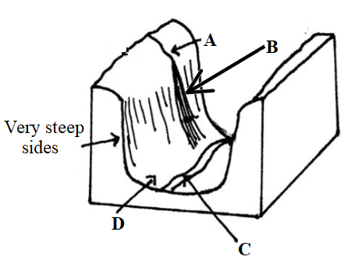

1. **Name the parts labeled A, B and C.**

* ***A*** *– Hanging valley*
* ***B*** *– Waterfall*
* ***C*** *– River* ***3×1mk=3mks***

1. **Describe how the part labeled D is formed.**

* *A pre-existing river valley is filled with ice/glacier*
* *As glacier moves downstream, tributary glaciers increase the amount of ice in the main valley*
* *Glacier erodes the main valley by plucking and abrasion*
* *The interlocking spurs in the main valley are trimmed into truncated spurs.*
* *Continued glacial erosion deepens, widens and straightens the main valley floor forming a U-shaped valley or a glacial trough* ***5×1mk=5mks***

**(d) List three depositional features of glaciation in lowland areas.**

* *Kames and eskers*
* *Erratics*
* *Boulder trains*
* *Outwash plains*
* *Drumlins*
* *Terminal moraines* ***3×1mk=3mks***

**(e) Explain three problems of glaciation to the environment.**

* *Some outwash plains may contain infertile sandy soils that hinder agricultural practices*
* *Glaciation results into rugged landscape that makes settlement and construction of transport and communication difficult*
* *Extensive areas of land are sometimes turned into glacial lakes by deposits from moraine thus reducing the amount of land available for settlement* ***3×2mks=6mks***

1. **(a) (i) Define the term weather forecasting.**

* *This is the prediction of the state of the atmosphere for a given place over a period of 24 to 48 hours.*

***1×2mks=2mks***

**(ii) State four problems facing weather forecasting in Kenya.**

* *Inadequate data on some weather elements.*
* *Inaccurate/unreliable data brought about by faulty equipment.*
* *Intervening factors like slope of the land, nature of the vegetation, soil moisture conditions and winds lead to variation in temperature at different areas adjacent to each other.*
* *Inadequate personnel in developing countries*
* *Vagaries/uncertainties of nature like storms and earthquakes.* ***4×1mk=4mks***

**(b) The diagrams below show some instruments that are used to measure temperature. Use them to answer the questions that follow.**

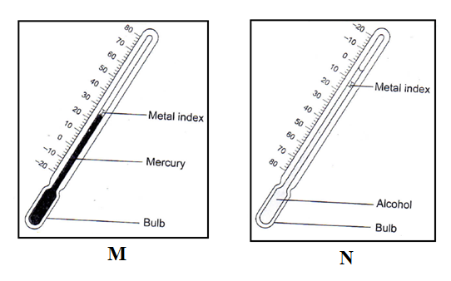

**Describe how the instruments are used to measure the weather element stated.**

* *When the temperature falls, the alcohol in N contracts and its meniscus pull the index towards the bulb.*
* *The minimum temperature in the previous 24 hours is obtained by reading the scale at the end of the index nearest to the meniscus.*
* *When the temperature rises, the mercury in M expands and pushes the index forward.*
* *The maximum temperature reached in the previous 24 hours is shown by the index that was in contact with the mercury last.*
* *Both the readings are recorded and used to calculate the mean daily temperature.* ***5×1mk=5mks***

**(c) The map below shows some climatic regions of Africa. Use it to answer the questions that follow.**

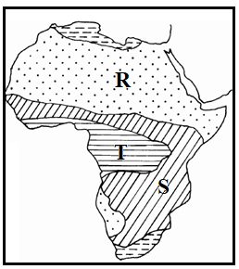

1. **Name the climatic types labeled R and S.**

* **R** – Tropical Desert
* **S** – Tropical Continental ***2×1mk=2mks***

1. **Describe the characteristics of climatic type marked T (Equatorial Climate)**

* *High temperatures all year round/ 24°C - 27°C.*
* *Small annual range of temperature/3°C - 5°C.*
* *The diurnal range of temperature is moderate/ 8° C.*
* *High rainfall throughout the year*
* *Rainfall is mainly convectional*
* *Rainfall regime is double maxima*
* *High relative humidity throughout the year*
* *Atmospheric pressure is relatively low*
* *Trade winds meet, converge and rise in this region.* ***5×1mk=5mks***

**(d) (i) Give the regions linked to the following vegetation types**

* **Pampas**
* *Argentina/South America* ***1×1mk=1mk***
* **Veldts**
* *South Africa* ***1×1mk=1mk***

**(ii) State five significance of vegetation.**

* *Forested areas act as water catchment areas providing for sources of rivers that in turn provide water for domestic and industrial uses*
* *Promote tourism by providing habitat/homes for wild animals*
* *Provides poles used in electricity, fencing and pit props in mining, trees provide timber for furniture, building and construction*
* *Vegetation adds aesthetic value to the landscape e.g. flowers, grasses, etc.*
* *Purification of air through the release oxygen during photosynthesis*
* *Vegetation provides raw materials for paper, pulp, rubber and textile industries thus leading to industrialization*
* *Some vegetation is of medicinal*
* *Helps in checking soil erosion by binding soil particles together at the roots and the trees act as wind breakers* ***5×1mk=5mks***

1. **(a) (i) Name two fresh water lakes that are found in Kenya.**

* *Lake Victoria*
* *Lake Naivasha*
* *Lake Baringo*
* *Lake Turkana* ***2×1mk=2mks***

**(ii) State three reasons why some lakes in Kenya have fresh water.**

* *Presence/existence of out-flowing rivers/outlets to drain out excess salts.*
* *Many fresh water rivers that drain into/emptying into the lakes that neutralizes the salt levels.*
* *Some lakes are located in areas with very high rainfall that adds fresh water into them*
* *The bed of the lake may comprise of insoluble rock* ***3×1mk=3mks***

**(b) (i) Describe the formation of an oxbow lake.**

* *An ox-bow lake forms when a river starts to meander on a flood plain.*
* *Lateral erosion dominates the outer sides of the bend/meander while deposition takes place on the inner banks*
* *Lateral erosion results in the reduction of the rock of land between the adjacent bends*
* *During flooding, deposition on the meander side seals off the meander*
* *The river abandons the meander and follows the new short cut that was the neck of land*
* *The abandoned meander with its waters form an ox bow lake.* ***7×1mk=7mks***

**(ii) Name two oxbow lakes in Kenya.**

* *Kanyaboli*
* *Shalu*
* *Bilisa*
* *Shakababo*
* *Gambi* ***2×1mk=2mks***

**(c) Explain three negative effects of lakes to human activities.**

* *Lakes may harbor diseases causing pests and micro-organisms.*
* *Seasonal flooding of the low-lying lake basin displace people*
* *Lakes are barriers to road and railway transport.* ***3×2mks=6mks***

**(d) Members of your class plan to conduct a field study on Lake Victoria.**

1. **Other than Kisumu County, name two other counties they may visit for the study.**

* *Busia*
* *Siaya*
* *Homa Bay*
* *Migori* ***2×1mk=2mks***

1. **State three significance of studying lakes through fieldwork.**

* *It breaks the boredom of classroom teaching and learning thus making them more realistic and clearer.*
* *It enables the learners to apply the skills acquired in the classroom in real life situation.*
* *It assists learners to get local examples of lakes and resultant features on their own.*
* *It enables the learners to familiarize with the environment hence the need to use it sustainably.*
* *It is an important source of primary data.* ***3×1mk=3mks***

**THIS IS THE LAST PRINTED PAGE**