**KASSU JOINT EXAM**

* **COMPUTER STUDIES -**

451//1 (THEORY)

JUNE 2024 – 2 ½ HOURS

Name:………………………………..…………………. Index Number:……………………

Candidate’s Signature………………………………….. Date………………….……………

**Instruction to candidates**

1. *Write your name and index number in the spaces provided above*
2. *Sign and write the date of examination in the spaces provided*
3. *This paper consists of* ***two*** *sections:* ***A*** *and* ***B***
4. *Answer all the questions in section* ***A***
5. *Answer question* ***16*** *and other* ***three*** *questions from section* ***B***
6. ***All*** *answers should be written in the spaces provided on the question paper.*
7. ***This paper consists of 13 printed pages.***
8. *Do not remove any pages from this booklet.*
9. ***Candidates should check the question paper to ascertain that all the pages are printed as indicated and that no questions are missing.***
10. ***Candidates should answer the questions in English.***

**For Examiner’s Use Only**

|  |  |  |  |
| --- | --- | --- | --- |
| **Section** | **Question** | **Maximum**  **Score** | **Candidate’s**  **Score** |
| A | 1-15 | 40 |  |
| B | 16 | 15 |  |
| 17 | 15 |  |
| 18 | 15 |  |
| 19 | 15 |  |
| 20 | 15 |  |
| **Total Score** | | |  |

*Answer* ***all*** *the questions in this section in the spaces provided*

1. List any THREE examples of Database packages popularly in use today.

(3 marks)

………………………………………………………………………………………………………………………………………………………………………………………………………………………………………………………………………………………………………………………………

1. List any TWO functions of the Control Unit (2 marks)

………………………………………………………………………………………………………………………………………………………………………………………………………………………………………………………………………………………………………………………………

1. Mobile devices such as Smartphones and Tablets use an operating system.

List any THREE types of operating system found in mobile devices. (3 marks)

………………………………………………………………………………………………………………………………………………………………………………………………………………………………………………………………………………………………………………………………

1. A group of students are producing a class newsletter which they will email to parents of students in the class. The students have decided to use a smartphone. Data for the newsletter will be input, stored and output by the smartphone.

Identify any TWO devices that are part of the smartphone that could be used to input the data for the newsletter. (2marks)

………………………………………………………………………………………………………………………………………………………………………………………………………………………………………………………………………………………………………………………………

1. Many books contain a *gutter margin*. Explain gutter margin as used in word processing. (2marks)

………………………………………………………………………………………………………………………………………………………………………………………………………………………………………………………………………………………………………………………………

1. a) Distinguish between General Purpose computers and Special Purpose Computers (2 marks)

…………………………………………………………………………………………………………………………………………………………………………………………………………………………………………………………………………………………………………………………………………………………………………………………………………………………………………

b) Define toggle keys found on a standard keyboard, giving any TWO examples (2 marks)

………………………………………………………………………………………………………………………………………………………………………………………………………………………………………………………………………………………………………………………………

1. Ujuzi High School is about to set up a computer Laboratory. Advise them on three measures to take in order to ensure proper ventilation in the Room.

(3 marks)

…………………………………………………………………………………………………………………………………………………………………………………………………………………………………………………………………………………………………………………………………………………………………………………………………………………………………………

1. a) Define Virtual Memory.

…………………………………………………………………………………………………………………………………………………………………………………………………………

b) Name any ONE place where virtual memory may be found in a computer.

(2 marks)

………………………………………………………………………………………………………………………………………………………………………………………………………………………………………………………………………………………………………………………………

1. List any THREE differences between *Cathode Ray Tube* Monitors and *Flat Panel* Monitors (3 marks)

……………………………………………………………………………………………………………………………………………………………………………………………………………………………………………………………………………………………………………………………………………………………………………………………………………………………………………………………………………………………………………………………………………………

1. a). One of the factors to consider when purchasing computer hardware is warranty. List any TWO contents of a warranty. (2 marks)

………………………………………………………………………………………………………………………………………………………………………………………………………………………………………………………………………………………………………………………………

b). Distinguish between portability and compatibility as used in computer hardware. (2 marks)

…………………………………………………………………………………………………………………………………………………………………………………………………………………………………………………………………………………………………………………………………………………………………………………………………………………………………………

1. A computer studies student is creating a movie, in school, for a project. He needs to take the movie home to edit it. The student decided to use solid-state memory card (SSD card) to transport the movie files. The student is unable to save the work on the memory card.

Give any TWO error messages that may appear when attempting to save the work. (2marks)

………………………………………………………………………………………………………………………………………………………………………………………………………………………………………………………………………………………………………………………………

1. Mention any TWO advantages of serial cables **over** parallel cables for data transmission. (2 marks)

………………………………………………………………………………………………………………………………………………………………………………………………………………………………………………………………………………………………………………………………

1. List any TWO ways that *text* can be made to fit in a text box in desktop publishing software (2marks)

………………………………………………………………………………………………………………………………………………………………………………………………………………………………………………………………………………………………………………………………

1. List any TWO application areas of artificial intelligence (2 marks)

………………………………………………………………………………………………………………………………………………………………………………………………………………………………………………………………………………………………………………………………

1. a). State any TWO functions of system software (2marks)

………………………………………………………………………………………………………………………………………………………………………………………………………………………………………………………………………………………………………………………………

b). Differentiate between freeware and shareware with reference to software.

(2marks) ………………………………………………………………………………………………………………………………………………………………………………………………………………………………………………………………………………………………………………………………

**SECTION B** (60 Marks)

*Answer question* ***16*** *and any other* ***three*** *questions in this section in the spaces provided*

1. a) State any TWO differences between *syntax error* and *logical error* as used in programming. (4 marks)

……………………………………………………………………………………………………………………………………………………………………………………………………………………………………………………………………………………………………………………………………………………………………………………………………………………………………………………………………………………………………………………………………………………

b) The Figure below shows flowchart used to find the sum of even numbers in the first 10 natural numbers. Study it and use it to answer questions that follow.

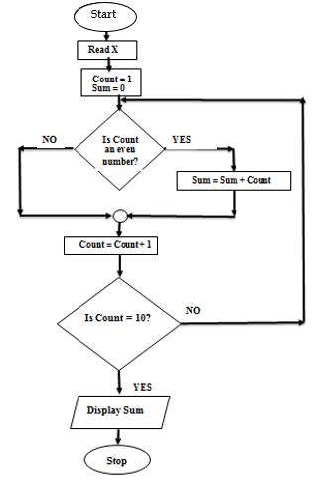

Determine the output from the flowchart. *Show your working*. (4 marks)

……………………………………………………………………………………………………………………………………………………………………………………………………………………

i) Write a pseudo code for the flowchart above. (7 marks)

1. a) List any TWO reasons why binary systems are used in computers. (2 marks)

………………………………………………………………………………………………………………………………………………………………………………………………………………………………………………………………………………………………………………………………

b) i) Convert 93CADF16 to its binary equivalent (2 marks)

………………………………………………………………………………………………………………………………………………………………………………………………………………………………………………………………………………………………………………………………

ii) Use the two’s compliment to solve: -3710 + 5110 (4 marks)

………………………………………………………………………………………………………………………………………………………………………………………………………………………………………………………………………………………………………………………………

iii) Convert 10111111.011112 to its Octal equivalent (2 marks)

………………………………………………………………………………………………………………………………………………………………………………………………………………………………………………………………………………………………………………………………

c) Give any TWO characteristics of a good system analyst. (2 marks)

………………………………………………………………………………………………………………………………………………………………………………………………………………………………………………………………………………………………………………………………

d). Describe the THREE components of an expert system (3 marks)

…………………………………………………………………………………………………………………………………………………………………………………………………………………………………………………………………………………………………………………………………………………………………………………………………………………………………………………………………………………………………………………………………………………………………………………………………………………………………………………………………………………………………………………………………………………………………………

1. Lawino opened her flash disk in one of the school’s computers using drive F. she had saved her work in a folder named “MINE”. This folder has subfolders for PICTURES, PERSONAL and AUDIO. In PERSONAL subfolder, there are files such as MyDocs.xlt and FamilyDocs.pff, while in PICTURES there are subfolders such as OFFICE and CHURCH.

a) i) Draw a directory tree structure for Lawino. (2 marks)

ii) In CHURCH subfolder there is a file named OldPicture.jpg. Write a path to this file. (2 marks)

………………………………………………………………………………………………………………………………………………………………………………………………………………………………………………………………………………………………………………………………

ii) She opened the file OldPicture.jpg, then decided to delete it. Explain what would happen. (2 marks)

………………………………………………………………………………………………………………………………………………………………………………………………………………………………………………………………………………………………………………………………

b) i) One classification of operating systems according to user-interface is menu driven. Explain menu driven. (2 marks)

………………………………………………………………………………………………………………………………………………………………………………………………………………………………………………………………………………………………………………………………

ii) Describe, with the help of an example, transcription errors. (3 marks)

………………………………………………………………………………………………………………………………………………………………………………………………………………………………………………………………………………………………………………………………

c) In the academic office of our school, there is a master file and a reference file.

i) Distinguish between a master file and a reference file. (2 marks)

………………………………………………………………………………………………………………………………………………………………………………………………………………………………………………………………………………………………………………………………

ii) For each of the files above (i), name any TWO pieces of information that can be held in each of them in relation to school. (2 marks).

………………………………………………………………………………………………………………………………………………………………………………………………………………………………………………………………………………………………………………………………

1. (a)(i) The formula B2+$C$2 was entered in cell D2 then copied to cell F2. Show the new formula in cell F2 and give a reason for your answer.. (2 marks)

………………………………………………………………………………………………………………………………………………………………………………………………………………………………………………………………………………………………………………………………

(ii) State the meaning of each of the following terms as used in spreadsheets:

1. Countif ( ) (2 marks)

………………………………………………………………………………………………………………………………………………………………………………………………………………………………………………………………………………………………………………………………

(B) Max ( ) (2 marks)

………………………………………………………………………………………………………………………………………………………………………………………………………………………………………………………………………………………………………………………………

(b)(i) Explain two types of *documentation* produced when developing a system by a system analyst. (2 marks)

……………………………………………………………………………………………………………………………………………………………………………………………………………………………………………………………………………………………………………………………………………………………………………………………………………………………………………………………………………………………………………………………………………………

(c)Nosim has developed a computerized system for a school and currently in its change over stage, where the new system is introduced in a department then tested to ascertain its effectiveness and once its performance is satisfactory it is implemented in the entire organization.

(i) Identify the changeover strategy used. (1 mark)

…………………………………………………………………………………………………………

(ii) Explain any TWO advantages of the changeover strategy identified in (i)above.

(4 marks)

……………………………………………………………………………………………………………………………………………………………………………………………………………………………………………………………………………………………………………………………………………………………………………………………………………………………………………………………………………………………………………………………………………………

1. Arosy bought a smartphone. Smartphones can be connected using wired or wireless methods.

a) i) Give two disadvantages, to Arosy, of using *a wired* method to connect to the smartphone. (2marks)

………………………………………………………………………………………………………………………………………………………………………………………………………………………………………………………………………………………………………………………………

ii) Give two disadvantages to Arosy of using *a wireless* method to connect to the smartphone. (2marks)

………………………………………………………………………………………………………………………………………………………………………………………………………………………………………………………………………………………………………………………………

b) The diagram shows how a network is connected to the internet.

i) Identify the hardware device labelled A on the diagram. 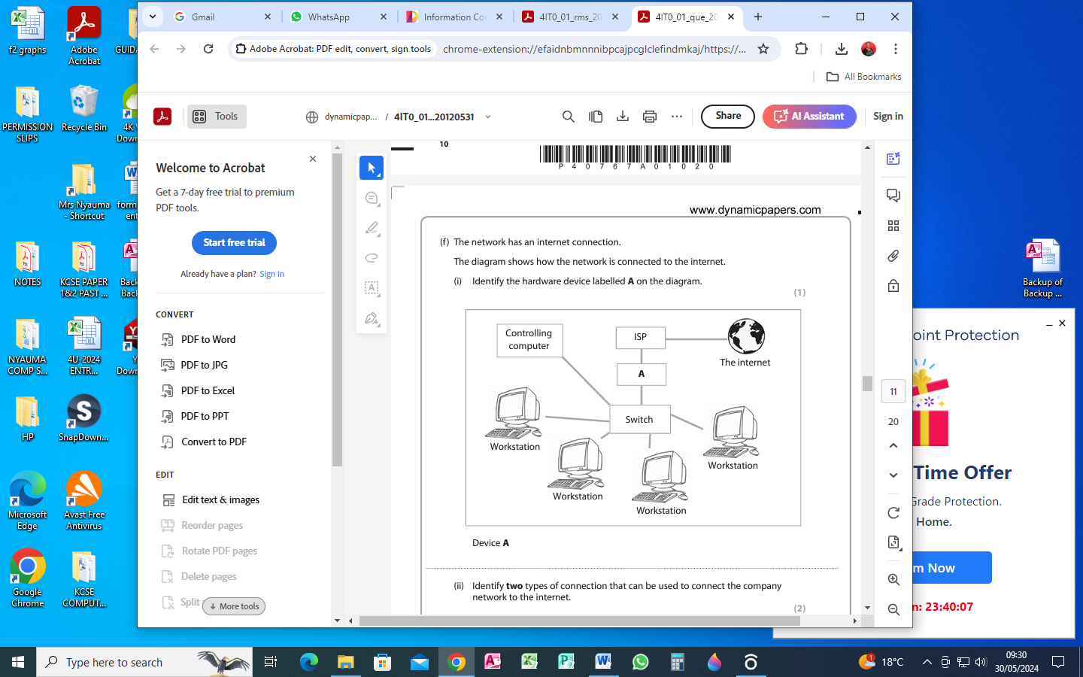

Device A (1 mark)

…………………………………………………………………………………………………………

ii) Identify any TWO types of connections that can be used to connect the company network to the internet. (2marks)

………………………………………………………………………………………………………………………………………………………………………………………………………………………………………………………………………………………………………………………………

c) i) What is an ISP? (2 Marks)

………………………………………………………………………………………………………………………………………………………………………………………………………………………………………………………………………………………………………………………………

ii) Give four examples of ISPs. (2 Marks)

………………………………………………………………………………………………………………………………………………………………………………………………………………………………………………………………………………………………………………………………

d) Security solutions prevent read and write access to data, which provides very strong protection against tampering and unauthorized access.

Explain the following terminology as used in data security (4 Marks)

i) Cypher text

………………………………………………………………………………………………………………………………………………………………………………………………………………………………………………………………………………………………………………………………

ii). Piracy

………………………………………………………………………………………………………………………………………………………………………………………………………………………………………………………………………………………………………………………………