**KASSU JOINT EXAM**

* **COMPUTER STUDIES -**

451//1 (THEORY)

JUNE 2024 – 2 ½ HOURS

**MARKING SCHEME**

**Instruction to candidates**

1. *Write your name and index number in the spaces provided above*
2. *Sign and write the date of examination in the spaces provided*
3. *This paper consists of* ***two*** *sections:* ***A*** *and* ***B***
4. *Answer all the questions in section* ***A***
5. *Answer question* ***16*** *and other* ***three*** *questions from section* ***B***
6. ***All*** *answers should be written in the spaces provided on the question paper.*
7. ***This paper consists of 13 printed pages.***
8. *Do not remove any pages from this booklet.*
9. ***Candidates should check the question paper to ascertain that all the pages are printed as indicated and that no questions are missing.***
10. ***Candidates should answer the questions in English.***

**For Examiner’s Use Only**

|  |  |  |  |
| --- | --- | --- | --- |
| **Section** | **Question** | **Maximum**  **Score** | **Candidate’s**  **Score** |
| A | 1-15 | 40 |  |
| B | 16 | 15 |  |
| 17 | 15 |  |
| 18 | 15 |  |
| 19 | 15 |  |
| 20 | 15 |  |
| **Total Score** | | |  |

*Answer* ***all*** *the questions in this section in the spaces provided*

1. List any THREE examples of Database packages popularly in use today.

(3 marks)

* *MySQL*
* *Microsoft Access*
* *SQL server*
* *FileMaker Pro*
* *Oracle*
* *dBASE.*

1. List any TWO functions of the Control Unit (2 marks)

* *Fetching instructions*
* *Decoding instructions*
* *Generating control signals*
* *Managing execution*
* *Coordinating data flow*
* *Handling interrupts*
* *Managing instruction cycle*
* *Synchronizing operations*

***2 points for 1 mark each***

1. Mobile devices such as Smartphones and Tablets use an operating system.

List any THREE types of operating system found in mobile devices. (3 marks)

* *Android*
* *iOS*
* *Symbian OS*
* *iPhone OS*
* *RIMs Blackberry*
* *Windows Mobile*
* *Palm Web OS.*

1. A group of students are producing a class newsletter which they will email to parents of students in the class. The students have decided to use a smartphone. Data for the newsletter will be input, stored and output by the smartphone.

Identify any TWO devices that are part of the smartphone that could be used to input the data for the newsletter. (2marks)

* *Camera*
* *Microphone*
* *Touch screen*

1. Many books contain a *gutter margin*. Explain gutter margin as used in word processing. (2marks)

* *Used as an extra margin*
* *Adds extra space to the inside / top margin*
* *Helps to ensure the text is not obscured by the binding*

1. a) Distinguish between General Purpose computers and Special Purpose Computers (2 marks)

* *General purpose computers are computers that are able to perform a variety of tasks while Special purpose computers are computers that only do a specific task.* ***Distinguishing 2 marks***

b) Define toggle keys found on a standard keyboard, giving any TWO examples (2 marks)

* *Toggle keys are keys on a keyboard that switch between two functions each time they are pressed.* ***Definition – 1 mark***
* *Common examples include the Caps Lock, Num Lock, and Scroll Lock keys* ***(two examples each ½ mark***

1. Ujuzi High School is about to set up a computer Laboratory. Advise them on three measures to take in order to ensure proper ventilation in the Room.

(3 marks)

* *Install Adequate Air Conditioning Systems:*
* *Use of Windows*
* *Proper Arrangement of Lab Equipment to allow air flow*
* *Use of ventilation Grills*

***3 points for 1 mark each***

a) Define Virtual Memory.

* ***Virtual memory*** *is a memory management technique that extends the apparent capacity of physical RAM by using a portion of the hard drive as additional memory, allowing programs to operate as if there is more memory available than what is physically installed.*
* *This enables efficient multitasking and handling of larger applications by swapping data between physical memory and disk storage as needed.* ***Definition 1 mark***

b) Name any ONE place where virtual memory may be found in a computer.

(2 marks)

* -hard disk ***1 mark***

1. List any THREE differences between *Cathode Ray Tube* Monitors and *Flat Panel* Monitors (3 marks)

|  |  |
| --- | --- |
| **CATHODE RAY TUBE** | **FLAT PANELS** |
| Bell shaped | Flat shaped |
| Has a poor resolution | Has a high resolution |
| Heavier, hence less portable | Light, hence more portable |
| Occupies more space | Occupies less space |
| Cheaper | Expensive |
| Produce a high amount of radiation | Produces a low amount of radiation |
| Consumes more power | Consumes less power |

***3 points for 1 mark each***

1. a). One of the factors to consider when purchasing computer hardware is warranty. List any TWO contents of a warranty. (2 marks)

* *scope of cover*
* *callout response and liability agreement*
* *preventive maintenance*.

***2 points for 1 mark each***

b). Distinguish between portability and compatibility as used in computer hardware. (2 marks)

* ***Portability****: Refers to the ease with which hardware can be physically moved and used in different location.*
* ***Compatibility****: Refers to the ability of a piece of hardware to work with other hardware without requiring special adaptations or modifications.*

***Distinguishing 2 marks***

1. A computer studies student is creating a movie, in school, for a project. He needs to take the movie home to edit it. The student decided to use solid-state memory card (SSD card) to transport the movie files. The student is unable to save the work on the memory card.

Give any TWO error messages that may appear when attempting to save the work. (2marks)

Any two from:

* *Medium is full*
* *Corrupt card*
* *Write error*
* *Card error*
* *Card not initialized*
* *Virus found on the card*
* *Device not recognized*

1. Mention any TWO advantages of serial cables **over** parallel cables for data transmission. (2 marks)

* *Cost less than other cables*
* *Supports long-distance communication between devices.*
* *Have fewer wires*
* *Reliable for transferring data to long distances.*

1. List any TWO ways that *text* can be made to fit in a text box in desktop publishing software (2marks)

* *Best fit*
* *Shrink text on overflow*
* *Grow textbox to fit*

1. List any TWO application areas of artificial intelligence (2 marks)

* *Expert systems*
* *Natural language processing*
* *Robotics*
* *Artificial neural networks*

1. a). State any TWO functions of system software (2marks)

* *Booting the computer to ensure all hardware elements are working properly*
* *Helps in storing and retrieving files*
* *Perform various system utility functions*

b). Differentiate between freeware and shareware with reference to software.

(2marks)

* *Freeware software is provided to its users for free of cost while shareware software is provided to its users for a limited period of time after which the software is paid for.*

**SECTION B** (60 Marks)

*Answer question* ***16*** *and any other* ***three*** *questions in this section in the spaces provided*

1. a) State any TWO differences between *syntax error* and *logical error* as used in programming. (4 marks)

|  |  |
| --- | --- |
| ***Syntax error*** | ***Logical error*** |
| *Result from improper use of language rules.* | *Result from improper sequence of events or formula* |
| *Detected by the language translator* | *Not detected by the language translator* |

b) The Figure below shows flowchart used to find the sum of even numbers in the first 10 natural numbers. Study it and use it to answer questions that follow.

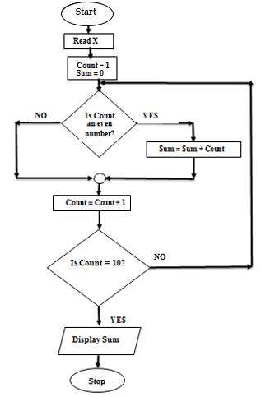

Determine the output from the flowchart. *Show your working*. (4 marks)

…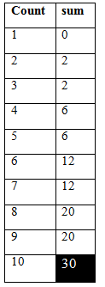

*Output = 30*

*Even number = 4 x ½ = 2*

*Ans = 30 (1 mark)*

i) Write a pseudo code for the flowchart above. (7 marks)

**Start**

**Sum = 0**

**Count = 1**

**Repeat**

**If count = even number then**

**Sum = sum + count**

**End if**

**Count = count +1**

**Until count = 20**

**Output sum**

**Stop**

1. a) List any TWO reasons why binary systems are used in computers. (2 marks)

* *Digital devices are smaller*
* *Digital computers are reliable*
* *Human language is complex for the computer to understand*
* *Digital computers are power efficient*

***2 points for 1 mark each***

b) i) Convert 93CADF16 to its binary equivalent (2 marks)

*9 – 1001 A – 1010 3 – 0011 C-1100 D – 1101 F – 1111* ***(1 mark)***

*93CADF – 1001 0011 1100 1010 1101 11112* ***(1 mark)***

ii) Use the two’s compliment to solve: -3710 + 5110 (4 marks)

*+37 = 00100111* ***(1 mark)***

*-37 = 11011000 (0ne’s Complement)* ***(1 mark)***

*-37 = 11011000 + 1 = 11011001 (Two’s Complement)* ***(1 mark)***

*11011001 + 00110011 =* ***000011002 (1 mark)***

iii) Convert 10111111.011112 to its Octal equivalent (2 marks)

***0****10-111-111.011-11****0****2* ***(1 mark)***

*=277.368* ***(1 mark)***

c) Give any TWO characteristics of a good system analyst. (2 marks)

* *Must have technical knowledge*
* *Must have good communication skills*
* *Must be good in problem solving*
* *Must be business oriented*

***2 points for 1 mark each***

d). Describe the THREE components of an expert system (3 marks)

* ***Knowledge base****- Acts as the repository of expertise and provides the foundational data that the system uses to make decisions*
* ***Inference Engine****: Interprets the data from the knowledge base to provide solutions or recommendations. It simulates the reasoning process of a human expert by drawing inferences based on the input data.*
* ***User Interface****: Facilitates the input of queries or problems from the user and presents the system’s conclusions, solutions, or recommendations in a comprehensible manner. It ensures the user can effectively communicate with the system and understand its outputs.*

***Listing – 1 ½ mark***

***Describing – 3 marks***

1. Lawino opened her flash disk in one of the school’s computers using drive F. she had saved her work in a folder named “MINE”. This folder has subfolders for PICTURES, PERSONAL and AUDIO. In PERSONAL subfolder, there are files such as MyDocs.xlt and FamilyDocs.pff, while in PICTURES there are subfolders such as OFFICE and CHURCH.

a) i) Draw a directory tree structure for Lawino. (2 marks)

MINE

PICTURES

PERSONAL

AUDIO

OFFICE

CHURCH

MyDocs.xlt

FamilyDocs.pff

F:\

½ mark

½ mark

½ mark

½ mark

ii) In CHURCH subfolder there is a file named OldPicture.jpg. Write a path to this file. (2 marks)

* *F:\MINE\PICTURES\CHURCH\OldPicture.jpg*

ii) She opened the file OldPicture.jpg, then decided to delete it. Explain what would happen. (2 marks)

* *She will receive a message saying “The action can’t be completed because the file is open in Paint. Close the file and try again”*

b) i) One classification of operating systems according to user-interface is menu driven. Explain menu driven. (2 marks)

* *A* ***menu-driven interface*** *is a type of user interface where users interact with a program or system through a series of menus. These menus present options or commands that the user can select, typically through the use of a pointer, keyboard, or touchscreen, simplifying the interaction with the system.*

ii) Describe, with the help of an example, transcription errors. (3 marks)

* ***Transcription errors*** *Are errors that occur during data entry caused by either misreading or mistyping of data.* ***(2 marks)***
* *They are caused by incorrect reading of the source documents by the user and hence entering of the wrong text or digits. E.g.Misread 589 and write S89 i.e. misread ‘5’ for ‘S’*

*Or*

* *When two digits or letters are swapped around. i.e. putting them in the wrong order. e.g. entering 396 instead of 369.*

***A mark for an example (1 mark)***

c) In the academic office of our school, there is a master file and a reference file.

i) Distinguish between a master file and a reference file. (2 marks)

* A master file *is the main that* ***contains relatively permanent records about particular items or entries****. While*
* A reference file *is mainly* ***used for reference or look-up purposes****. Look-up information is that information that is stored in a separate file but is required during processing.*

ii) For each of the files above (i), name any TWO pieces of information that can be held in each of them in relation to school. (2 marks).

* *An example of a master file is a student file containing details of a student such as student ID, name, Date of Admission and contact address.*
* *An example of a reference file is school grading list, mark range of students in the school, etc.*

***A mark for two examples of each. (1 mark)***

1. (a)(i) The formula B2+$C$2 was entered in cell D2 then copied to cell F2. Show the new formula in cell F2 and give a reason for your answer. (2 marks)

* *D5 +$C$2*
* *B2 change to D5 as it is in relative cell reference*
* *$C$2- do not change as it is in absolute cell reference*

(ii) State the meaning of each of the following terms as used in spreadsheets:

1. Countif ( ) (2 marks)

* *Counts number of cells within a specified range that meets a given condition or criteria.*

(B) Max ( ) (2 marks)

* *Returns the highest value in a set of values*

(b)(i) Explain two types of *documentation* produced when developing a system by a system analyst. (2 marks)

* *User –orientation – assist users learn how to use the system.*
* *Technical –orientation – assist programmer and system analyst during maintenance of system.*

(c)Nosim has developed a computerized system for a school and currently in its change over stage, where the new system is introduced in a department then tested to ascertain its effectiveness and once its performance is satisfactory it is implemented in the entire organization.

(i) Identify the changeover strategy used. (1 mark)

* *Piloting*

(ii) Explain any two advantages of the changeover strategy identified in (i)above.

(4 marks)

* *Reduces risks of data loss*
* *System tested thoroughly*
* *Provide platform to train all the employees of the organisation.*
* *Cheaper to train employees*

1. Arosy bought a smartphone. Smartphones can be connected using wired or wireless methods.

a) i) Give two disadvantages, to Arosy, of using *a wired* method to connect to the smartphone. (2marks)

* *Cannot move around (while transferring data)*
* *Have to waste time finding/connecting cables*
* *Cost of cables / more expensive*
* *Health and safety issues (trailing wires).*

ii) Give two disadvantages to Arosy of using *a wireless* method to connect to the smartphone. (2marks)

* *Slower / lower bandwidth / higher latency*
* *Shorter range*
* *Less stable connection*
* *Interference (e.g. dropped packets, loss of data) / Affected by obstructions*
* *Less secure*
* *Requires a password*
* *Increased demand on battery life.*

b) The diagram shows how a network is connected to the internet.

i) Identify the hardware device labelled A on the diagram. 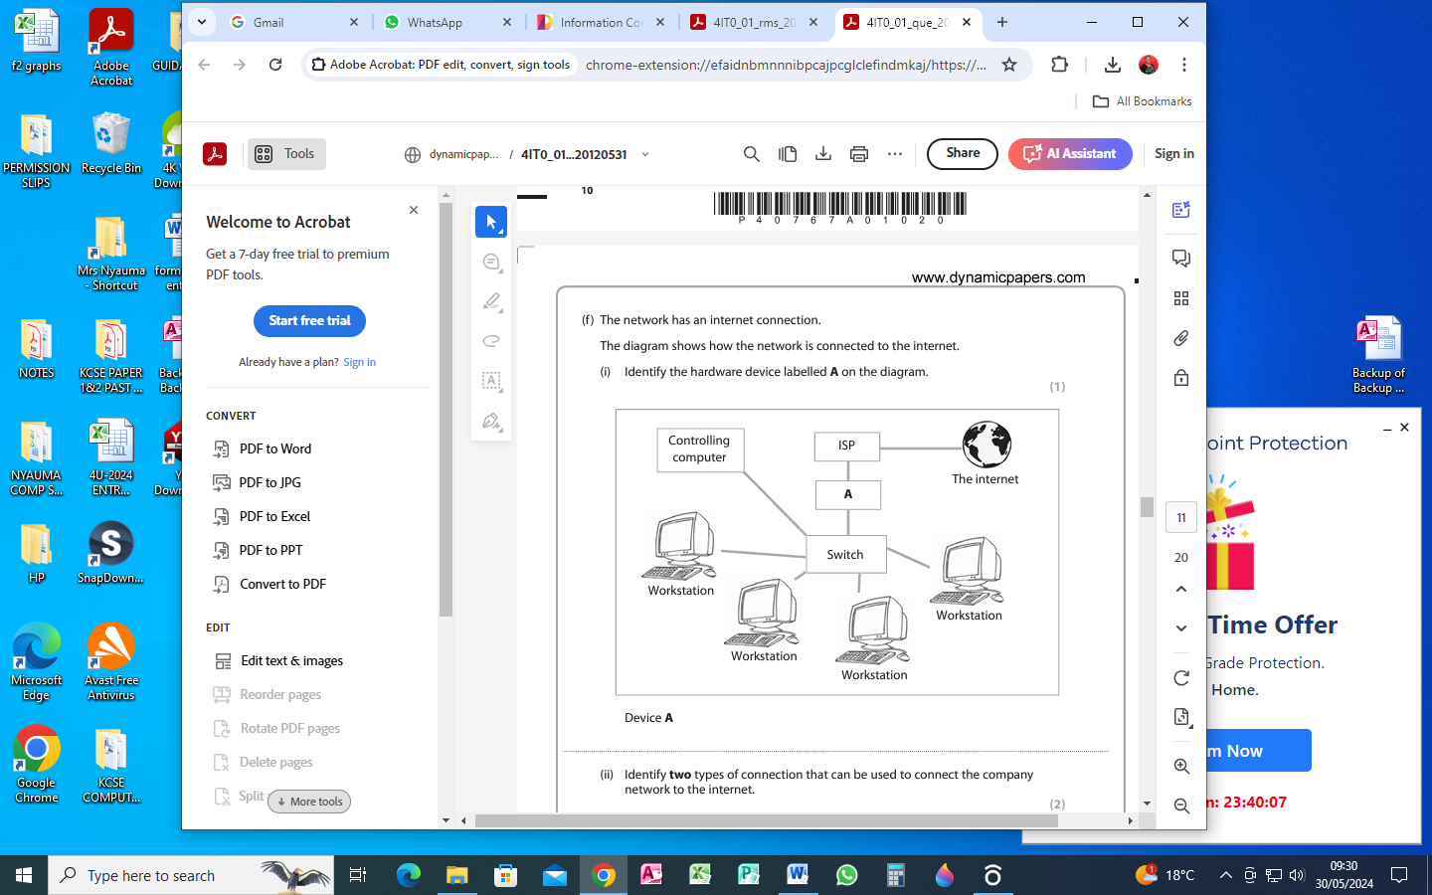

Device A (1 mark)

* + - *Router / gateway / modem*

ii) Identify any TWO types of connections that can be used to connect the company network to the internet. (2marks)

* *Broadband*
* *Dialup*
* *VPN*
* *Wi-fi*
* *Satellite*

c) i) What is an ISP? (2 Marks)

* *An internet service provider (ISP) is a company that provides access to the internet. ISPs can provide this access through multiple means, including dial-up, DSL, cable, wireless and fiber-optic connections.*

ii) Give four examples of ISPs found in Kenya. (2 Marks)

* *Safaricom.*
* *Faiba.*
* *Zuku.*
* *Telkom.*
* *Airtel.*

d) Security solutions prevent read and write access to data, which provides very strong protection against tampering and unauthorized access.

Explain the following terminology as used in data security (4 Marks)

i) Cypher text

* *Ciphertext is encrypted text transformed from plaintext using an encryption algorithm. Ciphertext can’t be read until it has been converted into plaintext*

ii). Piracy

* *Software, information &amp; data are protected by copyright laws. Piracy means making illegal copies of copyrighted software, data, or information either for personal use or for re-sale.*