**Name** **……………………………...................................……ADM…………..Class………**

**School………………................….…………………….. Date……...................………**

**233/2**

**CHEMISTRY**

Paper2

**THEORY**

**June 2024**

2 hours

**KASSU EXAMINATIONS**

**Kenya Certificate of Secondary Education**

CHEMISTRY

**Paper 2**

**THEORY**

2 hours

**Instructions**

* *Write your name, Index number and class in the spaces provided above.*
* *Answer* ***ALL*** *the questions in the spaces provided.*
* *Mathematical tables and silent electronic calculators may be used.*
* *All working* ***MUST*** *be clearly shown where necessary.*

**For Examiner’s use only**

|  |  |  |
| --- | --- | --- |
| **Question** | **Maximum**  **Score** | **Candidate’s**  **Score** |
| 1 | **10** |  |
| 2 | **12** |  |
| 3 | **12** |  |
| 4 | **10** |  |
| 5 | **12** |  |
| 6 | **12** |  |
| 7 | **12** |  |
| **Total** | **80** |  |

*This question paper has 12**printed pages. Confirm that all the pages are printed as indicated*

1. (a) Study the set up below and use it to answer the questions that follow.

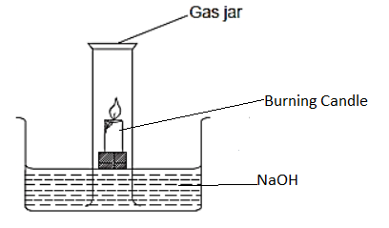

(i) What is the aim of the experiment? (1 mk)

.............................................................................................................................................

(ii) Identify one mistake in the set up above. (1 mk)

.............................................................................................................................................

(iii) After the experiment, the student calculated the volume of air used and found to be 19.2%. Comment on the results. (2 mks)

............................................................................................................................................................................................................................................................................................................................................................................................................................................................

(b) Another student carried out the same experiment using phosphorous. Instead of

burning candle:

(i) State one modification the student should carry out on the above set up to suit the experiment. (1 mk)

.............................................................................................................................................

.............................................................................................................................................

(ii) Describe the above experiment to show how results were obtained. (3 mks)

.............................................................................................................................................

.............................................................................................................................................

.............................................................................................................................................

.............................................................................................................................................

.............................................................................................................................................

.............................................................................................................................................

.............................................................................................................................................

(iii) After the experiment the student added three drops of methyl orange indicator in the trough. State and explain the observation made. (2 mks)

.............................................................................................................................................

.............................................................................................................................................

.............................................................................................................................................

1. (a) The grid below represents part of the periodic table. Study it and answer the

questions that follow. The letters do not represent the actual symbols of elements.

|  |  |  |  |  |  |  |  |  |
| --- | --- | --- | --- | --- | --- | --- | --- | --- |
|  |  |  |  |  |  |  |  |  |
| A |  |  |  |  | B |  | C |  |
|  | D |  | E |  |  | F | G | J |
| H |  |  |  |  |  |  |  |  |

(i) Using an ionic equation explain the observation made when a solution of potassium bromide is reacted with G. (2 mks)

............................................................................................................................................. ............................................................................................................................................. ............................................................................................................................................. .............................................................................................................................................

(ii) Both F and G are period 3 elements. Compare with a reason, their electronegativities. (2 mks)

............................................................................................................................................. ............................................................................................................................................. ............................................................................................................................................. .............................................................................................................................................

(iii) Element A combines with chlorine to form a chloride of A. State the most likely pH value of a solution of a chloride of A. Explain. (2 mks)

............................................................................................................................................. ............................................................................................................................................. ............................................................................................................................................. .............................................................................................................................................

1. Write a chemical equation for the reaction between an oxide of E and sodium hydroxide. (1 mk)

.............................................................................................................................................

(b) (i) Explain why molten calcium chloride and magnesium chloride conducts

electricity while carbon tetrachloride and silicon tetrachloride do not. (2 mks)

............................................................................................................................................. ............................................................................................................................................. ............................................................................................................................................. .............................................................................................................................................

(ii) Under the same conditions gaseous neon was found to diffuse faster than gaseous fluorine. Explain the observation. (F = 19.0, Ne = 20.0) (2 mks)

............................................................................................................................................. ............................................................................................................................................. ............................................................................................................................................. .............................................................................................................................................

(iii) Give one use of element J (1mk)

............................................................................................................................................. .............................................................................................................................................

1. I. Study Table below and answer the questions that follow

**Eθ(V)**

Ag+(aq) + e- Ag (s) + 0.80

Cu2+(aq) +2e- Cu(s) + 0.34

2H+(ag) + 2e- H2(g) 0.00

Cr3+(aq) + 3e-  Cr(s) -0.74

Na+(aq) + e-  Na (s) -2.17

1. Identify the strongest reducing agent. Explain. (2mks)

.......................................................................................................................................................................................................................................................................................................................................................................................................................................

1. Give two half cells which will produce the highest Eθ value when connected. (1mk) ...................................................................................................................................................................................................................................................................................................................................................................................................................
2. Why is it not practical to make the cell you have given in (b) above. (1mk)

....................................................................................................................................

1. A certain celebrity wanted to electroplate a certain ornament with Copper to a surface of 0.25 cm2. How long will to take to pass a current of 0.5A through a solution of copper (II) Sulphate in order to electroplate 2 cm of the ornament. (Density of copper = 8.92 g/cm3, IF = 96500, Cu = 63.5) (3mks)

........................................................................................................................................................................................................................................................................................................................................................................................................................................................................................................................................................................................................................................................................................................................................................................................................................................................................................................................................................................................................................................................................................................................................................................................................

1. A student set up the cell shown in the figure below

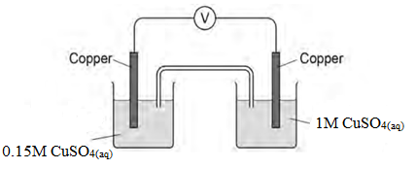

The student recorded an initial voltage of +0.16 V at 250C

1. Explain how the salt bridge provides an electrical connection between the two solutions. (1 mark)

............................................................................................................................................. .............................................................................................................................................

1. The standard electrode potential for the Cu2+(aq)/Cu(s) electrode is

Cu2+(aq) + 2e– → Cu(s) Eϴ= + 0.34 V

1. Calculate the electrode potential of the left-hand electrode in the Figure [1mark]

............................................................................................................................................................................................................................................................................................................................................................................................................................................................................................................................................................................................................................

1. Both electrodes contain a strip of copper metal in a solution of aqueous Cu2+ ions. State why the left-hand electrode does not have an electrode potential of +0.34 V [1mk]

............................................................................................................................................. .............................................................................................................................................

1. Give the conventional representation for the cell in the figure above. [1mk]

.............................................................................................................................................

1. When the voltmeter is replaced by a bulb, the emf of the cell in the Figure decreases over time to 0V, Suggest how the concentration of copper (II) ions in the left-hand electrode changes when the bulb is alight. Give one reason why the emf of the cell decreases to 0V [1mk]

....................................................................................................................................................................................................................................................................................................................................................................................................................................... ………………….

1. I. One of the factors which determine the reaction rate of solids is particle size.
2. A mixture of finely powdered aluminium and air may explode when ignited. This causes a large and sudden increase in temperature. Explain each of the following in terms of collisions between reacting particles.
3. Why is the reaction between finely powdered aluminium and air very fast? (1mk)

............................................................................................................................................. .............................................................................................................................................

1. Explain why for most reactions the rate of reaction decreases with time. (1mk)

............................................................................................................................................. .............................................................................................................................................

1. Suggest an explanation why the rate of reaction in an explosion could increase rather than decrease with time. (1mk)

............................................................................................................................................. ............................................................................................................................................. .............................................................................................................................................

1. A student compared the rates of reaction of three metal Hydrogen carbonates. She measured the volume of gas released using the apparatus shown.

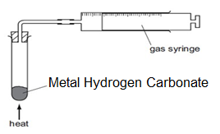

State one thing that must be kept constant if the rates of the three reactions are to be compared in a fair way. (1 mk)

............................................................................................................................................. .............................................................................................................................................

1. The graph shows the volume of carbon (IV) oxide released when the three metal Hydrogen carbonates were heated.

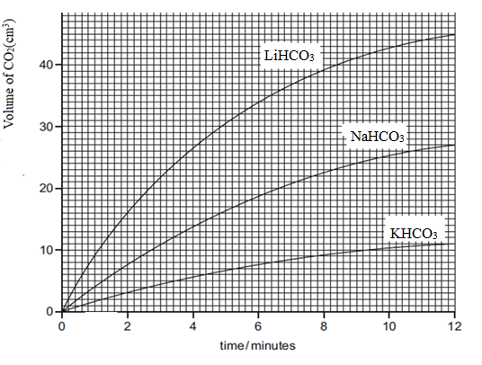

1. Which carbonate produced carbon (IV) oxide at the highest rate? (1mk)

............................................................................................................................................. .............................................................................................................................................

1. What volume of carbon (IV) oxide was produced by Sodium Hydrogen Carbonate in twelve minutes? (1 mk)

.............................................................................................................................................

II. Carbon (II) oxide and hydrogen are used in the manufacture of methanol (CH3OH). The reaction is reversible and can reach a position of dynamic equilibrium.

CO(g) + 2H2 (g) ⇌ CH3 OH(g) ΔH = –91 kJ/mol

The reaction is carried out at a pressure of about 100 atmospheres and a temperature of 2500C.

(a) State one feature of a reaction that is in dynamic equilibrium. (1mks)

..........................................................................................................................................................................................................................................................……….………….......................

(b) (i) How would a decrease in temperature at constant pressure affect the amount of

methanol in the equilibrium mixture? Explain your answer (2mks)

.....................................................................................................................................................................................................................................................................................................................................................................................................................................................................

(ii) How would an increase in pressure at constant temperature affect the amount of methanol in the equilibrium mixture? (1mk)

..............................................................................................................................................................................................................................................................................................................

1. Study the flow charts below and answer the questions that follow.

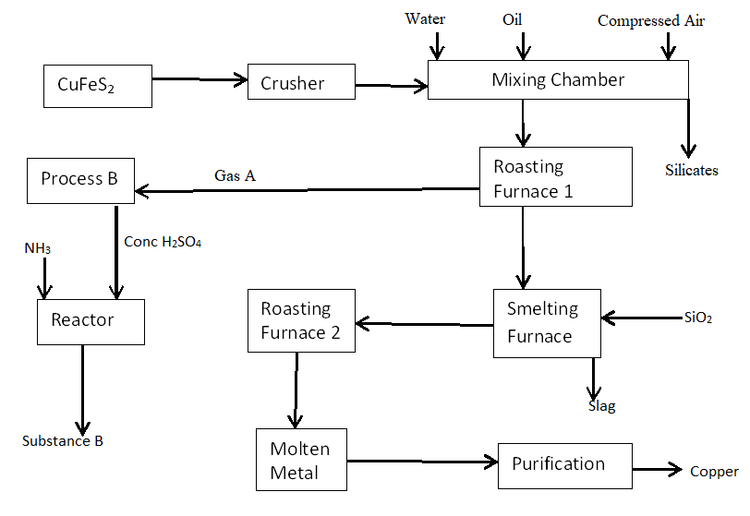

1. Identify process B. (1 mk)

.............................................................................................................................................

1. Give two optimum conditions required in the process named above. (2 mks)

..................................................................................................................................................................................................................................................................................................

1. Explain why the ore is crushed. (1 mk)

............................................................................................................................................. .............................................................................................................................................

1. Which process occurs in the mixing chamber?

........................................................................................................................................

1. Explain use of the following: (2 mks)
2. Water

............................................................................................................................................. .............................................................................................................................................

1. oil

............................................................................................................................................. .............................................................................................................................................

1. Write the equation for the formation of slag (1 mk)

............................................................................................................................................. .............................................................................................................................................

1. Identify the cations present where the metal is being purified (1 mk)

…………………………………………………………………………………………….

1. Give a reason for the following use of the above metal.
2. Making electrical wires (1 mk)

............................................................................................................................................. .............................................................................................................................................

1. Making soldering wires (1 mk)

............................................................................................................................................. .............................................................................................................................................

1. Give two environment effects of the above process. (2 mks)

............................................................................................................................................. .............................................................................................................................................

............................................................................................................................................. .............................................................................................................................................

1. a) Phosphorus trichloride reacts with water to form two acids.

(i) One of the acid is H3PO3, Calculate the oxidation state of Phosphorus in the acid and hence give the IUPAC name for the acid [2marks]

................................................................................................................................................... …...................................................................................................................................................

.................................................................................................................................................... ..........................................................................................................................................................................................................................................................................................................

(ii) Describe how you could show that the other acid is a weaker acid than hydrochloric acid. (2mks)

............................................................................................................................................................................................................................................................................................................................................................................................................................................................................................................................................................................................................................

(iii) Two salts of phosphoric acid are its sodium salt, which is soluble in water, and its calcium salt which is insoluble in water. Suggest a method of preparation for each of these salts from aqueous phosphoric acid. (2mks)

sodium salt ................................................................................................................ ....................................................................................................................................

Calcium salt...............................................................................................................

....................................................................................................................................

b) The formulae of insoluble compounds can be found by precipitation reactions. To 12.0 cm3 of an aqueous solution of the nitrate of metal T was added 2.0 cm3 of aqueous sodium phosphate, Na3PO4. The concentration of both solutions was 1M. When the precipitate had settled, its height was measured.

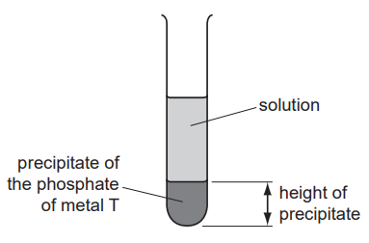

The experiment was repeated using different volumes of the phosphate solution. The results are shown on the following graph.

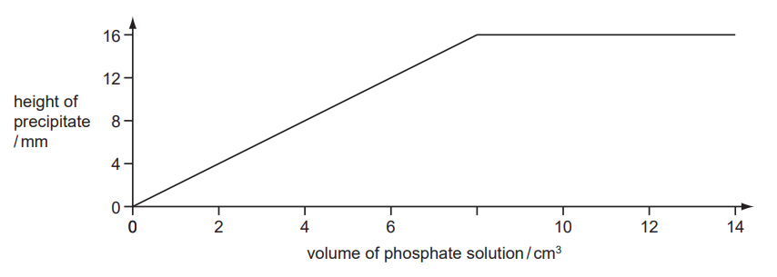

(i) What is the formula of the phosphate of metal T? Give your reasoning. (2mks)

...........................................................................................................................................................................................................................................................................................................................................................................................................................................................................................................................................................................................................................

c) The following apparatus was set up to investigate the electrical conductivity of dilute

acids

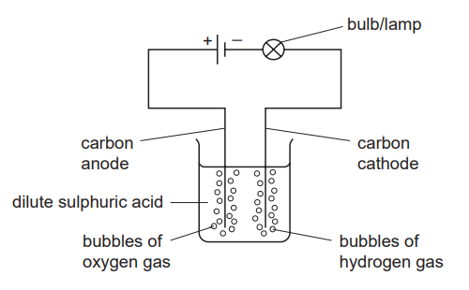

If it was replaced by a weak acid, what two differences in the observations would you expect to make (2mks)

............................................................................................................................................. .............................................................................................................................................

............................................................................................................................................. .............................................................................................................................................

d) Explain the following observation. A certain Chloride dissolves in water to form an electrolyte while the same chloride dissolves in methylbenzene to form a non-electrolyte. (2mks)

...................................................................................................................................................................................................................................................................................................................................................................................................................................................................................................................................................................................................................................................................................................................................................................................

1. (a) Name the following compounds (2mks)
2. CH3OHCH2

………………………………………………………………………………..



……………………………………………………………………………

(b)Study the flow chart below and answer the questions that follow.

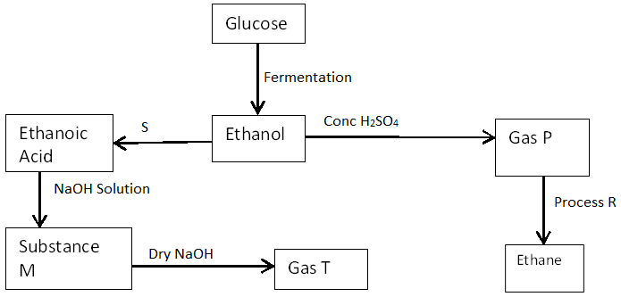

(i) State the conditions necessary for fermentation of glucose to take place. (1mk)

..............................................................................................................................................................................................................................................................................................................

(ii) State one reagent that can be used to carry out process S. (1 mk)

.............................................................................................................................................

1. Identify the substances (2 mks)

P......................................................................................................... T.........................................................................................................

1. Write an equation for the reaction resulting to formation of substance M.

(1 mk)

.............................................................................................................................................

1. How sodium hydroxide is kept dry during the reaction. (1 mk)

............................................................................................................................................. .............................................................................................................................................

1. Give one commercial use of process R. (1 mk)

.............................................................................................................................................

(c)Describe a chemical test to distinguish between the compounds represented by formula CnH2n+2 and CnH2n (2mks)

............................................................................................................................................. .......................................................................................................................................................................................................................................................................................... .............................................................................................................................................

(d) State one use of ethanol other than as an alcoholic drink. (1 mk)

.............................................................................................................................................

**THIS IS THE LAST PRINTED PAGE**