***MARKING SCHEME***

**233/2**

**CHEMISTRY**

Paper2

**THEORY**

**June 2024**

2 hours

**KASSU EXAMINATIONS**

**Kenya Certificate of Secondary Education**

CHEMISTRY

**Paper 2**

**THEORY**

2 hours

**Instructions**

* *Write your name, Index number and class in the spaces provided above.*
* *Answer* ***ALL*** *the questions in the spaces provided.*
* *Mathematical tables and silent electronic calculators may be used.*
* *All working* ***MUST*** *be clearly shown where necessary.*

**For Examiner’s use only**

|  |  |  |
| --- | --- | --- |
| **Question** | **Maximum**  **Score** | **Candidate’s**  **Score** |
| 1 | **10** |  |
| 2 | **12** |  |
| 3 | **12** |  |
| 4 | **10** |  |
| 5 | **12** |  |
| 6 | **12** |  |
| 7 | **12** |  |
| **Total** | **80** |  |

*This question paper has 12**printed pages. Confirm that all the pages are printed as indicated*

1. (a) Study the set up below and use it to answer the questions that follow.

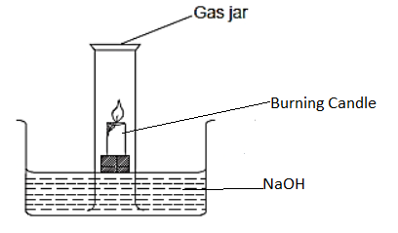

(i) What is the aim of the experiment? (1 mk)

***To investigate the active part of air***

(ii) Identify one mistake in the set up above. (1 mk)

***The beaker / gas jar used is not graduated***

(iii) After the experiment, the student calculated the volume of air used and found to be 19.2%. Comment on the results. (2 mks)

***- not all oxygen might not have been used up***

***-NaoH solution might not have absorbed all the carbon(IV) oxide in the jar / beaker***

(b) Another student carried out the same experiment using phosphorous. Instead of burning candle:

(i) State one modification the student should carry out on the above set up to suit the experiment. (1 mk)

***Replacing NaoH with water***

(ii) Describe the above experiment to show how results were obtained. (3 mks)

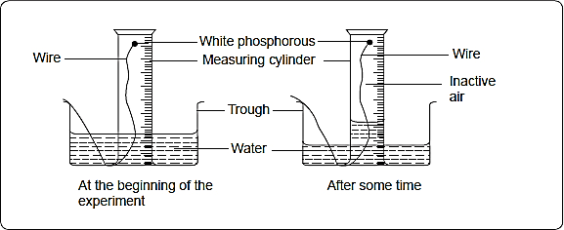

**Or**

***Phoshorus is inserted in a gas jar containiga fixed volume of air, it smoulders using up the oxygen in the gas jar. Then final volume of air remaining is subtracted from the initial volume of air. Volume used is used to determine the %of air used***

(iii) After the experiment the student added three drops of methyl orange indicator in the trough. State and explain the observation made. (2 mks)

***The solution changed to pink.***

***Phosphorous oxide dissolves in water to form an acidic solution of N3PO4 / H3PO3***

1. (a) The grid below represents part of the periodic table. Study it and answer the

questions that follow. The letters do not represent the actual symbols of elements.

|  |  |  |  |  |  |  |  |  |
| --- | --- | --- | --- | --- | --- | --- | --- | --- |
|  |  |  |  |  |  |  |  |  |
| A |  |  |  |  | B |  | C |  |
|  | D |  | E |  |  | F | G | J |
| H |  |  |  |  |  |  |  |  |

(i) Using an ionic equation explain the observation made when a solution of potassium bromide is reacted with C. (2 mks)

***2 Br- + Cl2 2 Cl- + Br2***

***Brown liquid is formed chlorine is more electronegative than Bromine hence displaces it in a compound containing***

(ii) Both F and G are period 3 elements. Compare with a reason, their electronegativities. (2 mks)

***G is more electronegative than F. G has smaller atomic size than F hence formation easily***

(iii) Element A combines with chlorine to form a chloride of A. state the most likely pH. Value of a solution of a chloride of A. Explain. (2 mks)

***The chloride is neutral / ionic compound formed.***

1. Write a chemical equation for the reaction between an oxide of E and sodium hydroxide. (1 mk)

***E2O3 + 2NaOH 2NaE O2 + H2O***

***or***

***Al2O3 + 2NaOH 2NaAl O2 + H2O***

(b) (i) Explain why molten calcium chloride and magnesium chloride conducts

electricity while carbon tetrachloride and silicon tetrachloride do not.

(2 mks)

***Both molten CaCl2 and MgCl2 are ionic compounds hence conduct electricity due to presence of mobile ions while CCl4 and SiCl4 are molecular compounds the no mobile ions***

(ii) Under the same conditions gaseous neon was found to diffuse faster than gaseous fluorine. Explain the observation. (F = 19.0, Ne = 20.0) (2 mks)

***Gaseous fluorine is stable as a molecule F2(diatomic) hence its molecular mass is 38. While gaseous neon exist as an monoatomic; its atomic mass is 20.***

(iii) Give one use of element J (1mk)

***Gas shielding in welding***

1. I. Study Table below and answer the questions that follow

**Eθ(V)**

Ag+(aq) + e- Ag (s) + 0.80

Cu2+(aq) +2e- Cu(s) + 0.34

2H+(ag) + 2e- H2(g) 0.00v

Cr3+(aq) + 3e-  Cr(s) -0.74

Na+(aq) + e-  Na (s) -2.17

1. Identify the strongest reducing agent. Explain. (2mks)

***Na – Has the highest –ve Eθ***

1. Give two half cells which will produce the highest Eθ value when connected. (1mk)
2. ***Na+ + e- Na and Ag+ + e- Ag***

***Na / Na+ and Ag / Ag+***

1. Why is it not practical to make the cell you have given in (b) above. (1mk)

***Na reacts explosively with its solution***

1. A certain celebrity wanted to electroplate a certain ornament with Copper to a surface of 0.25 cm2. How long will to take to pass a current of 0.5A through a solution of copper (II) Sulphate in order to electroplate 2 cm of the ornament. (Density of copper = 8.92 g/cm3, IF = 96500, Cu = 63.5) (3mks)

***Mass = dxv Mass = $\frac{Q x ram}{Fx 96500}$***

***Vol = 0.25 x 2 = 0.5 cm3 4.46 =***

***Mass = 0.5 x 8.92 = 4.46 g Q = 13,555.59 c***

***Q = It 13,555.59 = 0.5 x t***

***Cu2+ + 2e- Cu t = 27,11.18 sec / 451.85 min / 7.53 Hrs***

1. A student set up the cell shown in the figure below

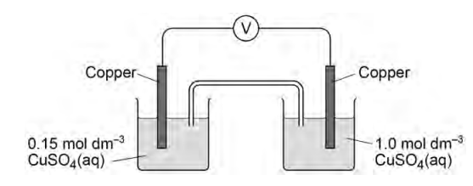

The student recorded an initial voltage of +0.16 V at 250C

1. Explain how the salt bridge provides an electrical connection between the two solutions. (1 mark)

***Has mobile ions and therefore allows movement of ions from one electrolyte (half cell) to the other***

1. The standard electrode potential for the Cu2+(aq)/Cu(s) electrode is

Cu2+(aq) + 2e– → Cu(s) Eϴ= + 0.34 V

1. Calculate the electrode potential of the left-hand electrode in the Figure [1mark]

***0.34 - 0.16 = +0.18v***

1. Both electrodes contain a strip of copper metal in a solution of aqueous Cu2+ ions. State why the left-hand electrode does not have an electrode potential of +0.34 V

[1 mark]

***The concentration is not the same as that on the right***

1. Give the conventional representation for the cell in the figure above. [1 mark]

***Cu(s) / Cu2+(aq) // Cu2+(aq) / Cu(s)***

1. When the voltmeter is replaced by a bulb, the emf of the cell in the Figure decreases over time to 0V, Suggest how the concentration of copper (II) ions in the left-hand electrode changes when the bulb is alight. Give one reason why the emf of the cell decreases to 0V [1mark]

***Energy being pruducedis being used up i.e. concentration decreases***

1. I. One of the factors which determine the reaction rate of solids is particle size.
2. A mixture of finely powdered aluminium and air may explode when ignited. This causes a large and sudden increase in temperature. Explain each of the following in terms of collisions between reacting particles.
3. Why is the reaction between finely powdered aluminium and air very fast?

(1 mk)

***High surface area hence more collision frequency***

1. Explain why for most reactions the rate of reaction decreases with time. (1 mk)

***As reaction continues Concentration of reactants decrease leading to decrease in collision frequency***

1. Suggest an explanation why the rate of reaction in an explosion could increase rather than decrease with time. (1 mk)

***Since heat is produced temperature increase which results in an increase in Kinetic energy of particles leading to high collision frequency***

1. A student compared the rates of reaction of three metal carbonates. She measured the volume of gas released using the apparatus shown.

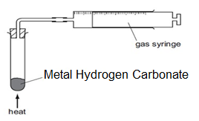

State one thing that must be kept constant if the rates of the three reactions are to be compared in a fair way. (1 mk)

* ***Mass of metal Hydrogen carbonate***
* ***Amount of heat applied***

1. The graph shows the volume of carbon (IV) oxide released when the three metal carbonates were heated.

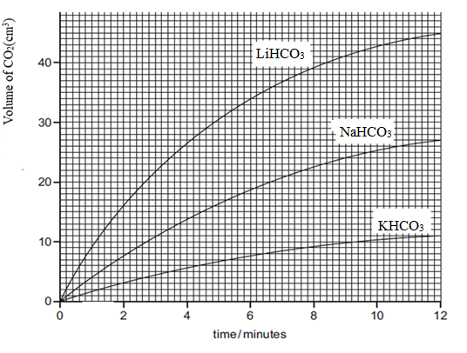

1. Which carbonate produced carbon (IV) oxide at the highest rate?

(1 mk)

***LiHCO3***

1. What volume of carbon (IV) oxide was produced by Sodium Carbonate in twelve minutes? (1 mk)

***27 cm3***

II. Carbon (II) oxide and hydrogen are used in the manufacture of methanol (CH3OH). The reaction is reversible and can reach a position of dynamic equilibrium.

CO(g) + 2H2 (g) ⇌ CH3 OH(g) ΔH = –91 kJ/mol

The reaction is carried out at a pressure of about 100 atmospheres and a temperature of

2500C.

(a) State one feature of a reaction that is in dynamic equilibrium. (1mks)

* ***Concentration of reactant and products remain constant***
* ***Rate of forward and backward is equal***

(b) (i) How would a decrease in temperature at constant pressure affect the amount of

methanol in the equilibrium mixture? Explain your answer (2mks)

***Amount / yield increase, forward reaction is exothermic hence forward reactionis favoured by low temperature***

(ii) How would an increase in pressure at constant temperature affect the amount of methanol in the equilibrium mixture? (1mk)

***Increases the amount / yield***

1. Study the flow charts below and answer the questions that follow.

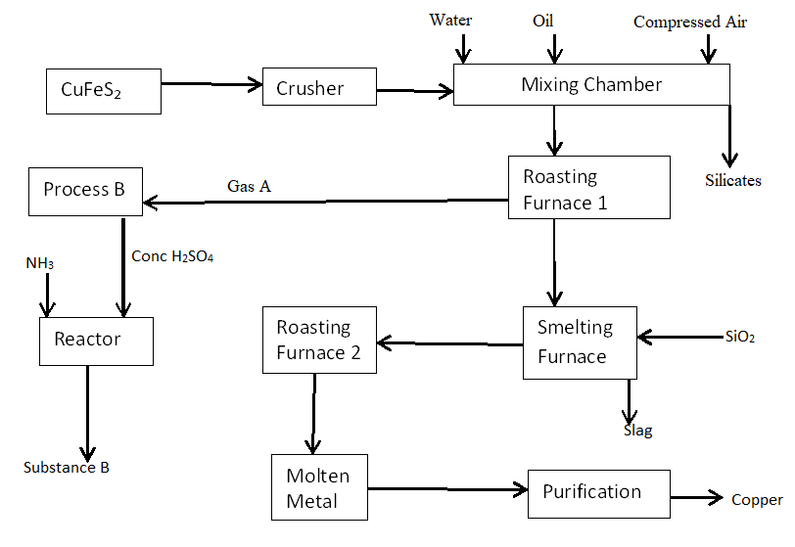

1. Identify process B. (1 mk)

***Contact process***

1. Give two optimum conditions required in the process above. (2 mks)

***Temperature of 4500c***

***Pressure of 2 – 3 atm***

***Vanadium (V) oxide/Pt***

1. Explain why the ore is crushed. (1 mk)

***To increase the surface area for extraction***

1. Which process occurs in the mixing chamber?

***Froath floatation***

1. Explain use of the following: (2 mks)
2. Water

***Sinks earthy impurities and float the ore***

1. Oil

***Covers the ore and enables it to float in water***

1. Write the equation for the formation of slag (1 mk)

***Fe O(s) + SiO2(s)  FeSiO3***

1. Identify the cations present where the metal is being purified (1 mk)

***Cu2+ and H+***

1. Give a reason for the following use of the above metal.
2. Making electrical wires (1 mk)

***Good electric conductivity***

1. Making soldering wires (1 mk)

***Good thermal conductivity***

1. Give two environment effects of the above process. (2 mks)

* ***SO2 produced causes respiratory Problems / acid rain which corrode iron sheets***
* ***Deposition of slag inhibits growth of vegetation***
* ***Mining leaves open quarries which can lead to water accumulation leading to mosquito breeding***

1. a) Phosphorus trichloride reacts with water to form two acids.

(i) One of the acid is H3PO3, Calculate the oxidation state of Phosphorus in the acid and hence give the IUPAC name for the acid [2marks]

***(3x + 1) + x + (-2 x 3) = 0***

***+3 + x – 6 = 0***

***x = +3***

***Phosphoric (III) acid***

(ii) Describe how you could show that the other acid is a weaker acid than hydrochloric acid. (2mks)

* ***Add the acids to different samples of carbonate/hydrogen carbonate and measure volume of CO2 produced per give timeand compare – HCl produces CO2 ata faster rate***
* ***Use each acid as electrolyte and determine the conductivity, HCl gives a high conductivity***

(iii) Two salts of phosphoric acid are its sodium salt, which is soluble in water, and its calcium salt which is insoluble in water. Suggest a method of preparation for each of these salts from aqueous phosphoric acid. (2mks)

sodium salt ***Rx of NaOH with H3 PO4 acid and alkali***

Calcium salt ***Rx of H3PO4 with NaOH to produce Na3PO4 then addition of***

***Ca(NO3)2 / CaCl2 i.e Double decomposition***

b) The formulae of insoluble compounds can be found by precipitation reactions. To 12.0 cm3 of an aqueous solution of the nitrate of metal T was added 2.0 cm3 of aqueous sodium phosphate, Na3PO4. The concentration of both solutions was 1M. When the precipitate had settled, its height was measured.

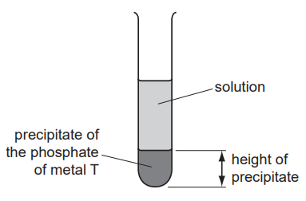

The experiment was repeated using different volumes of the phosphate solution. The results are shown on the following graph.

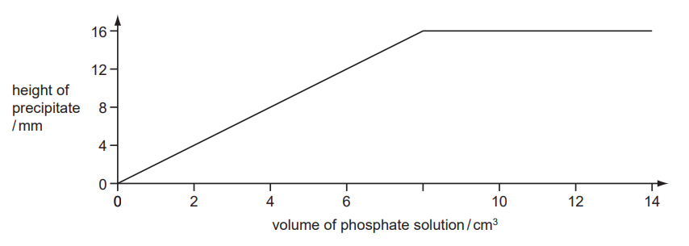

(i) What is the formula of the phosphate of metal T? Give your reasoning. (2mks)

***Moles of Nitrate $\frac{12*1}{1000}$ =0.012 moles***

***Moles of Phospahte $\frac{8*1}{1000}$ = 0.008***

***Ratio :***

***2 : 3***

***= 2***

***T3 (PO4)2***

***T has vary of 2***

c) The following apparatus was set up to investigate the electrical conductivity of dilute

acids

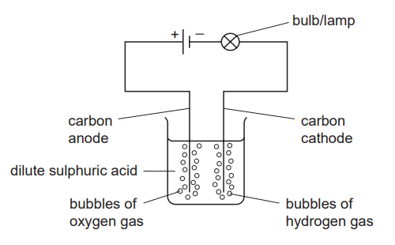

If it was replaced by a weak acid, what two differences in the observations would you expect to make (2mks)

* ***Bubbles of O2 and H2 produced at a slower rate (less)***
* ***The brightness of the bulb will decrease***

d) Explain the following observation. A certain Chloride dissolves in water to form an electrolyte while the same chloride dissolves in methylbenzene to form a non-electrolyte. (2mks)

***Water being polar will ionise Cloride forming Chloride ions while in methylbenze which is non polar it does not ionize***

1. (a) Name the following compounds (2mks)
2. CH3OHCH2

* ***Ethanol***



* ***Hexane***

(b)Study the flow chart below and answer the questions that follow.

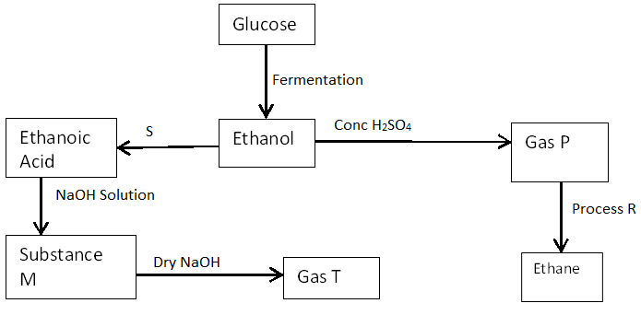

(i) State the conditions necessary for fermentation of glucose to take place.

(1 mk)

***Yeast***

***Room temperature / 25 – 350C***

(ii) State one reagent that can be used to carry out process S. (1 mk)

***Acidified KMnO4/K2Cr2O7***

1. Identify the substances (2 mks)

***P – Ethene***

***T - Methane***

1. Write an equation for the reaction resulting to formation of substance M.

(1 mk)

***CH3COONa + NaOH Na2CO3 + CH4***

1. How sodium hydroxide is kept dry during the reaction. (1 mk)

***By adding quicklime (CaO)***

1. Give one commercial use of process R. (1 mk)

***Hardening of oils to fats through hydrogenation***

(c) Describe a chemical test to distinguish between the compounds represented by formula CnH2n+2 and CnH2n (2mks)

***Add acidified potassium dichromate(VI) to both compounds separately*** CnH2n ***changes orange acidified potassium dichromate(VI) to green while*** CnH2n+2  ***does not***

***Or Using Potassium Manganate (VII)***

(d) State one use of ethanol other than as an alcoholic drink. (1 mk)

***- in cosmetics***

***- As an additive in fuel***

***- to prevent skin infections***

**THIS IS THE LAST PRINTED PAGE**