**MARANDA HIGH SCHOOL**

***Kenya Certificate of secondary Education (KCSE)***

**Paper 1**

**565/1**

**MOCK 2024**

**Marking scheme**

**Confidential**

|  |  |
| --- | --- |
| **MARKING SCHEDULE** | |
|  |  |
|  |  |
|  |  |
|  |  |
|  |  |
|  |  |
|  |  |

1. **Name four methods of reproducing documents. (4marks)**
2. *Printing*
3. *Carbon copying*
4. *Photocopying*
5. *Duplicating*
6. **Classify each of the following items as either basic or secondary. (4marks)**

|  |  |
| --- | --- |
| **Items** | **Type** |
| 1. Biscuits | *Secondary* |
| 1. Shoes | *Basic* |
| 1. Medicine to the sick | *Basic* |
| 1. Security | *Secondary* |

1. **State four Features of effective communication. (4marks)**

1. *Language used must be understood*
2. *Language must be simple and clear*
3. *No noise*
4. *Not ambiguous*
5. *Positive attitude for both sender and receiver*
6. *Medium should be suitable*
7. *Timing should be suitable*
8. *Feedback*
9. *Information overload should be avoided*
10. **Highlight four characteristics of a good tax system. (4marks)**
11. *It should be equitable*
12. *Should be certain*
13. *Should be convenient*
14. *Should be flexible*
15. *Should be diversified*
16. *Tax system should be simple to be understood by tax payer*
17. The following information relates to Uwezo Traders for the year ended 31st December 2022.

Sales 480,000

Stock ( 1/1/2022) 60,000

Stock ( 31/12/2022) 30,000

Margin 25%

Determine;

1. **Gross profit**

**Margin =Gross profit/Sales**

**¼=Gp/480000**

**=120000**

**ii) Cost of sales**

**= Sales – Gp**

**=480000-120000**

**=360000**

**iii) ROSTO**

**360000/45000**

**=8 times.**

1. Under what four circumstances would it be advisable for a manufacturer to sell his product directly to the consumer. **(4marks)**
2. *Where goods are expensive for middlemen*
3. *Where goods are technical in nature*
4. *Where goods are perishable*
5. *Where the market is concentrated / localized in one area*
6. *Where goods are produced according to customers specification*
7. *Where manufacturer requires immediate feedback.*
8. **State four ways in which the government can increase demand for bread in the country.**

**(4marks)**

1. *Lowering tax*
2. *Imposing subsidies*
3. *Favourable laws that encourage consumption*
4. *Price control, fixing the price at a low rate*
5. **Identify the type of unemployment described in the statement in the table bellow.**

**(4marks)**

|  |  |
| --- | --- |
| **Description** | **Type of unemployment** |
| 1. Improvement in technology | *Structural* |
| 1. Occurs repeatedly at similar times | *Cyclical/ demand deficient/ general unemployment* |
| 1. Where workers capability are under utilized | *Disguised/ hidden* |
| 1. Where demand for labour is irregular | *Erratic / casual* |

1. Outline four factors limiting the roles of consumer associations in Kenya (4marks)
2. *Very high prices for products*
3. *Poor /Inferior quality good*
4. *Misleading information about a product misleading advertisement.*
5. *Harmful products*
6. *Hoarding of products*
7. *Breach of contracts*
8. State four structural changes that may take place when a country is experiencing economic development. (4marks)
9. *Shifting from agricultural to manufacturing sector*
10. *Reduction in illiteracy*
11. *Increase in skilled manpower*
12. *Increase in technology*
13. *Improvement in entrepreneurial ability*
14. *Increase in institutions that handle new methods of production.*
15. **State four demerits of division of labour. (4marks)**
16. *Hinders creativity*
17. *Create unemployment*
18. *Leads to social problems such as crime and prostitution*
19. *Lack of pride in the final product*
20. **State reasons why it’s suitable to locate bonded warehouse at the point of entry. (4 marks)**
21. *To prevent entry of harmful illegal goods*
22. *For easy collection of custom duties.*
23. *For easy inspection of imported goods*
24. *To prevent smuggling of goods*
25. *For easy re-exportation of goods.*
26. **The country Kenya is experiencing rapid inflation, highlight four measures that the government may put in place to control aggregate demand for the goods and services.**

**(4marks)**

1. *Reducing government spending*
2. *Increase in income tax*
3. *Reducing tax on production*
4. *subsidizing production*
5. *Producing commodities that are in short supply*
6. **List four various policies available under marine insurance policy. (4marks)**
7. *Port policy*
8. *Voyage policy*
9. *Floating policy*
10. *Time policy*
11. *Mixed policy*
12. *Fleet policy*
13. *Composite policy*
14. *Marine cargo policy*
15. *Marine hull policy*
16. **The balance sheet of Makelele Wholesale had a capital of SH 347,000 as at 1st January 2023. During the year he brought cash amounting to Sh 100,000 from his own source while drawings were Sh 6,000. Calculate his final capital as at 31st December 2024 if he realize a profit of Sh 123,000**. **(4marks)**

**Final capital = Opening Capital + Additional Capital + Profit – Drawing**

= 347,000 + 100,000 + 123,000 – 6,000 **√√**

= 564,000 **√√**

1. **Identify four items included in computing national income using income approach.**

**(4 marks)**

1. *Personal income/ rewards for factors of production e.g rent, interest , wages or profit*
2. *Public income/earning government investment*
3. *Retained profit*
4. *Transfer payment*
5. *Stock appreciation*
6. *Capital consumption/ capital depreciation*
7. **Outline four function of central Bank to the government. (4 marks)**
8. *Issuing of currency*
9. *Act as banker to the government*
10. *Act as a link bank to the external financial institution*
11. *Maintain stability in exchange rates*
12. *Administer public debt*
13. *Control monetary system*
14. Complete the table bellow . (4 marks)

|  |  |  |
| --- | --- | --- |
| Capital | Liabilities | Assets |
| **8,490** | 21,920 | 30,410 |
| 3,788 | **7,233** | 11,021 |
| 421,009 | 11,457 | **432,466** |
| **Capital deficiency of 33,356** | 108,977 | 75,621 |

1. **Outline four forms of economic integration (4 marks)**
2. *Customs union*
3. *Common market*
4. *Free trade area*
5. *Economic union*
6. **Highlight four measures that have been in place by government Kenya to curb road carnage. (4 marks)**
7. *Installation of traffic lights*
8. *Construction of bumps*
9. *Installation of cctv*
10. *Ensuring road operators be retrained/*
11. *Heavy fining of traffic offenders*
12. *Sensitizing the public/ education to the public on road use*
13. *Construction of footpath/ by pass*
14. *Burning of night travel of school buses/ vehicles*
15. **State four uses of proforma invoice in home trade (4marks)**
16. *A polite way of asking for payement before goods are delivered*
17. *Sent when the seller does not want to give credit*
18. *Used by importers to get custom clearence before goods are delivered*
19. *Issued to an agent who sells goods on behalf of the seller*
20. *Sent to show what the buyer would have to pay if the order is approved*
21. *Can be used to serve as a quotation.*
22. **State four ways through which an entrepreneur can improve business operations internally. (4marks)**
23. *Employing skilled employees*
24. *Well organized/laid out/defined business structure*
25. *Providing adequate capital*
26. *Improving management policies/styles/good decision making*
27. *Improving /favourable culture*
28. *Identifying better equipment for production*
29. *Setting clear and achievable objectives*
30. Record the following transaction in the relevant ledger account of Mwita

2024

March March 1st Started a business with cash in hand worth 980,000

2nd Borrowed loan amounting to 79,500 from Chase Bank and deposited in business bank account

17th Withdrew 9500 from the bank for office use .

20th Took 10000 from the bank to pay part of the loan.

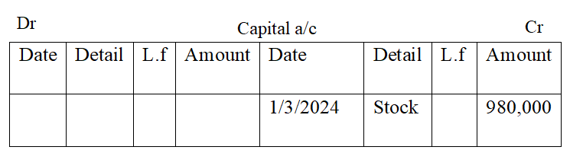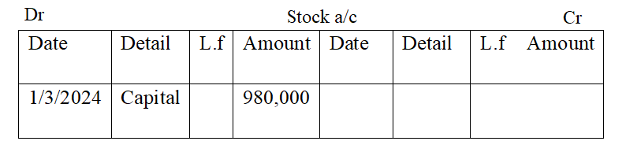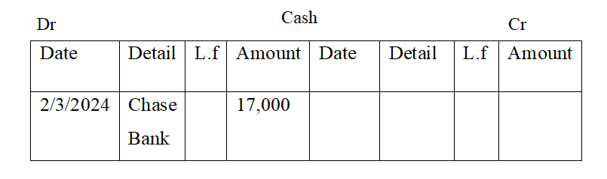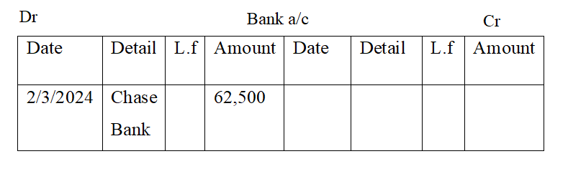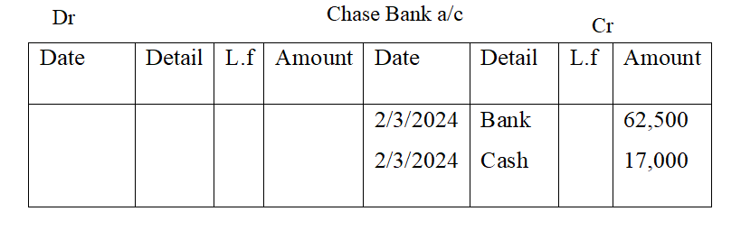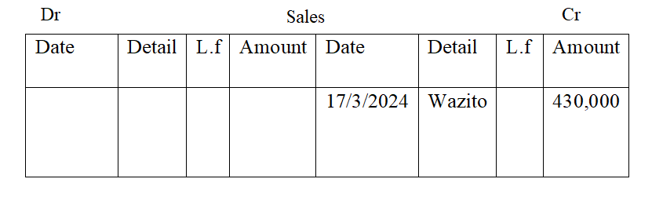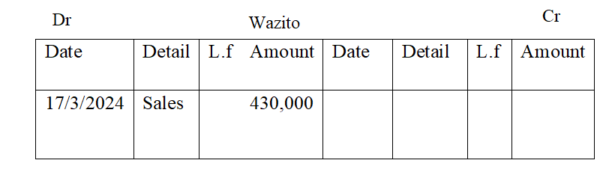

1. **Outline four causes of business success (4marks)**
2. *Proper location of resources/ availability of adequate of customers*
3. *Adequate finance*
4. *Least competition/Little competition/No competition*
5. *Proper management of finances*
6. *Proper debt management*
7. *Good public relations*
8. *Availability of adequate raw materials/stock of goods*
9. *Proper market research*
10. *Ability to manage people*
11. **The diagram below shows a population pyramid for a certain country**

**0**

**10**

**20**

**30**

**40**

**90**

**1**

**2**

**3**

**4**

**6**

**7**

**Population in Millions**

**Age in years**

**Give four challenges facing this country (4mks)**

1. *High depending ratio*
2. *High rate of unemployment*
3. *Increased social evils/ crimes*
4. *Low labour supply*
5. *Pressure on goods and services*
6. *Reduced savings and investment*
7. *Diversion of government expenditure*