NAME: ....................................................................ADM/No.................CLASS………

DATE……………………………………… Signature………………………

**BIOLOGY (231/3)**

**Paper 3 (PRACTICAL)**

**JUNE 2024 TIME: 13/4 hours**

**KASSU JOINT EXAMINATIONS**

**Kenya Certificate of Secondary Education**

Instructions to candidates

* Write your name and Index Number in the spaces provided above.
* Sign and write date of examination in the spaces provided above.
* Answer **ALL** questions in the spaces provided in the question paper.
* You are **not** allowed to start working with the apparatus for the first 15 minutes of the 1 3/4 hours allowed for this paper.

**For Examiner's Use Only**

|  |  |  |
| --- | --- | --- |
| **QUESTION** | **MAXIMUM SCORE** | **CANDIDATE SCORE** |
|  | **14** |  |
|  | **13** |  |
|  | **13** |  |
|  | **40** |  |

1. You are provided with **specimen W, liquid G** (Hydrogen peroxide) and **1% copper sulphate solution, 2M sodium hydroxide solution, distilled water, ethanol and iodine solution**. Use them to carry out ttests below.

Place five pieces of specimen W into a mortar and crush into paste using a pestle. Transfer the paste into 100ml beaker and add 30ml of water and stir then divide the solution into two equal portions in two different boiling tube. Label the portions X and Y.

a) Divide portion X into two separate test tubes.

i) To the first test tube add 2ml of hydrogen peroxide and record your observations. (1mark)

………………………………………………………………………………

ii) Boil the contents of the second test tube then add 2ml of hydrogen peroxide and record your observations. (1mark)

………………………………………………………………………………..

b) Explain your observation in (ii) above. (2marks)

………………………………………………………………………………………………………………………………………………………………………………………………………………………………………………………………………..……………………..

1. Use portion Y to test for the food substances present using the reagents provided.

(9marks)

|  |  |  |  |
| --- | --- | --- | --- |
| *Food substance* | *Procedure* | *Observation* | *Conclusion* |
|  |  |  |  |
|  |  |  |  |
|  |  |  |  |

1. Name the enzyme in the human digestive system required for the complete digestion of the food substance absent. (1mark)

………………………………………………………………………………………………………………………………………………………………………………………………

2. You are provided with specimen Q. Observe it then compare with the photograph R shown below and answer the questions that follow.

P

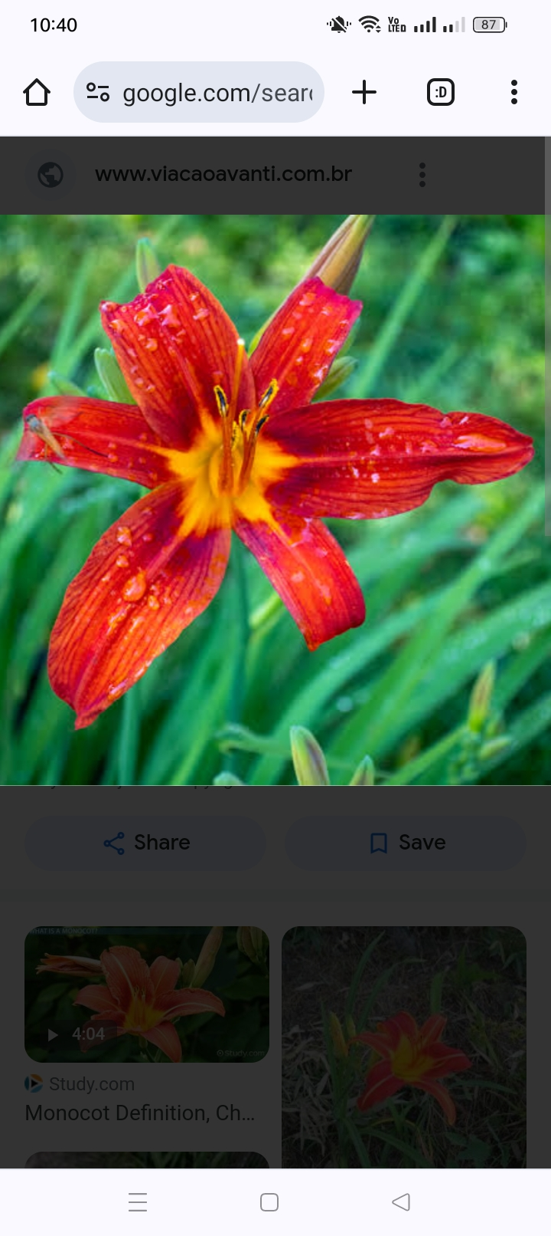

Photograph R

1. Name the classes of organisms represented by Q, R and P and give a reason for each one basing on observable features only (6marks)

|  |  |  |
| --- | --- | --- |
| SPECIMEN | CLASS | REASON |
| Q |  |  |
| R |  |  |
| P |  |  |

1. Specimen P probes into nectaries of specimens Q and R. State two characteristics of living organisms achieved after the process (2marks)

………………………………………………………………………………………………………………………………………………………………………………………………

1. Explain the adaptations of specimen in photograph R to pollination (2marks)

………………………………………………………………………………………………………………………………………………………………………………………………

1. Carefully remove one stamen of specimen Q then draw a well labeled diagram. (3marks)

3. You are provided with photographs of specimens **P** and **Q** examine them carefully and answer the questions that follow.

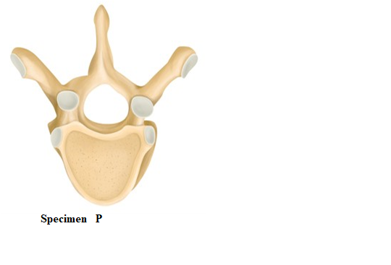 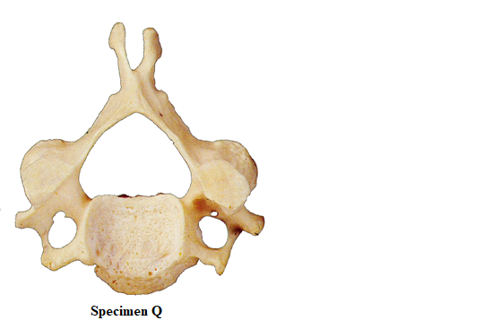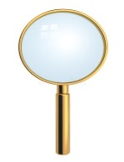

1. Name the region of the mammalian skeleton from which the specimen P and Q were obtained from. (2 marks)

**P.** ………………………………………………………………………………………

**Q.** ……………………………………………………………………………………….

1. With a reason identify the specimen represented in the photographs above

**Specimen P**

Identity (1mark)

………………………………………………………………………………………………

Reason (1mark)

………………………………………………………………………………………………

**Specimen Q**

Identity (1mark)

………………………………………………………………………………………………

Reason (1mark)

………………………………………………………………………………………………

1. State **two** ways specimen **Q** is suited to its function ( 2marks)

………………………………………………………………………………………………………………………………………………………………………………………………

1. State **two** structural differences between specimen **P** and **Q** (2marks)

|  |  |
| --- | --- |
| P | Q |
|  |  |
|  |  |

1. The actual length of the hand-lens next to specimen **Q** is 6. 5cm.Use this information to calculate the actual lateral length of specimen **P** ( 3marks)