QUESTION 1

a)
1. a) Body bilaterally symmetrical.............................................. go to 2
b) Body radially symmetrical .................................................Sea anemone

2. a) With limbs ...........................................................................go to 3
b) Without limbs .......................................................................go to 7

3. a) With six legs ........................................................................ go to 4
b) With more than six legs ....................................................... go to 5

4. a)With two pairs of wings ....................................................... Honey bee
b) With one pair of wings .......................................................House fly

5. a)With eight legs .....................................................................Spider
b) With more than eight legs ................................................... go to 6

6. a)With two pairs of legs in each segment ................................Millipede
b) With one pair of legs in each segment .................................Centipede

7. a) Body segmented...................................................................Earthworm
b) Body not segmented............................................................... Roundworm
(Allow 1mk for 13 correct steps – 13x1 = 13mks)

b). i) Arthropoda; (1mk)
Rej. Wrong spelling

ii) - Body segmented
- Jointed appendages; (1mk)

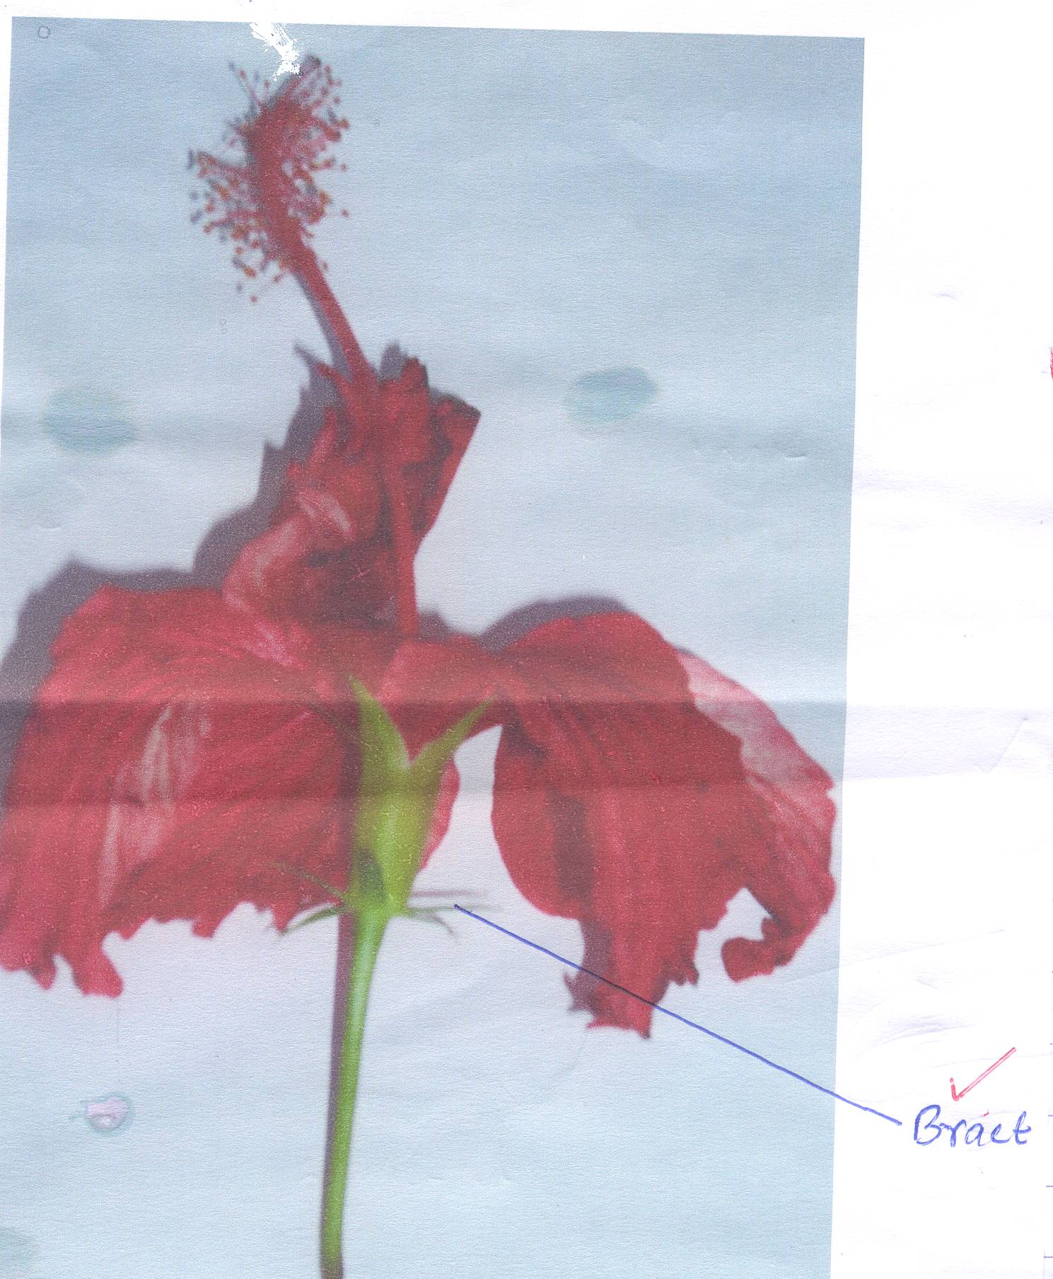
QUESTION 2

a) Bract√ Rj – Use of arrow
- Wrong spelling (1mk)

(b) i) Stamens
- Many/√numerous
- Located√ below stigma
- Filaments partially fuse to form staminate tube √ Max 1mk

ii) Corolla
Consists of free petals√/polypetalous 1mk

(iii) Calyx
Consists of fused sepals√/gamosepalous calyx 1mk

c) i) Dicotyledonae√ rej spelling error
ii) – Petals have network venation √
- Has wide/broad petals√
- Floral parts in multiples√ of 5s max 1

(d) (i) Insect√/insects/Entomorphilous 1mk rej spelling error
(ii) – Has brightly coloured √petals
- Has large√/conspicuous petals/corolla

(e) (i) Inferior√/Hypogynous ovary
(ii) Floral parts arise above the ovary√/ovary is located below floral parts 1mk

(f) Magnification = Linear length of photograph √ = 15
Linear length of real specimens 14
= X1.0√

QUESTION 3

 | Visking tubing |  | Beaker
Set up | Iodine solution | Benedicts solution | Iodine solution | Benedict’s solution
A | Iodine solution turns black/blue black | Benedicts solution turns green, yellow, brown and finally orange | Iodine solution remains yellow/brown | Benedicts solution turns green, yellow, brown and finally orange
B | Iodine solution remains yellow/brown | Benedicts solution turns greens, yellow, brown and finally orange. | Iodine solution turns black/blue black | Benedicts solution turns green and finally yellow

