NAME ………………………………………… INDEX NO …….…………………..
SCHOOL ………………………………………… SIGNATURE …………..……....…….
DATE ……………….………..
231/2
BIOLOGY
PAPER 2
(THEORY)
JULY/AUGUST, 2024
2 HOURS
NAKURU NORTH SUB -COUNTY JOINT MOCK 2024

Kenya Certificate of Secondary Education (K.C.S.E)

231/2
BIOLOGY
PAPER 2
(THEORY)
JULY/AUGUST, 2024
2 HOURS

INSTRUCTIONS TO CANDIDATES
- Write your name and Index Number in the spaces provided above.
- This paper consists of two sections. Section A and section B.
- Answer ALL questions in section A in the spaces provided. In section B answer question 6 (compulsory) and either question 7 or 8 in the spaces provided after question 8
- This paper consists of 10 Printed pages. Candidates should check the question paper to ensure that all the papers are printed as indicated and no questions are missing
For Examiners use only.
Section | Question | Maximum score | Candidates score
A | 1 | 8
A | 2 | 8
A | 3 | 8
A | 4 | 8
A | 5 | 8
B | 6 | 20
B | 7 | 20
B | 8 | 20
 | Total score | 80
1. A Pure – line pea plant with green pods was crossed with a pure – line plant with yellow pods. All F₁ plants had green pods. The F₁ plants were selfed and out of 1160 F₂ plants, 856 had green pods and 304 had yellow pods.
a) i) Identify the dominant and the recessive genes. (1mark)
...............................................................................................................................................................
..............................................................................................................................................................................................................................................................................................................................

ii) Using letter G to represent dominant gene and g to represent recessive gene, work out the phenotypic ratio of the F₂ generation. (3marks)

b) Showing your working, state the number of plants with; (3marks)
i) Recessive genes; ...............................................................................................................................................................
...............................................................................................................................................................

ii) Dominant genes;
..............................................................................................................................................................................................................................................................................................................................

iii) Heterozygous genes;
.............................................................................................................................................................................................................................................................................................................................................................................................................................................................................................
c) i) What is sickle cell Anemia? (1mark)
......................................................................................................................................................................................................................................................................................................................
ii) State one problem faced by people suffering from sickle cell anemia? (1mark)
......................................................................................................................................................................................................................................................................................................................

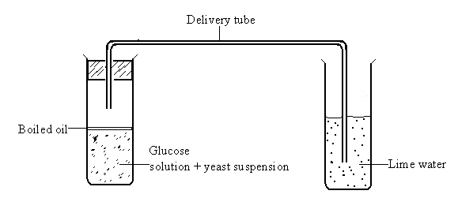
2. (a) Examine the diagram which shows a set used to demonstrate a certain process.
Boiling tube
Test tube

(i) State the aim of the experiment. (1 mark)
…………………………………………………………………………………………………………..………………………………………………………………………………………………………..

(ii) Why was it necessary to boil the glucose solution before adding the yeast suspension? (1 mark)
…………………………………………………………………………………………………………..………………………………………………………………………………………………………..

(iii) Why was it necessary to cool the glucose before adding the yeast suspension? (1mark)
…………………………………………………………………………………………………………..………………………………………………………………………………………………………..

(iv) Why was the oil layer added? (1 mark)
…………………………………………………………………………………………………………..………………………………………………………………………………………………………..…………………………………………………………………………………………………………

(v) Write down the equation for the chemical reaction that took place in the boiling tube (2 marks)
…………………………………………………………………………………………………………..………………………………………………………………………………………………………..
(vi) State the observations made in the test tube after 45 minutes (2 marks)
…………………………………………………………………………………………………………..………………………………………………………………………………………………………..…………………………………………………………………………………………………………

3. The diagram below represents a simplified nitrogen cycle.
- Name the group of bacteria represented by: (2 marks)
A ………………………...……………………………………………………………………………
B …………………………...…………………………………………………………………………

i) Name the group of organisms represented by C. (1 mark)
…………………………………………………………………………………………………………..………………………………………………………………………………………………………..…………………………………………………………………………………………………………

ii) Give the reasons for your answer in b (i) above. (2 marks)
…………………………………………………………………………………………………………..………………………………………………………………………………………………………..…………………………………………………………………………………………………………

b i) Define the term nitrification. (1 mark)
…………………………………………………………………………………………………………..………………………………………………………………………………………………………..…………………………………………………………………………………………………………

ii) Explain how excessive use of pesticides will affect nitrification. (2 marks)
…………………………………………………………………………………………………………..………………………………………………………………………………………………………..…………………………………………………………………………………………………………
…………………………………………………………………………………………………………

- Study the diagram below and answer the questions which follow.
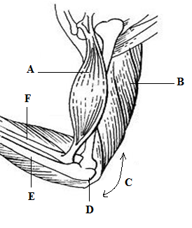

- Identify the muscle represented by letters A and B (2 marks)
A……………………………………………………………………………………………………
B..………………………………………………………………………………………………….
- Describe how muscles A and B cause straightening of joint C (2 marks)
…………………………………………………………………………………………………………..………………………………………………………………………………………………………..…………………………………………………………………………………………………………
…………………………………………………………………………………………………………..………………………………………………………………………………………………………..

b) Name the joint C (1 mark)
…………………………………………………………………………………………………………..………………………………………………………………………………………………………..…………………………………………………………………………………………………………
c) Name parts label D, E and F (3marks)
D………………………………………………………………………………………………………
E………………………………………………………………………………………………………
F………………………………………………………………………………………………………
- The figure below represents a structure obtained from the ileum of a mammal.
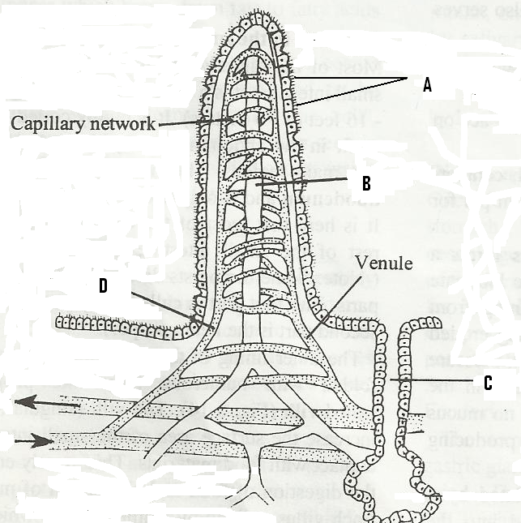

- Give the identity of the structure. (1 mark)
…………………………………………………………………………………………………………..………………………………………………………………………………………………………..

- What is the importance of the structure named in (a) above? (1 mark)
…………………………………………………………………………………………………………..………………………………………………………………………………………………………..
- Name the parts labeled A, B and D. (3 marks)

A……………………………………………………………………………………………………
B.......................…………………………………………………………………………………….
D...………………………………………………………………………………………………….
- (i) Name the juice secreted by the part labeled C. (1 mark)
…………………………………………………………...........…………………………………………………………………………………..............................................................................……
(ii) List two enzymes present in the juice named in d (i) above. (2 marks)
……………………………………………………………………………………………………...
...........................................................................................................................................................
...........................................................................................................................................................
SECTION B (40 MARKS)

Answer questions 6 (compulsory) and either question 7 or 8 in the spaces provided.
6. In an experiment to investigate a certain process in a given plant species, the rate of carbon(iv) oxide consumption and the rate of carbon (iv) oxide released were measured over a period of time of the day. The results of the investigation are shown in the table below.

Time of day (hrs) | 6 | 8 | 10 | 12 | 14 | 16 | 18 | 20 | 22 | 24
Carbon (IV) Oxide consumption mm³/min | 0 | 43 | 69 | 91 | 91 | 50 | 18 | 0 | 0 | 0
Carbon (iv) oxide released mm³/min | 38 | 22 | 10 | 3 | 3 | 6 | 31 | 48 | 48 | 48
a) On the same axes, draw the graphs of volume of carbon (IV) oxide consumed and released against time (7mks)


b) Name the biochemical process represented by
i) Carbon (IV) oxide consumption (1mark)
…………………………………………………………………………………………………………..………………………………………………………………………………………………………..
(ii) Carbon (iv) oxide release (1mark)
…………………………………………………………………………………………………………..………………………………………………………………………………………………………..
c) Account for the shape of the curve for
i) Carbon (IV) Oxide consumption (3marks)

…………………………………………………………………………………………………………..………………………………………………………………………………………………………..
…………………………………………………………………………………………………………..………………………………………………………………………………………………………..

ii) Carbon (IV) Oxide release. (3marks)

…………………………………………………………………………………………………………..………………………………………………………………………………………………………..
…………………………………………………………………………………………………………..………………………………………………………………………………………………………..
d) i) From the graph state the time of the day when the plant attains compensation point (1mark)

…………………………………………………………………………………………………………..………………………………………………………………………………………………………..
ii) What is made by compensation point? (2marks)

…………………………………………………………………………………………………………..………………………………………………………………………………………………………..
…………………………………………………………………………………………………………
e) Explain how temperature affects the rate of carbon (IV) oxide consumption in a plant. (2marks)
…………………………………………………………………………………………………………..………………………………………………………………………………………………………..
…………………………………………………………………………………………………………..………………………………………………………………………………………………………..
7. a) i) State two significances of transpiration. (2 marks)

ii) Discuss the forces involved in movements of water from roots to the leaves. (8 marks)

- Describe the mechanism of opening and closing of stomata using photosynthesis theory. (10 marks)

8. a) State four characteristics of gaseous exchange surfaces (4marks)

b) Describe the mechanism of gaseous exchange in a named mammal (16marks)
…………………………………………………………………………………………………………..………………………………………………………………………………………………………..
…………………………………………………………………………………………………………..………………………………………………………………………………………………………..
…………………………………………………………………………………………………………..………………………………………………………………………………………………………..
…………………………………………………………………………………………………………..………………………………………………………………………………………………………..
…………………………………………………………………………………………………………..………………………………………………………………………………………………………..
…………………………………………………………………………………………………………..………………………………………………………………………………………………………..
…………………………………………………………………………………………………………..………………………………………………………………………………………………………..
…………………………………………………………………………………………………………..………………………………………………………………………………………………………..
…………………………………………………………………………………………………………..………………………………………………………………………………………………………..
…………………………………………………………………………………………………………..………………………………………………………………………………………………………..
…………………………………………………………………………………………………………..………………………………………………………………………………………………………..
…………………………………………………………………………………………………………..………………………………………………………………………………………………………..
…………………………………………………………………………………………………………..………………………………………………………………………………………………………..
…………………………………………………………………………………………………………..………………………………………………………………………………………………………..
…………………………………………………………………………………………………………..………………………………………………………………………………………………………..
…………………………………………………………………………………………………………..………………………………………………………………………………………………………..
…………………………………………………………………………………………………………..………………………………………………………………………………………………………..
…………………………………………………………………………………………………………..………………………………………………………………………………………………………..
…………………………………………………………………………………………………………..………………………………………………………………………………………………………..
…………………………………………………………………………………………………………..………………………………………………………………………………………………………..
…………………………………………………………………………………………………………..………………………………………………………………………………………………………..
…………………………………………………………………………………………………………..………………………………………………………………………………………………………..
…………………………………………………………………………………………………………..………………………………………………………………………………………………………..
…………………………………………………………………………………………………………..………………………………………………………………………………………………………..
…………………………………………………………………………………………………………..………………………………………………………………………………………………………..
…………………………………………………………………………………………………………..………………………………………………………………………………………………………..
…………………………………………………………………………………………………………..………………………………………………………………………………………………………..
…………………………………………………………………………………………………………..………………………………………………………………………………………………………..

