MARANDA HIGH SCHOOL

Kenya Certificate of Secondary Education
PRE-MOCK EXAMINATIONS 2024
231/2 BIOLOGY Paper 2
March 2024 – TIME: 2 Hours

Name: …………………………………………………... Adm No: ……….……
Class: ……………Candidate’s Signature: …….……….. Date: ……/03/2024.
INSTRUCTIONS TO CANDIDATES
- Answer all the questions.
- Answers must be written in the spaces provided in the question paper.
- Additional pages must not be inserted.
- Candidates may be penalized for recording irrelevant information and for incorrect spellings.
FOR EXAMINER’S USE ONLY
Section | Question | Maximum  Score | Candidate’s  Score
A | 1 | 8
A | 2 | 8
A | 3 | 8
A | 4 | 8
A | 5 | 8
A | 6 | 20
B | 7 | 20
B | 8 | 20

- Bile and pancreatic juice are important secretions in animal nutrition.
- In which part of the digestive system do the above juices exert their influence?
(1 mark)
________________________________________________________________
i).Which of the two secretions should be mixed with chyme first for efficient digestion? (2 marks)
________________________________________________________________________________________________________________________________
ii). Explain your answer above. (2 marks)
________________________________________________________________________________________________________________________________
- Explain why:
i) It is not necessary to eat too much protein in the diet. (2 marks)
________________________________________________________________________________________________________________________________
ii). Liver is recommended in the diet of anaemic persons. (2 marks)
________________________________________________________________________________________________________________________________________________________________________________________________
- Below is a representation of an independent unit of the biosphere. Use it to answer the questions that follow.
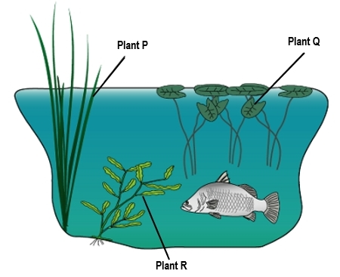
- Identify the unit represented above. (1 mark)
________________________________________________________________
- i) Compare the primary productivity of the plants R and Q. (1 mark)
___________________________________________________________________________________________________________________________________________________________________________________________________
ii) Account for your answer above. (2 marks)
________________________________________________________________________________________________________________________________________________________________________________________________

- Give two differences between the chloroplasts of plants Q and R. (2 marks)
Chloroplast of Q | Chloroplast of R

- Name:
i) The instrument that you can use to measure light penetration in the unit above. (1 mark)
________________________________________________________________
ii) The class to which the animal in the illustration belongs. (1 mark)
________________________________________________________________
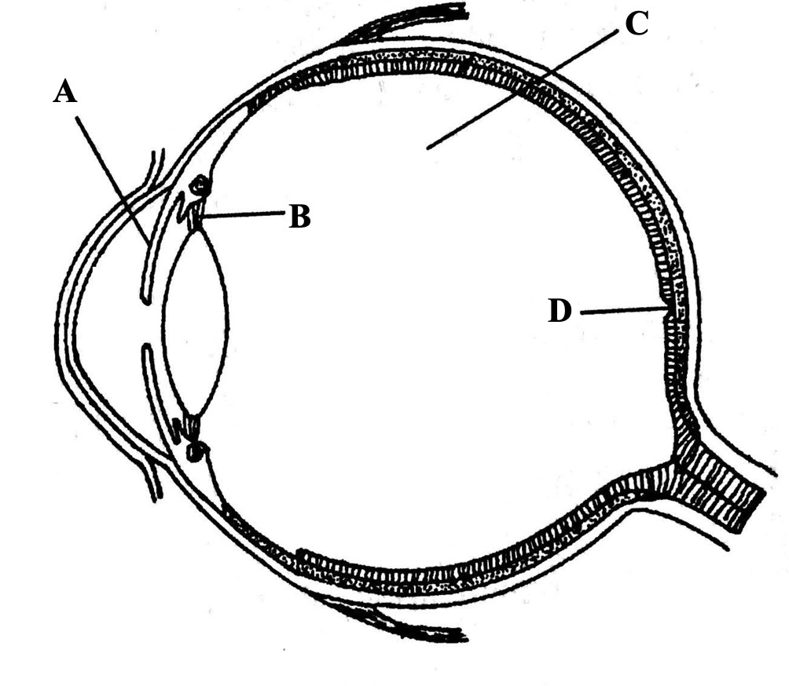
- (a) The diagram below represents a longitudinal section through the human eye.

- Name the parts labeled A and B. (2 marks)
A ______________________________________________________________
B_______________________________________________________________
- Explain the changes that would occur on the structure labelled A when a person in a dark room switches on lights. (2 marks)

________________________________________________________________________________________________________________________________________________________________________________________________
- Explain how part labelled D is adapted to its functions. (2 mark)

________________________________________________________________________________________________________________________________________________________________________________________________
(b) Give functions of the following parts of human brain.
- Optic lobe. (1 mark)

_______________________________________________________________
- Cerebellum. (1 mark)

________________________________________________________________

- (a) Distinguish between a sex linked trait and a sex linked gene. (2 marks)
________________________________________________________________________________________________________________________________________________________________________________________________
- Sexual reproduction is great source of variation. Explain. (2 marks)

________________________________________________________________________________________________________________________________________________________________________________________________
- The beak length in a given bird species in Gwassi Hills Forest is linked to the X chromosome. The beaks can be long or short. A recessive allele t is responsible for short beaks. Use a genetic cross to show the genotypes of a cross between a short beaked male bird and a long beaked female bird. (4 marks)
________________________________________________________________________________________________________________________________________________________________________________________________
________________________________________________________________________________________________________________________________________________________________________________________________
________________________________________________________________

- The photographs below illustrates different biological phenomena.
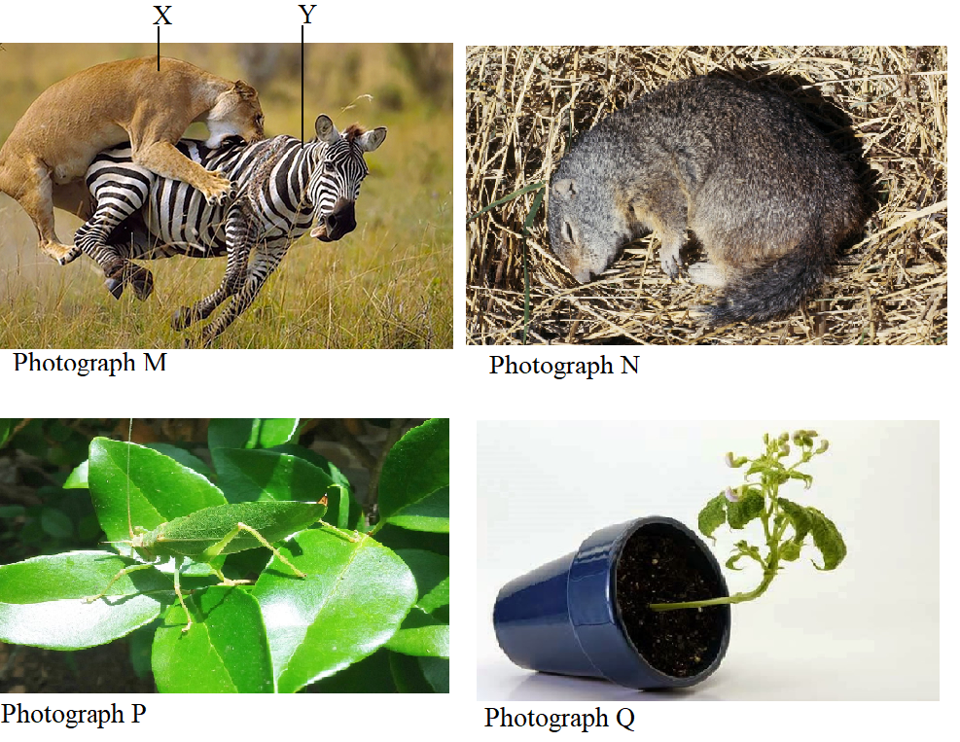
  - Name the biological phenomena represented by photograph M. (1 mark)
________________________________________________________________
  - Give the significance of phenomenon represented by photograph P. (1 mark)
________________________________________________________________________________________________________________________________
  - Explain how the change in photograph Q occurs. (2 marks)
________________________________________________________________________________________________________________________________________________________________________________________________

  - Identify which of the two animals X and Y will have the least biomass. Give a reason for your answer. (2 marks)

________________________________________________________________________________________________________________________________________________________________________________________________
  - Photograph N shows the behavior of an animal during hot weather. Explain the significance of the phenomenon. (2 marks)
________________________________________________________________________________________________________________________________________________________________________________________________
- An athlete undertook a race that lasted ten minutes. The concentration of lactic acid in his blood from the beginning of the race to 45 minutes after the race determined at five minutes interval. The results were as shown in the table below.
Time in minutes | 0 | 5 | 10 | 15 | 20 | 25 | 30 | 35 | 40 | 45 | 50 | 55
Lactic acid concentration mg/ml | 20 | 24 | 74 | 98 | 88 | 78 | 70 | 66 | 62 | 58 | 54 | 50

- On the graph provided, draw a graph of lactic acid concentration against time. (6 marks)


- (i) By how much did the lactic acid increase at the end 13th minute? (1 mark)
______________________________________________________________
(ii) What is the concentration of lactic at 48th minute? (1 mark)
______________________________________________________________
- Account for the high rate of lactic acid production up to 20th minute.
(2 marks)
__________________________________________________________________________________________________________________________________________________________________________________________

- Account for the decline in lactic acid concentration after the excersise.
(2marks)
____________________________________________________________________________________________________________________________
______________________________________________________________
- (i) In man, glucose molecule is broken down aerobically to yield 2880KJ of energy while anaerobic breakdown of the glucose molecule yield 150KJ of energy. Give explanation for the difference. (2 marks)
____________________________________________________________________________________________________________________________
______________________________________________________________
ii) Write down a balanced equation to show fermentation in plants. (1 mark)
______________________________________________________________
f) (i) Other than carbohydrate, name two other respiratory substrates. (2 marks)
______________________________________________________________________________________________________________________________
(ii) Under what condition does each of the substrate named in f (i) above respired? (2 marks)
______________________________________________________________________________________________________________________________
h) What do you understand by the term obligate anaerobes? (1 marks)
__________________________________________________________________________________________________________________________________
- Describe various evidences that supports the theory of organic evolution.
(20 marks)
- Describe how water moves from the soil to the leaves in a tree. (20 marks)
__________________________________________________________________________________________________________________________________________________________________________________________________________________________________________________________________________________________________________________________________________________________________________________________________________________________________________________________________________________________________________________________________________________________________________________________________________________________________________________________________________________________________________________________________________________________________________________________________________________________________________________________________________________________________________________________________________________________________________________________________________________________________________________________________________________________________________________________________________________________________________________________________________________________________________________________________________________________________________________________________________________________________________________________________________________________________________________________________________________________________________________________________________________________________________________________________________________________________________________________________________________________________________________________________________________________________________________________________________________________________________________________________________________________________________________________________________________________________________________________________________________________________________________________________________________________________________________________________________________________________________________________________________________________________________________________________________________________________________________________________________________________________________________________________________________________________________________________________________________________________________________________________________

