NAKURU NORTH SUB -COUNTY JOINT MOCK 2024
BIOLOGY PAPER 2
MARKING SCHEME
Question 1

a) i) Dominant is the gene for green pods

- Recessive is gene for the yellow pods

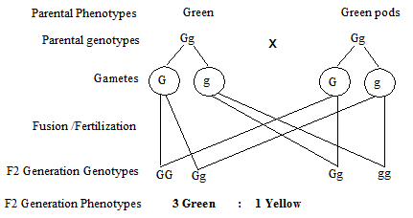

Homozygous recessive
b) i) ¼ x 1160 = 290
Homozygous dominant
(ii) ¼ x 1160 = 290
Heterozygous
(iii) 2/4 x 1160 = 580
c) i) A genetic/ Hereditary – disorder of the blood in which the RBC’S assume a sickle or crescent shape instead of the normal biconcave shape this makes the RBC’s not to carry enough oxygen to the tissues because the S.A is reduced.

ii) - Periodic painful attacks characteristic of anaemia such as fatigue, shortness of breath, delayed growth and rapid heartbeat.

- Damage of internal organs such as the kidney, heart and joints

- In severe cases early death from the kidney failure and respiratory failure or stroke is common.

- Decreased Immune reaction due to malfunctioning of the spleen.
(Mark any one)

Question 2

b) (i) To investigate anaerobic respiration in yeast cells/fermentation.

(ii) To avoid destroying/killing yeast cells and to remove oxygen; rej air

(iii) To avoid denaturing enzymes in yeast cells;

(iv) Prevent re-entry of air into yeast solution;

Question 3

- A – Denitrifying bacteria;

D – Saprophytic bacteria

- i) Plant;

ii) They absorb nitrate; animals get proteins by feeding on them; both C and animals die and decay to form ammonia;

c) i) Nitrification is the conversion of nitrogen to nitrates;

ii) Pesticides kill nitrifying bacterial Nitrobacter/azotobacter; which convert nitrogen into nitrates/reduce nitrates in the soil.

Question 4

(a) (i) A – Biceps
B – Triceps

(ii) A (Biceps) relaxes; as B (Triceps) contracts;

(b) Hinge joint;

(c) D – Olecranon process; E – Ulna, F - Radius.

Question 5

(a) Villus; Reject Villi

(b) To provide a large surface area for absorption of digested food;

(c) A – Microvillus; Reject – microvillus
B – Lacteal;
D – Arterial; Reject – artery

(d) (i) Succus entericcus / intestinal juice;

(ii) Maltase; Lactase; Sucrase; Peptidase; [Any two correct]

Question 6

(a) Scale – 1mark
Plotting – 2marks
Curves – 1mark
Identity – 1 mark
Axes – 2 marks
Total 7 marks

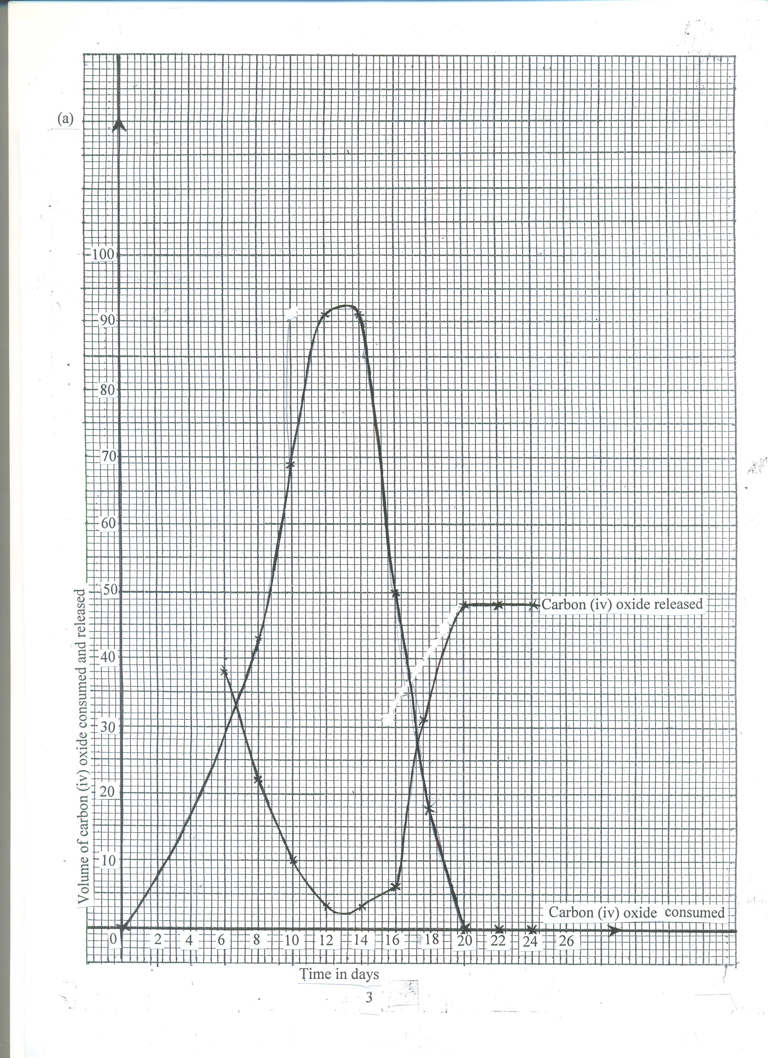

(b) (i) Photosynthesis;

(ii) Respiration;

(c) (i) Rate of CO₂ consumption increases from 6hrs – 12hrs; this is due to increase in light intensity; The rate remains the same between 12hrs and 14 hrs which is the period of optimum light intensity; after which it decreases due to increase in light intensity; (3mks)

(ii) Rate of CO₂ released decreased from 6hrs to 12hrs; because some of the CO₂ is used for photosynthesis; from 14hrs to 20 hrs the rate of carbon (iv) oxide released increased; because the rate of photosynthesis is decreasing as light intensity decreases after which the rate remains constant since no photosynthesis is taking place to consume the CO₂ (4mks max 3mks)

- (i) 8 hrs and 18 hours

(ii) Point at which rate of photosynthesis; equals to the rate of respiration/rate of CO₂
consumption equals to the rate of CO₂ released; (2mks)

(e) Increase in temperature increases the rate of CO₂ consumption upto an optimum; because temperature activates enzymes; (2mks)

- (a) (i) It serves to cool the leaves especially during hot environment;
      - It provides a mechanism through which mineral salts are transported in the plants;
      - Allows loss of excess water from the plants;

  - Root pressure: This is the force which push water from the root to the stem.

Cohesion and adhesion force
Cohesion force – force which attracts water molecules together maintaining a continuous column of water preventing the break of water column.

Adhesion force – water molecules cling to the sides of the xylem vessels wall.

Capillary force – The forces of adhesion and cohesion are the basis of capillarity the rise of liquids in capillary tubes.

Transpiration pull – as water evaporates from the cells on the exposed parts of plants, water molecules are drawn from the adjacent cells. Eventually those cells that are adjacent to the xylem vessels draw water from them by osmosis.

  - The guard cells have chloroplasts; in presence of light; photosynthesis occur in the guard cells of stomata; producing sugar in guard cells; This increases the osmotic pressure of guard cells; water is drawn from the neighbouring cells by osmosis; causing turgidity of guard cells; the inner walls of the guard cells which are thicker than outer wall stretch more causing the guard cells to bulge outwards; stomata open.

In absence of light, no photosynthesis in guard cells; sugar in guard cells is converted into starch; osmotic pressure lowers; guard cell lose water to adjacent epidermal cells by osmosis; become flaccid; the inner walls of guard cells shrink; the thicker wall reduces; this closes this stomata.

8. (a) Moist to dissolve gases before diffusing;
- Thin walled/epithelium which is one cell thick to reduce the distance of
diffusing molecules
- Highly folded to increase surface area for exchange of gases
- Highly vascularised to maintain a steep concentration gradient hence maximum gaseous exchange
- Well ventilated to allow circulation of respiratory gases (mark 1st 4)

(b) Breathing in/inhalation
External intercostals muscles contract; while internal intercoastal muscles relax; this causes raising of ribcage upward and outwards; muscles of diaphragm contract hence flattens; the volume of thoracic cavity increases; and pressure decrease; than the atmospheric pressure; The higher air pressure in the atmosphere forces air into the lungs and the lungs inflate

Breathing out/exhalation

External intercostals muscles relax; while internal intercoastal muscles contract; this causes ribcage to move downwards and inwards; the muscles of the diaphragm relax and diaphragm assume a done shape; this makes the volume of thoracic cavity to decrease; while pressure increases; than atmospheric pressure; higher pressure in the thoracic cavity forces air out of the lungs and the lungs deflate;

